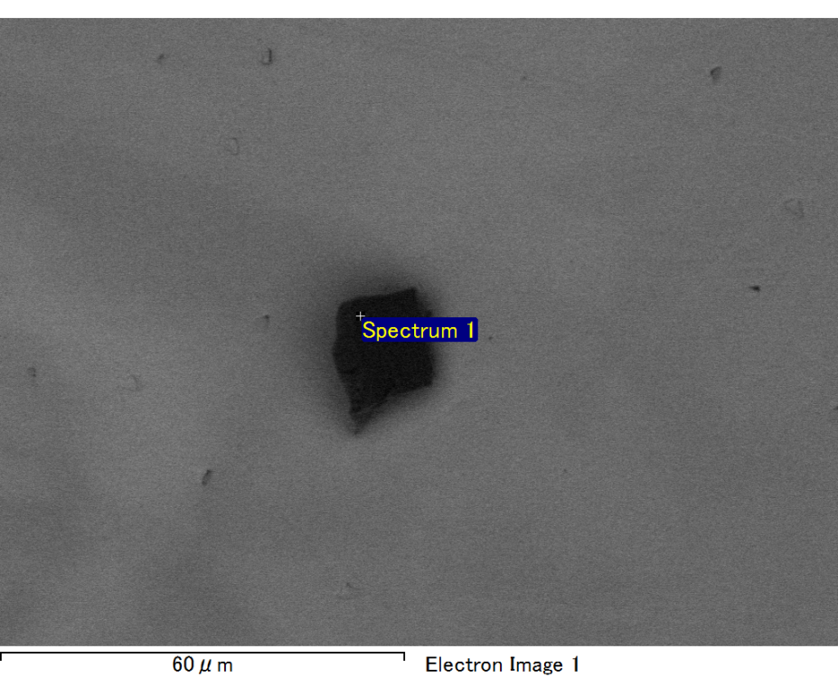

Spectrum processing :

No peaks omitted

Processing option : All elements analyzed (Normalised)

Number of iterations = 2

Standard :

C CaCO3 1-Jun-1999 12:00 AM

O SiO2 1-Jun-1999 12:00 AM

Mg MgO 1-Jun-1999 12:00 AM

Si SiO2 1-Jun-1999 12:00 AM

Fe Fe 1-Jun-1999 12:00 AM

Au Au 1-Jun-1999 12:00 AM

|  |  |  |  |
| --- | --- | --- | --- |
| Element | Weight% | Atomic% |  |
|  |  |  |  |
| C K | 2.39 | 8.89 |  |
| O K | 18.83 | 52.63 |  |
| Mg K | 5.77 | 10.61 |  |
| Si K | 4.36 | 6.94 |  |
| Fe L | 9.33 | 7.47 |  |
| Au M | 59.32 | 13.47 |  |
|  |  |  |  |
| Totals | 100.00 |  |  |

Spectrum Label: Spectrum 1

Livetime 60.0 s

Acquisition geometry ( degrees ):

Tilt = 15.0

Azimuth = 0.0

Elevation = 30.0

Accelerating voltage = 10.00 kV

Total spectrum counts = 49533

|  |  |  |  |
| --- | --- | --- | --- |
| Sample data : | Energy (eV) | Resn. (eV) | Area |
| Strobe : | 3.8 | 47.42 | 1000312 |
|  |  |  |  |

No quant optimization performed

Sample: Sample 1

Type: Default

ID:

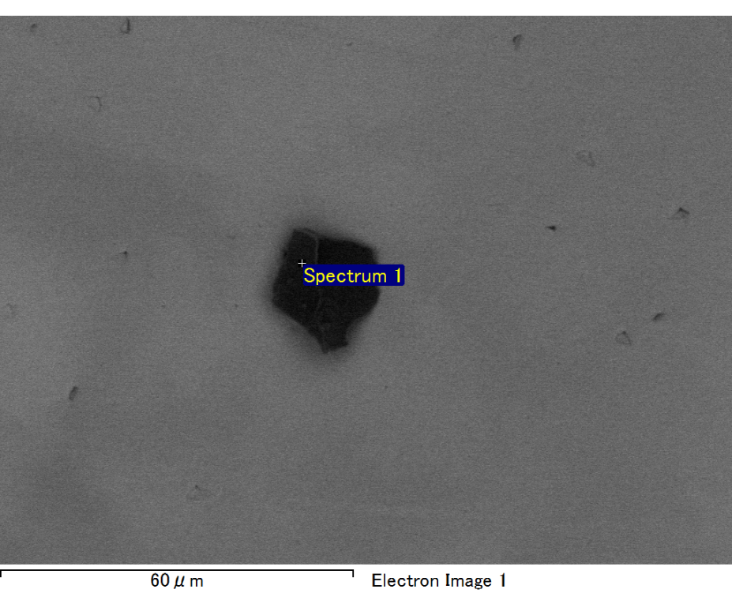

Spectrum processing :

No peaks omitted

Processing option : All elements analyzed (Normalised)

Number of iterations = 2

Standard :

C CaCO3 1-Jun-1999 12:00 AM

O SiO2 1-Jun-1999 12:00 AM

Mg MgO 1-Jun-1999 12:00 AM

Si SiO2 1-Jun-1999 12:00 AM

Fe Fe 1-Jun-1999 12:00 AM

Au Au 1-Jun-1999 12:00 AM

|  |  |  |  |
| --- | --- | --- | --- |
| Element | Weight% | Atomic% |  |
|  |  |  |  |
| C K | 2.33 | 8.54 |  |
| O K | 19.33 | 53.14 |  |
| Mg K | 6.18 | 11.18 |  |
| Si K | 4.49 | 7.03 |  |
| Fe L | 8.85 | 6.97 |  |
| Au M | 58.81 | 13.13 |  |
|  |  |  |  |
| Totals | 100.00 |  |  |

Spectrum Label: Spectrum 1

Livetime 60.0 s

Acquisition geometry ( degrees ):

Tilt = 15.0

Azimuth = 0.0

Elevation = 30.0

Accelerating voltage = 10.00 kV

Total spectrum counts = 50297

|  |  |  |  |
| --- | --- | --- | --- |
| Sample data : | Energy (eV) | Resn. (eV) | Area |
| Strobe : | 3.8 | 47.46 | 999816 |
|  |  |  |  |

No quant optimization performed

Sample: Sample 1

Type: Default

ID:

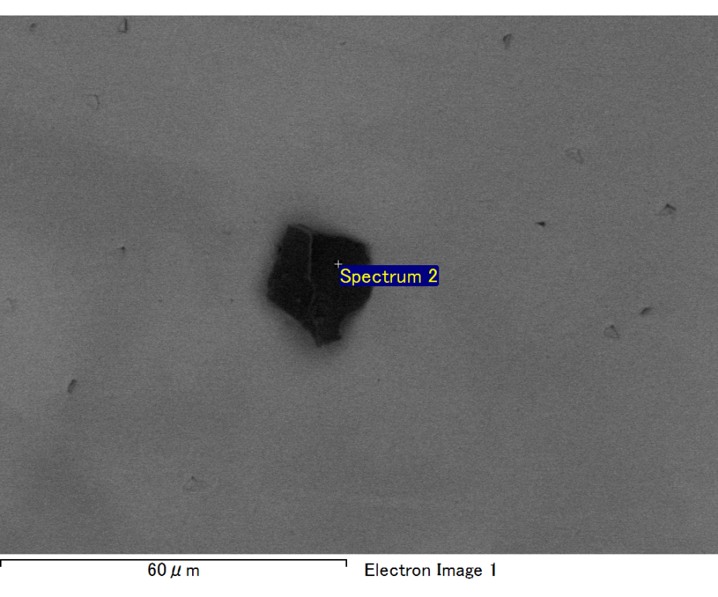

Spectrum processing :

No peaks omitted

Processing option : All elements analyzed (Normalised)

Number of iterations = 2

Standard :

C CaCO3 1-Jun-1999 12:00 AM

O SiO2 1-Jun-1999 12:00 AM

Mg MgO 1-Jun-1999 12:00 AM

Si SiO2 1-Jun-1999 12:00 AM

Fe Fe 1-Jun-1999 12:00 AM

Au Au 1-Jun-1999 12:00 AM

|  |  |  |  |
| --- | --- | --- | --- |
| Element | Weight% | Atomic% |  |
|  |  |  |  |
| C K | 2.23 | 7.73 |  |
| O K | 21.08 | 54.90 |  |
| Mg K | 6.40 | 10.96 |  |
| Si K | 4.26 | 6.32 |  |
| Fe L | 11.44 | 8.54 |  |
| Au M | 54.60 | 11.55 |  |
|  |  |  |  |
| Totals | 100.00 |  |  |

Spectrum Label: Spectrum 2

Livetime 60.0 s

Acquisition geometry ( degrees ):

Tilt = 15.0

Azimuth = 0.0

Elevation = 30.0

Accelerating voltage = 10.00 kV

Total spectrum counts = 50989

|  |  |  |  |
| --- | --- | --- | --- |
| Sample data : | Energy (eV) | Resn. (eV) | Area |
| Strobe : | 3.8 | 47.47 | 1000417 |
|  |  |  |  |

No quant optimization performed

Sample: Sample 1

Type: Default

ID:

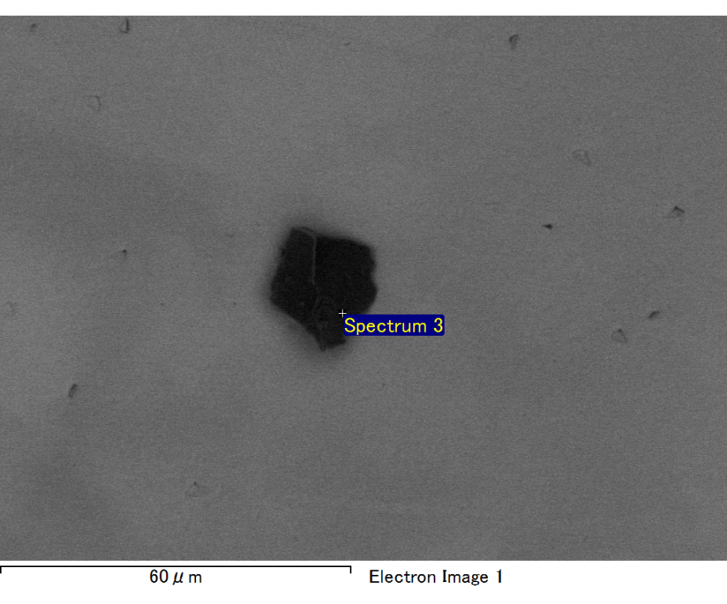

Spectrum processing :

No peaks omitted

Processing option : All elements analyzed (Normalised)

Number of iterations = 2

Standard :

C CaCO3 1-Jun-1999 12:00 AM

O SiO2 1-Jun-1999 12:00 AM

Mg MgO 1-Jun-1999 12:00 AM

Si SiO2 1-Jun-1999 12:00 AM

Fe Fe 1-Jun-1999 12:00 AM

Au Au 1-Jun-1999 12:00 AM

|  |  |  |  |
| --- | --- | --- | --- |
| Element | Weight% | Atomic% |  |
|  |  |  |  |
| C K | 2.54 | 9.72 |  |
| O K | 17.84 | 51.15 |  |
| Mg K | 5.74 | 10.83 |  |
| Si K | 4.50 | 7.35 |  |
| Fe L | 8.12 | 6.67 |  |
| Au M | 61.25 | 14.27 |  |
|  |  |  |  |
| Totals | 100.00 |  |  |

Spectrum Label: Spectrum 3

Livetime 60.0 s

Acquisition geometry ( degrees ):

Tilt = 15.0

Azimuth = 0.0

Elevation = 30.0

Accelerating voltage = 10.00 kV

Total spectrum counts = 48843

|  |  |  |  |
| --- | --- | --- | --- |
| Sample data : | Energy (eV) | Resn. (eV) | Area |
| Strobe : | 3.8 | 47.46 | 999824 |
|  |  |  |  |

No quant optimization performed

Sample: Sample 1

Type: Default

ID:

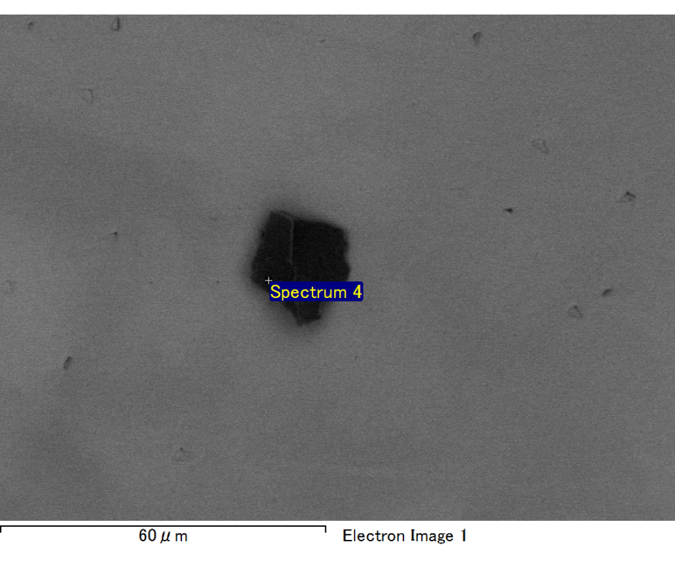

Spectrum processing :

No peaks omitted

Processing option : All elements analyzed (Normalised)

Number of iterations = 2

Standard :

C CaCO3 1-Jun-1999 12:00 AM

O SiO2 1-Jun-1999 12:00 AM

Mg MgO 1-Jun-1999 12:00 AM

Si SiO2 1-Jun-1999 12:00 AM

Fe Fe 1-Jun-1999 12:00 AM

Au Au 1-Jun-1999 12:00 AM

|  |  |  |  |
| --- | --- | --- | --- |
| Element | Weight% | Atomic% |  |
|  |  |  |  |
| C K | 2.96 | 11.30 |  |
| O K | 17.23 | 49.29 |  |
| Mg K | 6.15 | 11.59 |  |
| Si K | 4.61 | 7.51 |  |
| Fe L | 7.27 | 5.96 |  |
| Au M | 61.77 | 14.35 |  |
|  |  |  |  |
| Totals | 100.00 |  |  |

Spectrum Label: Spectrum 4

Livetime 60.0 s

Acquisition geometry ( degrees ):

Tilt = 15.0

Azimuth = 0.0

Elevation = 30.0

Accelerating voltage = 10.00 kV

Total spectrum counts = 48401

|  |  |  |  |
| --- | --- | --- | --- |
| Sample data : | Energy (eV) | Resn. (eV) | Area |
| Strobe : | 3.8 | 47.40 | 1000345 |
|  |  |  |  |

No quant optimization performed

Sample: Sample 1

Type: Default

ID: