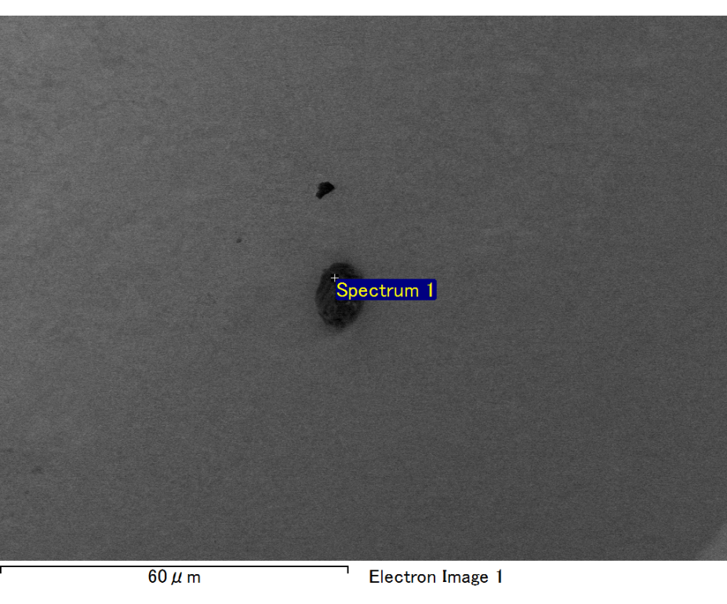

Spectrum processing :

No peaks omitted

Processing option : All elements analyzed (Normalised)

Number of iterations = 2

Standard :

C CaCO3 1-Jun-1999 12:00 AM

O SiO2 1-Jun-1999 12:00 AM

Mg MgO 1-Jun-1999 12:00 AM

Si SiO2 1-Jun-1999 12:00 AM

Fe Fe 1-Jun-1999 12:00 AM

Au Au 1-Jun-1999 12:00 AM

|  |  |  |  |
| --- | --- | --- | --- |
| Element | Weight% | Atomic% |  |
|  |  |  |  |
| C K | 2.71 | 9.32 |  |
| O K | 21.75 | 56.09 |  |
| Mg K | 4.45 | 7.56 |  |
| Si K | 5.75 | 8.45 |  |
| Fe L | 9.24 | 6.83 |  |
| Au M | 56.10 | 11.75 |  |
|  |  |  |  |
| Totals | 100.00 |  |  |

Spectrum Label: Spectrum 1

Livetime 60.0 s

Acquisition geometry ( degrees ):

Tilt = 15.0

Azimuth = 0.0

Elevation = 30.0

Accelerating voltage = 10.00 kV

Total spectrum counts = 53448

|  |  |  |  |
| --- | --- | --- | --- |
| Sample data : | Energy (eV) | Resn. (eV) | Area |
| Strobe : | 3.8 | 47.44 | 999743 |
|  |  |  |  |

No quant optimization performed

Sample: Sample 1

Type: Default

ID:

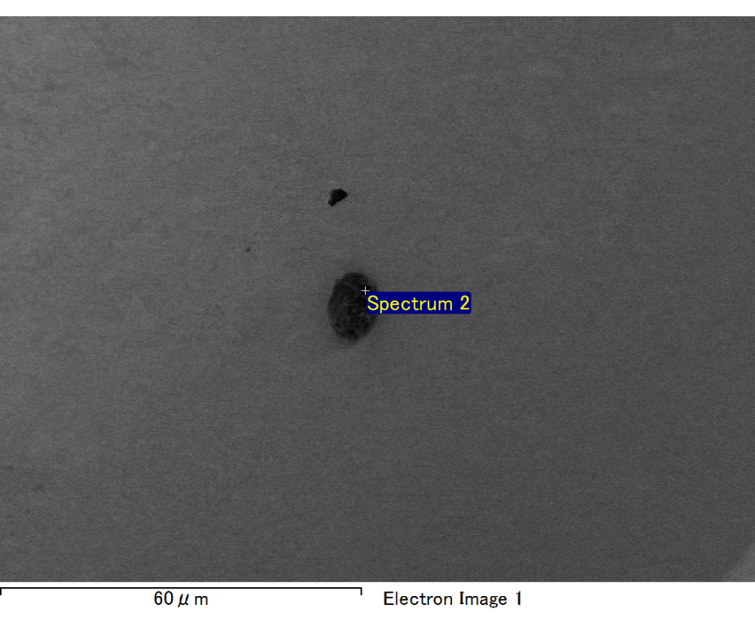

Spectrum processing :

No peaks omitted

Processing option : All elements analyzed (Normalised)

Number of iterations = 2

Standard :

C CaCO3 1-Jun-1999 12:00 AM

O SiO2 1-Jun-1999 12:00 AM

Mg MgO 1-Jun-1999 12:00 AM

Si SiO2 1-Jun-1999 12:00 AM

Fe Fe 1-Jun-1999 12:00 AM

Au Au 1-Jun-1999 12:00 AM

|  |  |  |  |
| --- | --- | --- | --- |
| Element | Weight% | Atomic% |  |
|  |  |  |  |
| C K | 3.13 | 10.54 |  |
| O K | 22.33 | 56.52 |  |
| Mg K | 4.71 | 7.84 |  |
| Si K | 5.63 | 8.12 |  |
| Fe L | 7.28 | 5.28 |  |
| Au M | 56.92 | 11.70 |  |
|  |  |  |  |
| Totals | 100.00 |  |  |

Spectrum Label: Spectrum 2

Livetime 60.0 s

Acquisition geometry ( degrees ):

Tilt = 15.0

Azimuth = 0.0

Elevation = 30.0

Accelerating voltage = 10.00 kV

Total spectrum counts = 54425

|  |  |  |  |
| --- | --- | --- | --- |
| Sample data : | Energy (eV) | Resn. (eV) | Area |
| Strobe : | 3.8 | 47.47 | 1000937 |
|  |  |  |  |

No quant optimization performed

Sample: Sample 1

Type: Default

ID:

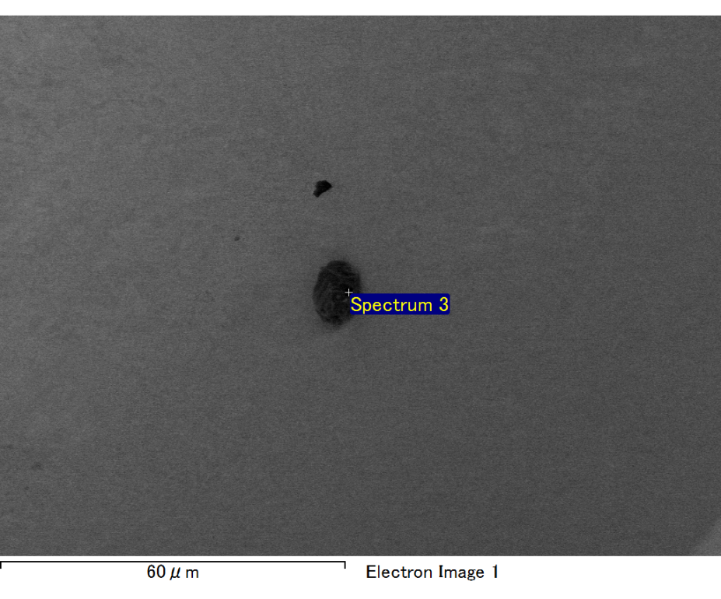

Spectrum processing :

No peaks omitted

Processing option : All elements analyzed (Normalised)

Number of iterations = 2

Standard :

C CaCO3 1-Jun-1999 12:00 AM

O SiO2 1-Jun-1999 12:00 AM

Mg MgO 1-Jun-1999 12:00 AM

Si SiO2 1-Jun-1999 12:00 AM

Fe Fe 1-Jun-1999 12:00 AM

Au Au 1-Jun-1999 12:00 AM

|  |  |  |  |
| --- | --- | --- | --- |
| Element | Weight% | Atomic% |  |
|  |  |  |  |
| C K | 2.30 | 7.74 |  |
| O K | 23.24 | 58.80 |  |
| Mg K | 4.63 | 7.70 |  |
| Si K | 6.14 | 8.84 |  |
| Fe L | 7.36 | 5.34 |  |
| Au M | 56.34 | 11.58 |  |
|  |  |  |  |
| Totals | 100.00 |  |  |

Spectrum Label: Spectrum 3

Livetime 60.0 s

Acquisition geometry ( degrees ):

Tilt = 15.0

Azimuth = 0.0

Elevation = 30.0

Accelerating voltage = 10.00 kV

Total spectrum counts = 53842

|  |  |  |  |
| --- | --- | --- | --- |
| Sample data : | Energy (eV) | Resn. (eV) | Area |
| Strobe : | 3.8 | 47.42 | 1001520 |
|  |  |  |  |

No quant optimization performed

Sample: Sample 1

Type: Default

ID:

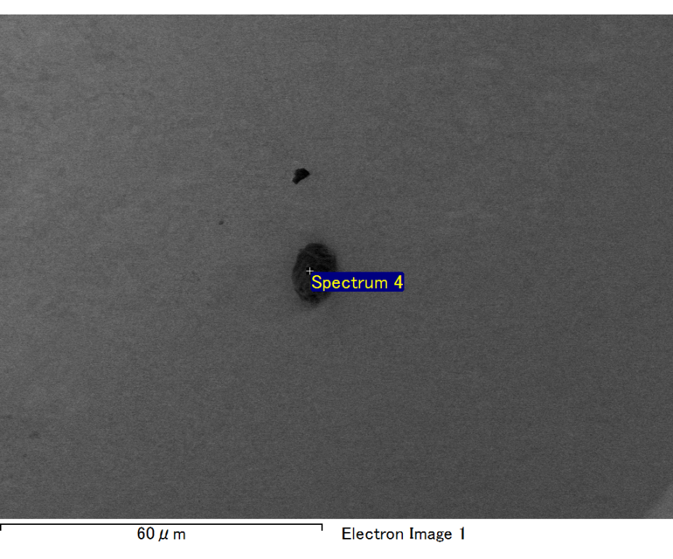

Spectrum processing :

No peaks omitted

Processing option : All elements analyzed (Normalised)

Number of iterations = 2

Standard :

C CaCO3 1-Jun-1999 12:00 AM

O SiO2 1-Jun-1999 12:00 AM

Mg MgO 1-Jun-1999 12:00 AM

Si SiO2 1-Jun-1999 12:00 AM

Fe Fe 1-Jun-1999 12:00 AM

Au Au 1-Jun-1999 12:00 AM

|  |  |  |  |
| --- | --- | --- | --- |
| Element | Weight% | Atomic% |  |
|  |  |  |  |
| C K | 3.18 | 11.37 |  |
| O K | 20.39 | 54.79 |  |
| Mg K | 4.14 | 7.32 |  |
| Si K | 5.12 | 7.85 |  |
| Fe L | 7.27 | 5.59 |  |
| Au M | 59.90 | 13.08 |  |
|  |  |  |  |
| Totals | 100.00 |  |  |

Spectrum Label: Spectrum 4

Livetime 60.0 s

Acquisition geometry ( degrees ):

Tilt = 15.0

Azimuth = 0.0

Elevation = 30.0

Accelerating voltage = 10.00 kV

Total spectrum counts = 53526

|  |  |  |  |
| --- | --- | --- | --- |
| Sample data : | Energy (eV) | Resn. (eV) | Area |
| Strobe : | 3.8 | 47.50 | 999591 |
|  |  |  |  |

No quant optimization performed

Sample: Sample 1

Type: Default

ID:

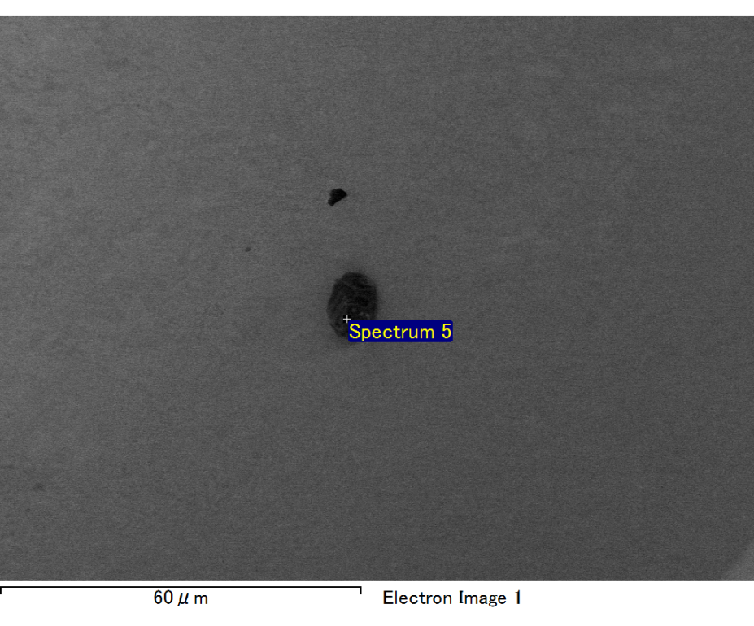

Spectrum processing :

No peaks omitted

Processing option : All elements analyzed (Normalised)

Number of iterations = 2

Standard :

C CaCO3 1-Jun-1999 12:00 AM

O SiO2 1-Jun-1999 12:00 AM

Mg MgO 1-Jun-1999 12:00 AM

Si SiO2 1-Jun-1999 12:00 AM

Fe Fe 1-Jun-1999 12:00 AM

Au Au 1-Jun-1999 12:00 AM

|  |  |  |  |
| --- | --- | --- | --- |
| Element | Weight% | Atomic% |  |
|  |  |  |  |
| C K | 2.98 | 10.92 |  |
| O K | 19.55 | 53.76 |  |
| Mg K | 4.23 | 7.65 |  |
| Si K | 5.47 | 8.57 |  |
| Fe L | 7.01 | 5.52 |  |
| Au M | 60.77 | 13.58 |  |
|  |  |  |  |
| Totals | 100.00 |  |  |

Spectrum Label: Spectrum 5

Livetime 60.0 s

Acquisition geometry ( degrees ):

Tilt = 15.0

Azimuth = 0.0

Elevation = 30.0

Accelerating voltage = 10.00 kV

Total spectrum counts = 52891

|  |  |  |  |
| --- | --- | --- | --- |
| Sample data : | Energy (eV) | Resn. (eV) | Area |
| Strobe : | 3.8 | 47.46 | 999597 |
|  |  |  |  |

No quant optimization performed

Sample: Sample 1

Type: Default

ID: