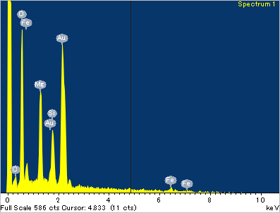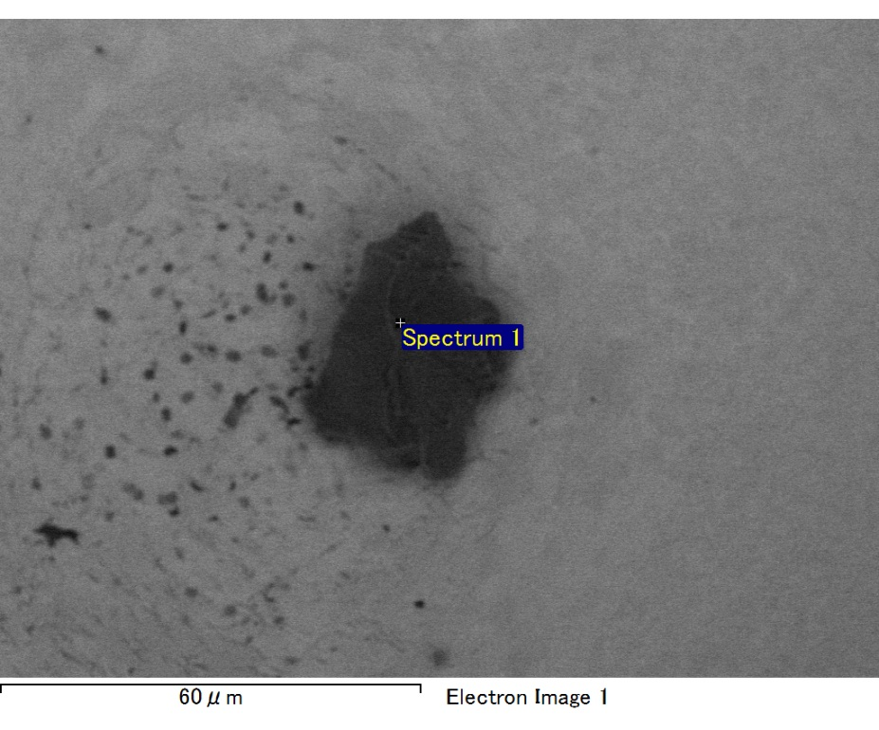

Spectrum processing :

No peaks omitted

Processing option : All elements analyzed (Normalised)

Number of iterations = 2

Standard :

C CaCO3 1-Jun-1999 12:00 AM

O SiO2 1-Jun-1999 12:00 AM

Mg MgO 1-Jun-1999 12:00 AM

Si SiO2 1-Jun-1999 12:00 AM

Fe Fe 1-Jun-1999 12:00 AM

Au Au 1-Jun-1999 12:00 AM

|  |  |  |  |
| --- | --- | --- | --- |
| Element | Weight% | Atomic% |  |
|  |  |  |  |
| C K | 2.10 | 7.44 |  |
| O K | 20.43 | 54.27 |  |
| Mg K | 6.24 | 10.90 |  |
| Si K | 4.13 | 6.26 |  |
| Fe L | 12.19 | 9.28 |  |
| Au M | 54.91 | 11.85 |  |
|  |  |  |  |
| Totals | 100.00 |  |  |

Spectrum Label: Spectrum 1

Livetime 60.0 s

Acquisition geometry ( degrees ):

Tilt = 15.0

Azimuth = 0.0

Elevation = 30.0

Accelerating voltage = 10.00 kV

Total spectrum counts = 51226

|  |  |  |  |
| --- | --- | --- | --- |
| Sample data : | Energy (eV) | Resn. (eV) | Area |
| Strobe : | 3.8 | 47.44 | 1000477 |
|  |  |  |  |

No quant optimization performed

Sample: Sample 1

Type: Default

ID:

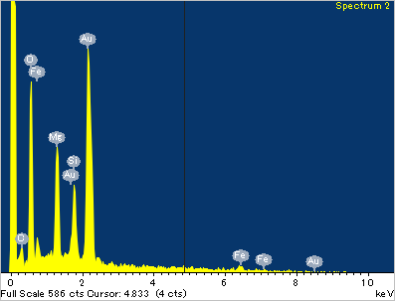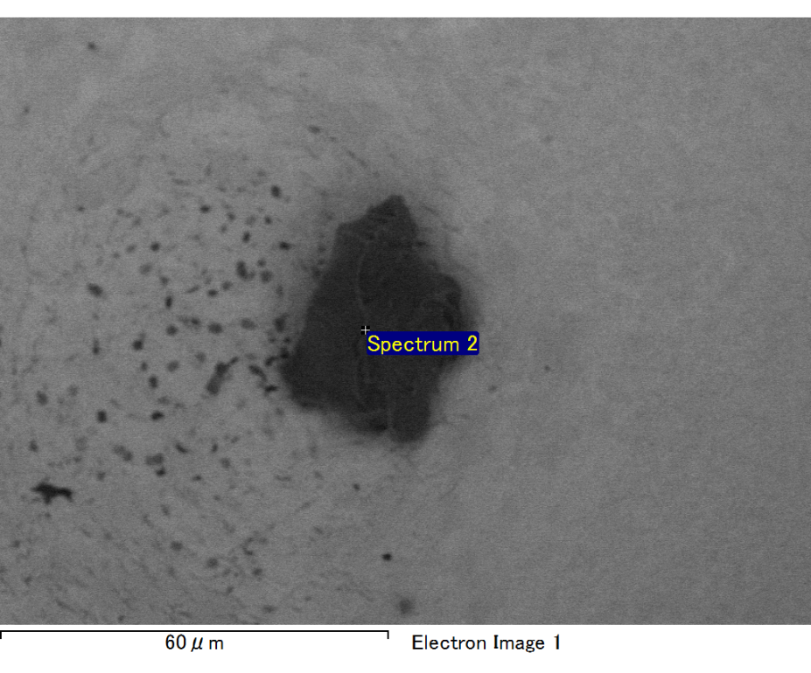

Spectrum processing :

No peaks omitted

Processing option : All elements analyzed (Normalised)

Number of iterations = 2

Standard :

C CaCO3 1-Jun-1999 12:00 AM

O SiO2 1-Jun-1999 12:00 AM

Mg MgO 1-Jun-1999 12:00 AM

Si SiO2 1-Jun-1999 12:00 AM

Fe Fe 1-Jun-1999 12:00 AM

Au Au 1-Jun-1999 12:00 AM

|  |  |  |  |
| --- | --- | --- | --- |
| Element | Weight% | Atomic% |  |
|  |  |  |  |
| C K | 2.43 | 9.12 |  |
| O K | 18.43 | 51.92 |  |
| Mg K | 5.88 | 10.90 |  |
| Si K | 4.08 | 6.54 |  |
| Fe L | 9.86 | 7.95 |  |
| Au M | 59.32 | 13.57 |  |
|  |  |  |  |
| Totals | 100.00 |  |  |

Spectrum Label: Spectrum 2

Livetime 60.0 s

Acquisition geometry ( degrees ):

Tilt = 15.0

Azimuth = 0.0

Elevation = 30.0

Accelerating voltage = 10.00 kV

Total spectrum counts = 50407

|  |  |  |  |
| --- | --- | --- | --- |
| Sample data : | Energy (eV) | Resn. (eV) | Area |
| Strobe : | 3.8 | 47.45 | 1000707 |
|  |  |  |  |

No quant optimization performed

Sample: Sample 1

Type: Default

ID:

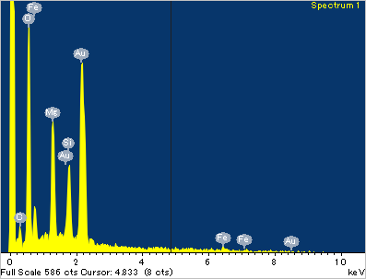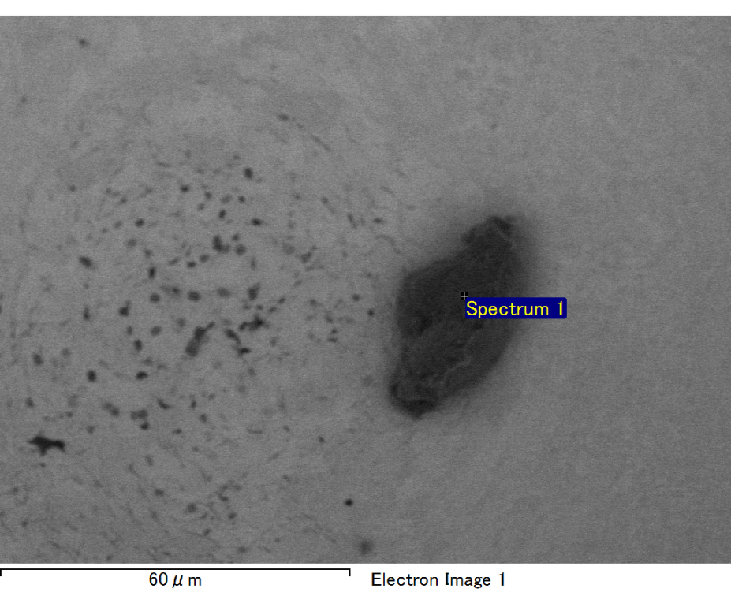

Spectrum processing :

No peaks omitted

Processing option : All elements analyzed (Normalised)

Number of iterations = 2

Standard :

C CaCO3 1-Jun-1999 12:00 AM

O SiO2 1-Jun-1999 12:00 AM

Mg MgO 1-Jun-1999 12:00 AM

Si SiO2 1-Jun-1999 12:00 AM

Fe Fe 1-Jun-1999 12:00 AM

Au Au 1-Jun-1999 12:00 AM

|  |  |  |  |
| --- | --- | --- | --- |
| Element | Weight% | Atomic% |  |
|  |  |  |  |
| C K | 2.45 | 8.43 |  |
| O K | 20.79 | 53.72 |  |
| Mg K | 5.86 | 9.97 |  |
| Si K | 4.31 | 6.34 |  |
| Fe L | 14.24 | 10.54 |  |
| Au M | 52.35 | 10.99 |  |
|  |  |  |  |
| Totals | 100.00 |  |  |

Spectrum Label: Spectrum 1

Livetime 60.0 s

Acquisition geometry ( degrees ):

Tilt = 15.0

Azimuth = 0.0

Elevation = 30.0

Accelerating voltage = 10.00 kV

Total spectrum counts = 51505

|  |  |  |  |
| --- | --- | --- | --- |
| Sample data : | Energy (eV) | Resn. (eV) | Area |
| Strobe : | 3.8 | 47.40 | 1000069 |
|  |  |  |  |

No quant optimization performed

Sample: Sample 1

Type: Default

ID:

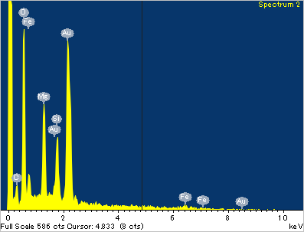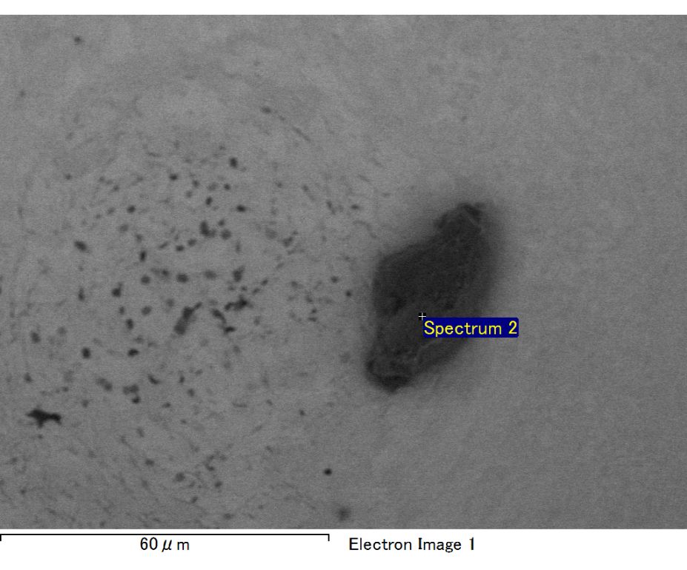

Spectrum processing :

No peaks omitted

Processing option : All elements analyzed (Normalised)

Number of iterations = 2

Standard :

C CaCO3 1-Jun-1999 12:00 AM

O SiO2 1-Jun-1999 12:00 AM

Mg MgO 1-Jun-1999 12:00 AM

Si SiO2 1-Jun-1999 12:00 AM

Fe Fe 1-Jun-1999 12:00 AM

Au Au 1-Jun-1999 12:00 AM

|  |  |  |  |
| --- | --- | --- | --- |
| Element | Weight% | Atomic% |  |
|  |  |  |  |
| C K | 3.19 | 11.16 |  |
| O K | 19.92 | 52.33 |  |
| Mg K | 5.63 | 9.74 |  |
| Si K | 3.78 | 5.66 |  |
| Fe L | 12.42 | 9.35 |  |
| Au M | 55.05 | 11.75 |  |
|  |  |  |  |
| Totals | 100.00 |  |  |

Spectrum Label: Spectrum 2

Livetime 60.0 s

Acquisition geometry ( degrees ):

Tilt = 15.0

Azimuth = 0.0

Elevation = 30.0

Accelerating voltage = 10.00 kV

Total spectrum counts = 52690

|  |  |  |  |
| --- | --- | --- | --- |
| Sample data : | Energy (eV) | Resn. (eV) | Area |
| Strobe : | 3.8 | 47.39 | 999754 |
|  |  |  |  |

No quant optimization performed

Sample: Sample 1

Type: Default

ID:

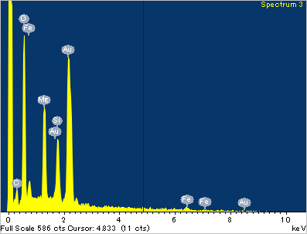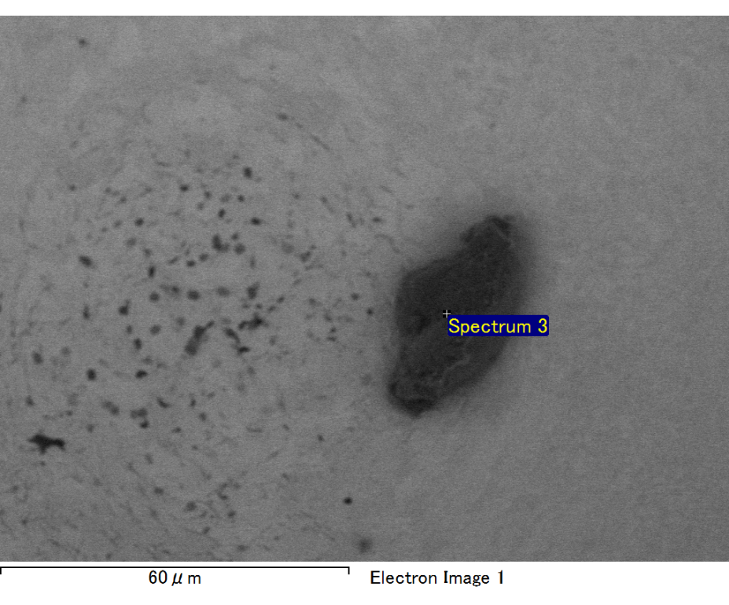

Spectrum processing :

No peaks omitted

Processing option : All elements analyzed (Normalised)

Number of iterations = 2

Standard :

C CaCO3 1-Jun-1999 12:00 AM

O SiO2 1-Jun-1999 12:00 AM

Mg MgO 1-Jun-1999 12:00 AM

Si SiO2 1-Jun-1999 12:00 AM

Fe Fe 1-Jun-1999 12:00 AM

Au Au 1-Jun-1999 12:00 AM

|  |  |  |  |
| --- | --- | --- | --- |
| Element | Weight% | Atomic% |  |
|  |  |  |  |
| C K | 2.51 | 8.82 |  |
| O K | 20.41 | 53.84 |  |
| Mg K | 6.20 | 10.76 |  |
| Si K | 4.52 | 6.79 |  |
| Fe L | 10.28 | 7.77 |  |
| Au M | 56.09 | 12.02 |  |
|  |  |  |  |
| Totals | 100.00 |  |  |

Spectrum Label: Spectrum 3

Livetime 60.0 s

Acquisition geometry ( degrees ):

Tilt = 15.0

Azimuth = 0.0

Elevation = 30.0

Accelerating voltage = 10.00 kV

Total spectrum counts = 51175

|  |  |  |  |
| --- | --- | --- | --- |
| Sample data : | Energy (eV) | Resn. (eV) | Area |
| Strobe : | 3.8 | 47.46 | 1000690 |
|  |  |  |  |

No quant optimization performed

Sample: Sample 1

Type: Default

ID: