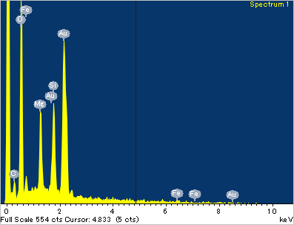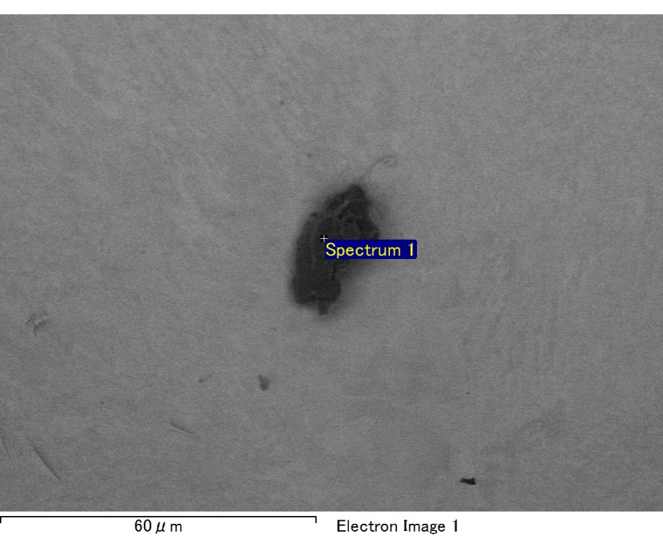

Spectrum processing :

No peaks omitted

Processing option : All elements analyzed (Normalised)

Number of iterations = 2

Standard :

C CaCO3 1-Jun-1999 12:00 AM

O SiO2 1-Jun-1999 12:00 AM

Mg MgO 1-Jun-1999 12:00 AM

Si SiO2 1-Jun-1999 12:00 AM

Fe Fe 1-Jun-1999 12:00 AM

Au Au 1-Jun-1999 12:00 AM

|  |  |  |  |
| --- | --- | --- | --- |
| Element | Weight% | Atomic% |  |
|  |  |  |  |
| C K | 3.00 | 9.87 |  |
| O K | 23.05 | 56.97 |  |
| Mg K | 4.61 | 7.50 |  |
| Si K | 6.08 | 8.55 |  |
| Fe L | 8.68 | 6.15 |  |
| Au M | 54.58 | 10.96 |  |
|  |  |  |  |
| Totals | 100.00 |  |  |

Spectrum Label: Spectrum 1

Livetime 60.0 s

Acquisition geometry ( degrees ):

Tilt = 15.0

Azimuth = 0.0

Elevation = 30.0

Accelerating voltage = 10.00 kV

Total spectrum counts = 51439

|  |  |  |  |
| --- | --- | --- | --- |
| Sample data : | Energy (eV) | Resn. (eV) | Area |
| Strobe : | 3.8 | 47.45 | 1000087 |
|  |  |  |  |

No quant optimization performed

Sample: Sample 1

Type: Default

ID:

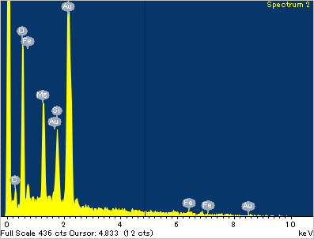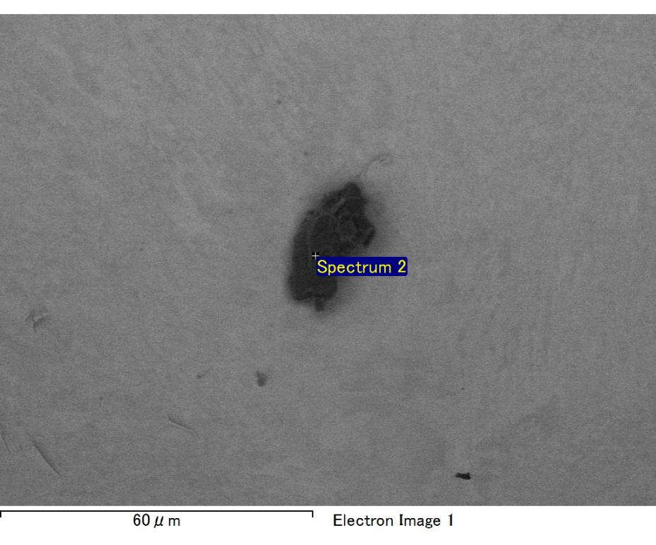

Spectrum processing :

No peaks omitted

Processing option : All elements analyzed (Normalised)

Number of iterations = 2

Standard :

C CaCO3 1-Jun-1999 12:00 AM

O SiO2 1-Jun-1999 12:00 AM

Mg MgO 1-Jun-1999 12:00 AM

Si SiO2 1-Jun-1999 12:00 AM

Fe Fe 1-Jun-1999 12:00 AM

Au Au 1-Jun-1999 12:00 AM

|  |  |  |  |
| --- | --- | --- | --- |
| Element | Weight% | Atomic% |  |
|  |  |  |  |
| C K | 3.14 | 11.98 |  |
| O K | 17.68 | 50.65 |  |
| Mg K | 5.15 | 9.70 |  |
| Si K | 4.13 | 6.74 |  |
| Fe L | 7.92 | 6.50 |  |
| Au M | 61.99 | 14.43 |  |
|  |  |  |  |
| Totals | 100.00 |  |  |

Spectrum Label: Spectrum 2

Livetime 60.0 s

Acquisition geometry ( degrees ):

Tilt = 15.0

Azimuth = 0.0

Elevation = 30.0

Accelerating voltage = 10.00 kV

Total spectrum counts = 49350

|  |  |  |  |
| --- | --- | --- | --- |
| Sample data : | Energy (eV) | Resn. (eV) | Area |
| Strobe : | 3.8 | 47.39 | 999846 |
|  |  |  |  |

No quant optimization performed

Sample: Sample 1

Type: Default

ID:

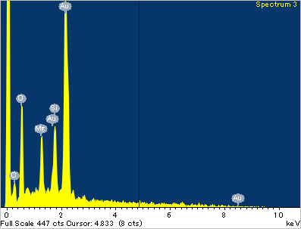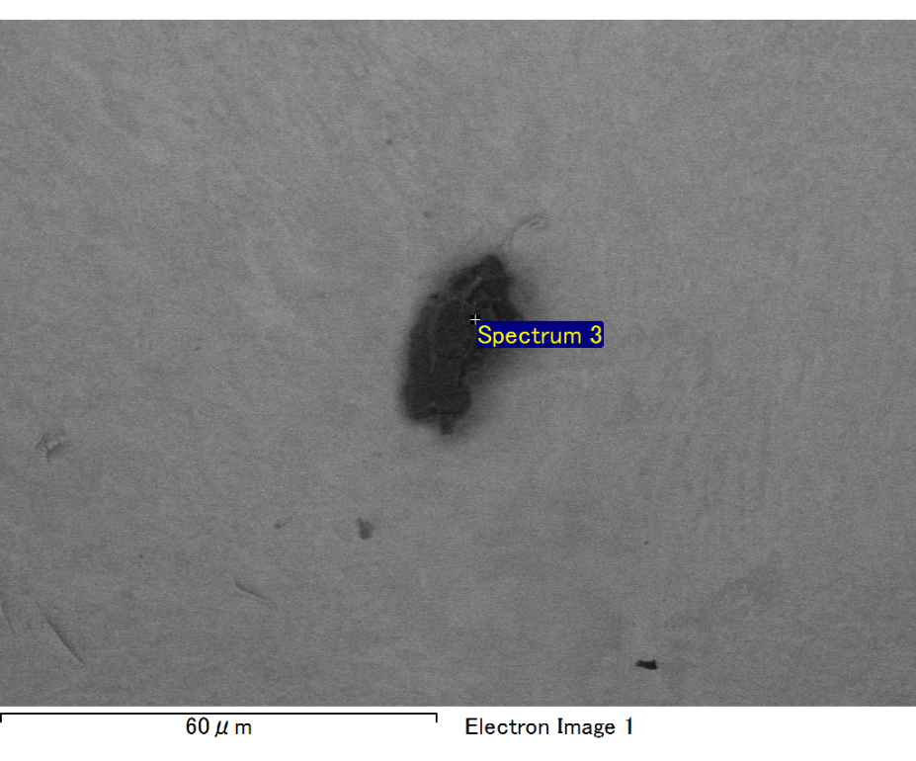

Spectrum processing :

No peaks omitted

Processing option : All elements analyzed (Normalised)

Number of iterations = 2

Standard :

C CaCO3 1-Jun-1999 12:00 AM

O SiO2 1-Jun-1999 12:00 AM

Mg MgO 1-Jun-1999 12:00 AM

Si SiO2 1-Jun-1999 12:00 AM

Au Au 1-Jun-1999 12:00 AM

|  |  |  |  |
| --- | --- | --- | --- |
| Element | Weight% | Atomic% |  |
|  |  |  |  |
| C K | 3.37 | 15.20 |  |
| O K | 13.68 | 46.39 |  |
| Mg K | 3.75 | 8.37 |  |
| Si K | 4.97 | 9.59 |  |
| Au M | 74.23 | 20.44 |  |
|  |  |  |  |
| Totals | 100.00 |  |  |

Spectrum Label: Spectrum 3

Livetime 60.0 s

Acquisition geometry ( degrees ):

Tilt = 15.0

Azimuth = 0.0

Elevation = 30.0

Accelerating voltage = 10.00 kV

Total spectrum counts = 47307

|  |  |  |  |
| --- | --- | --- | --- |
| Sample data : | Energy (eV) | Resn. (eV) | Area |
| Strobe : | 3.8 | 47.38 | 1001062 |
|  |  |  |  |

No quant optimization performed

Sample: Sample 1

Type: Default

ID:

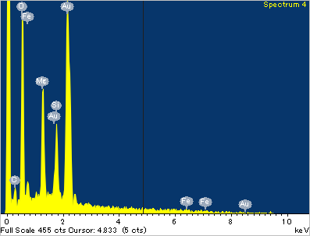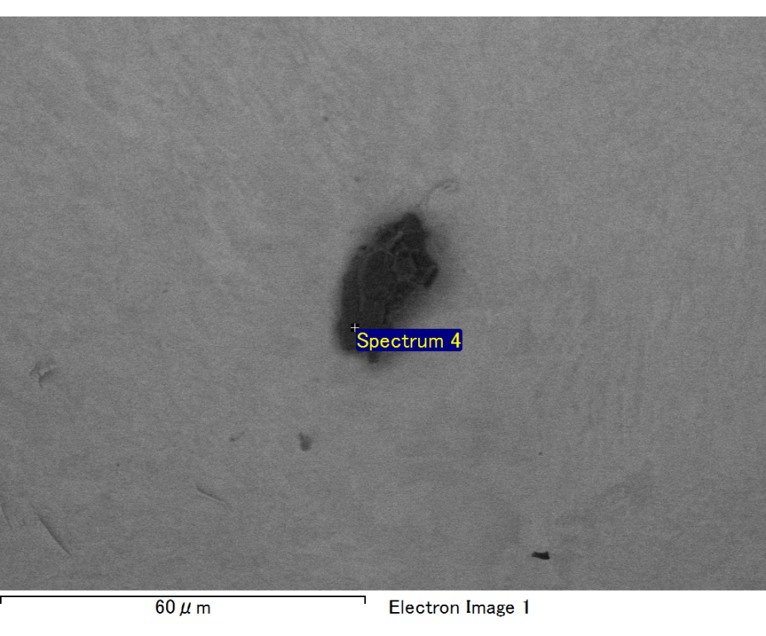

Spectrum processing :

No peaks omitted

Processing option : All elements analyzed (Normalised)

Number of iterations = 2

Standard :

C CaCO3 1-Jun-1999 12:00 AM

O SiO2 1-Jun-1999 12:00 AM

Mg MgO 1-Jun-1999 12:00 AM

Si SiO2 1-Jun-1999 12:00 AM

Fe Fe 1-Jun-1999 12:00 AM

Au Au 1-Jun-1999 12:00 AM

|  |  |  |  |
| --- | --- | --- | --- |
| Element | Weight% | Atomic% |  |
|  |  |  |  |
| C K | 2.62 | 9.58 |  |
| O K | 19.84 | 54.47 |  |
| Mg K | 5.53 | 9.99 |  |
| Si K | 3.95 | 6.17 |  |
| Fe L | 8.17 | 6.43 |  |
| Au M | 59.89 | 13.36 |  |
|  |  |  |  |
| Totals | 100.00 |  |  |

Spectrum Label: Spectrum 4

Livetime 60.0 s

Acquisition geometry ( degrees ):

Tilt = 15.0

Azimuth = 0.0

Elevation = 30.0

Accelerating voltage = 10.00 kV

Total spectrum counts = 50203

|  |  |  |  |
| --- | --- | --- | --- |
| Sample data : | Energy (eV) | Resn. (eV) | Area |
| Strobe : | 3.8 | 47.46 | 1000290 |
|  |  |  |  |

No quant optimization performed

Sample: Sample 1

Type: Default

ID:

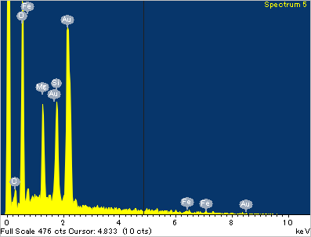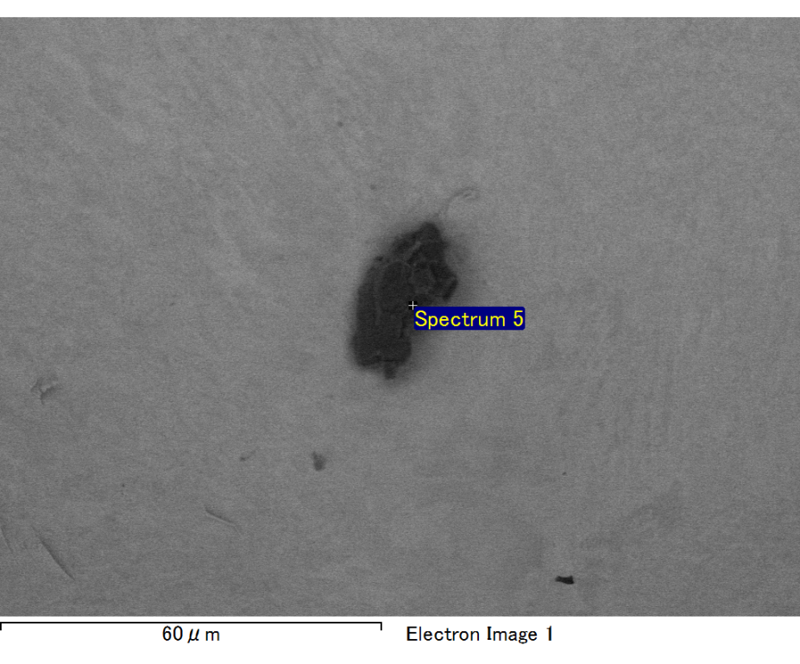

Spectrum processing :

No peaks omitted

Processing option : All elements analyzed (Normalised)

Number of iterations = 2

Standard :

C CaCO3 1-Jun-1999 12:00 AM

O SiO2 1-Jun-1999 12:00 AM

Mg MgO 1-Jun-1999 12:00 AM

Si SiO2 1-Jun-1999 12:00 AM

Fe Fe 1-Jun-1999 12:00 AM

Au Au 1-Jun-1999 12:00 AM

|  |  |  |  |
| --- | --- | --- | --- |
| Element | Weight% | Atomic% |  |
|  |  |  |  |
| C K | 2.72 | 9.27 |  |
| O K | 22.28 | 56.94 |  |
| Mg K | 4.74 | 7.96 |  |
| Si K | 6.14 | 8.93 |  |
| Fe L | 6.85 | 5.01 |  |
| Au M | 57.27 | 11.89 |  |
|  |  |  |  |
| Totals | 100.00 |  |  |

Spectrum Label: Spectrum 5

Livetime 60.0 s

Acquisition geometry ( degrees ):

Tilt = 15.0

Azimuth = 0.0

Elevation = 30.0

Accelerating voltage = 10.00 kV

Total spectrum counts = 50516

|  |  |  |  |
| --- | --- | --- | --- |
| Sample data : | Energy (eV) | Resn. (eV) | Area |
| Strobe : | 3.8 | 47.41 | 1000888 |
|  |  |  |  |

No quant optimization performed

Sample: Sample 1

Type: Default

ID: