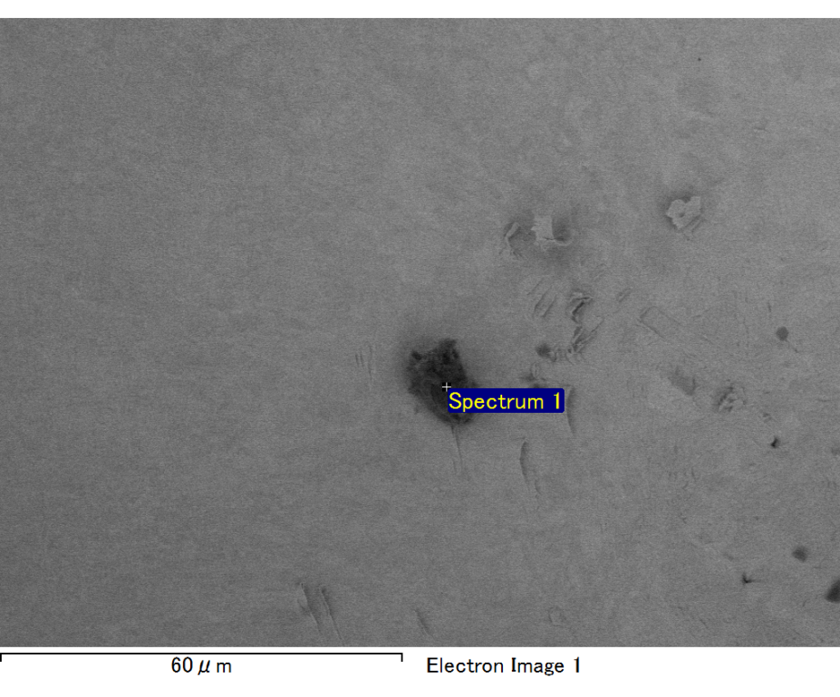

Spectrum processing :

No peaks omitted

Processing option : All elements analyzed (Normalised)

Number of iterations = 2

Standard :

C CaCO3 1-Jun-1999 12:00 AM

O SiO2 1-Jun-1999 12:00 AM

Al Al2O3 1-Jun-1999 12:00 AM

Si SiO2 1-Jun-1999 12:00 AM

Au Au 1-Jun-1999 12:00 AM

|  |  |  |  |
| --- | --- | --- | --- |
| Element | Weight% | Atomic% |  |
|  |  |  |  |
| C K | 3.82 | 26.36 |  |
| O K | 3.40 | 17.64 |  |
| Al K | 2.12 | 6.52 |  |
| Si K | 4.47 | 13.20 |  |
| Au M | 86.19 | 36.28 |  |
|  |  |  |  |
| Totals | 100.00 |  |  |

Spectrum Label: Spectrum 1

Livetime 60.0 s

Acquisition geometry ( degrees ):

Tilt = 15.0

Azimuth = 0.0

Elevation = 30.0

Accelerating voltage = 10.00 kV

Total spectrum counts = 44422

|  |  |  |  |
| --- | --- | --- | --- |
| Sample data : | Energy (eV) | Resn. (eV) | Area |
| Strobe : | 3.8 | 47.51 | 1000525 |
|  |  |  |  |

No quant optimization performed

Sample: Sample 1

Type: Default

ID:

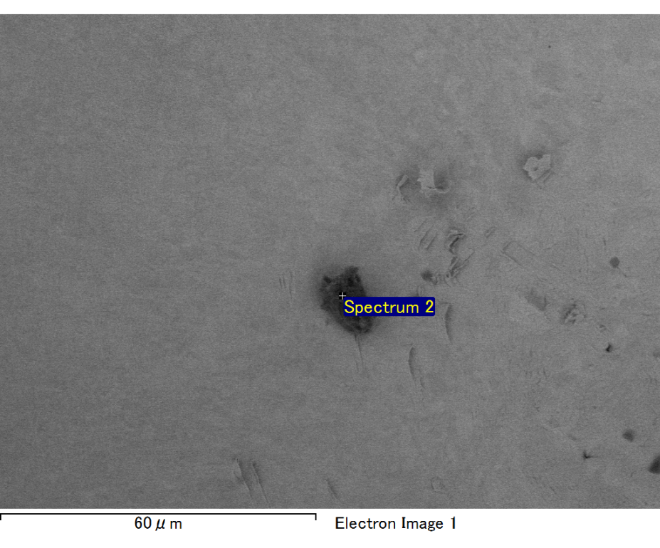

Spectrum processing :

No peaks omitted

Processing option : All elements analyzed (Normalised)

Number of iterations = 2

Standard :

C CaCO3 1-Jun-1999 12:00 AM

O SiO2 1-Jun-1999 12:00 AM

Na Albite 1-Jun-1999 12:00 AM

Al Al2O3 1-Jun-1999 12:00 AM

Si SiO2 1-Jun-1999 12:00 AM

Au Au 1-Jun-1999 12:00 AM

|  |  |  |  |
| --- | --- | --- | --- |
| Element | Weight% | Atomic% |  |
|  |  |  |  |
| C K | 3.45 | 15.56 |  |
| O K | 12.82 | 43.39 |  |
| Na K | 1.19 | 2.80 |  |
| Al K | 2.55 | 5.12 |  |
| Si K | 6.74 | 13.00 |  |
| Au M | 73.25 | 20.14 |  |
|  |  |  |  |
| Totals | 100.00 |  |  |

Spectrum Label: Spectrum 2

Livetime 60.0 s

Acquisition geometry ( degrees ):

Tilt = 15.0

Azimuth = 0.0

Elevation = 30.0

Accelerating voltage = 10.00 kV

Total spectrum counts = 47761

|  |  |  |  |
| --- | --- | --- | --- |
| Sample data : | Energy (eV) | Resn. (eV) | Area |
| Strobe : | 3.8 | 47.53 | 999451 |
|  |  |  |  |

No quant optimization performed

Sample: Sample 1

Type: Default

ID:

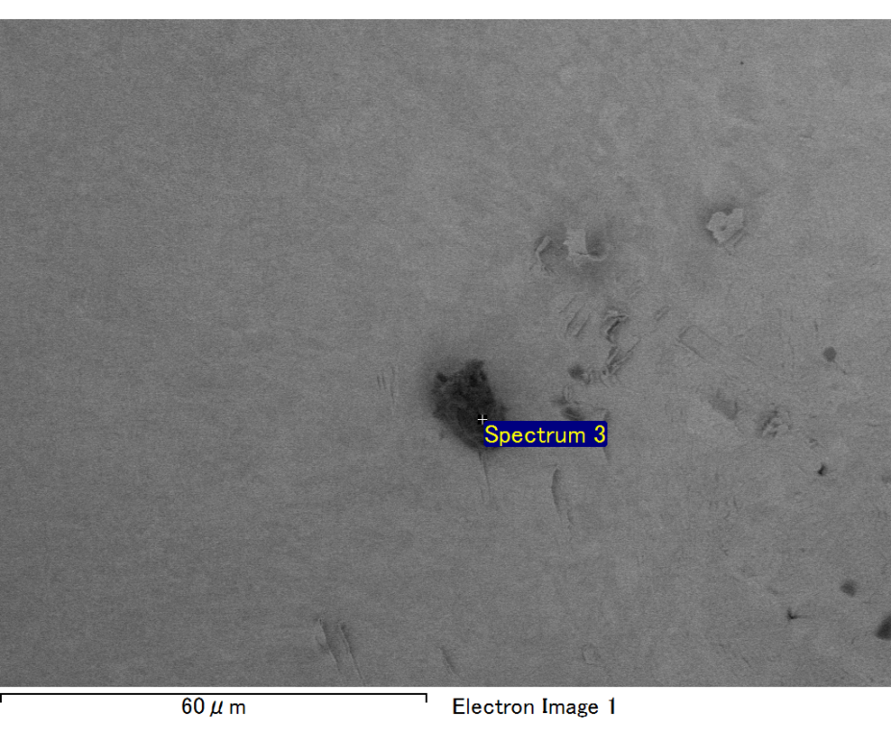

Spectrum processing :

No peaks omitted

Processing option : All elements analyzed (Normalised)

Number of iterations = 2

Standard :

C CaCO3 1-Jun-1999 12:00 AM

O SiO2 1-Jun-1999 12:00 AM

Na Albite 1-Jun-1999 12:00 AM

Al Al2O3 1-Jun-1999 12:00 AM

Si SiO2 1-Jun-1999 12:00 AM

Au Au 1-Jun-1999 12:00 AM

|  |  |  |  |
| --- | --- | --- | --- |
| Element | Weight% | Atomic% |  |
|  |  |  |  |
| C K | 2.67 | 11.08 |  |
| O K | 15.78 | 49.20 |  |
| Na K | 1.81 | 3.94 |  |
| Al K | 2.83 | 5.23 |  |
| Si K | 7.27 | 12.91 |  |
| Au M | 69.64 | 17.64 |  |
|  |  |  |  |
| Totals | 100.00 |  |  |

Spectrum Label: Spectrum 3

Livetime 60.0 s

Acquisition geometry ( degrees ):

Tilt = 15.0

Azimuth = 0.0

Elevation = 30.0

Accelerating voltage = 10.00 kV

Total spectrum counts = 48587

|  |  |  |  |
| --- | --- | --- | --- |
| Sample data : | Energy (eV) | Resn. (eV) | Area |
| Strobe : | 3.8 | 47.48 | 1001392 |
|  |  |  |  |

No quant optimization performed

Sample: Sample 1

Type: Default

ID: