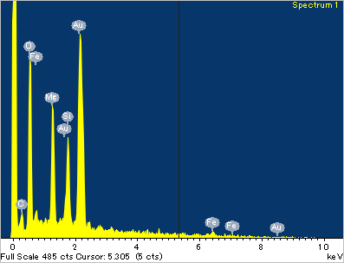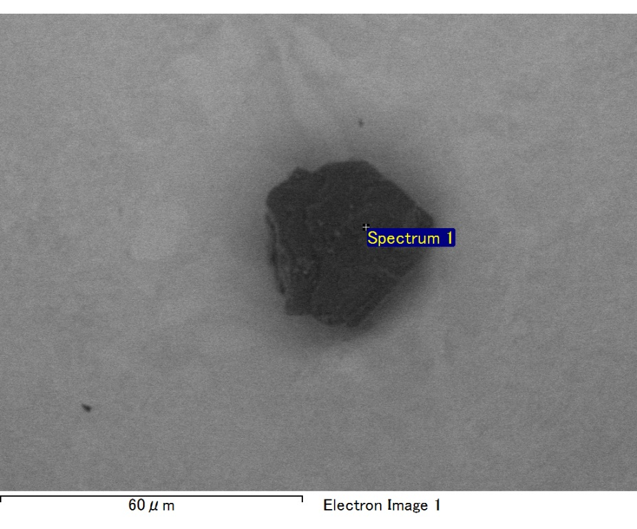

Spectrum processing :

No peaks omitted

Processing option : All elements analyzed (Normalised)

Number of iterations = 2

Standard :

C CaCO3 1-Jun-1999 12:00 AM

O SiO2 1-Jun-1999 12:00 AM

Mg MgO 1-Jun-1999 12:00 AM

Si SiO2 1-Jun-1999 12:00 AM

Fe Fe 1-Jun-1999 12:00 AM

Au Au 1-Jun-1999 12:00 AM

|  |  |  |  |
| --- | --- | --- | --- |
| Element | Weight% | Atomic% |  |
|  |  |  |  |
| C K | 2.37 | 8.80 |  |
| O K | 18.89 | 52.71 |  |
| Mg K | 6.42 | 11.78 |  |
| Si K | 4.94 | 7.85 |  |
| Fe L | 6.25 | 5.00 |  |
| Au M | 61.13 | 13.86 |  |
|  |  |  |  |
| Totals | 100.00 |  |  |

Spectrum Label: Spectrum 1

Livetime 60.0 s

Acquisition geometry ( degrees ):

Tilt = 15.0

Azimuth = 0.0

Elevation = 30.0

Accelerating voltage = 10.00 kV

Total spectrum counts = 48974

|  |  |  |  |
| --- | --- | --- | --- |
| Sample data : | Energy (eV) | Resn. (eV) | Area |
| Strobe : | 3.8 | 47.42 | 999604 |
|  |  |  |  |

No quant optimization performed

Sample: Sample 1

Type: Default

ID:

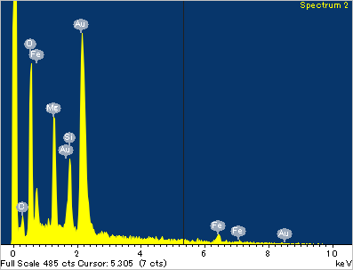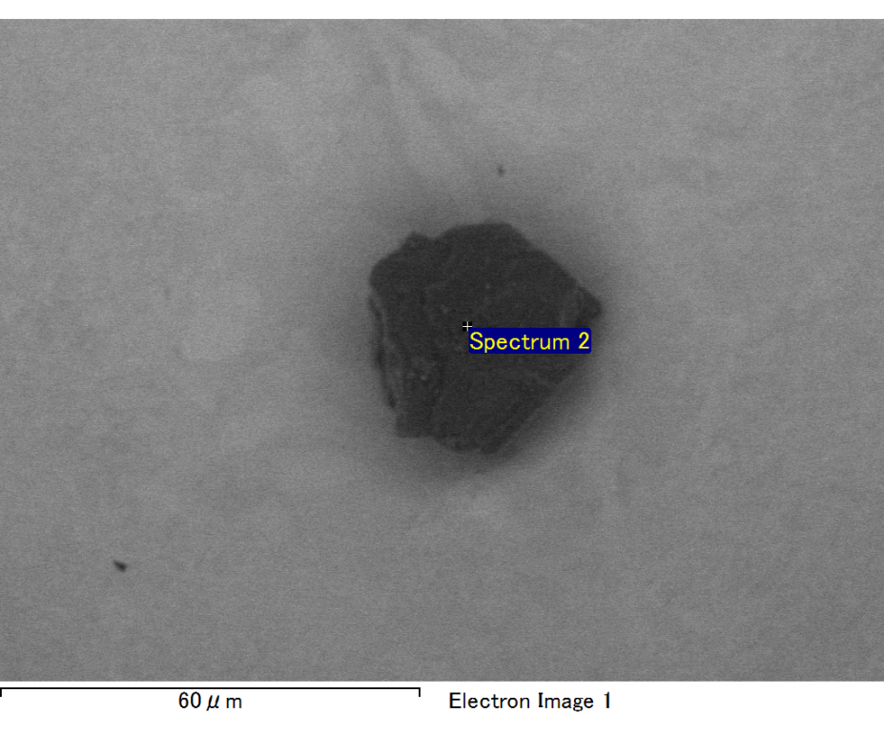

Spectrum processing :

No peaks omitted

Processing option : All elements analyzed (Normalised)

Number of iterations = 2

Standard :

C CaCO3 1-Jun-1999 12:00 AM

O SiO2 1-Jun-1999 12:00 AM

Mg MgO 1-Jun-1999 12:00 AM

Si SiO2 1-Jun-1999 12:00 AM

Fe Fe 1-Jun-1999 12:00 AM

Au Au 1-Jun-1999 12:00 AM

|  |  |  |  |
| --- | --- | --- | --- |
| Element | Weight% | Atomic% |  |
|  |  |  |  |
| C K | 2.86 | 10.62 |  |
| O K | 16.93 | 47.20 |  |
| Mg K | 5.88 | 10.79 |  |
| Si K | 4.03 | 6.40 |  |
| Fe L | 15.86 | 12.67 |  |
| Au M | 54.43 | 12.32 |  |
|  |  |  |  |
| Totals | 100.00 |  |  |

Spectrum Label: Spectrum 2

Livetime 60.0 s

Acquisition geometry ( degrees ):

Tilt = 15.0

Azimuth = 0.0

Elevation = 30.0

Accelerating voltage = 10.00 kV

Total spectrum counts = 50586

|  |  |  |  |
| --- | --- | --- | --- |
| Sample data : | Energy (eV) | Resn. (eV) | Area |
| Strobe : | 3.8 | 47.46 | 1000734 |
|  |  |  |  |

No quant optimization performed

Sample: Sample 1

Type: Default

ID:

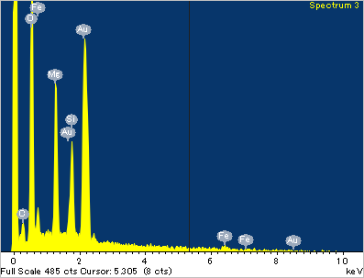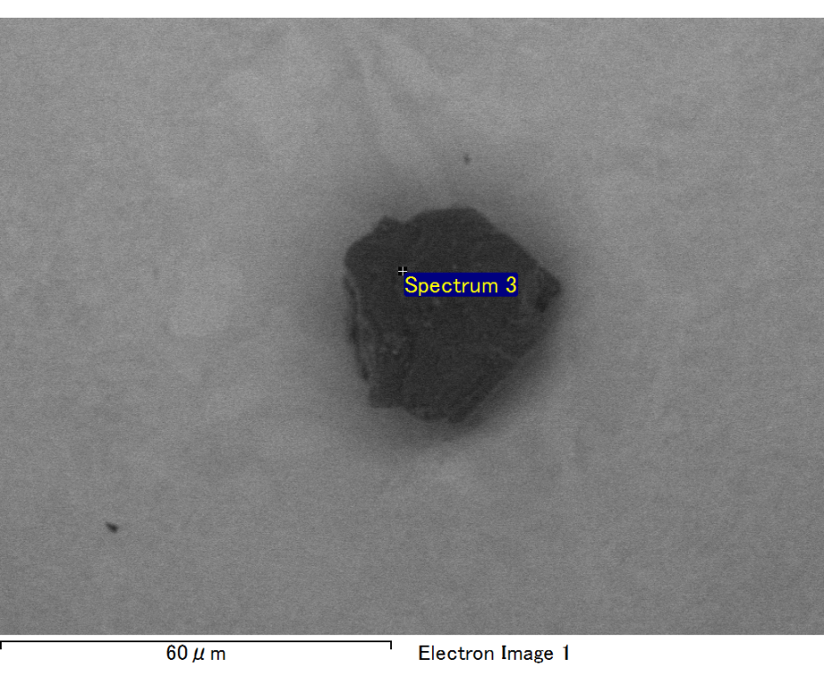

Spectrum processing :

No peaks omitted

Processing option : All elements analyzed (Normalised)

Number of iterations = 2

Standard :

C CaCO3 1-Jun-1999 12:00 AM

O SiO2 1-Jun-1999 12:00 AM

Mg MgO 1-Jun-1999 12:00 AM

Si SiO2 1-Jun-1999 12:00 AM

Fe Fe 1-Jun-1999 12:00 AM

Au Au 1-Jun-1999 12:00 AM

|  |  |  |  |
| --- | --- | --- | --- |
| Element | Weight% | Atomic% |  |
|  |  |  |  |
| C K | 2.33 | 7.85 |  |
| O K | 22.09 | 55.88 |  |
| Mg K | 6.78 | 11.29 |  |
| Si K | 4.57 | 6.58 |  |
| Fe L | 10.03 | 7.27 |  |
| Au M | 54.21 | 11.14 |  |
|  |  |  |  |
| Totals | 100.00 |  |  |

Spectrum Label: Spectrum 3

Livetime 60.0 s

Acquisition geometry ( degrees ):

Tilt = 15.0

Azimuth = 0.0

Elevation = 30.0

Accelerating voltage = 10.00 kV

Total spectrum counts = 51033

|  |  |  |  |
| --- | --- | --- | --- |
| Sample data : | Energy (eV) | Resn. (eV) | Area |
| Strobe : | 3.8 | 47.48 | 1000177 |
|  |  |  |  |

No quant optimization performed

Sample: Sample 1

Type: Default

ID:

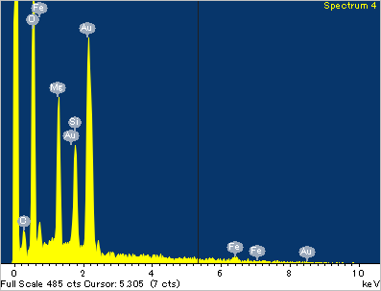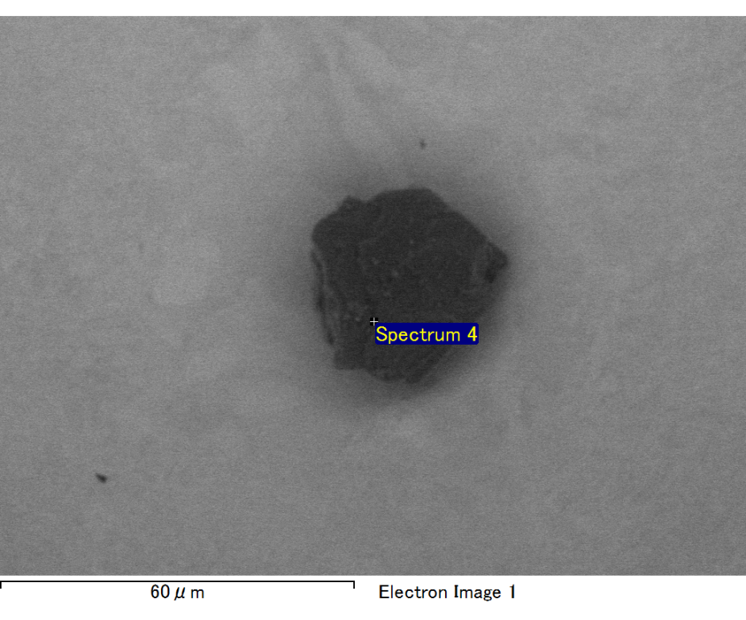

Spectrum processing :

No peaks omitted

Processing option : All elements analyzed (Normalised)

Number of iterations = 2

Standard :

C CaCO3 1-Jun-1999 12:00 AM

O SiO2 1-Jun-1999 12:00 AM

Mg MgO 1-Jun-1999 12:00 AM

Si SiO2 1-Jun-1999 12:00 AM

Fe Fe 1-Jun-1999 12:00 AM

Au Au 1-Jun-1999 12:00 AM

|  |  |  |  |
| --- | --- | --- | --- |
| Element | Weight% | Atomic% |  |
|  |  |  |  |
| C K | 2.62 | 8.67 |  |
| O K | 22.43 | 55.77 |  |
| Mg K | 6.45 | 10.55 |  |
| Si K | 5.34 | 7.57 |  |
| Fe L | 9.18 | 6.54 |  |
| Au M | 53.97 | 10.90 |  |
|  |  |  |  |
| Totals | 100.00 |  |  |

Spectrum Label: Spectrum 4

Livetime 60.0 s

Acquisition geometry ( degrees ):

Tilt = 15.0

Azimuth = 0.0

Elevation = 30.0

Accelerating voltage = 10.00 kV

Total spectrum counts = 51266

|  |  |  |  |
| --- | --- | --- | --- |
| Sample data : | Energy (eV) | Resn. (eV) | Area |
| Strobe : | 3.8 | 47.46 | 1000508 |
|  |  |  |  |

No quant optimization performed

Sample: Sample 1

Type: Default

ID:

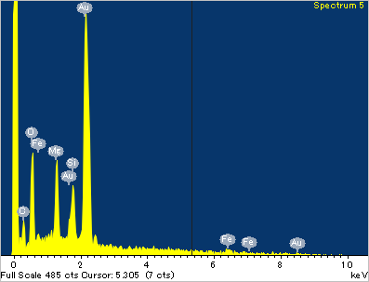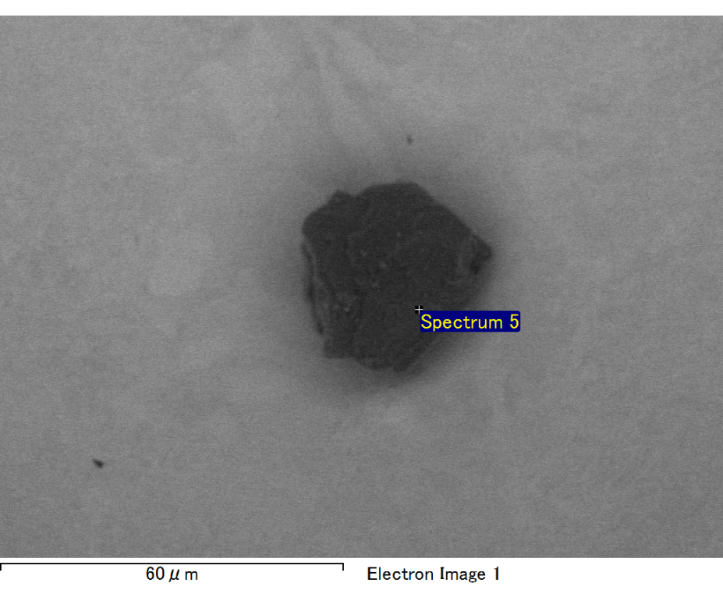

Spectrum processing :

No peaks omitted

Processing option : All elements analyzed (Normalised)

Number of iterations = 2

Standard :

C CaCO3 1-Jun-1999 12:00 AM

O SiO2 1-Jun-1999 12:00 AM

Mg MgO 1-Jun-1999 12:00 AM

Si SiO2 1-Jun-1999 12:00 AM

Fe Fe 1-Jun-1999 12:00 AM

Au Au 1-Jun-1999 12:00 AM

|  |  |  |  |
| --- | --- | --- | --- |
| Element | Weight% | Atomic% |  |
|  |  |  |  |
| C K | 4.46 | 20.80 |  |
| O K | 11.36 | 39.76 |  |
| Mg K | 4.16 | 9.59 |  |
| Si K | 3.03 | 6.04 |  |
| Fe L | 2.67 | 2.68 |  |
| Au M | 74.31 | 21.13 |  |
|  |  |  |  |
| Totals | 100.00 |  |  |

Spectrum Label: Spectrum 5

Livetime 60.0 s

Acquisition geometry ( degrees ):

Tilt = 15.0

Azimuth = 0.0

Elevation = 30.0

Accelerating voltage = 10.00 kV

Total spectrum counts = 47076

|  |  |  |  |
| --- | --- | --- | --- |
| Sample data : | Energy (eV) | Resn. (eV) | Area |
| Strobe : | 3.8 | 47.53 | 1000525 |
|  |  |  |  |

No quant optimization performed

Sample: Sample 1

Type: Default

ID: