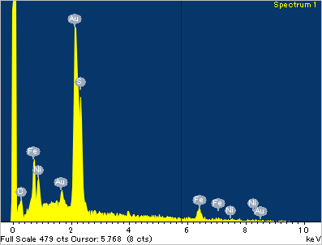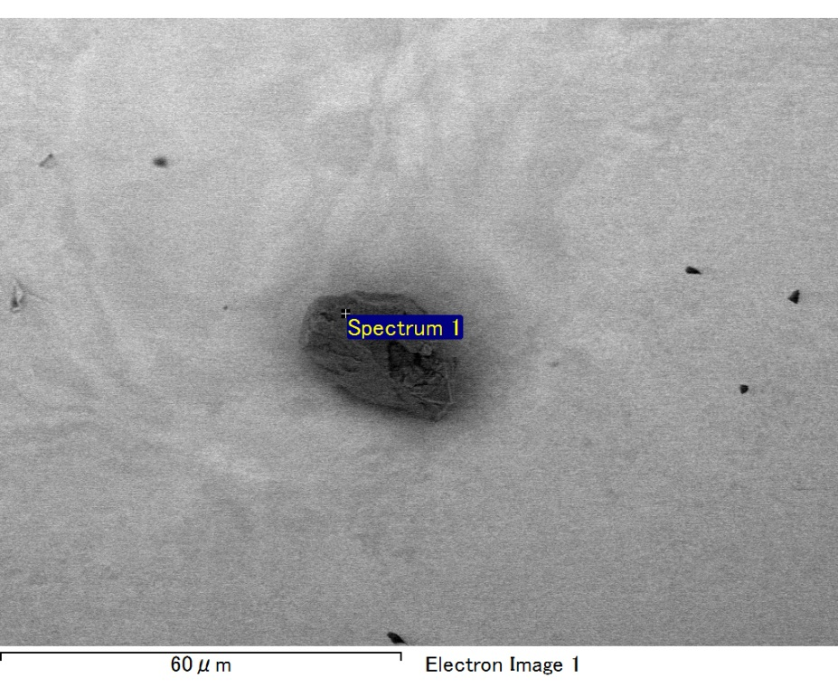

Spectrum processing :

No peaks omitted

Processing option : All elements analyzed (Normalised)

Number of iterations = 2

Standard :

C CaCO3 1-Jun-1999 12:00 AM

S FeS2 1-Jun-1999 12:00 AM

Fe Fe 1-Jun-1999 12:00 AM

Ni Ni 1-Jun-1999 12:00 AM

Au Au 1-Jun-1999 12:00 AM

|  |  |  |  |
| --- | --- | --- | --- |
| Element | Weight% | Atomic% |  |
|  |  |  |  |
| C K | 3.11 | 18.78 |  |
| S K | 12.39 | 28.00 |  |
| Fe L | 18.65 | 24.20 |  |
| Ni L | 5.55 | 6.85 |  |
| Au M | 60.29 | 22.18 |  |
|  |  |  |  |
| Totals | 100.00 |  |  |

Spectrum Label: Spectrum 1

Livetime 60.0 s

Acquisition geometry ( degrees ):

Tilt = 15.0

Azimuth = 0.0

Elevation = 30.0

Accelerating voltage = 10.00 kV

Total spectrum counts = 48743

|  |  |  |  |
| --- | --- | --- | --- |
| Sample data : | Energy (eV) | Resn. (eV) | Area |
| Strobe : | 3.8 | 47.42 | 1000162 |
|  |  |  |  |

No quant optimization performed

Sample: Sample 1

Type: Default

ID:

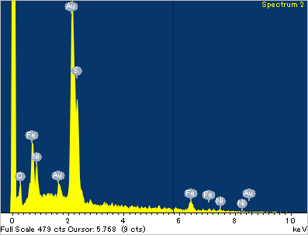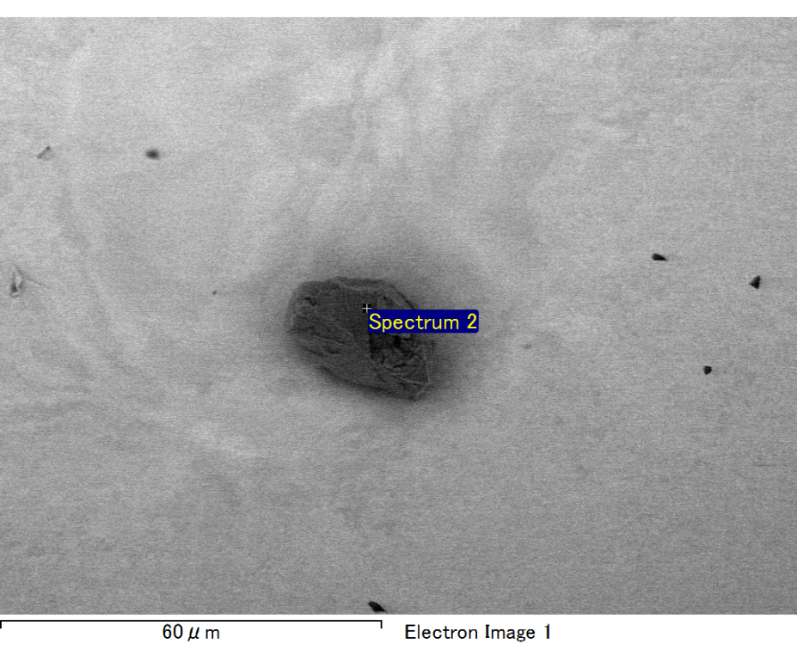

Spectrum processing :

No peaks omitted

Processing option : All elements analyzed (Normalised)

Number of iterations = 2

Standard :

C CaCO3 1-Jun-1999 12:00 AM

S FeS2 1-Jun-1999 12:00 AM

Fe Fe 1-Jun-1999 12:00 AM

Ni Ni 1-Jun-1999 12:00 AM

Au Au 1-Jun-1999 12:00 AM

|  |  |  |  |
| --- | --- | --- | --- |
| Element | Weight% | Atomic% |  |
|  |  |  |  |
| C K | 3.90 | 22.34 |  |
| S K | 11.21 | 24.05 |  |
| Fe L | 21.79 | 26.83 |  |
| Ni L | 5.76 | 6.75 |  |
| Au M | 57.34 | 20.02 |  |
|  |  |  |  |
| Totals | 100.00 |  |  |

Spectrum Label: Spectrum 2

Livetime 60.0 s

Acquisition geometry ( degrees ):

Tilt = 15.0

Azimuth = 0.0

Elevation = 30.0

Accelerating voltage = 10.00 kV

Total spectrum counts = 50200

|  |  |  |  |
| --- | --- | --- | --- |
| Sample data : | Energy (eV) | Resn. (eV) | Area |
| Strobe : | 3.8 | 47.47 | 1000714 |
|  |  |  |  |

No quant optimization performed

Sample: Sample 1

Type: Default

ID:

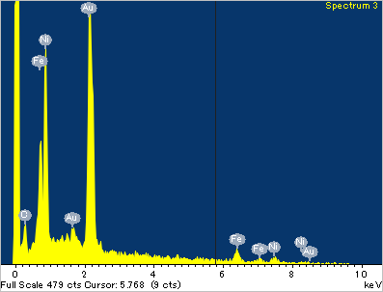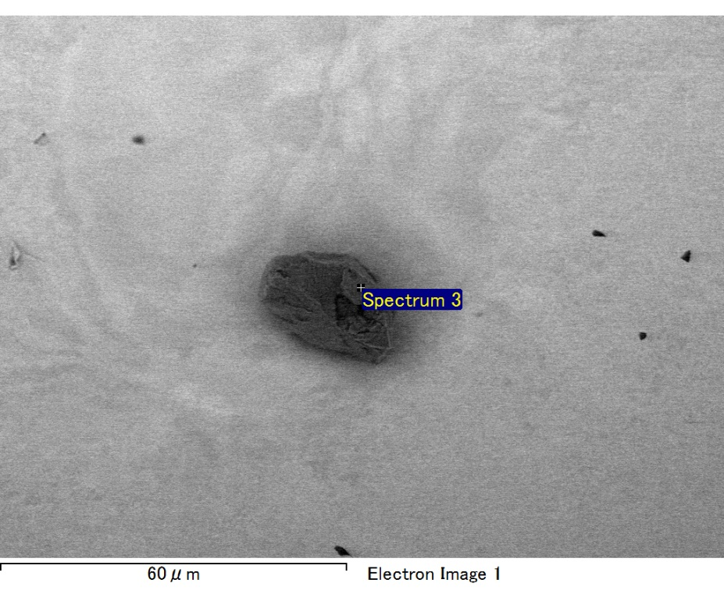

Spectrum processing :

No peaks omitted

Processing option : All elements analyzed (Normalised)

Number of iterations = 2

Standard :

C CaCO3 1-Jun-1999 12:00 AM

Fe Fe 1-Jun-1999 12:00 AM

Ni Ni 1-Jun-1999 12:00 AM

Au Au 1-Jun-1999 12:00 AM

|  |  |  |  |
| --- | --- | --- | --- |
| Element | Weight% | Atomic% |  |
|  |  |  |  |
| C K | 2.80 | 17.77 |  |
| Fe L | 20.89 | 28.57 |  |
| Ni L | 26.35 | 34.28 |  |
| Au M | 49.96 | 19.37 |  |
|  |  |  |  |
| Totals | 100.00 |  |  |

Spectrum Label: Spectrum 3

Livetime 60.0 s

Acquisition geometry ( degrees ):

Tilt = 15.0

Azimuth = 0.0

Elevation = 30.0

Accelerating voltage = 10.00 kV

Total spectrum counts = 52272

|  |  |  |  |
| --- | --- | --- | --- |
| Sample data : | Energy (eV) | Resn. (eV) | Area |
| Strobe : | 3.8 | 47.45 | 1000307 |
|  |  |  |  |

No quant optimization performed

Sample: Sample 1

Type: Default

ID:

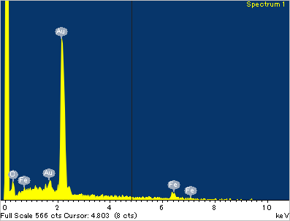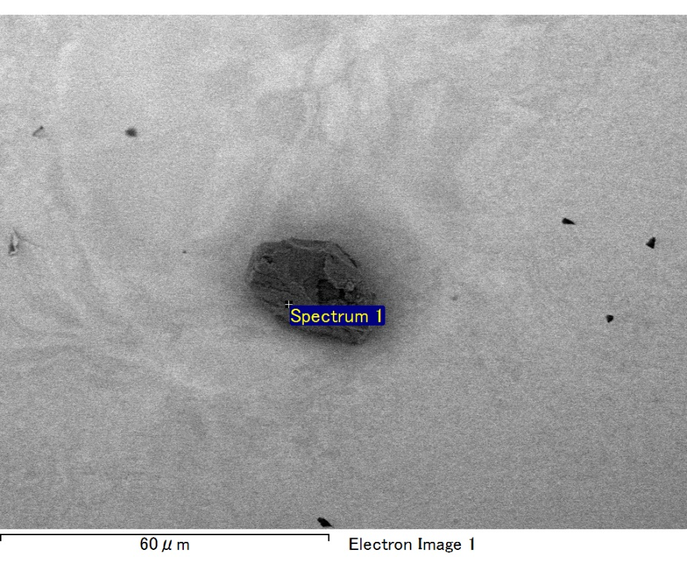

Spectrum processing :

No peaks omitted

Processing option : All elements analyzed (Normalised)

Number of iterations = 2

Standard :

C CaCO3 1-Jun-1999 12:00 AM

Fe Fe 1-Jun-1999 12:00 AM

Au Au 1-Jun-1999 12:00 AM

|  |  |  |  |
| --- | --- | --- | --- |
| Element | Weight% | Atomic% |  |
|  |  |  |  |
| C K | 4.58 | 42.70 |  |
| Fe L | 2.10 | 4.22 |  |
| Au M | 93.32 | 53.08 |  |
|  |  |  |  |
| Totals | 100.00 |  |  |

Spectrum Label: Spectrum 1

Livetime 60.0 s

Acquisition geometry ( degrees ):

Tilt = 15.0

Azimuth = 0.0

Elevation = 30.0

Accelerating voltage = 10.00 kV

Total spectrum counts = 42926

|  |  |  |  |
| --- | --- | --- | --- |
| Sample data : | Energy (eV) | Resn. (eV) | Area |
| Strobe : | 3.8 | 47.47 | 999789 |
|  |  |  |  |

No quant optimization performed

Sample: Sample 1

Type: Default

ID:

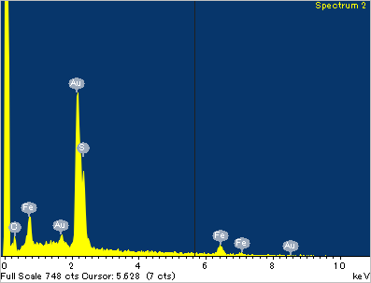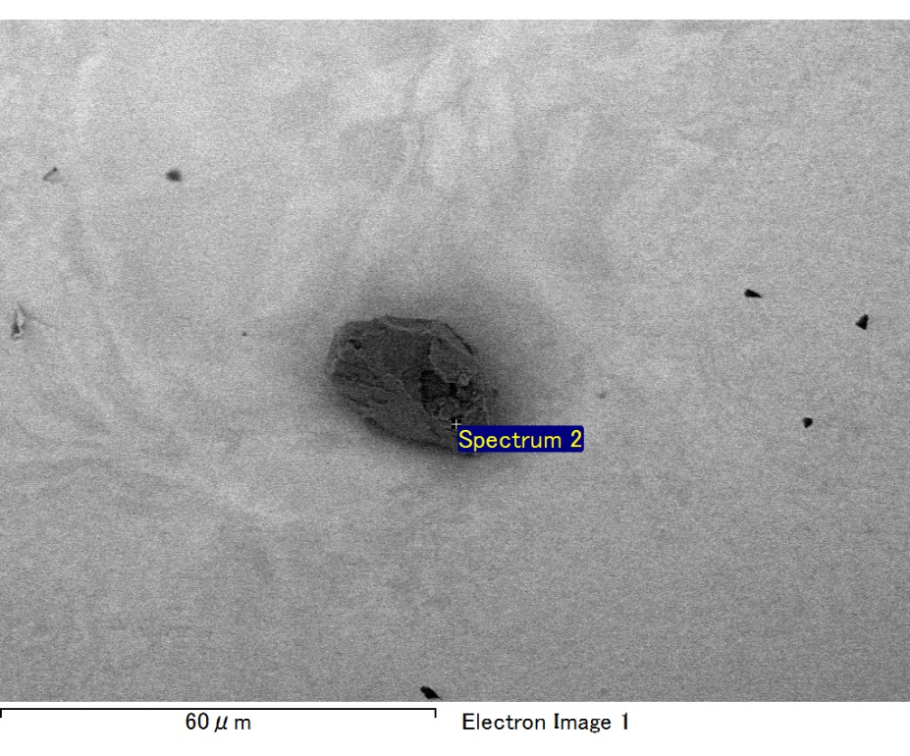

Spectrum processing :

No peaks omitted

Processing option : All elements analyzed (Normalised)

Number of iterations = 2

Standard :

C CaCO3 1-Jun-1999 12:00 AM

S FeS2 1-Jun-1999 12:00 AM

Fe Fe 1-Jun-1999 12:00 AM

Au Au 1-Jun-1999 12:00 AM

|  |  |  |  |
| --- | --- | --- | --- |
| Element | Weight% | Atomic% |  |
|  |  |  |  |
| C K | 3.88 | 23.95 |  |
| S K | 12.38 | 28.64 |  |
| Fe L | 16.65 | 22.13 |  |
| Au M | 67.09 | 25.28 |  |
|  |  |  |  |
| Totals | 100.00 |  |  |

Spectrum Label: Spectrum 2

Livetime 60.0 s

Acquisition geometry ( degrees ):

Tilt = 15.0

Azimuth = 0.0

Elevation = 30.0

Accelerating voltage = 10.00 kV

Total spectrum counts = 48626

|  |  |  |  |
| --- | --- | --- | --- |
| Sample data : | Energy (eV) | Resn. (eV) | Area |
| Strobe : | 3.8 | 47.39 | 1000468 |
|  |  |  |  |

No quant optimization performed

Sample: Sample 1

Type: Default

ID:

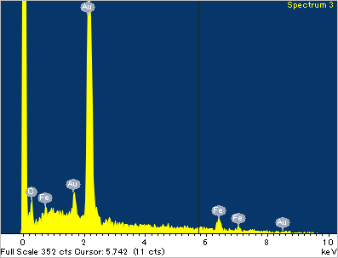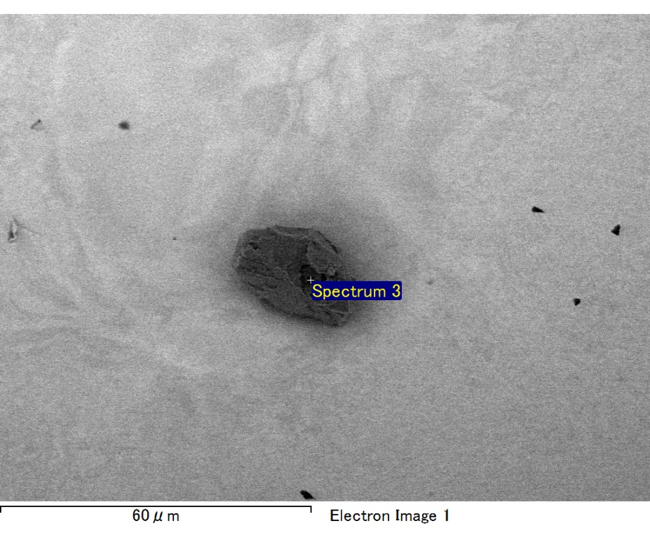

Spectrum processing :

No peaks omitted

Processing option : All elements analyzed (Normalised)

Number of iterations = 2

Standard :

C CaCO3 1-Jun-1999 12:00 AM

Fe Fe 1-Jun-1999 12:00 AM

Au Au 1-Jun-1999 12:00 AM

|  |  |  |  |
| --- | --- | --- | --- |
| Element | Weight% | Atomic% |  |
|  |  |  |  |
| C K | 4.23 | 38.77 |  |
| Fe L | 5.45 | 10.74 |  |
| Au M | 90.32 | 50.49 |  |
|  |  |  |  |
| Totals | 100.00 |  |  |

Spectrum Label: Spectrum 3

Livetime 60.0 s

Acquisition geometry ( degrees ):

Tilt = 15.0

Azimuth = 0.0

Elevation = 30.0

Accelerating voltage = 10.00 kV

Total spectrum counts = 43176

|  |  |  |  |
| --- | --- | --- | --- |
| Sample data : | Energy (eV) | Resn. (eV) | Area |
| Strobe : | 3.8 | 47.42 | 1000820 |
|  |  |  |  |

No quant optimization performed

Sample: Sample 1

Type: Default

ID: