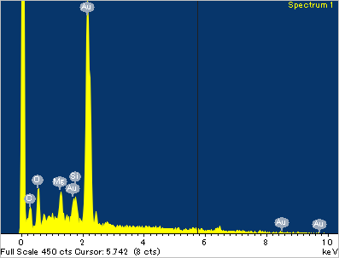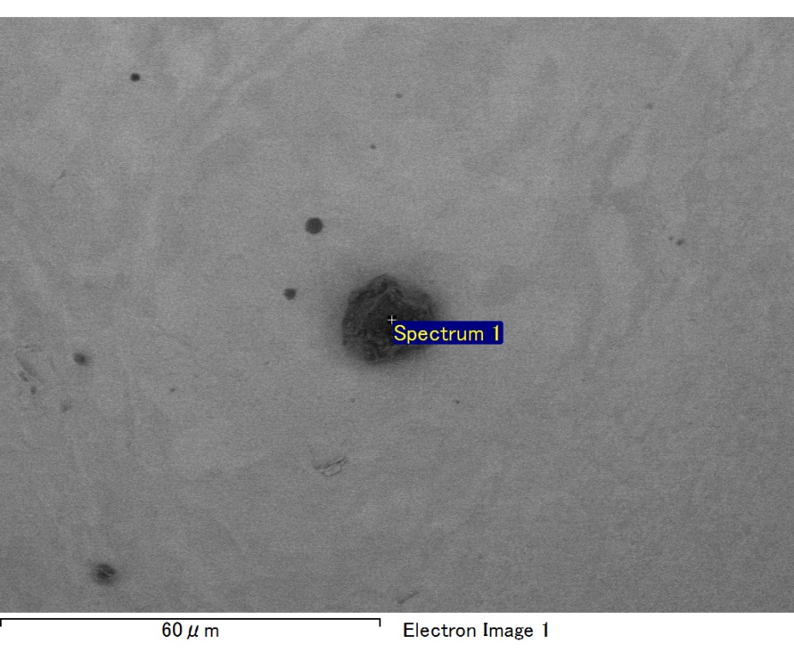

Spectrum processing :

No peaks omitted

Processing option : All elements analyzed (Normalised)

Number of iterations = 2

Standard :

C CaCO3 1-Jun-1999 12:00 AM

O SiO2 1-Jun-1999 12:00 AM

Mg MgO 1-Jun-1999 12:00 AM

Si SiO2 1-Jun-1999 12:00 AM

Au Au 1-Jun-1999 12:00 AM

|  |  |  |  |
| --- | --- | --- | --- |
| Element | Weight% | Atomic% |  |
|  |  |  |  |
| C K | 4.42 | 27.23 |  |
| O K | 6.85 | 31.68 |  |
| Mg K | 1.67 | 5.08 |  |
| Si K | 1.47 | 3.87 |  |
| Au M | 85.59 | 32.14 |  |
|  |  |  |  |
| Totals | 100.00 |  |  |

Spectrum Label: Spectrum 1

Livetime 60.0 s

Acquisition geometry ( degrees ):

Tilt = 15.0

Azimuth = 0.0

Elevation = 30.0

Accelerating voltage = 10.00 kV

Total spectrum counts = 44027

|  |  |  |  |
| --- | --- | --- | --- |
| Sample data : | Energy (eV) | Resn. (eV) | Area |
| Strobe : | 3.8 | 47.45 | 1000231 |
|  |  |  |  |

No quant optimization performed

Sample: Sample 1

Type: Default

ID:

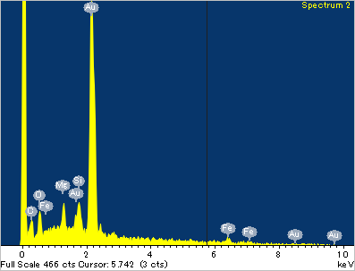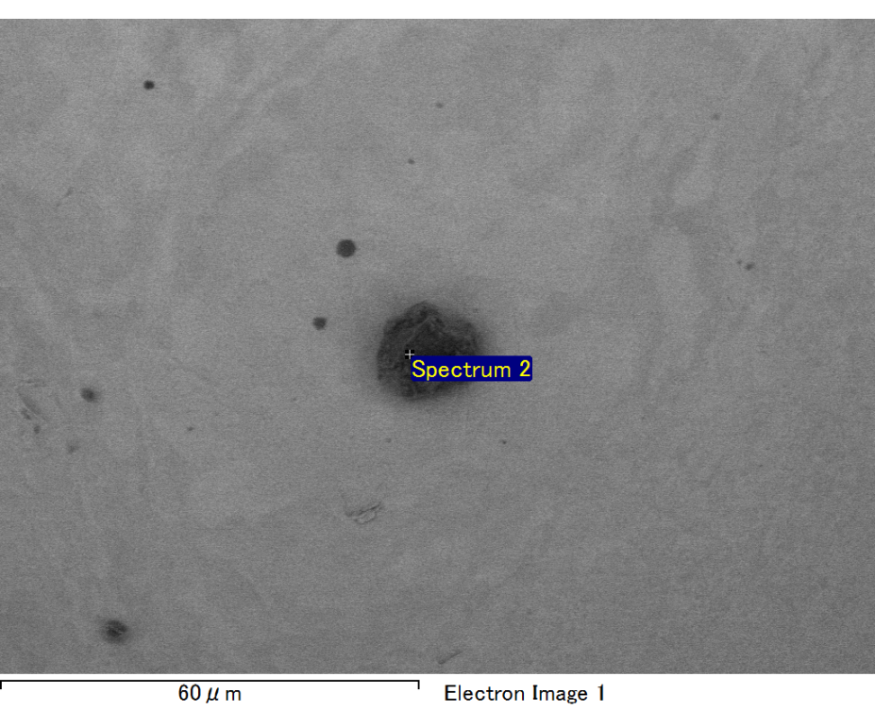

Spectrum processing :

No peaks omitted

Processing option : All elements analyzed (Normalised)

Number of iterations = 2

Standard :

C CaCO3 1-Jun-1999 12:00 AM

O SiO2 1-Jun-1999 12:00 AM

Mg MgO 1-Jun-1999 12:00 AM

Si SiO2 1-Jun-1999 12:00 AM

Fe Fe 1-Jun-1999 12:00 AM

Au Au 1-Jun-1999 12:00 AM

|  |  |  |  |
| --- | --- | --- | --- |
| Element | Weight% | Atomic% |  |
|  |  |  |  |
| C K | 3.64 | 25.73 |  |
| O K | 4.60 | 24.38 |  |
| Mg K | 1.49 | 5.19 |  |
| Si K | 2.02 | 6.10 |  |
| Fe L | 0.55 | 0.84 |  |
| Au M | 87.70 | 37.77 |  |
|  |  |  |  |
| Totals | 100.00 |  |  |

Spectrum Label: Spectrum 2

Livetime 60.0 s

Acquisition geometry ( degrees ):

Tilt = 15.0

Azimuth = 0.0

Elevation = 30.0

Accelerating voltage = 10.00 kV

Total spectrum counts = 45117

|  |  |  |  |
| --- | --- | --- | --- |
| Sample data : | Energy (eV) | Resn. (eV) | Area |
| Strobe : | 3.8 | 47.44 | 1001332 |
|  |  |  |  |

No quant optimization performed

Sample: Sample 1

Type: Default

ID:

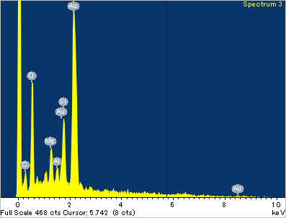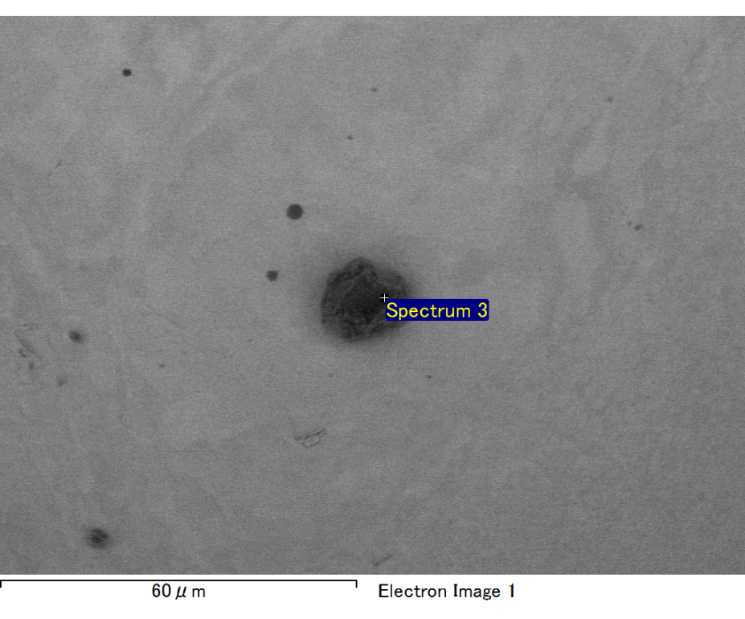

Spectrum processing :

No peaks omitted

Processing option : All elements analyzed (Normalised)

Number of iterations = 2

Standard :

C CaCO3 1-Jun-1999 12:00 AM

O SiO2 1-Jun-1999 12:00 AM

Mg MgO 1-Jun-1999 12:00 AM

Al Al2O3 1-Jun-1999 12:00 AM

Si SiO2 1-Jun-1999 12:00 AM

Au Au 1-Jun-1999 12:00 AM

|  |  |  |  |
| --- | --- | --- | --- |
| Element | Weight% | Atomic% |  |
|  |  |  |  |
| C K | 3.30 | 13.98 |  |
| O K | 16.01 | 50.89 |  |
| Mg K | 2.60 | 5.43 |  |
| Al K | 1.08 | 2.04 |  |
| Si K | 5.01 | 9.06 |  |
| Au M | 71.99 | 18.58 |  |
|  |  |  |  |
| Totals | 100.00 |  |  |

Spectrum Label: Spectrum 3

Livetime 60.0 s

Acquisition geometry ( degrees ):

Tilt = 15.0

Azimuth = 0.0

Elevation = 30.0

Accelerating voltage = 10.00 kV

Total spectrum counts = 48632

|  |  |  |  |
| --- | --- | --- | --- |
| Sample data : | Energy (eV) | Resn. (eV) | Area |
| Strobe : | 3.8 | 47.44 | 1000396 |
|  |  |  |  |

No quant optimization performed

Sample: Sample 1

Type: Default

ID:

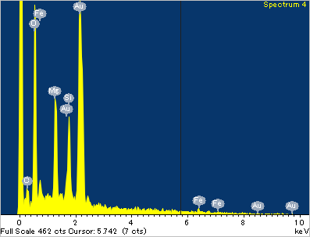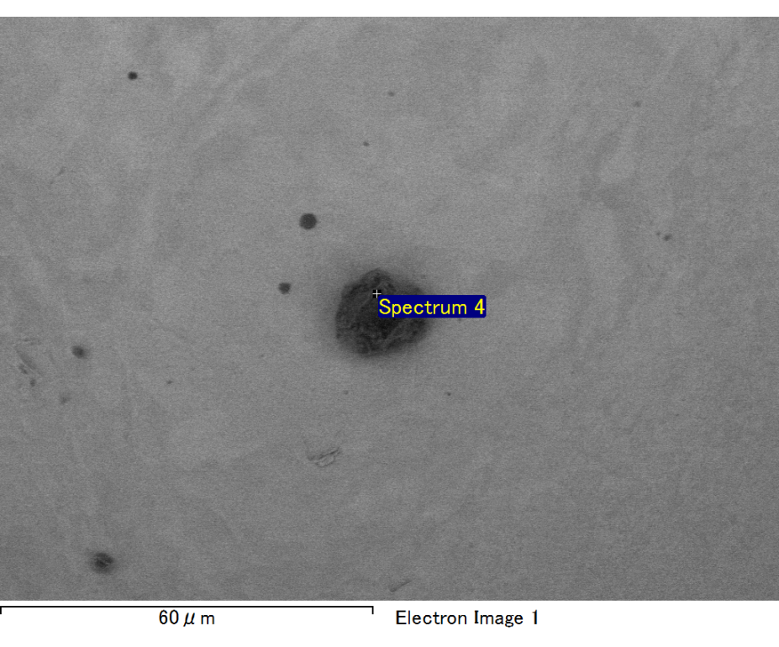

Spectrum processing :

No peaks omitted

Processing option : All elements analyzed (Normalised)

Number of iterations = 2

Standard :

C CaCO3 1-Jun-1999 12:00 AM

O SiO2 1-Jun-1999 12:00 AM

Mg MgO 1-Jun-1999 12:00 AM

Si SiO2 1-Jun-1999 12:00 AM

Fe Fe 1-Jun-1999 12:00 AM

Au Au 1-Jun-1999 12:00 AM

|  |  |  |  |
| --- | --- | --- | --- |
| Element | Weight% | Atomic% |  |
|  |  |  |  |
| C K | 2.71 | 9.76 |  |
| O K | 20.32 | 54.89 |  |
| Mg K | 5.47 | 9.72 |  |
| Si K | 4.25 | 6.53 |  |
| Fe L | 7.85 | 6.07 |  |
| Au M | 59.40 | 13.03 |  |
|  |  |  |  |
| Totals | 100.00 |  |  |

Spectrum Label: Spectrum 4

Livetime 60.0 s

Acquisition geometry ( degrees ):

Tilt = 15.0

Azimuth = 0.0

Elevation = 30.0

Accelerating voltage = 10.00 kV

Total spectrum counts = 51217

|  |  |  |  |
| --- | --- | --- | --- |
| Sample data : | Energy (eV) | Resn. (eV) | Area |
| Strobe : | 3.8 | 47.47 | 1000223 |
|  |  |  |  |

No quant optimization performed

Sample: Sample 1

Type: Default

ID:

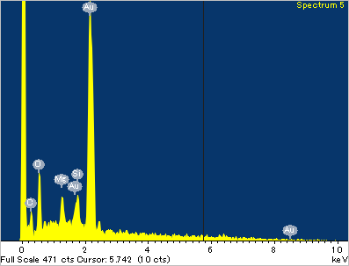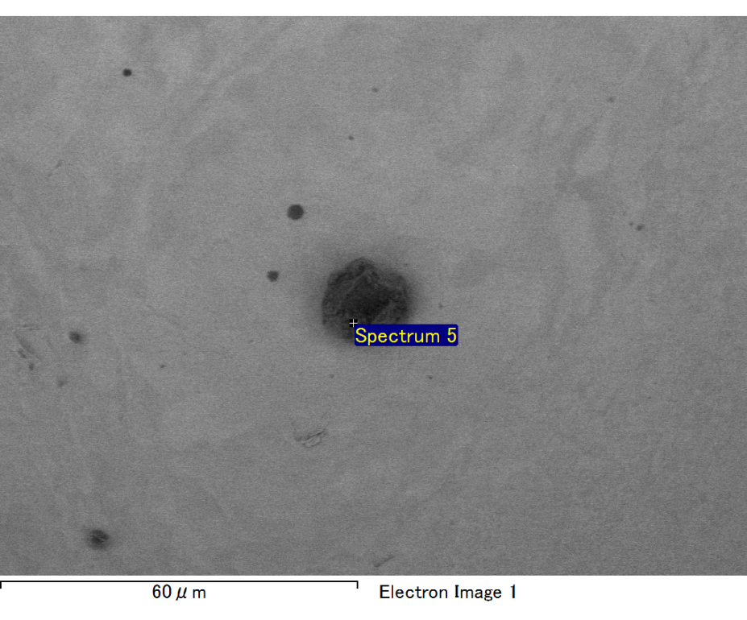

Spectrum processing :

No peaks omitted

Processing option : All elements analyzed (Normalised)

Number of iterations = 2

Standard :

C CaCO3 1-Jun-1999 12:00 AM

O SiO2 1-Jun-1999 12:00 AM

Mg MgO 1-Jun-1999 12:00 AM

Si SiO2 1-Jun-1999 12:00 AM

Au Au 1-Jun-1999 12:00 AM

|  |  |  |  |
| --- | --- | --- | --- |
| Element | Weight% | Atomic% |  |
|  |  |  |  |
| C K | 4.41 | 24.64 |  |
| O K | 9.05 | 38.00 |  |
| Mg K | 1.60 | 4.42 |  |
| Si K | 1.95 | 4.65 |  |
| Au M | 82.99 | 28.29 |  |
|  |  |  |  |
| Totals | 100.00 |  |  |

Spectrum Label: Spectrum 5

Livetime 60.0 s

Acquisition geometry ( degrees ):

Tilt = 15.0

Azimuth = 0.0

Elevation = 30.0

Accelerating voltage = 10.00 kV

Total spectrum counts = 45925

|  |  |  |  |
| --- | --- | --- | --- |
| Sample data : | Energy (eV) | Resn. (eV) | Area |
| Strobe : | 3.8 | 47.51 | 1000201 |
|  |  |  |  |

No quant optimization performed

Sample: Sample 1

Type: Default

ID: