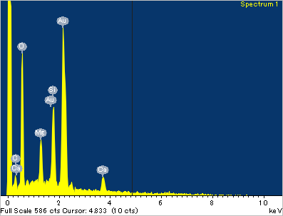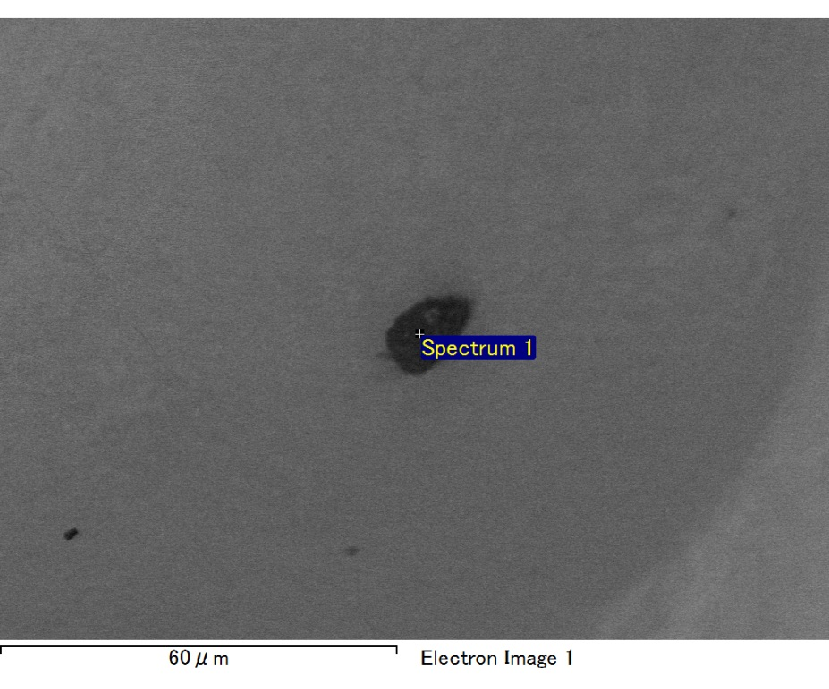

Spectrum processing :

Peak possibly omitted : 0.720 keV

Processing option : All elements analyzed (Normalised)

Number of iterations = 2

Standard :

C CaCO3 1-Jun-1999 12:00 AM

O SiO2 1-Jun-1999 12:00 AM

Mg MgO 1-Jun-1999 12:00 AM

Si SiO2 1-Jun-1999 12:00 AM

Ca Wollastonite 1-Jun-1999 12:00 AM

Au Au 1-Jun-1999 12:00 AM

|  |  |  |  |
| --- | --- | --- | --- |
| Element | Weight% | Atomic% |  |
|  |  |  |  |
| C K | 2.26 | 8.12 |  |
| O K | 21.37 | 57.79 |  |
| Mg K | 3.04 | 5.42 |  |
| Si K | 6.66 | 10.26 |  |
| Ca K | 4.37 | 4.72 |  |
| Au M | 62.30 | 13.69 |  |
|  |  |  |  |
| Totals | 100.00 |  |  |

Spectrum Label: Spectrum 1

Livetime 60.0 s

Acquisition geometry ( degrees ):

Tilt = 15.0

Azimuth = 0.0

Elevation = 30.0

Accelerating voltage = 10.00 kV

Total spectrum counts = 51343

|  |  |  |  |
| --- | --- | --- | --- |
| Sample data : | Energy (eV) | Resn. (eV) | Area |
| Strobe : | 3.8 | 47.44 | 1000671 |
|  |  |  |  |

No quant optimization performed

Sample: Sample 1

Type: Default

ID:

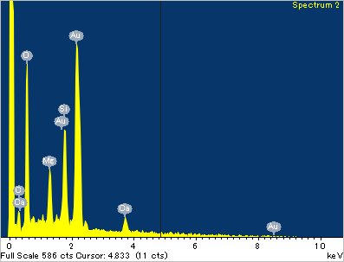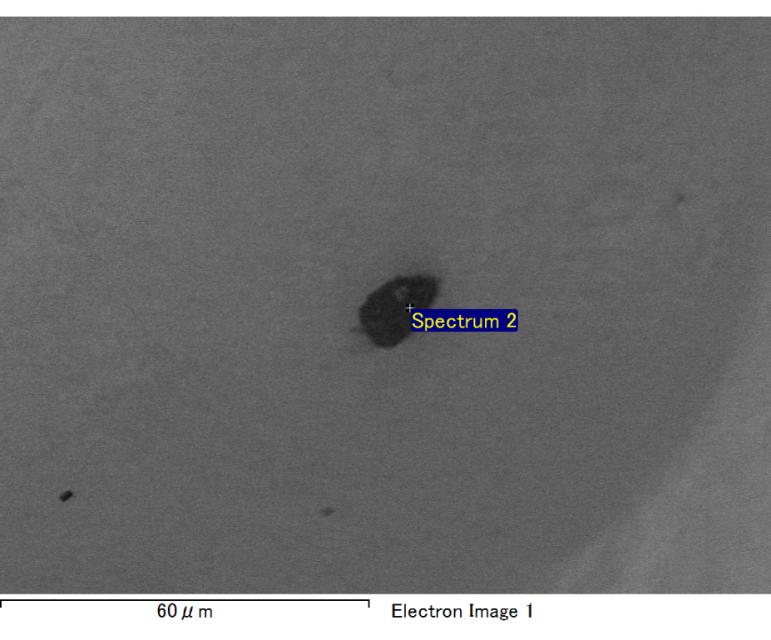

Spectrum processing :

No peaks omitted

Processing option : All elements analyzed (Normalised)

Number of iterations = 2

Standard :

C CaCO3 1-Jun-1999 12:00 AM

O SiO2 1-Jun-1999 12:00 AM

Mg MgO 1-Jun-1999 12:00 AM

Si SiO2 1-Jun-1999 12:00 AM

Ca Wollastonite 1-Jun-1999 12:00 AM

Au Au 1-Jun-1999 12:00 AM

|  |  |  |  |
| --- | --- | --- | --- |
| Element | Weight% | Atomic% |  |
|  |  |  |  |
| C K | 3.20 | 11.65 |  |
| O K | 20.25 | 55.29 |  |
| Mg K | 3.06 | 5.49 |  |
| Si K | 6.24 | 9.71 |  |
| Ca K | 3.38 | 3.69 |  |
| Au M | 63.86 | 14.16 |  |
|  |  |  |  |
| Totals | 100.00 |  |  |

Spectrum Label: Spectrum 2

Livetime 60.0 s

Acquisition geometry ( degrees ):

Tilt = 15.0

Azimuth = 0.0

Elevation = 30.0

Accelerating voltage = 10.00 kV

Total spectrum counts = 51343

|  |  |  |  |
| --- | --- | --- | --- |
| Sample data : | Energy (eV) | Resn. (eV) | Area |
| Strobe : | 3.8 | 47.44 | 1000437 |
|  |  |  |  |

No quant optimization performed

Sample: Sample 1

Type: Default

ID:

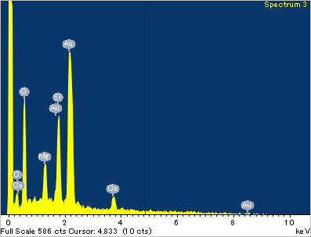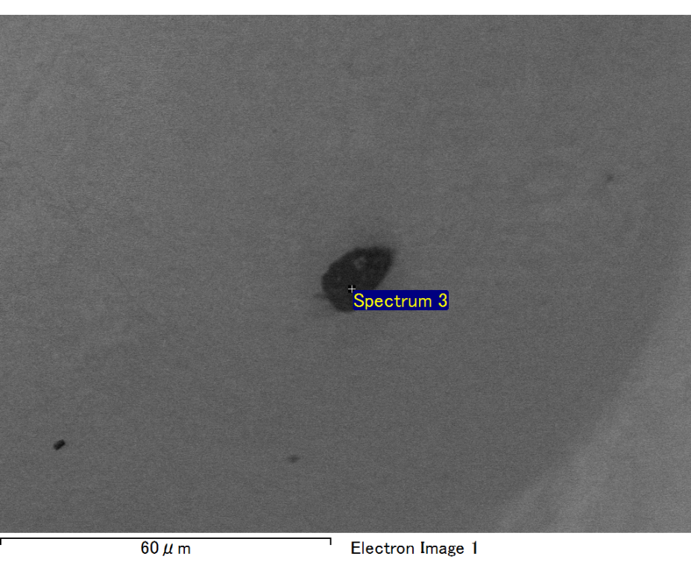

Spectrum processing :

No peaks omitted

Processing option : All elements analyzed (Normalised)

Number of iterations = 2

Standard :

C CaCO3 1-Jun-1999 12:00 AM

O SiO2 1-Jun-1999 12:00 AM

Mg MgO 1-Jun-1999 12:00 AM

Si SiO2 1-Jun-1999 12:00 AM

Ca Wollastonite 1-Jun-1999 12:00 AM

Au Au 1-Jun-1999 12:00 AM

|  |  |  |  |
| --- | --- | --- | --- |
| Element | Weight% | Atomic% |  |
|  |  |  |  |
| C K | 2.83 | 11.21 |  |
| O K | 17.36 | 51.59 |  |
| Mg K | 2.72 | 5.32 |  |
| Si K | 6.55 | 11.10 |  |
| Ca K | 3.96 | 4.70 |  |
| Au M | 66.57 | 16.07 |  |
|  |  |  |  |
| Totals | 100.00 |  |  |

Spectrum Label: Spectrum 3

Livetime 60.0 s

Acquisition geometry ( degrees ):

Tilt = 15.0

Azimuth = 0.0

Elevation = 30.0

Accelerating voltage = 10.00 kV

Total spectrum counts = 50861

|  |  |  |  |
| --- | --- | --- | --- |
| Sample data : | Energy (eV) | Resn. (eV) | Area |
| Strobe : | 3.8 | 47.39 | 1000239 |
|  |  |  |  |

No quant optimization performed

Sample: Sample 1

Type: Default

ID:

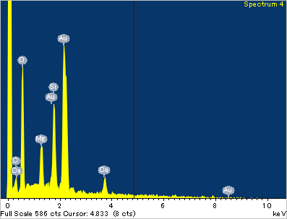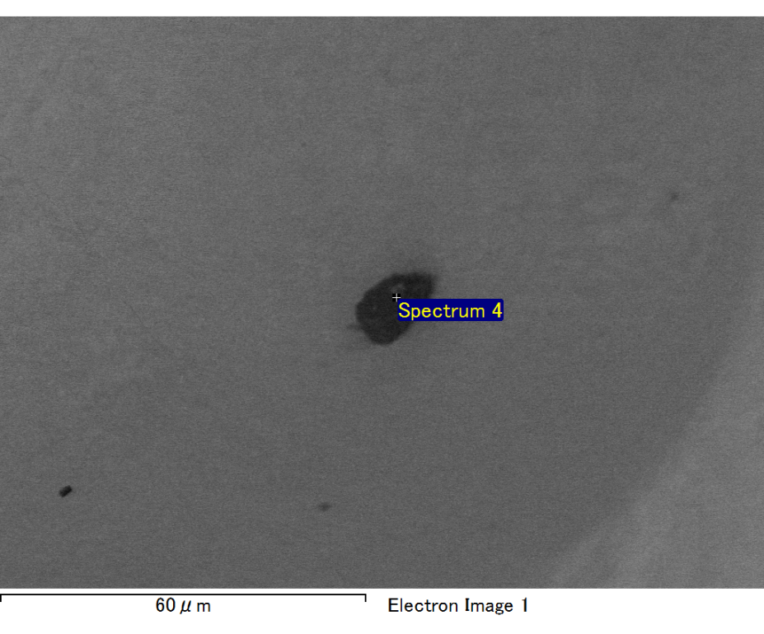

Spectrum processing :

No peaks omitted

Processing option : All elements analyzed (Normalised)

Number of iterations = 2

Standard :

C CaCO3 1-Jun-1999 12:00 AM

O SiO2 1-Jun-1999 12:00 AM

Mg MgO 1-Jun-1999 12:00 AM

Si SiO2 1-Jun-1999 12:00 AM

Ca Wollastonite 1-Jun-1999 12:00 AM

Au Au 1-Jun-1999 12:00 AM

|  |  |  |  |
| --- | --- | --- | --- |
| Element | Weight% | Atomic% |  |
|  |  |  |  |
| C K | 2.93 | 10.66 |  |
| O K | 19.85 | 54.30 |  |
| Mg K | 3.14 | 5.65 |  |
| Si K | 6.74 | 10.51 |  |
| Ca K | 4.51 | 4.92 |  |
| Au M | 62.84 | 13.96 |  |
|  |  |  |  |
| Totals | 100.00 |  |  |

Spectrum Label: Spectrum 4

Livetime 60.0 s

Acquisition geometry ( degrees ):

Tilt = 15.0

Azimuth = 0.0

Elevation = 30.0

Accelerating voltage = 10.00 kV

Total spectrum counts = 50538

|  |  |  |  |
| --- | --- | --- | --- |
| Sample data : | Energy (eV) | Resn. (eV) | Area |
| Strobe : | 3.8 | 47.44 | 1000240 |
|  |  |  |  |

No quant optimization performed

Sample: Sample 1

Type: Default

ID:

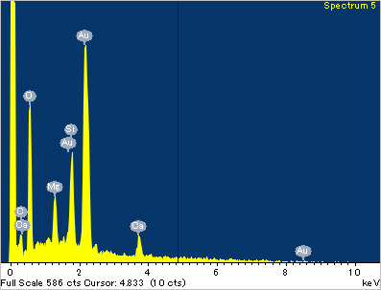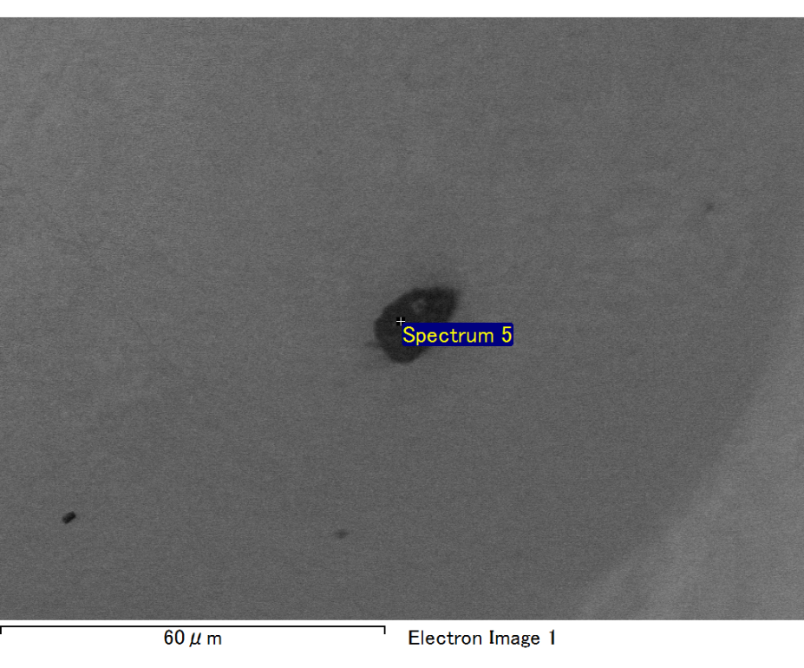

Spectrum processing :

No peaks omitted

Processing option : All elements analyzed (Normalised)

Number of iterations = 2

Standard :

C CaCO3 1-Jun-1999 12:00 AM

O SiO2 1-Jun-1999 12:00 AM

Mg MgO 1-Jun-1999 12:00 AM

Si SiO2 1-Jun-1999 12:00 AM

Ca Wollastonite 1-Jun-1999 12:00 AM

Au Au 1-Jun-1999 12:00 AM

|  |  |  |  |
| --- | --- | --- | --- |
| Element | Weight% | Atomic% |  |
|  |  |  |  |
| C K | 2.98 | 11.48 |  |
| O K | 18.50 | 53.46 |  |
| Mg K | 2.52 | 4.79 |  |
| Si K | 5.81 | 9.55 |  |
| Ca K | 4.63 | 5.33 |  |
| Au M | 65.56 | 15.38 |  |
|  |  |  |  |
| Totals | 100.00 |  |  |

Spectrum Label: Spectrum 5

Livetime 60.0 s

Acquisition geometry ( degrees ):

Tilt = 15.0

Azimuth = 0.0

Elevation = 30.0

Accelerating voltage = 10.00 kV

Total spectrum counts = 51643

|  |  |  |  |
| --- | --- | --- | --- |
| Sample data : | Energy (eV) | Resn. (eV) | Area |
| Strobe : | 3.8 | 47.48 | 1000691 |
|  |  |  |  |

No quant optimization performed

Sample: Sample 1

Type: Default

ID: