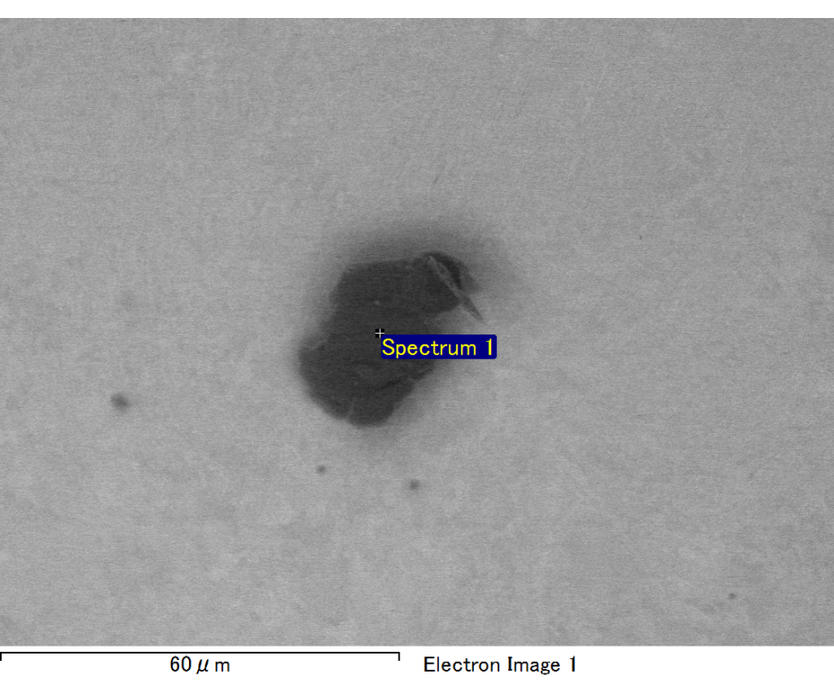

Spectrum processing :

No peaks omitted

Processing option : All elements analyzed (Normalised)

Number of iterations = 2

Standard :

C CaCO3 1-Jun-1999 12:00 AM

Al Al2O3 1-Jun-1999 12:00 AM

Au Au 1-Jun-1999 12:00 AM

|  |  |  |  |
| --- | --- | --- | --- |
| Element | Weight% | Atomic% |  |
|  |  |  |  |
| C K | 4.20 | 34.17 |  |
| Al K | 5.87 | 21.26 |  |
| Au M | 89.92 | 44.57 |  |
|  |  |  |  |
| Totals | 100.00 |  |  |

Spectrum Label: Spectrum 1

Livetime 60.0 s

Acquisition geometry ( degrees ):

Tilt = 10.0

Azimuth = 0.0

Elevation = 30.0

Accelerating voltage = 10.00 kV

Total spectrum counts = 38759

|  |  |  |  |
| --- | --- | --- | --- |
| Sample data : | Energy (eV) | Resn. (eV) | Area |
| Strobe : | 3.8 | 47.55 | 999402 |
|  |  |  |  |

No quant optimization performed

Sample: Sample 1

Type: Default

ID: