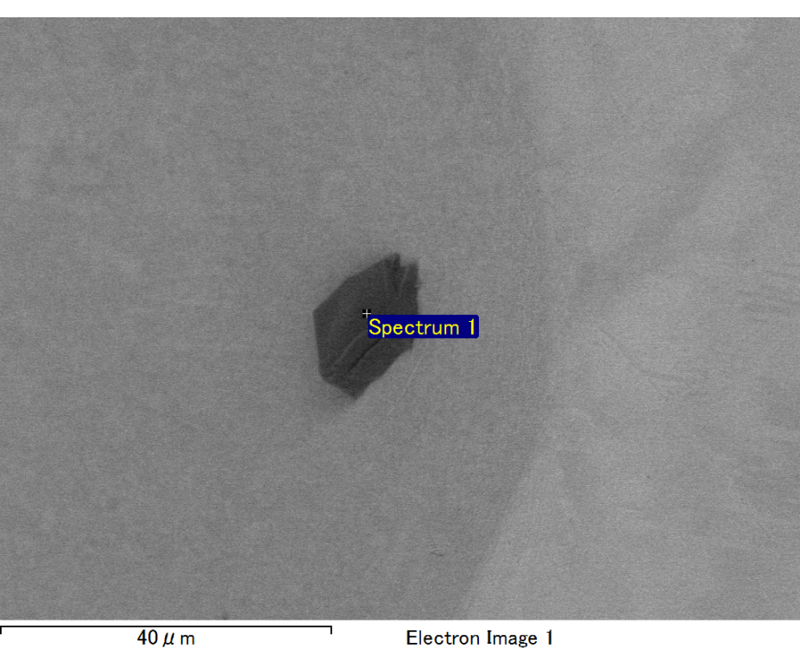

Spectrum processing :

No peaks omitted

Processing option : All elements analyzed (Normalised)

Number of iterations = 2

Standard :

C CaCO3 1-Jun-1999 12:00 AM

O SiO2 1-Jun-1999 12:00 AM

Mg MgO 1-Jun-1999 12:00 AM

Si SiO2 1-Jun-1999 12:00 AM

Fe Fe 1-Jun-1999 12:00 AM

Au Au 1-Jun-1999 12:00 AM

|  |  |  |  |
| --- | --- | --- | --- |
| Element | Weight% | Atomic% |  |
|  |  |  |  |
| C K | 2.14 | 7.59 |  |
| O K | 19.85 | 52.79 |  |
| Mg K | 5.85 | 10.23 |  |
| Si K | 4.16 | 6.31 |  |
| Fe L | 15.39 | 11.72 |  |
| Au M | 52.60 | 11.36 |  |
|  |  |  |  |
| Totals | 100.00 |  |  |

Spectrum Label: Spectrum 1

Livetime 60.0 s

Acquisition geometry ( degrees ):

Tilt = 10.0

Azimuth = 0.0

Elevation = 30.0

Accelerating voltage = 10.00 kV

Total spectrum counts = 50481

|  |  |  |  |
| --- | --- | --- | --- |
| Sample data : | Energy (eV) | Resn. (eV) | Area |
| Strobe : | 3.8 | 47.47 | 999994 |
|  |  |  |  |

No quant optimization performed

Sample: Sample 1

Type: Default

ID:

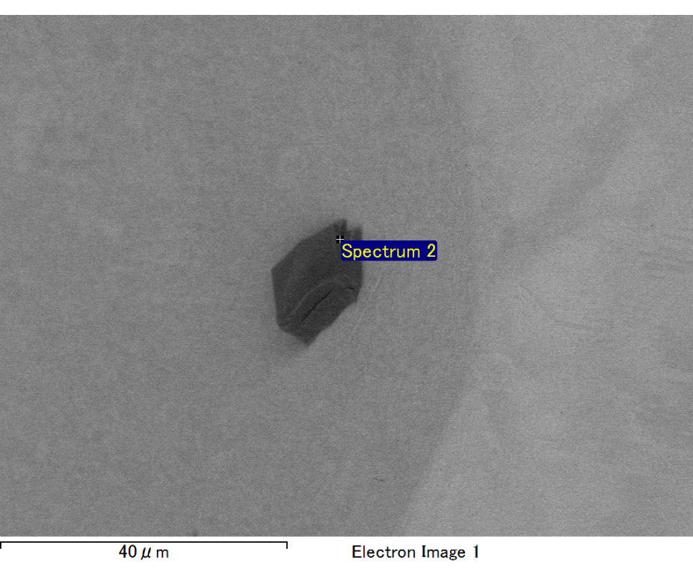

Spectrum processing :

No peaks omitted

Processing option : All elements analyzed (Normalised)

Number of iterations = 2

Standard :

C CaCO3 1-Jun-1999 12:00 AM

O SiO2 1-Jun-1999 12:00 AM

Mg MgO 1-Jun-1999 12:00 AM

Si SiO2 1-Jun-1999 12:00 AM

Fe Fe 1-Jun-1999 12:00 AM

Au Au 1-Jun-1999 12:00 AM

|  |  |  |  |
| --- | --- | --- | --- |
| Element | Weight% | Atomic% |  |
|  |  |  |  |
| C K | 2.47 | 8.28 |  |
| O K | 21.75 | 54.65 |  |
| Mg K | 6.14 | 10.16 |  |
| Si K | 4.07 | 5.82 |  |
| Fe L | 14.96 | 10.77 |  |
| Au M | 50.60 | 10.33 |  |
|  |  |  |  |
| Totals | 100.00 |  |  |

Spectrum Label: Spectrum 2

Livetime 60.0 s

Acquisition geometry ( degrees ):

Tilt = 10.0

Azimuth = 0.0

Elevation = 30.0

Accelerating voltage = 10.00 kV

Total spectrum counts = 52451

|  |  |  |  |
| --- | --- | --- | --- |
| Sample data : | Energy (eV) | Resn. (eV) | Area |
| Strobe : | 3.8 | 47.48 | 1000674 |
|  |  |  |  |

No quant optimization performed

Sample: Sample 1

Type: Default

ID:

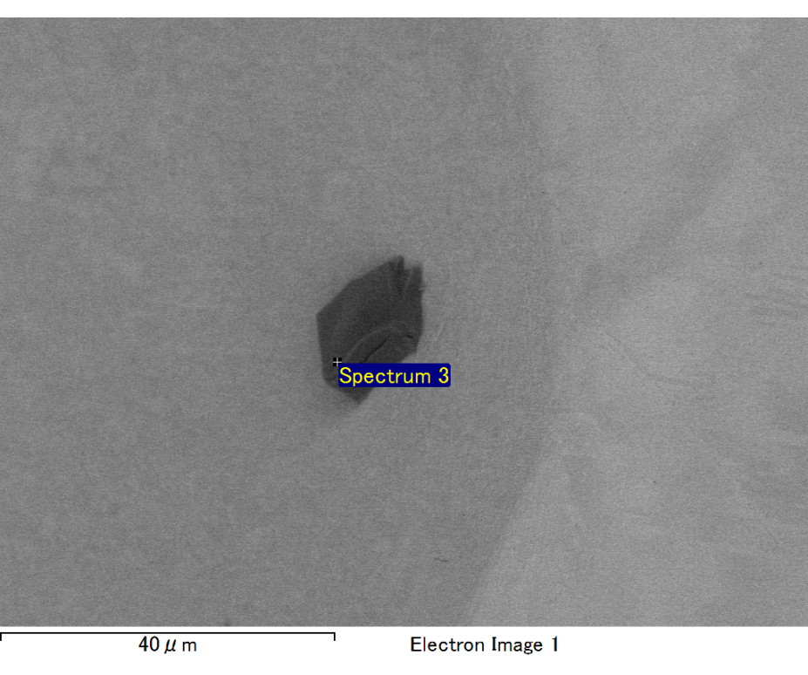

Spectrum processing :

No peaks omitted

Processing option : All elements analyzed (Normalised)

Number of iterations = 2

Standard :

C CaCO3 1-Jun-1999 12:00 AM

O SiO2 1-Jun-1999 12:00 AM

Mg MgO 1-Jun-1999 12:00 AM

Si SiO2 1-Jun-1999 12:00 AM

Fe Fe 1-Jun-1999 12:00 AM

Au Au 1-Jun-1999 12:00 AM

|  |  |  |  |
| --- | --- | --- | --- |
| Element | Weight% | Atomic% |  |
|  |  |  |  |
| C K | 2.62 | 9.53 |  |
| O K | 19.23 | 52.51 |  |
| Mg K | 5.32 | 9.56 |  |
| Si K | 3.94 | 6.13 |  |
| Fe L | 12.47 | 9.76 |  |
| Au M | 56.42 | 12.51 |  |
|  |  |  |  |
| Totals | 100.00 |  |  |

Spectrum Label: Spectrum 3

Livetime 60.0 s

Acquisition geometry ( degrees ):

Tilt = 10.0

Azimuth = 0.0

Elevation = 30.0

Accelerating voltage = 10.00 kV

Total spectrum counts = 50080

|  |  |  |  |
| --- | --- | --- | --- |
| Sample data : | Energy (eV) | Resn. (eV) | Area |
| Strobe : | 3.8 | 47.53 | 1000245 |
|  |  |  |  |

No quant optimization performed

Sample: Sample 1

Type: Default

ID:

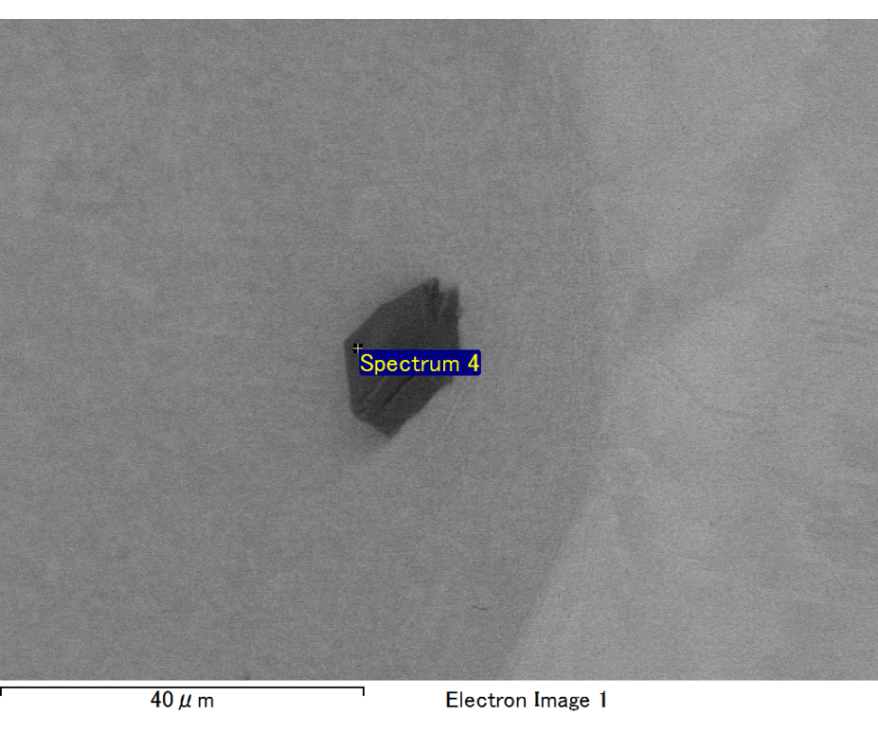

Spectrum processing :

No peaks omitted

Processing option : All elements analyzed (Normalised)

Number of iterations = 2

Standard :

C CaCO3 1-Jun-1999 12:00 AM

O SiO2 1-Jun-1999 12:00 AM

Mg MgO 1-Jun-1999 12:00 AM

Si SiO2 1-Jun-1999 12:00 AM

Fe Fe 1-Jun-1999 12:00 AM

Au Au 1-Jun-1999 12:00 AM

|  |  |  |  |
| --- | --- | --- | --- |
| Element | Weight% | Atomic% |  |
|  |  |  |  |
| C K | 2.62 | 9.22 |  |
| O K | 20.30 | 53.72 |  |
| Mg K | 5.53 | 9.63 |  |
| Si K | 4.26 | 6.43 |  |
| Fe L | 12.04 | 9.13 |  |
| Au M | 55.25 | 11.88 |  |
|  |  |  |  |
| Totals | 100.00 |  |  |

Spectrum Label: Spectrum 4

Livetime 60.0 s

Acquisition geometry ( degrees ):

Tilt = 10.0

Azimuth = 0.0

Elevation = 30.0

Accelerating voltage = 10.00 kV

Total spectrum counts = 50742

|  |  |  |  |
| --- | --- | --- | --- |
| Sample data : | Energy (eV) | Resn. (eV) | Area |
| Strobe : | 3.8 | 47.42 | 1000947 |
|  |  |  |  |

No quant optimization performed

Sample: Sample 1

Type: Default

ID:

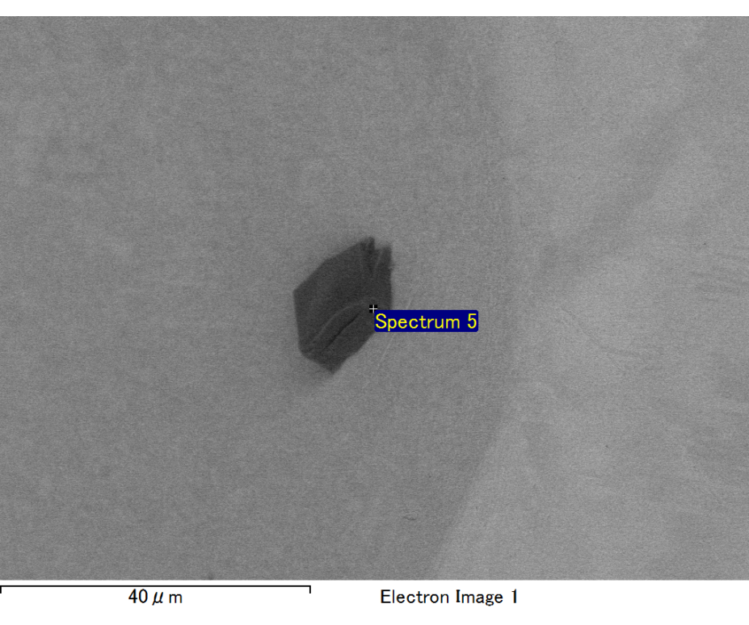

Spectrum processing :

No peaks omitted

Processing option : All elements analyzed (Normalised)

Number of iterations = 2

Standard :

C CaCO3 1-Jun-1999 12:00 AM

O SiO2 1-Jun-1999 12:00 AM

Mg MgO 1-Jun-1999 12:00 AM

Si SiO2 1-Jun-1999 12:00 AM

Fe Fe 1-Jun-1999 12:00 AM

Au Au 1-Jun-1999 12:00 AM

|  |  |  |  |
| --- | --- | --- | --- |
| Element | Weight% | Atomic% |  |
|  |  |  |  |
| C K | 4.04 | 24.92 |  |
| O K | 6.10 | 28.24 |  |
| Mg K | 2.34 | 7.11 |  |
| Si K | 2.64 | 6.96 |  |
| Fe L | 0.91 | 1.20 |  |
| Au M | 83.97 | 31.57 |  |
|  |  |  |  |
| Totals | 100.00 |  |  |

Spectrum Label: Spectrum 5

Livetime 60.0 s

Acquisition geometry ( degrees ):

Tilt = 10.0

Azimuth = 0.0

Elevation = 30.0

Accelerating voltage = 10.00 kV

Total spectrum counts = 44258

|  |  |  |  |
| --- | --- | --- | --- |
| Sample data : | Energy (eV) | Resn. (eV) | Area |
| Strobe : | 3.8 | 47.42 | 999894 |
|  |  |  |  |

No quant optimization performed

Sample: Sample 1

Type: Default

ID: