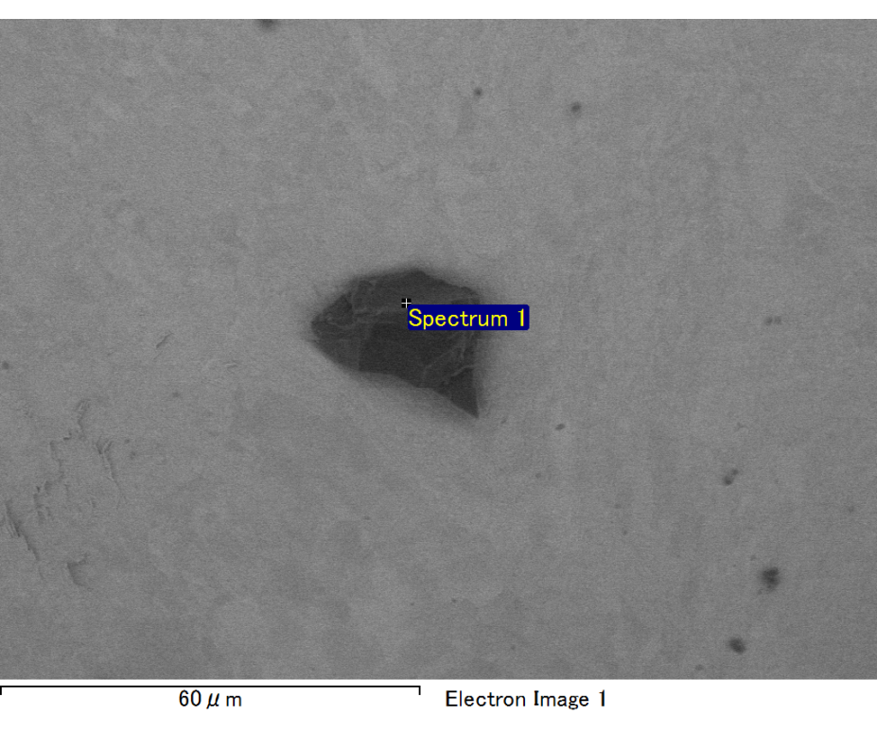

Spectrum processing :

No peaks omitted

Processing option : All elements analyzed (Normalised)

Number of iterations = 2

Standard :

C CaCO3 1-Jun-1999 12:00 AM

O SiO2 1-Jun-1999 12:00 AM

Mg MgO 1-Jun-1999 12:00 AM

Si SiO2 1-Jun-1999 12:00 AM

Fe Fe 1-Jun-1999 12:00 AM

Au Au 1-Jun-1999 12:00 AM

|  |  |  |  |
| --- | --- | --- | --- |
| Element | Weight% | Atomic% |  |
|  |  |  |  |
| C K | 2.58 | 8.80 |  |
| O K | 21.51 | 55.15 |  |
| Mg K | 5.95 | 10.04 |  |
| Si K | 4.22 | 6.17 |  |
| Fe L | 11.68 | 8.58 |  |
| Au M | 54.07 | 11.26 |  |
|  |  |  |  |
| Totals | 100.00 |  |  |

Spectrum Label: Spectrum 1

Livetime 60.0 s

Acquisition geometry ( degrees ):

Tilt = 15.0

Azimuth = 0.0

Elevation = 30.0

Accelerating voltage = 10.00 kV

Total spectrum counts = 53623

|  |  |  |  |
| --- | --- | --- | --- |
| Sample data : | Energy (eV) | Resn. (eV) | Area |
| Strobe : | 3.8 | 47.46 | 999849 |
|  |  |  |  |

No quant optimization performed

Sample: Sample 1

Type: Default

ID:

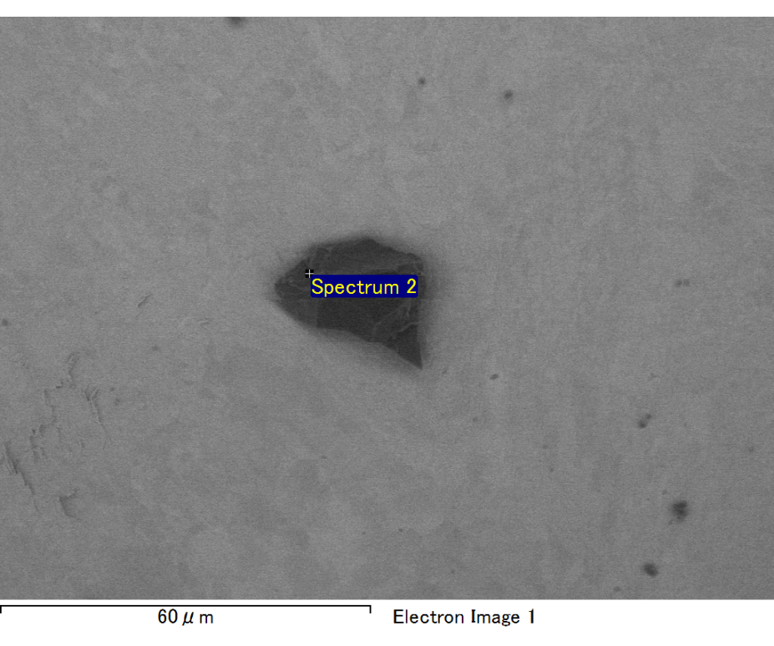

Spectrum processing :

No peaks omitted

Processing option : All elements analyzed (Normalised)

Number of iterations = 2

Standard :

C CaCO3 1-Jun-1999 12:00 AM

O SiO2 1-Jun-1999 12:00 AM

Mg MgO 1-Jun-1999 12:00 AM

Si SiO2 1-Jun-1999 12:00 AM

Fe Fe 1-Jun-1999 12:00 AM

Au Au 1-Jun-1999 12:00 AM

|  |  |  |  |
| --- | --- | --- | --- |
| Element | Weight% | Atomic% |  |
|  |  |  |  |
| C K | 2.51 | 9.05 |  |
| O K | 19.73 | 53.37 |  |
| Mg K | 5.74 | 10.21 |  |
| Si K | 4.38 | 6.75 |  |
| Fe L | 10.38 | 8.04 |  |
| Au M | 57.26 | 12.58 |  |
|  |  |  |  |
| Totals | 100.00 |  |  |

Spectrum Label: Spectrum 2

Livetime 60.0 s

Acquisition geometry ( degrees ):

Tilt = 15.0

Azimuth = 0.0

Elevation = 30.0

Accelerating voltage = 10.00 kV

Total spectrum counts = 51394

|  |  |  |  |
| --- | --- | --- | --- |
| Sample data : | Energy (eV) | Resn. (eV) | Area |
| Strobe : | 3.8 | 47.50 | 999860 |
|  |  |  |  |

No quant optimization performed

Sample: Sample 1

Type: Default

ID:

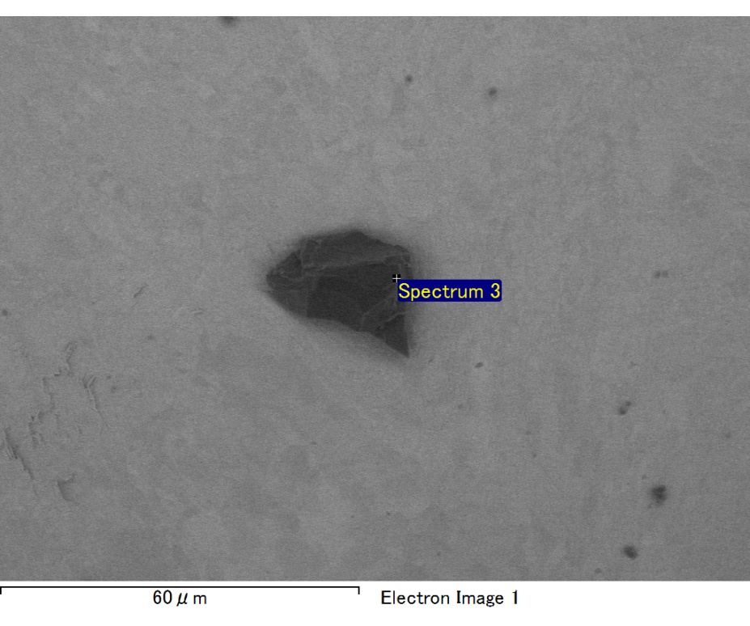

Spectrum processing :

No peaks omitted

Processing option : All elements analyzed (Normalised)

Number of iterations = 2

Standard :

C CaCO3 1-Jun-1999 12:00 AM

O SiO2 1-Jun-1999 12:00 AM

Na Albite 1-Jun-1999 12:00 AM

Al Al2O3 1-Jun-1999 12:00 AM

Si SiO2 1-Jun-1999 12:00 AM

Au Au 1-Jun-1999 12:00 AM

|  |  |  |  |
| --- | --- | --- | --- |
| Element | Weight% | Atomic% |  |
|  |  |  |  |
| C K | 2.82 | 8.96 |  |
| O K | 25.63 | 61.14 |  |
| Na K | 2.25 | 3.74 |  |
| Al K | 3.16 | 4.47 |  |
| Si K | 7.61 | 10.34 |  |
| Au M | 58.52 | 11.34 |  |
|  |  |  |  |
| Totals | 100.00 |  |  |

Spectrum Label: Spectrum 3

Livetime 60.0 s

Acquisition geometry ( degrees ):

Tilt = 15.0

Azimuth = 0.0

Elevation = 30.0

Accelerating voltage = 10.00 kV

Total spectrum counts = 52742

|  |  |  |  |
| --- | --- | --- | --- |
| Sample data : | Energy (eV) | Resn. (eV) | Area |
| Strobe : | 3.8 | 47.46 | 1000906 |
|  |  |  |  |

No quant optimization performed

Sample: Sample 1

Type: Default

ID:

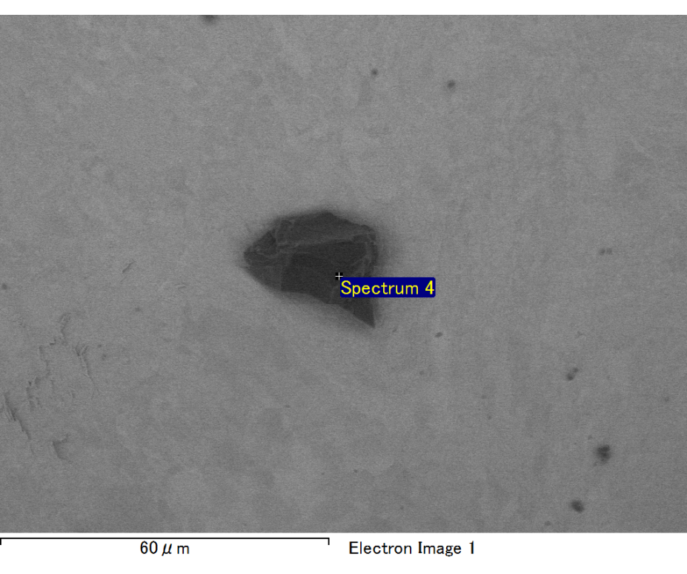

Spectrum processing :

No peaks omitted

Processing option : All elements analyzed (Normalised)

Number of iterations = 2

Standard :

C CaCO3 1-Jun-1999 12:00 AM

O SiO2 1-Jun-1999 12:00 AM

Na Albite 1-Jun-1999 12:00 AM

Al Al2O3 1-Jun-1999 12:00 AM

Si SiO2 1-Jun-1999 12:00 AM

Au Au 1-Jun-1999 12:00 AM

|  |  |  |  |
| --- | --- | --- | --- |
| Element | Weight% | Atomic% |  |
|  |  |  |  |
| C K | 2.57 | 8.61 |  |
| O K | 23.98 | 60.27 |  |
| Na K | 1.87 | 3.27 |  |
| Al K | 3.29 | 4.90 |  |
| Si K | 7.34 | 10.50 |  |
| Au M | 60.95 | 12.44 |  |
|  |  |  |  |
| Totals | 100.00 |  |  |

Spectrum Label: Spectrum 4

Livetime 60.0 s

Acquisition geometry ( degrees ):

Tilt = 15.0

Azimuth = 0.0

Elevation = 30.0

Accelerating voltage = 10.00 kV

Total spectrum counts = 51964

|  |  |  |  |
| --- | --- | --- | --- |
| Sample data : | Energy (eV) | Resn. (eV) | Area |
| Strobe : | 3.8 | 47.47 | 999869 |
|  |  |  |  |

No quant optimization performed

Sample: Sample 1

Type: Default

ID:

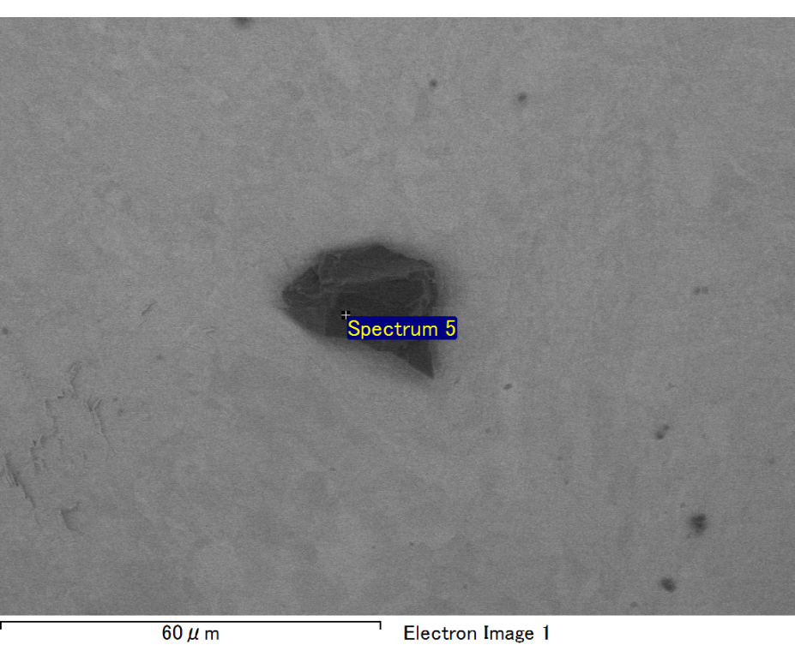

Spectrum processing :

No peaks omitted

Processing option : All elements analyzed (Normalised)

Number of iterations = 2

Standard :

C CaCO3 1-Jun-1999 12:00 AM

O SiO2 1-Jun-1999 12:00 AM

Na Albite 1-Jun-1999 12:00 AM

Al Al2O3 1-Jun-1999 12:00 AM

Si SiO2 1-Jun-1999 12:00 AM

Au Au 1-Jun-1999 12:00 AM

|  |  |  |  |
| --- | --- | --- | --- |
| Element | Weight% | Atomic% |  |
|  |  |  |  |
| C K | 3.18 | 13.06 |  |
| O K | 15.32 | 47.23 |  |
| Na K | 1.72 | 3.69 |  |
| Al K | 2.92 | 5.34 |  |
| Si K | 7.59 | 13.33 |  |
| Au M | 69.26 | 17.34 |  |
|  |  |  |  |
| Totals | 100.00 |  |  |

Spectrum Label: Spectrum 5

Livetime 60.0 s

Acquisition geometry ( degrees ):

Tilt = 15.0

Azimuth = 0.0

Elevation = 30.0

Accelerating voltage = 10.00 kV

Total spectrum counts = 48768

|  |  |  |  |
| --- | --- | --- | --- |
| Sample data : | Energy (eV) | Resn. (eV) | Area |
| Strobe : | 3.8 | 47.45 | 999949 |
|  |  |  |  |

No quant optimization performed

Sample: Sample 1

Type: Default

ID: