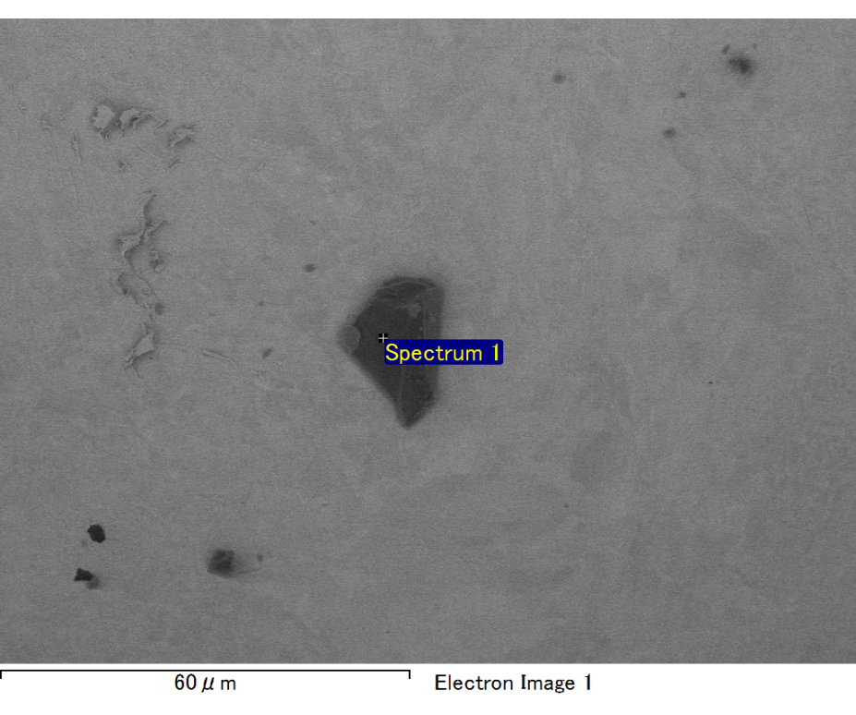

Spectrum processing :

No peaks omitted

Processing option : All elements analyzed (Normalised)

Number of iterations = 2

Standard :

C CaCO3 1-Jun-1999 12:00 AM

O SiO2 1-Jun-1999 12:00 AM

Mg MgO 1-Jun-1999 12:00 AM

Si SiO2 1-Jun-1999 12:00 AM

Fe Fe 1-Jun-1999 12:00 AM

Au Au 1-Jun-1999 12:00 AM

|  |  |  |  |
| --- | --- | --- | --- |
| Element | Weight% | Atomic% |  |
|  |  |  |  |
| C K | 2.64 | 10.17 |  |
| O K | 18.20 | 52.59 |  |
| Mg K | 4.95 | 9.42 |  |
| Si K | 3.77 | 6.21 |  |
| Fe L | 8.56 | 7.09 |  |
| Au M | 61.88 | 14.53 |  |
|  |  |  |  |
| Totals | 100.00 |  |  |

Spectrum Label: Spectrum 1

Livetime 60.0 s

Acquisition geometry ( degrees ):

Tilt = 15.0

Azimuth = 0.0

Elevation = 30.0

Accelerating voltage = 10.00 kV

Total spectrum counts = 50339

|  |  |  |  |
| --- | --- | --- | --- |
| Sample data : | Energy (eV) | Resn. (eV) | Area |
| Strobe : | 3.8 | 47.46 | 1000599 |
|  |  |  |  |

No quant optimization performed

Sample: Sample 1

Type: Default

ID:

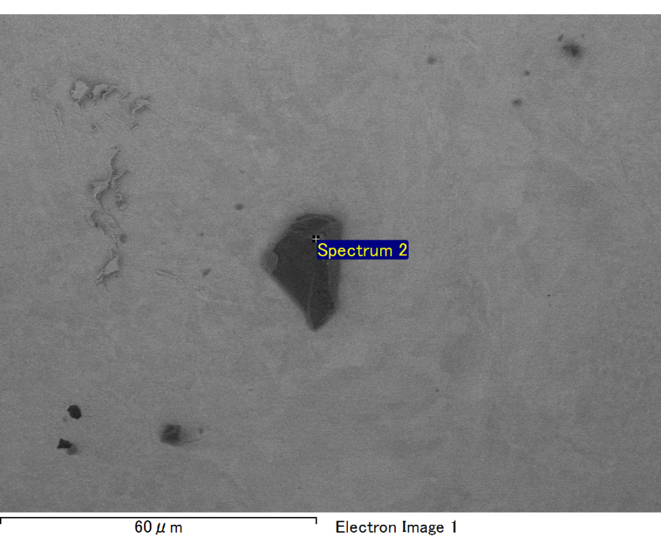

Spectrum processing :

No peaks omitted

Processing option : All elements analyzed (Normalised)

Number of iterations = 2

Standard :

C CaCO3 1-Jun-1999 12:00 AM

O SiO2 1-Jun-1999 12:00 AM

Mg MgO 1-Jun-1999 12:00 AM

S FeS2 1-Jun-1999 12:00 AM

Fe Fe 1-Jun-1999 12:00 AM

Au Au 1-Jun-1999 12:00 AM

|  |  |  |  |
| --- | --- | --- | --- |
| Element | Weight% | Atomic% |  |
|  |  |  |  |
| C K | 3.68 | 19.95 |  |
| O K | 2.78 | 11.31 |  |
| Mg K | 0.75 | 2.02 |  |
| S K | 9.43 | 19.16 |  |
| Fe L | 23.96 | 27.93 |  |
| Au M | 59.40 | 19.64 |  |
|  |  |  |  |
| Totals | 100.00 |  |  |

Spectrum Label: Spectrum 2

Livetime 60.0 s

Acquisition geometry ( degrees ):

Tilt = 15.0

Azimuth = 0.0

Elevation = 30.0

Accelerating voltage = 10.00 kV

Total spectrum counts = 50817

|  |  |  |  |
| --- | --- | --- | --- |
| Sample data : | Energy (eV) | Resn. (eV) | Area |
| Strobe : | 3.8 | 47.47 | 1001052 |
|  |  |  |  |

No quant optimization performed

Sample: Sample 1

Type: Default

ID:

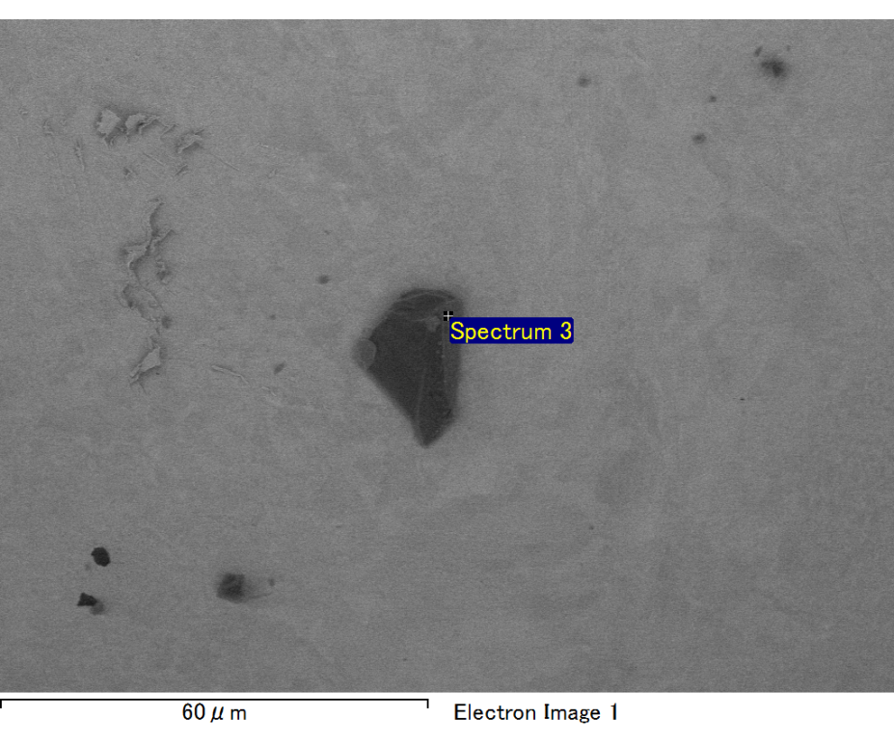

Spectrum processing :

No peaks omitted

Processing option : All elements analyzed (Normalised)

Number of iterations = 2

Standard :

C CaCO3 1-Jun-1999 12:00 AM

O SiO2 1-Jun-1999 12:00 AM

Mg MgO 1-Jun-1999 12:00 AM

Si SiO2 1-Jun-1999 12:00 AM

Fe Fe 1-Jun-1999 12:00 AM

Au Au 1-Jun-1999 12:00 AM

|  |  |  |  |
| --- | --- | --- | --- |
| Element | Weight% | Atomic% |  |
|  |  |  |  |
| C K | 4.17 | 19.92 |  |
| O K | 11.23 | 40.29 |  |
| Mg K | 3.10 | 7.31 |  |
| Si K | 2.71 | 5.54 |  |
| Fe L | 5.40 | 5.55 |  |
| Au M | 73.39 | 21.38 |  |
|  |  |  |  |
| Totals | 100.00 |  |  |

Spectrum Label: Spectrum 3

Livetime 60.0 s

Acquisition geometry ( degrees ):

Tilt = 15.0

Azimuth = 0.0

Elevation = 30.0

Accelerating voltage = 10.00 kV

Total spectrum counts = 50766

|  |  |  |  |
| --- | --- | --- | --- |
| Sample data : | Energy (eV) | Resn. (eV) | Area |
| Strobe : | 3.8 | 47.42 | 1000475 |
|  |  |  |  |

No quant optimization performed

Sample: Sample 1

Type: Default

ID:

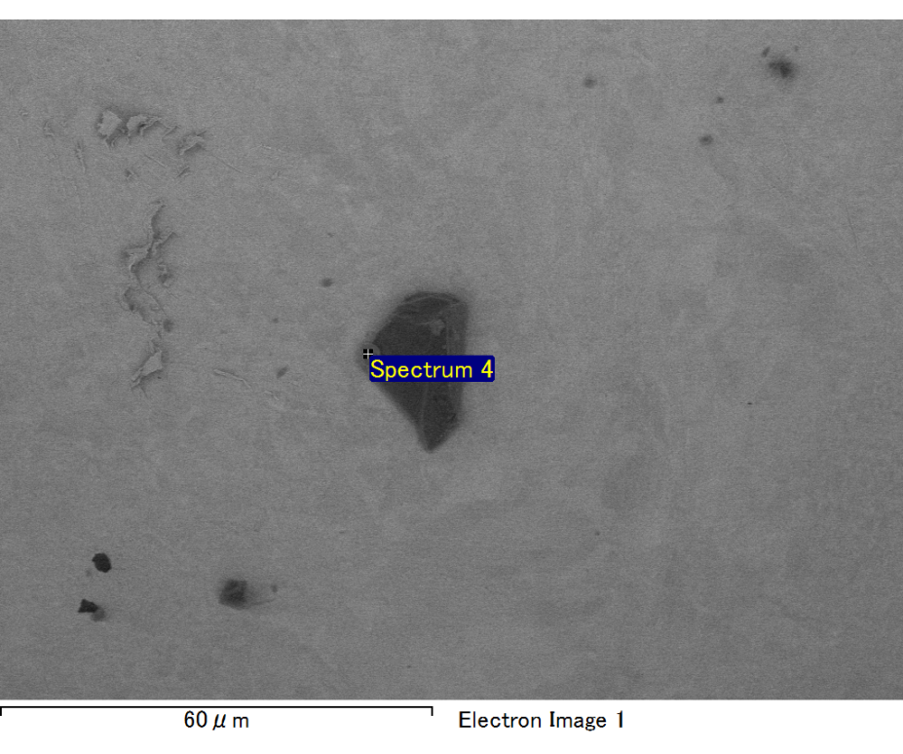

Spectrum processing :

No peaks omitted

Processing option : All elements analyzed (Normalised)

Number of iterations = 2

Standard :

C CaCO3 1-Jun-1999 12:00 AM

S FeS2 1-Jun-1999 12:00 AM

Fe Fe 1-Jun-1999 12:00 AM

Au Au 1-Jun-1999 12:00 AM

|  |  |  |  |
| --- | --- | --- | --- |
| Element | Weight% | Atomic% |  |
|  |  |  |  |
| C K | 4.25 | 24.12 |  |
| S K | 11.67 | 24.83 |  |
| Fe L | 25.06 | 30.61 |  |
| Au M | 59.02 | 20.44 |  |
|  |  |  |  |
| Totals | 100.00 |  |  |

Spectrum Label: Spectrum 4

Livetime 60.0 s

Acquisition geometry ( degrees ):

Tilt = 15.0

Azimuth = 0.0

Elevation = 30.0

Accelerating voltage = 10.00 kV

Total spectrum counts = 51510

|  |  |  |  |
| --- | --- | --- | --- |
| Sample data : | Energy (eV) | Resn. (eV) | Area |
| Strobe : | 3.8 | 47.41 | 1000646 |
|  |  |  |  |

No quant optimization performed

Sample: Sample 1

Type: Default

ID:

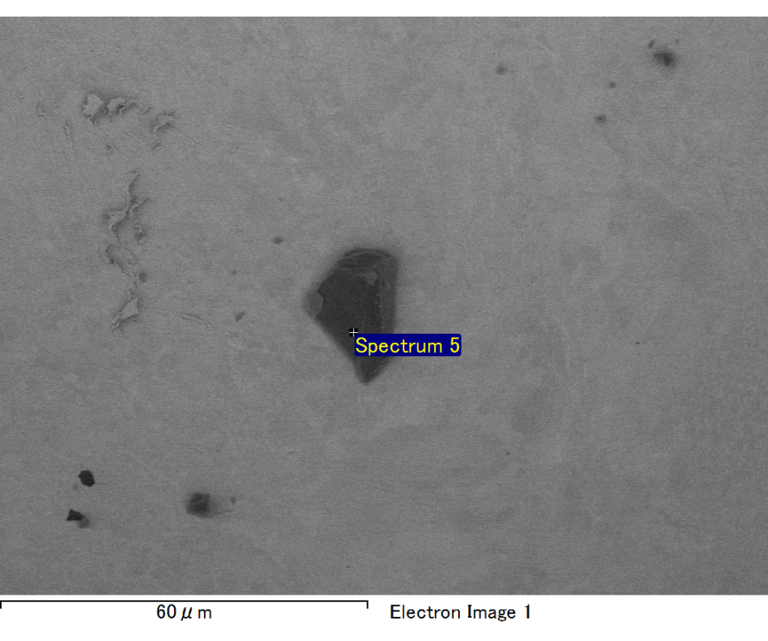

Spectrum processing :

No peaks omitted

Processing option : All elements analyzed (Normalised)

Number of iterations = 2

Standard :

C CaCO3 1-Jun-1999 12:00 AM

O SiO2 1-Jun-1999 12:00 AM

Mg MgO 1-Jun-1999 12:00 AM

Si SiO2 1-Jun-1999 12:00 AM

Fe Fe 1-Jun-1999 12:00 AM

Au Au 1-Jun-1999 12:00 AM

|  |  |  |  |
| --- | --- | --- | --- |
| Element | Weight% | Atomic% |  |
|  |  |  |  |
| C K | 2.35 | 9.57 |  |
| O K | 16.84 | 51.57 |  |
| Mg K | 4.78 | 9.64 |  |
| Si K | 3.35 | 5.85 |  |
| Fe L | 8.41 | 7.38 |  |
| Au M | 64.26 | 15.99 |  |
|  |  |  |  |
| Totals | 100.00 |  |  |

Spectrum Label: Spectrum 5

Livetime 60.0 s

Acquisition geometry ( degrees ):

Tilt = 15.0

Azimuth = 0.0

Elevation = 30.0

Accelerating voltage = 10.00 kV

Total spectrum counts = 49683

|  |  |  |  |
| --- | --- | --- | --- |
| Sample data : | Energy (eV) | Resn. (eV) | Area |
| Strobe : | 3.8 | 47.44 | 1000066 |
|  |  |  |  |

No quant optimization performed

Sample: Sample 1

Type: Default

ID: