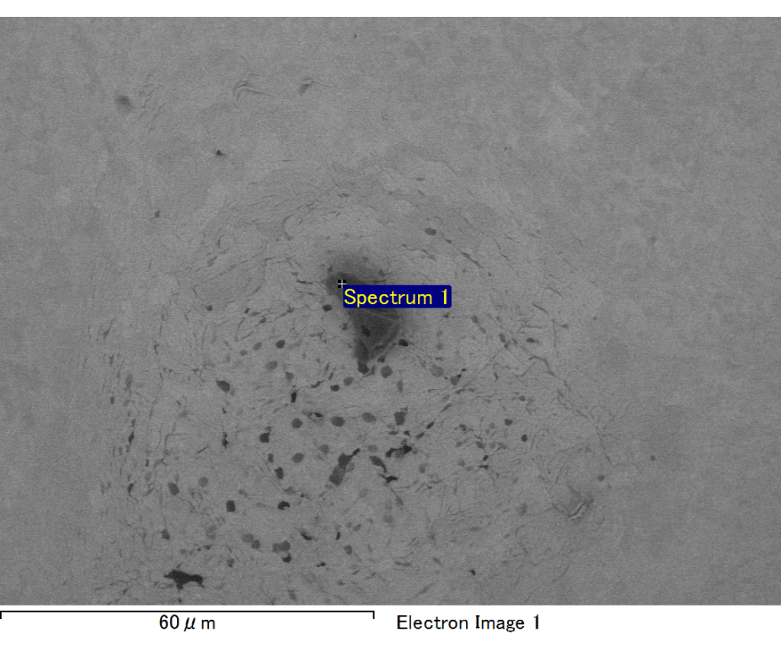

Spectrum processing :

No peaks omitted

Processing option : All elements analyzed (Normalised)

Number of iterations = 2

Standard :

C CaCO3 1-Jun-1999 12:00 AM

O SiO2 1-Jun-1999 12:00 AM

Mg MgO 1-Jun-1999 12:00 AM

Si SiO2 1-Jun-1999 12:00 AM

Fe Fe 1-Jun-1999 12:00 AM

Au Au 1-Jun-1999 12:00 AM

|  |  |  |  |
| --- | --- | --- | --- |
| Element | Weight% | Atomic% |  |
|  |  |  |  |
| C K | 3.08 | 10.71 |  |
| O K | 20.21 | 52.71 |  |
| Mg K | 5.49 | 9.42 |  |
| Si K | 4.01 | 5.95 |  |
| Fe L | 12.99 | 9.71 |  |
| Au M | 54.22 | 11.49 |  |
|  |  |  |  |
| Totals | 100.00 |  |  |

Spectrum Label: Spectrum 1

Livetime 60.0 s

Acquisition geometry ( degrees ):

Tilt = 15.0

Azimuth = 0.0

Elevation = 30.0

Accelerating voltage = 10.00 kV

Total spectrum counts = 53505

|  |  |  |  |
| --- | --- | --- | --- |
| Sample data : | Energy (eV) | Resn. (eV) | Area |
| Strobe : | 3.8 | 47.47 | 1000531 |
|  |  |  |  |

No quant optimization performed

Sample: Sample 1

Type: Default

ID:

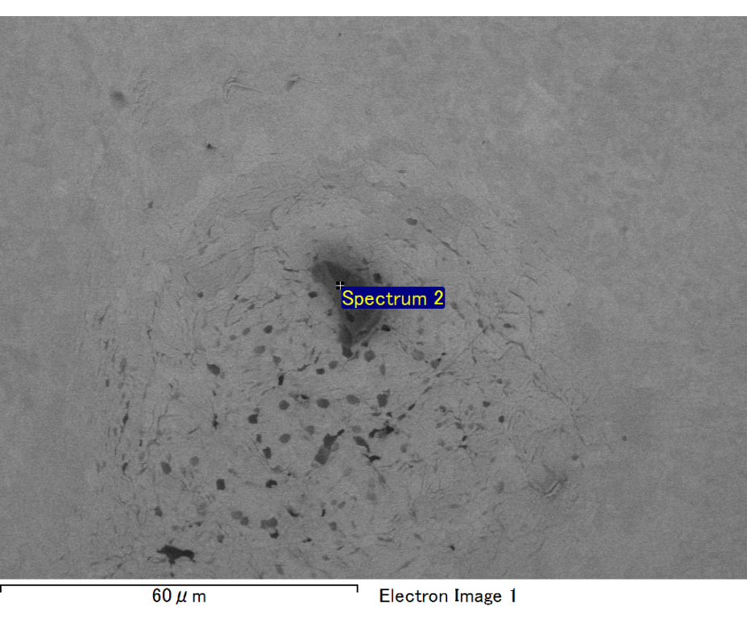

Spectrum processing :

No peaks omitted

Processing option : All elements analyzed (Normalised)

Number of iterations = 2

Standard :

C CaCO3 1-Jun-1999 12:00 AM

O SiO2 1-Jun-1999 12:00 AM

Mg MgO 1-Jun-1999 12:00 AM

Si SiO2 1-Jun-1999 12:00 AM

Fe Fe 1-Jun-1999 12:00 AM

Au Au 1-Jun-1999 12:00 AM

|  |  |  |  |
| --- | --- | --- | --- |
| Element | Weight% | Atomic% |  |
|  |  |  |  |
| C K | 2.66 | 9.11 |  |
| O K | 21.35 | 55.01 |  |
| Mg K | 6.45 | 10.93 |  |
| Si K | 3.95 | 5.80 |  |
| Fe L | 10.24 | 7.56 |  |
| Au M | 55.35 | 11.58 |  |
|  |  |  |  |
| Totals | 100.00 |  |  |

Spectrum Label: Spectrum 2

Livetime 60.0 s

Acquisition geometry ( degrees ):

Tilt = 15.0

Azimuth = 0.0

Elevation = 30.0

Accelerating voltage = 10.00 kV

Total spectrum counts = 51718

|  |  |  |  |
| --- | --- | --- | --- |
| Sample data : | Energy (eV) | Resn. (eV) | Area |
| Strobe : | 3.8 | 47.43 | 1001127 |
|  |  |  |  |

No quant optimization performed

Sample: Sample 1

Type: Default

ID:

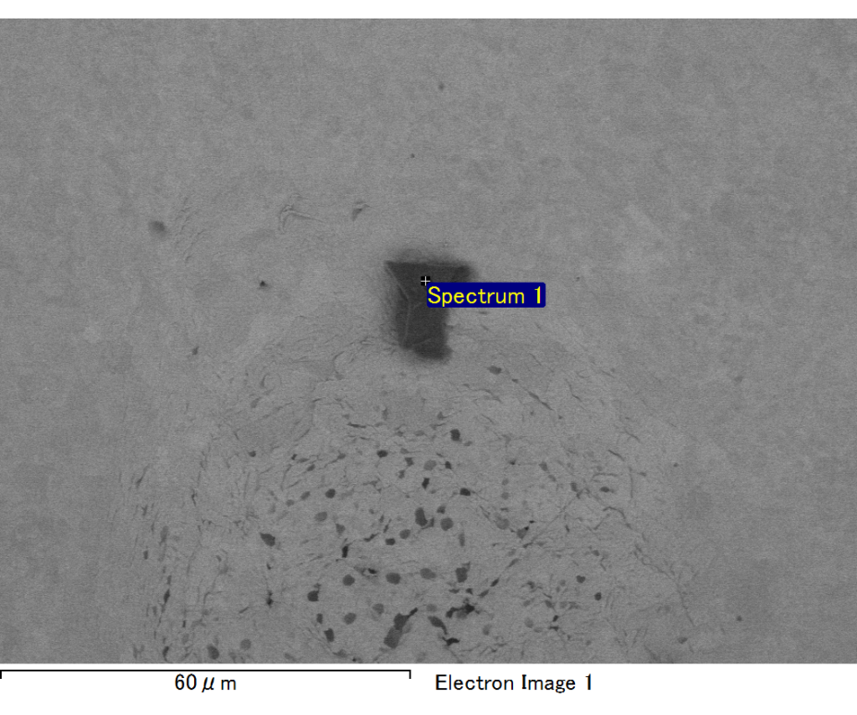

Spectrum processing :

No peaks omitted

Processing option : All elements analyzed (Normalised)

Number of iterations = 2

Standard :

C CaCO3 1-Jun-1999 12:00 AM

O SiO2 1-Jun-1999 12:00 AM

Mg MgO 1-Jun-1999 12:00 AM

Si SiO2 1-Jun-1999 12:00 AM

Au Au 1-Jun-1999 12:00 AM

|  |  |  |  |
| --- | --- | --- | --- |
| Element | Weight% | Atomic% |  |
|  |  |  |  |
| C K | 3.44 | 23.71 |  |
| O K | 5.07 | 26.19 |  |
| Mg K | 2.18 | 7.41 |  |
| Si K | 2.05 | 6.04 |  |
| Au M | 87.26 | 36.64 |  |
|  |  |  |  |
| Totals | 100.00 |  |  |

Spectrum Label: Spectrum 1

Livetime 60.0 s

Acquisition geometry ( degrees ):

Tilt = 15.0

Azimuth = 0.0

Elevation = 30.0

Accelerating voltage = 10.00 kV

Total spectrum counts = 42654

|  |  |  |  |
| --- | --- | --- | --- |
| Sample data : | Energy (eV) | Resn. (eV) | Area |
| Strobe : | 3.8 | 47.50 | 1000477 |
|  |  |  |  |

No quant optimization performed

Sample: Sample 1

Type: Default

ID:

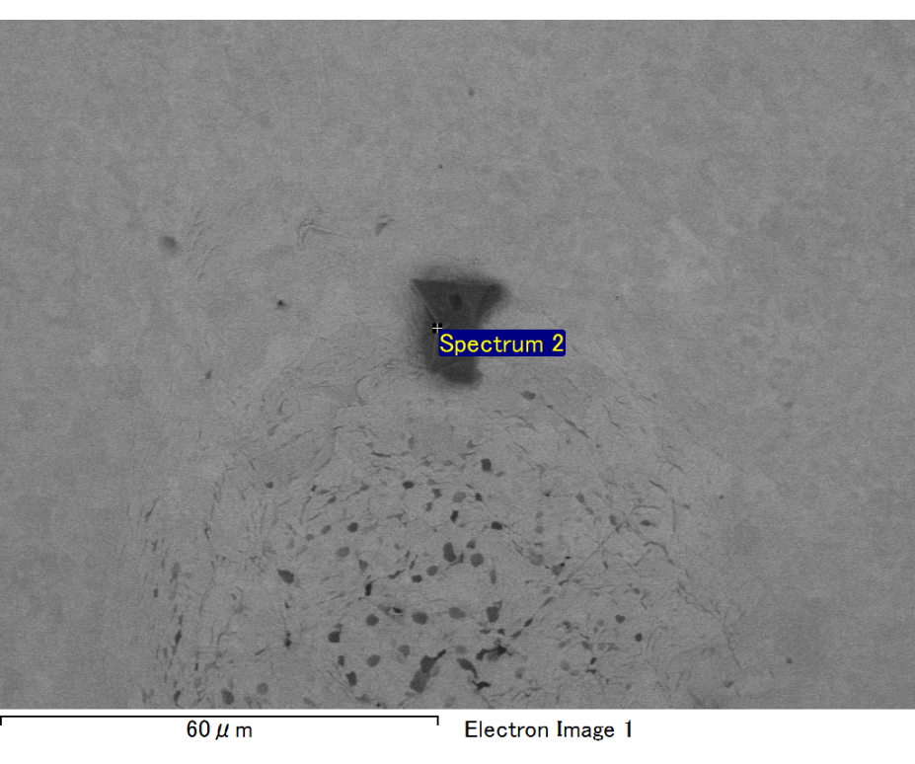

Spectrum processing :

No peaks omitted

Processing option : All elements analyzed (Normalised)

Number of iterations = 2

Standard :

C CaCO3 1-Jun-1999 12:00 AM

O SiO2 1-Jun-1999 12:00 AM

Mg MgO 1-Jun-1999 12:00 AM

Si SiO2 1-Jun-1999 12:00 AM

Fe Fe 1-Jun-1999 12:00 AM

Au Au 1-Jun-1999 12:00 AM

|  |  |  |  |
| --- | --- | --- | --- |
| Element | Weight% | Atomic% |  |
|  |  |  |  |
| C K | 2.11 | 7.71 |  |
| O K | 19.75 | 54.07 |  |
| Mg K | 5.82 | 10.49 |  |
| Si K | 4.36 | 6.81 |  |
| Fe L | 10.35 | 8.12 |  |
| Au M | 57.60 | 12.81 |  |
|  |  |  |  |
| Totals | 100.00 |  |  |

Spectrum Label: Spectrum 2

Livetime 60.0 s

Acquisition geometry ( degrees ):

Tilt = 15.0

Azimuth = 0.0

Elevation = 30.0

Accelerating voltage = 10.00 kV

Total spectrum counts = 50688

|  |  |  |  |
| --- | --- | --- | --- |
| Sample data : | Energy (eV) | Resn. (eV) | Area |
| Strobe : | 3.8 | 47.49 | 1000726 |
|  |  |  |  |

No quant optimization performed

Sample: Sample 1

Type: Default

ID:

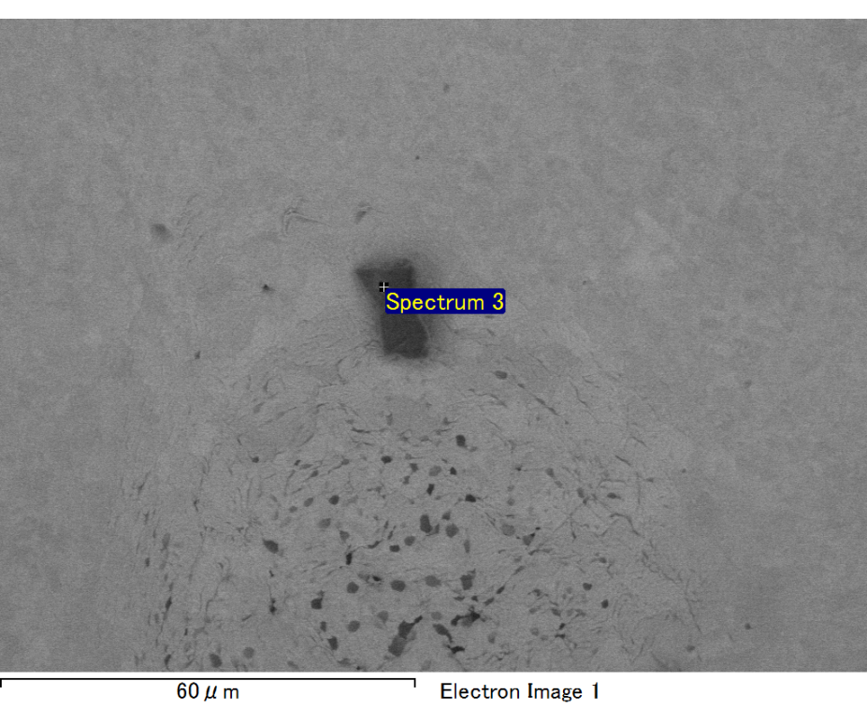

Spectrum processing :

No peaks omitted

Processing option : All elements analyzed (Normalised)

Number of iterations = 2

Standard :

C CaCO3 1-Jun-1999 12:00 AM

O SiO2 1-Jun-1999 12:00 AM

Mg MgO 1-Jun-1999 12:00 AM

Si SiO2 1-Jun-1999 12:00 AM

Fe Fe 1-Jun-1999 12:00 AM

Au Au 1-Jun-1999 12:00 AM

|  |  |  |  |
| --- | --- | --- | --- |
| Element | Weight% | Atomic% |  |
|  |  |  |  |
| C K | 2.23 | 7.88 |  |
| O K | 20.64 | 54.86 |  |
| Mg K | 5.99 | 10.48 |  |
| Si K | 3.88 | 5.87 |  |
| Fe L | 11.71 | 8.91 |  |
| Au M | 55.55 | 11.99 |  |
|  |  |  |  |
| Totals | 100.00 |  |  |

Spectrum Label: Spectrum 3

Livetime 60.0 s

Acquisition geometry ( degrees ):

Tilt = 15.0

Azimuth = 0.0

Elevation = 30.0

Accelerating voltage = 10.00 kV

Total spectrum counts = 51689

|  |  |  |  |
| --- | --- | --- | --- |
| Sample data : | Energy (eV) | Resn. (eV) | Area |
| Strobe : | 3.8 | 47.51 | 999471 |
|  |  |  |  |

No quant optimization performed

Sample: Sample 1

Type: Default

ID: