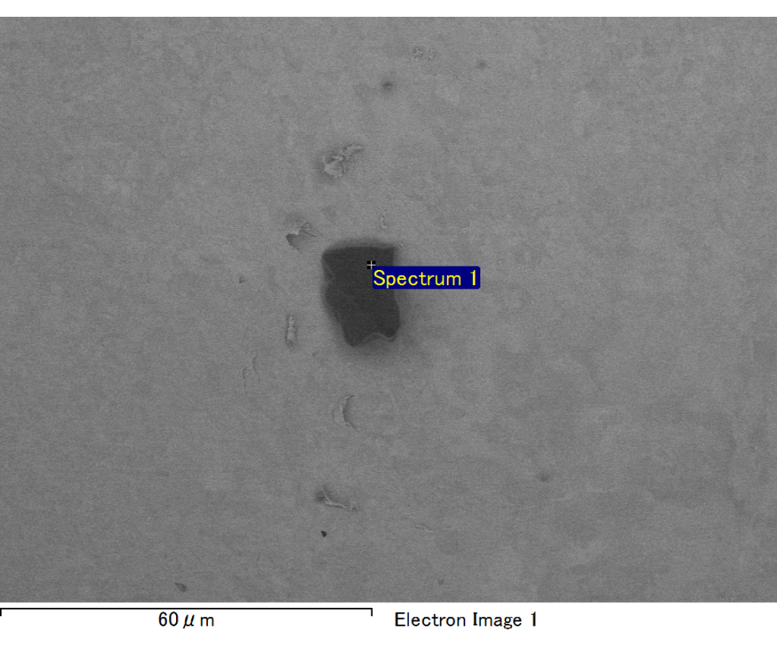

Spectrum processing :

No peaks omitted

Processing option : All elements analyzed (Normalised)

Number of iterations = 2

Standard :

C CaCO3 1-Jun-1999 12:00 AM

O SiO2 1-Jun-1999 12:00 AM

Mg MgO 1-Jun-1999 12:00 AM

Si SiO2 1-Jun-1999 12:00 AM

Fe Fe 1-Jun-1999 12:00 AM

Au Au 1-Jun-1999 12:00 AM

|  |  |  |  |
| --- | --- | --- | --- |
| Element | Weight% | Atomic% |  |
|  |  |  |  |
| C K | 2.76 | 9.58 |  |
| O K | 20.84 | 54.27 |  |
| Mg K | 5.65 | 9.68 |  |
| Si K | 3.87 | 5.74 |  |
| Fe L | 12.33 | 9.19 |  |
| Au M | 54.55 | 11.54 |  |
|  |  |  |  |
| Totals | 100.00 |  |  |

Spectrum Label: Spectrum 1

Livetime 60.0 s

Acquisition geometry ( degrees ):

Tilt = 15.0

Azimuth = 0.0

Elevation = 30.0

Accelerating voltage = 10.00 kV

Total spectrum counts = 52257

|  |  |  |  |
| --- | --- | --- | --- |
| Sample data : | Energy (eV) | Resn. (eV) | Area |
| Strobe : | 3.8 | 47.43 | 1000233 |
|  |  |  |  |

No quant optimization performed

Sample: Sample 1

Type: Default

ID:

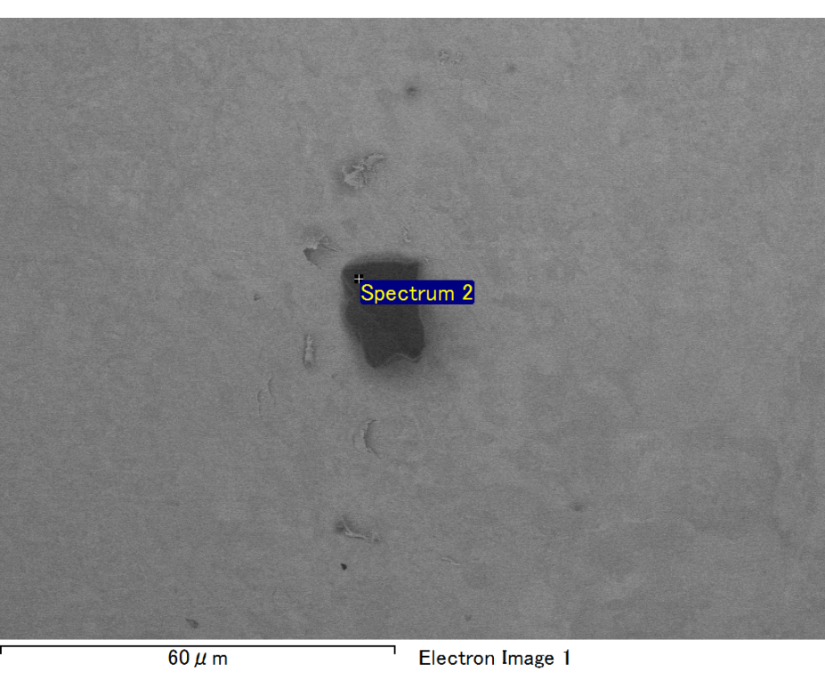

Spectrum processing :

No peaks omitted

Processing option : All elements analyzed (Normalised)

Number of iterations = 2

Standard :

C CaCO3 1-Jun-1999 12:00 AM

O SiO2 1-Jun-1999 12:00 AM

Mg MgO 1-Jun-1999 12:00 AM

Si SiO2 1-Jun-1999 12:00 AM

Fe Fe 1-Jun-1999 12:00 AM

Au Au 1-Jun-1999 12:00 AM

|  |  |  |  |
| --- | --- | --- | --- |
| Element | Weight% | Atomic% |  |
|  |  |  |  |
| C K | 3.06 | 10.57 |  |
| O K | 20.87 | 54.17 |  |
| Mg K | 5.71 | 9.75 |  |
| Si K | 3.73 | 5.51 |  |
| Fe L | 11.17 | 8.31 |  |
| Au M | 55.46 | 11.69 |  |
|  |  |  |  |
| Totals | 100.00 |  |  |

Spectrum Label: Spectrum 2

Livetime 60.0 s

Acquisition geometry ( degrees ):

Tilt = 15.0

Azimuth = 0.0

Elevation = 30.0

Accelerating voltage = 10.00 kV

Total spectrum counts = 51793

|  |  |  |  |
| --- | --- | --- | --- |
| Sample data : | Energy (eV) | Resn. (eV) | Area |
| Strobe : | 3.8 | 47.45 | 999885 |
|  |  |  |  |

No quant optimization performed

Sample: Sample 1

Type: Default

ID:

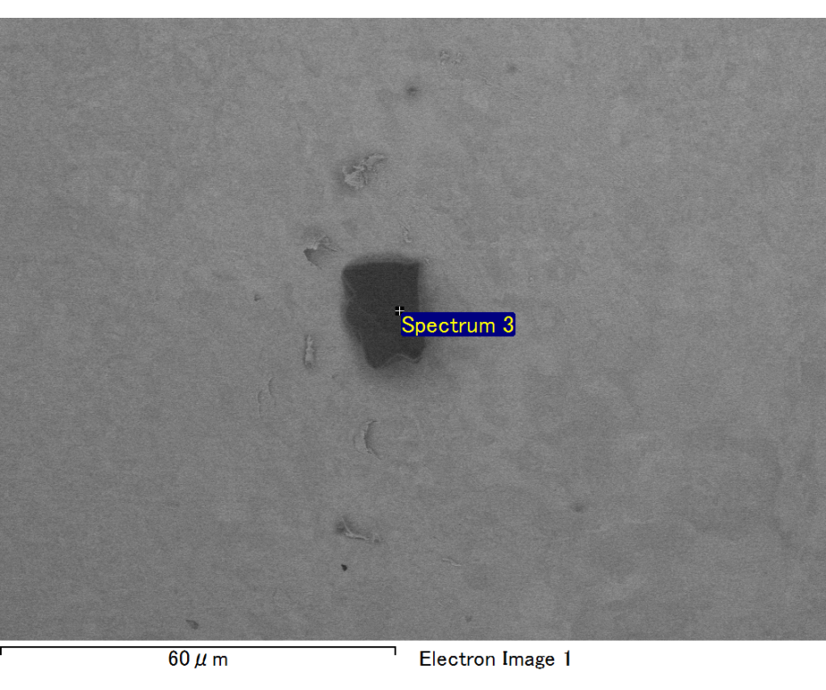

Spectrum processing :

No peaks omitted

Processing option : All elements analyzed (Normalised)

Number of iterations = 2

Standard :

C CaCO3 1-Jun-1999 12:00 AM

O SiO2 1-Jun-1999 12:00 AM

Mg MgO 1-Jun-1999 12:00 AM

Si SiO2 1-Jun-1999 12:00 AM

Fe Fe 1-Jun-1999 12:00 AM

Au Au 1-Jun-1999 12:00 AM

|  |  |  |  |
| --- | --- | --- | --- |
| Element | Weight% | Atomic% |  |
|  |  |  |  |
| C K | 2.82 | 9.77 |  |
| O K | 20.53 | 53.35 |  |
| Mg K | 5.53 | 9.46 |  |
| Si K | 4.22 | 6.25 |  |
| Fe L | 13.19 | 9.82 |  |
| Au M | 53.70 | 11.34 |  |
|  |  |  |  |
| Totals | 100.00 |  |  |

Spectrum Label: Spectrum 3

Livetime 60.0 s

Acquisition geometry ( degrees ):

Tilt = 15.0

Azimuth = 0.0

Elevation = 30.0

Accelerating voltage = 10.00 kV

Total spectrum counts = 52492

|  |  |  |  |
| --- | --- | --- | --- |
| Sample data : | Energy (eV) | Resn. (eV) | Area |
| Strobe : | 3.8 | 47.51 | 1000153 |
|  |  |  |  |

No quant optimization performed

Sample: Sample 1

Type: Default

ID:

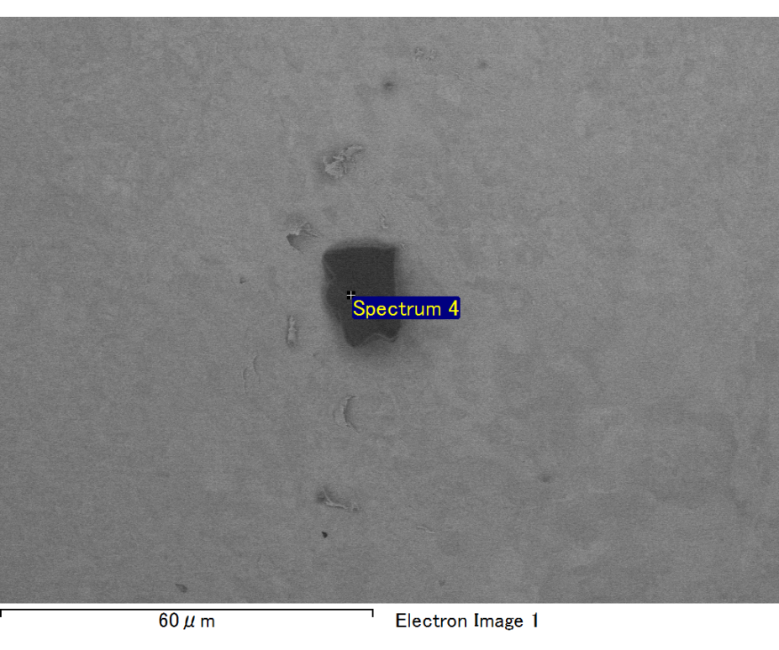

Spectrum processing :

No peaks omitted

Processing option : All elements analyzed (Normalised)

Number of iterations = 2

Standard :

C CaCO3 1-Jun-1999 12:00 AM

O SiO2 1-Jun-1999 12:00 AM

Mg MgO 1-Jun-1999 12:00 AM

Si SiO2 1-Jun-1999 12:00 AM

Fe Fe 1-Jun-1999 12:00 AM

Au Au 1-Jun-1999 12:00 AM

|  |  |  |  |
| --- | --- | --- | --- |
| Element | Weight% | Atomic% |  |
|  |  |  |  |
| C K | 2.69 | 9.37 |  |
| O K | 20.78 | 54.25 |  |
| Mg K | 5.71 | 9.82 |  |
| Si K | 4.11 | 6.11 |  |
| Fe L | 11.76 | 8.80 |  |
| Au M | 54.95 | 11.65 |  |
|  |  |  |  |
| Totals | 100.00 |  |  |

Spectrum Label: Spectrum 4

Livetime 60.0 s

Acquisition geometry ( degrees ):

Tilt = 15.0

Azimuth = 0.0

Elevation = 30.0

Accelerating voltage = 10.00 kV

Total spectrum counts = 52413

|  |  |  |  |
| --- | --- | --- | --- |
| Sample data : | Energy (eV) | Resn. (eV) | Area |
| Strobe : | 3.8 | 47.45 | 1000040 |
|  |  |  |  |

No quant optimization performed

Sample: Sample 1

Type: Default

ID:

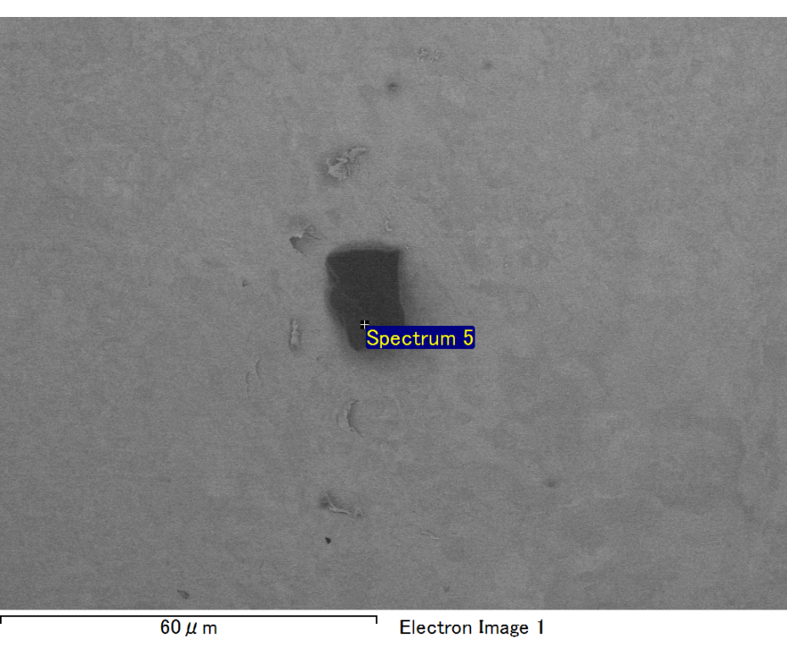

Spectrum processing :

No peaks omitted

Processing option : All elements analyzed (Normalised)

Number of iterations = 2

Standard :

C CaCO3 1-Jun-1999 12:00 AM

O SiO2 1-Jun-1999 12:00 AM

Mg MgO 1-Jun-1999 12:00 AM

Si SiO2 1-Jun-1999 12:00 AM

Fe Fe 1-Jun-1999 12:00 AM

Au Au 1-Jun-1999 12:00 AM

|  |  |  |  |
| --- | --- | --- | --- |
| Element | Weight% | Atomic% |  |
|  |  |  |  |
| C K | 3.06 | 11.89 |  |
| O K | 17.76 | 51.73 |  |
| Mg K | 5.12 | 9.81 |  |
| Si K | 3.62 | 6.00 |  |
| Fe L | 6.54 | 5.46 |  |
| Au M | 63.91 | 15.12 |  |
|  |  |  |  |
| Totals | 100.00 |  |  |

Spectrum Label: Spectrum 5

Livetime 60.0 s

Acquisition geometry ( degrees ):

Tilt = 15.0

Azimuth = 0.0

Elevation = 30.0

Accelerating voltage = 10.00 kV

Total spectrum counts = 50253

|  |  |  |  |
| --- | --- | --- | --- |
| Sample data : | Energy (eV) | Resn. (eV) | Area |
| Strobe : | 3.8 | 47.47 | 1000049 |
|  |  |  |  |

No quant optimization performed

Sample: Sample 1

Type: Default

ID: