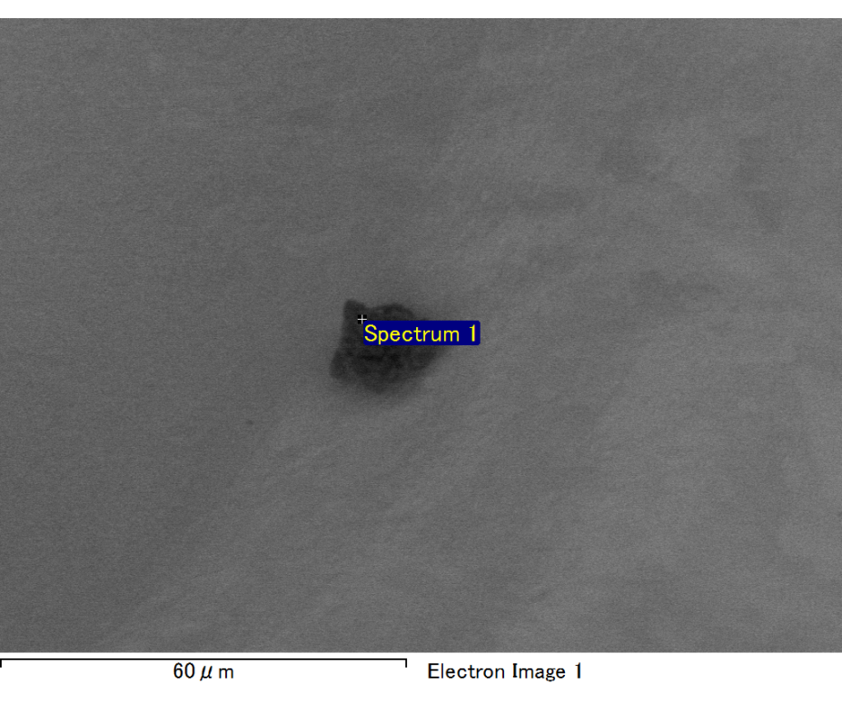

Spectrum processing :

No peaks omitted

Processing option : All elements analyzed (Normalised)

Number of iterations = 2

Standard :

C CaCO3 1-Jun-1999 12:00 AM

O SiO2 1-Jun-1999 12:00 AM

Mg MgO 1-Jun-1999 12:00 AM

Al Al2O3 1-Jun-1999 12:00 AM

Si SiO2 1-Jun-1999 12:00 AM

Fe Fe 1-Jun-1999 12:00 AM

Au Au 1-Jun-1999 12:00 AM

|  |  |  |  |
| --- | --- | --- | --- |
| Element | Weight% | Atomic% |  |
|  |  |  |  |
| C K | 2.85 | 9.48 |  |
| O K | 22.37 | 55.96 |  |
| Mg K | 5.29 | 8.70 |  |
| Al K | 0.74 | 1.09 |  |
| Si K | 5.00 | 7.13 |  |
| Fe L | 9.12 | 6.53 |  |
| Au M | 54.64 | 11.10 |  |
|  |  |  |  |
| Totals | 100.00 |  |  |

Spectrum Label: Spectrum 1

Livetime 60.0 s

Acquisition geometry ( degrees ):

Tilt = 15.0

Azimuth = 0.0

Elevation = 30.0

Accelerating voltage = 10.00 kV

Total spectrum counts = 52471

|  |  |  |  |
| --- | --- | --- | --- |
| Sample data : | Energy (eV) | Resn. (eV) | Area |
| Strobe : | 3.8 | 47.45 | 999877 |
|  |  |  |  |

No quant optimization performed

Sample: Sample 1

Type: Default

ID:

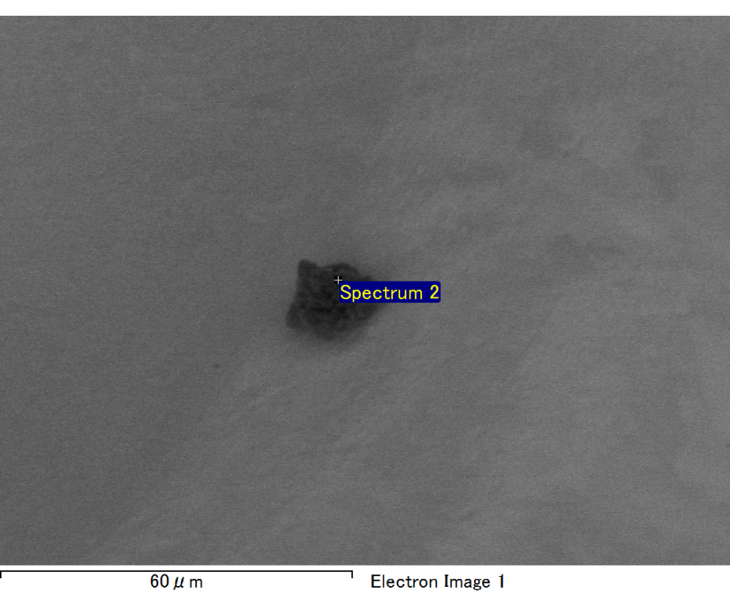

Spectrum processing :

No peaks omitted

Processing option : All elements analyzed (Normalised)

Number of iterations = 2

Standard :

C CaCO3 1-Jun-1999 12:00 AM

O SiO2 1-Jun-1999 12:00 AM

Mg MgO 1-Jun-1999 12:00 AM

Al Al2O3 1-Jun-1999 12:00 AM

Si SiO2 1-Jun-1999 12:00 AM

Fe Fe 1-Jun-1999 12:00 AM

Au Au 1-Jun-1999 12:00 AM

|  |  |  |  |
| --- | --- | --- | --- |
| Element | Weight% | Atomic% |  |
|  |  |  |  |
| C K | 2.80 | 9.71 |  |
| O K | 21.19 | 55.13 |  |
| Mg K | 5.08 | 8.71 |  |
| Al K | 0.70 | 1.08 |  |
| Si K | 4.99 | 7.39 |  |
| Fe L | 7.86 | 5.86 |  |
| Au M | 57.37 | 12.12 |  |
|  |  |  |  |
| Totals | 100.00 |  |  |

Spectrum Label: Spectrum 2

Livetime 60.0 s

Acquisition geometry ( degrees ):

Tilt = 15.0

Azimuth = 0.0

Elevation = 30.0

Accelerating voltage = 10.00 kV

Total spectrum counts = 52446

|  |  |  |  |
| --- | --- | --- | --- |
| Sample data : | Energy (eV) | Resn. (eV) | Area |
| Strobe : | 3.8 | 47.45 | 1000284 |
|  |  |  |  |

No quant optimization performed

Sample: Sample 1

Type: Default

ID:

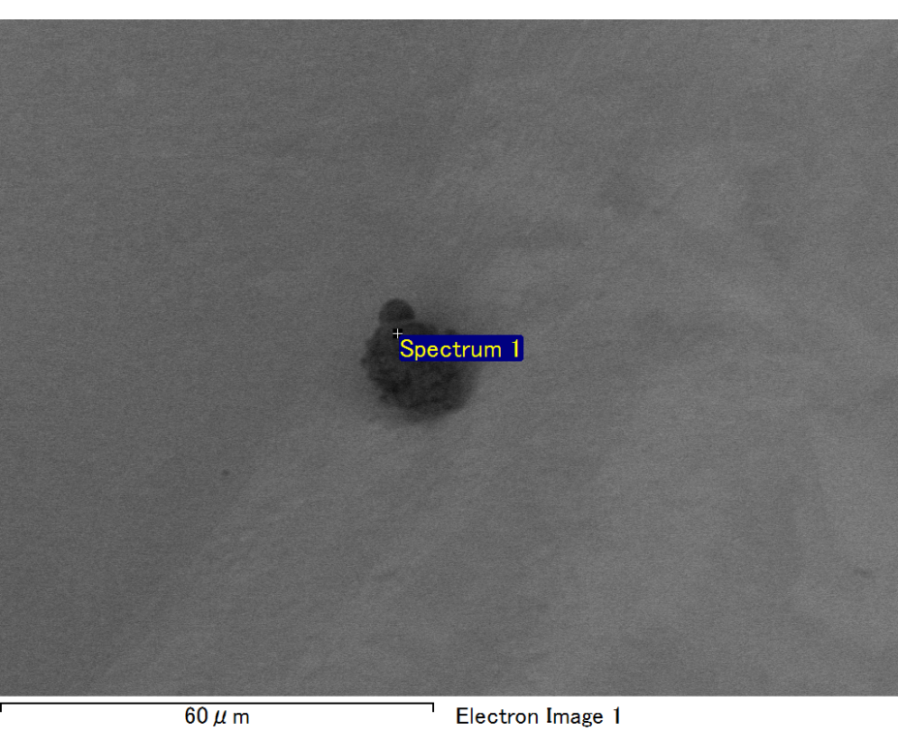

Spectrum processing :

No peaks omitted

Processing option : All elements analyzed (Normalised)

Number of iterations = 2

Standard :

C CaCO3 1-Jun-1999 12:00 AM

O SiO2 1-Jun-1999 12:00 AM

Na Albite 1-Jun-1999 12:00 AM

Al Al2O3 1-Jun-1999 12:00 AM

Si SiO2 1-Jun-1999 12:00 AM

Au Au 1-Jun-1999 12:00 AM

|  |  |  |  |
| --- | --- | --- | --- |
| Element | Weight% | Atomic% |  |
|  |  |  |  |
| C K | 3.23 | 11.28 |  |
| O K | 20.73 | 54.42 |  |
| Na K | 2.02 | 3.68 |  |
| Al K | 3.18 | 4.95 |  |
| Si K | 8.23 | 12.32 |  |
| Au M | 62.62 | 13.36 |  |
|  |  |  |  |
| Totals | 100.00 |  |  |

Spectrum Label: Spectrum 1

Livetime 60.0 s

Acquisition geometry ( degrees ):

Tilt = 15.0

Azimuth = 0.0

Elevation = 30.0

Accelerating voltage = 10.00 kV

Total spectrum counts = 50853

|  |  |  |  |
| --- | --- | --- | --- |
| Sample data : | Energy (eV) | Resn. (eV) | Area |
| Strobe : | 3.8 | 47.49 | 999960 |
|  |  |  |  |

No quant optimization performed

Sample: Sample 1

Type: Default

ID:

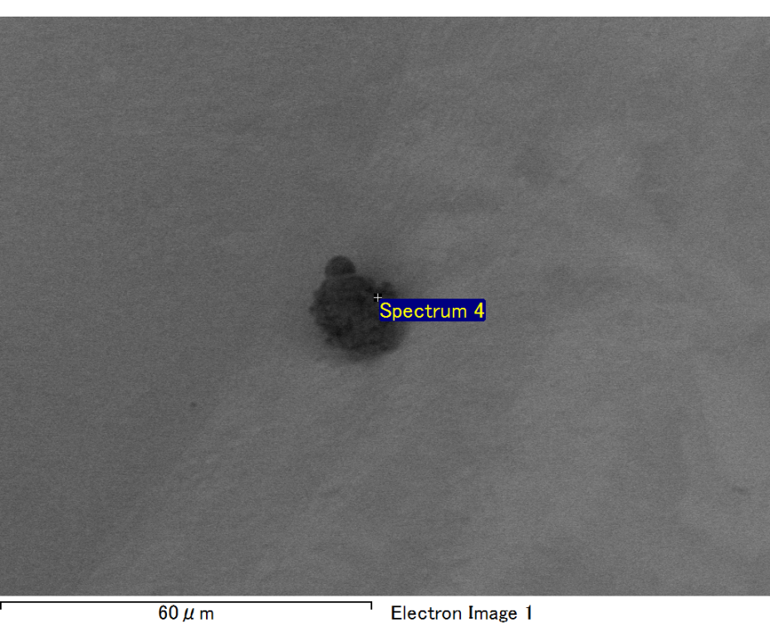

Spectrum processing :

No peaks omitted

Processing option : All elements analyzed (Normalised)

Number of iterations = 2

Standard :

C CaCO3 1-Jun-1999 12:00 AM

O SiO2 1-Jun-1999 12:00 AM

Na Albite 1-Jun-1999 12:00 AM

Al Al2O3 1-Jun-1999 12:00 AM

Si SiO2 1-Jun-1999 12:00 AM

Au Au 1-Jun-1999 12:00 AM

|  |  |  |  |
| --- | --- | --- | --- |
| Element | Weight% | Atomic% |  |
|  |  |  |  |
| C K | 3.45 | 10.90 |  |
| O K | 24.85 | 58.94 |  |
| Na K | 2.45 | 4.04 |  |
| Al K | 2.85 | 4.01 |  |
| Si K | 8.03 | 10.85 |  |
| Au M | 58.37 | 11.25 |  |
|  |  |  |  |
| Totals | 100.00 |  |  |

Spectrum Label: Spectrum 4

Livetime 60.0 s

Acquisition geometry ( degrees ):

Tilt = 15.0

Azimuth = 0.0

Elevation = 30.0

Accelerating voltage = 10.00 kV

Total spectrum counts = 53148

|  |  |  |  |
| --- | --- | --- | --- |
| Sample data : | Energy (eV) | Resn. (eV) | Area |
| Strobe : | 3.8 | 47.47 | 1000791 |
|  |  |  |  |

No quant optimization performed

Sample: Sample 1

Type: Default

ID:

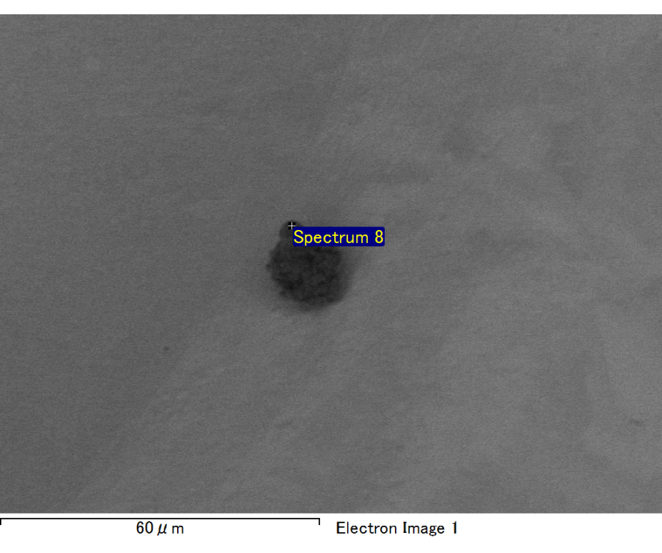

Spectrum processing :

No peaks omitted

Processing option : All elements analyzed (Normalised)

Number of iterations = 2

Standard :

C CaCO3 1-Jun-1999 12:00 AM

O SiO2 1-Jun-1999 12:00 AM

Al Al2O3 1-Jun-1999 12:00 AM

Si SiO2 1-Jun-1999 12:00 AM

K MAD-10 Feldspar 1-Jun-1999 12:00 AM

Au Au 1-Jun-1999 12:00 AM

|  |  |  |  |
| --- | --- | --- | --- |
| Element | Weight% | Atomic% |  |
|  |  |  |  |
| C K | 1.88 | 6.93 |  |
| O K | 22.42 | 61.96 |  |
| Al K | 2.45 | 4.02 |  |
| Si K | 6.40 | 10.08 |  |
| K K | 2.20 | 2.49 |  |
| Au M | 64.64 | 14.51 |  |
|  |  |  |  |
| Totals | 100.00 |  |  |

Spectrum Label: Spectrum 8

Livetime 60.0 s

Acquisition geometry ( degrees ):

Tilt = 15.0

Azimuth = 0.0

Elevation = 30.0

Accelerating voltage = 10.00 kV

Total spectrum counts = 53521

|  |  |  |  |
| --- | --- | --- | --- |
| Sample data : | Energy (eV) | Resn. (eV) | Area |
| Strobe : | 3.8 | 47.43 | 1000754 |
|  |  |  |  |

No quant optimization performed

Sample: Sample 1

Type: Default

ID: