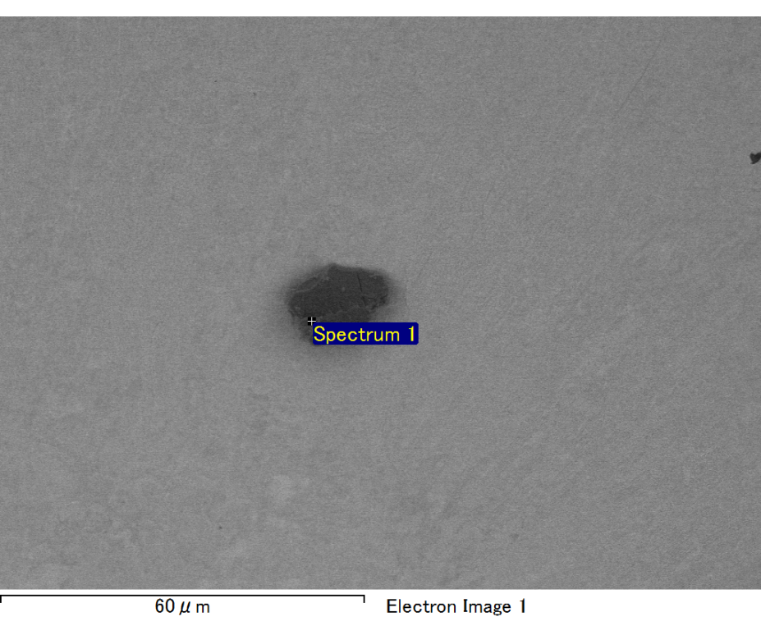

Spectrum processing :

No peaks omitted

Processing option : All elements analyzed (Normalised)

Number of iterations = 2

Standard :

C CaCO3 1-Jun-1999 12:00 AM

O SiO2 1-Jun-1999 12:00 AM

Mg MgO 1-Jun-1999 12:00 AM

Si SiO2 1-Jun-1999 12:00 AM

Fe Fe 1-Jun-1999 12:00 AM

Au Au 1-Jun-1999 12:00 AM

|  |  |  |  |
| --- | --- | --- | --- |
| Element | Weight% | Atomic% |  |
|  |  |  |  |
| C K | 2.23 | 8.37 |  |
| O K | 18.70 | 52.77 |  |
| Mg K | 5.65 | 10.49 |  |
| Si K | 4.50 | 7.23 |  |
| Fe L | 9.22 | 7.45 |  |
| Au M | 59.70 | 13.68 |  |
|  |  |  |  |
| Totals | 100.00 |  |  |

Spectrum Label: Spectrum 1

Livetime 60.0 s

Acquisition geometry ( degrees ):

Tilt = 15.0

Azimuth = 0.0

Elevation = 30.0

Accelerating voltage = 10.00 kV

Total spectrum counts = 46556

|  |  |  |  |
| --- | --- | --- | --- |
| Sample data : | Energy (eV) | Resn. (eV) | Area |
| Strobe : | 3.8 | 47.51 | 1000741 |
|  |  |  |  |

No quant optimization performed

Sample: Sample 1

Type: Default

ID:

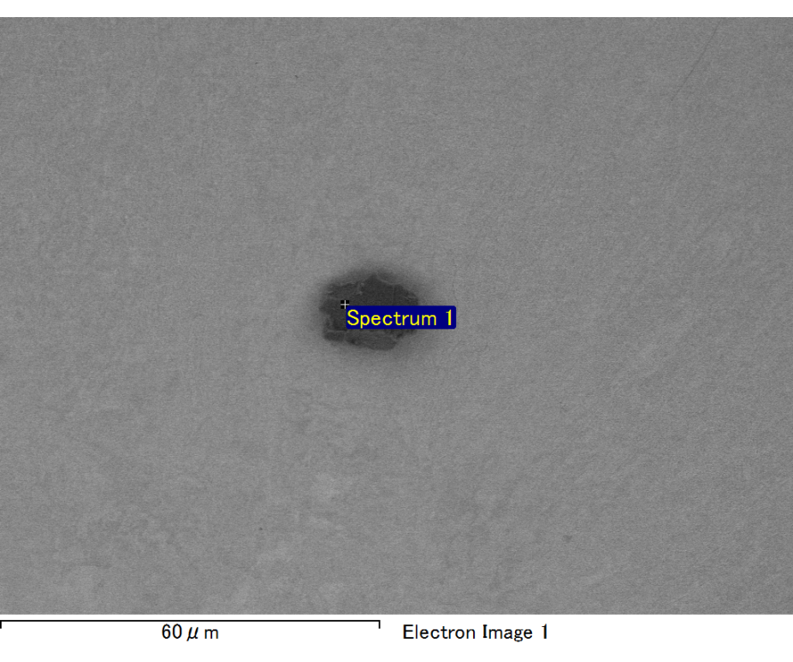

Spectrum processing :

Peak possibly omitted : 0.265 keV

Processing option : All elements analyzed (Normalised)

Number of iterations = 2

Standard :

O SiO2 1-Jun-1999 12:00 AM

Mg MgO 1-Jun-1999 12:00 AM

Si SiO2 1-Jun-1999 12:00 AM

Fe Fe 1-Jun-1999 12:00 AM

Au Au 1-Jun-1999 12:00 AM

|  |  |  |  |
| --- | --- | --- | --- |
| Element | Weight% | Atomic% |  |
|  |  |  |  |
| O K | 19.03 | 56.92 |  |
| Mg K | 5.80 | 11.41 |  |
| Si K | 4.62 | 7.87 |  |
| Fe L | 10.83 | 9.28 |  |
| Au M | 59.73 | 14.51 |  |
|  |  |  |  |
| Totals | 100.00 |  |  |

Spectrum Label: Spectrum 1

Livetime 60.0 s

Acquisition geometry ( degrees ):

Tilt = 15.0

Azimuth = 0.0

Elevation = 30.0

Accelerating voltage = 10.00 kV

Total spectrum counts = 46526

|  |  |  |  |
| --- | --- | --- | --- |
| Sample data : | Energy (eV) | Resn. (eV) | Area |
| Strobe : | 3.8 | 47.43 | 1000756 |
|  |  |  |  |

No quant optimization performed

Sample: Sample 1

Type: Default

ID:

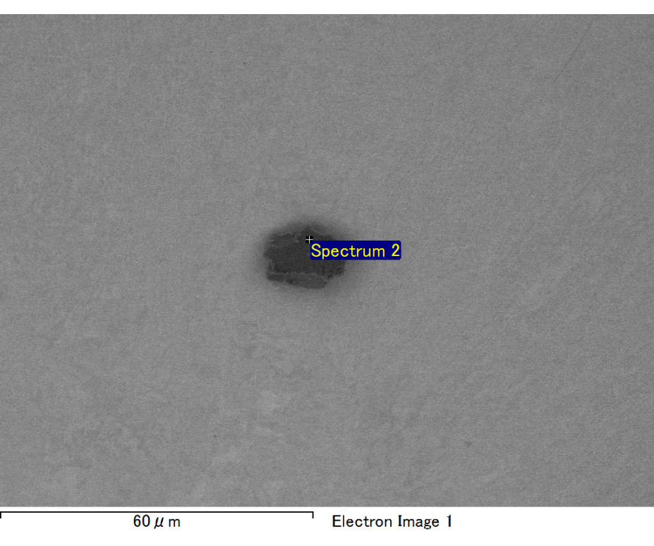

Spectrum processing :

Peak possibly omitted : 0.251 keV

Processing option : All elements analyzed (Normalised)

Number of iterations = 2

Standard :

O SiO2 1-Jun-1999 12:00 AM

Mg MgO 1-Jun-1999 12:00 AM

Si SiO2 1-Jun-1999 12:00 AM

Fe Fe 1-Jun-1999 12:00 AM

Au Au 1-Jun-1999 12:00 AM

|  |  |  |  |
| --- | --- | --- | --- |
| Element | Weight% | Atomic% |  |
|  |  |  |  |
| O K | 21.91 | 59.21 |  |
| Mg K | 6.46 | 11.49 |  |
| Si K | 4.67 | 7.20 |  |
| Fe L | 13.34 | 10.33 |  |
| Au M | 53.62 | 11.77 |  |
|  |  |  |  |
| Totals | 100.00 |  |  |

Spectrum Label: Spectrum 2

Livetime 60.0 s

Acquisition geometry ( degrees ):

Tilt = 15.0

Azimuth = 0.0

Elevation = 30.0

Accelerating voltage = 10.00 kV

Total spectrum counts = 47419

|  |  |  |  |
| --- | --- | --- | --- |
| Sample data : | Energy (eV) | Resn. (eV) | Area |
| Strobe : | 3.8 | 47.45 | 999956 |
|  |  |  |  |

No quant optimization performed

Sample: Sample 1

Type: Default

ID:

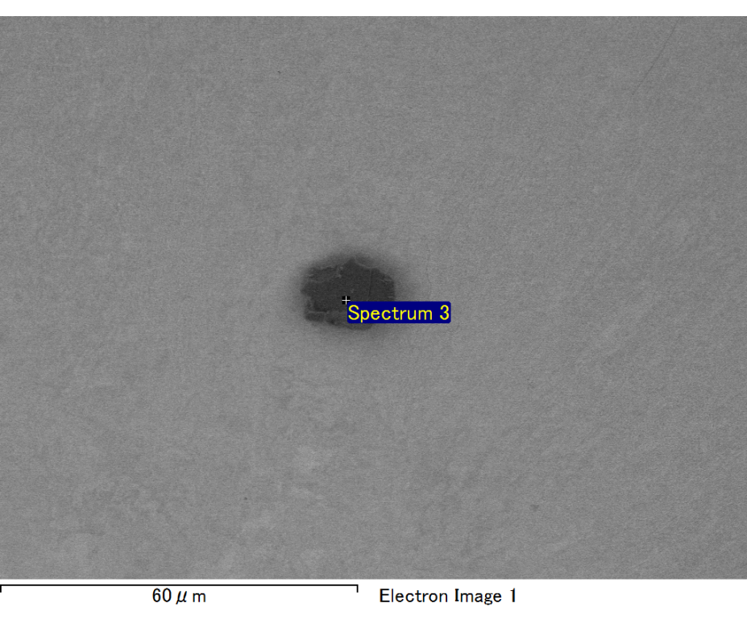

Spectrum processing :

No peaks omitted

Processing option : All elements analyzed (Normalised)

Number of iterations = 2

Standard :

C CaCO3 1-Jun-1999 12:00 AM

O SiO2 1-Jun-1999 12:00 AM

Mg MgO 1-Jun-1999 12:00 AM

Si SiO2 1-Jun-1999 12:00 AM

Fe Fe 1-Jun-1999 12:00 AM

Au Au 1-Jun-1999 12:00 AM

|  |  |  |  |
| --- | --- | --- | --- |
| Element | Weight% | Atomic% |  |
|  |  |  |  |
| C K | 2.06 | 7.43 |  |
| O K | 20.61 | 55.80 |  |
| Mg K | 5.94 | 10.59 |  |
| Si K | 4.90 | 7.56 |  |
| Fe L | 7.21 | 5.59 |  |
| Au M | 59.27 | 13.03 |  |
|  |  |  |  |
| Totals | 100.00 |  |  |

Spectrum Label: Spectrum 3

Livetime 60.0 s

Acquisition geometry ( degrees ):

Tilt = 15.0

Azimuth = 0.0

Elevation = 30.0

Accelerating voltage = 10.00 kV

Total spectrum counts = 47048

|  |  |  |  |
| --- | --- | --- | --- |
| Sample data : | Energy (eV) | Resn. (eV) | Area |
| Strobe : | 3.8 | 47.41 | 1000411 |
|  |  |  |  |

No quant optimization performed

Sample: Sample 1

Type: Default

ID:

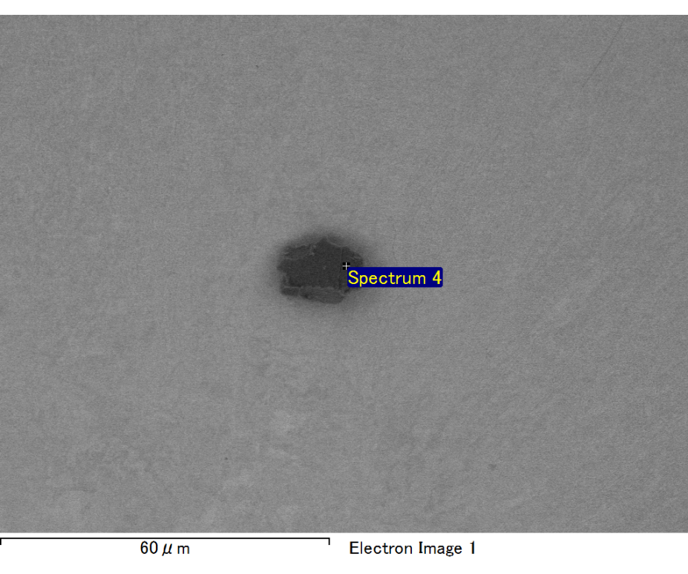

Spectrum processing :

No peaks omitted

Processing option : All elements analyzed (Normalised)

Number of iterations = 2

Standard :

C CaCO3 1-Jun-1999 12:00 AM

O SiO2 1-Jun-1999 12:00 AM

Mg MgO 1-Jun-1999 12:00 AM

Si SiO2 1-Jun-1999 12:00 AM

Fe Fe 1-Jun-1999 12:00 AM

Au Au 1-Jun-1999 12:00 AM

|  |  |  |  |
| --- | --- | --- | --- |
| Element | Weight% | Atomic% |  |
|  |  |  |  |
| C K | 2.84 | 9.47 |  |
| O K | 21.73 | 54.46 |  |
| Mg K | 6.48 | 10.68 |  |
| Si K | 4.38 | 6.26 |  |
| Fe L | 11.65 | 8.36 |  |
| Au M | 52.92 | 10.77 |  |
|  |  |  |  |
| Totals | 100.00 |  |  |

Spectrum Label: Spectrum 4

Livetime 60.0 s

Acquisition geometry ( degrees ):

Tilt = 15.0

Azimuth = 0.0

Elevation = 30.0

Accelerating voltage = 10.00 kV

Total spectrum counts = 48991

|  |  |  |  |
| --- | --- | --- | --- |
| Sample data : | Energy (eV) | Resn. (eV) | Area |
| Strobe : | 3.8 | 47.44 | 999838 |
|  |  |  |  |

No quant optimization performed

Sample: Sample 1

Type: Default

ID: