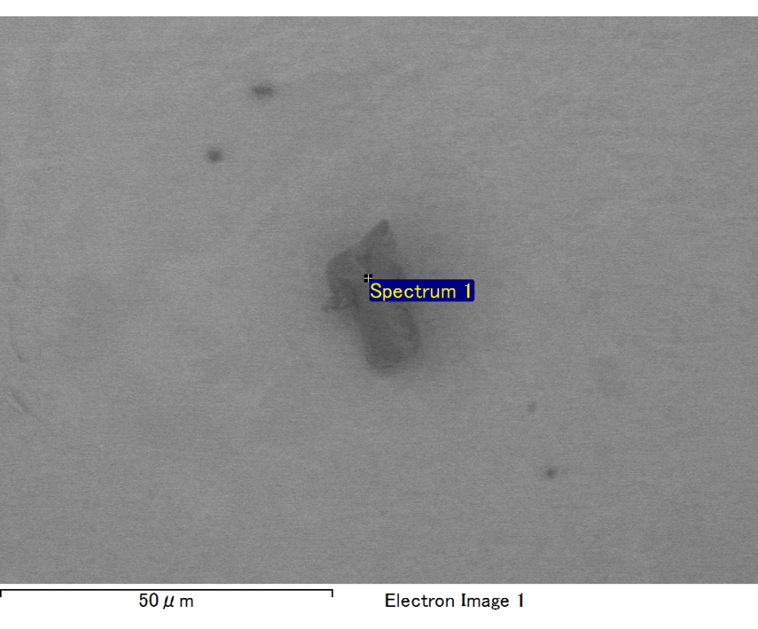

Spectrum processing :

No peaks omitted

Processing option : All elements analyzed (Normalised)

Number of iterations = 2

Standard :

C CaCO3 1-Jun-1999 12:00 AM

O SiO2 1-Jun-1999 12:00 AM

Mg MgO 1-Jun-1999 12:00 AM

Si SiO2 1-Jun-1999 12:00 AM

Au Au 1-Jun-1999 12:00 AM

|  |  |  |  |
| --- | --- | --- | --- |
| Element | Weight% | Atomic% |  |
|  |  |  |  |
| C K | 3.48 | 14.13 |  |
| O K | 16.84 | 51.25 |  |
| Mg K | 5.20 | 10.42 |  |
| Si K | 3.90 | 6.76 |  |
| Au M | 70.57 | 17.45 |  |
|  |  |  |  |
| Totals | 100.00 |  |  |

Spectrum Label: Spectrum 1

Livetime 60.0 s

Acquisition geometry ( degrees ):

Tilt = 10.0

Azimuth = 0.0

Elevation = 30.0

Accelerating voltage = 10.00 kV

Total spectrum counts = 36361

|  |  |  |  |
| --- | --- | --- | --- |
| Sample data : | Energy (eV) | Resn. (eV) | Area |
| Strobe : | 3.8 | 47.35 | 1000106 |
|  |  |  |  |

No quant optimization performed

Sample: Sample 1

Type: Default

ID: