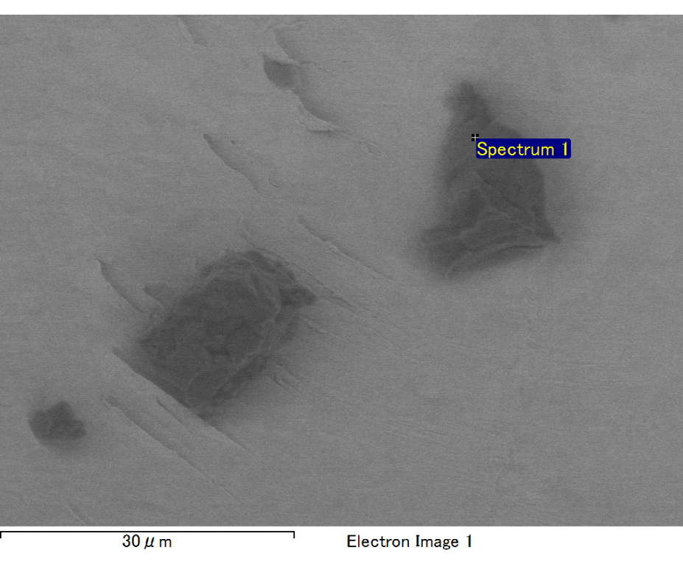

Spectrum processing :

Peak possibly omitted : 3.205 keV

Processing option : All elements analyzed (Normalised)

Number of iterations = 2

Standard :

C CaCO3 1-Jun-1999 12:00 AM

O SiO2 1-Jun-1999 12:00 AM

Mg MgO 1-Jun-1999 12:00 AM

Si SiO2 1-Jun-1999 12:00 AM

Fe Fe 1-Jun-1999 12:00 AM

Au Au 1-Jun-1999 12:00 AM

|  |  |  |  |
| --- | --- | --- | --- |
| Element | Weight% | Atomic% |  |
|  |  |  |  |
| C K | 3.12 | 10.59 |  |
| O K | 21.20 | 54.07 |  |
| Mg K | 5.53 | 9.28 |  |
| Si K | 4.38 | 6.37 |  |
| Fe L | 11.61 | 8.48 |  |
| Au M | 54.15 | 11.22 |  |
|  |  |  |  |
| Totals | 100.00 |  |  |

Spectrum Label: Spectrum 1

Livetime 60.0 s

Acquisition geometry ( degrees ):

Tilt = 10.0

Azimuth = 0.0

Elevation = 30.0

Accelerating voltage = 10.00 kV

Total spectrum counts = 36938

|  |  |  |  |
| --- | --- | --- | --- |
| Sample data : | Energy (eV) | Resn. (eV) | Area |
| Strobe : | 3.8 | 47.30 | 1000105 |
|  |  |  |  |

No quant optimization performed

Sample: Sample 1

Type: Default

ID: