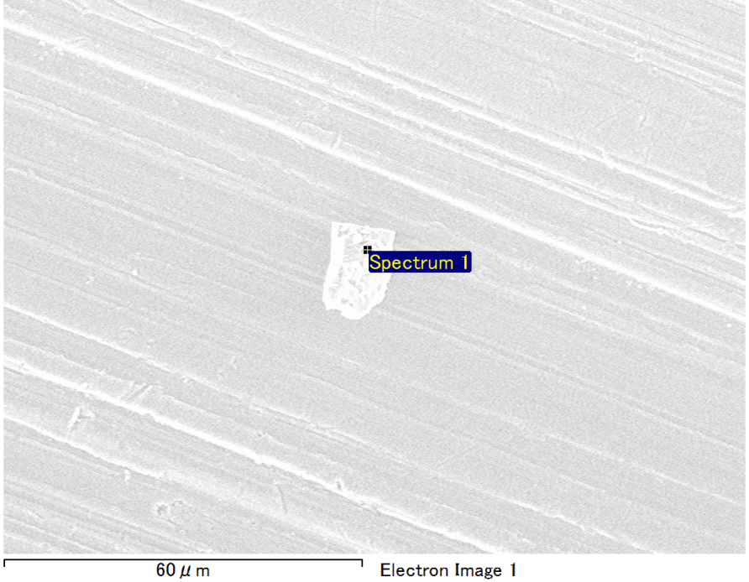

Spectrum Label: Spectrum 1

Livetime 90.0 s

Acquisition geometry ( degrees ):

Tilt = 0.0

Azimuth = 0.0

Elevation = 30.0

Accelerating voltage = 10.00 kV

Total spectrum counts = 68199

|  |  |  |  |
| --- | --- | --- | --- |
| Sample data : | Energy (eV) | Resn. (eV) | Area |
| Strobe : | 3.8 | 52.78 | 919119 |
|  |  |  |  |
| Optimization data : Manganese K series |  |  |  |
|  | Energy (eV) | Resn. (eV) | Area |
| Strobe : | .1 | 53.38 | 1150729 |
| Optimization element : | 5892.6 | 129.89 | 573533 |

Spectrum processing :

No peaks omitted

Processing option : Oxygen by stoichiometry (Normalised)

Number of iterations = 1

Standard :

Mg MgO 1-Jun-1999 12:00 AM

Al Al2O3 1-Jun-1999 12:00 AM

Si SiO2 1-Jun-1999 12:00 AM

Fe Fe 1-Jun-1999 12:00 AM

|  |  |  |  |  |  |
| --- | --- | --- | --- | --- | --- |
| Element | Weight% | Atomic% | Compd% | Formula |  |
|  |  |  |  |  |  |
| Mg K | 4.20 | 3.71 | 6.96 | MgO |  |
| Al K | 39.32 | 31.28 | 74.30 | Al2O3 |  |
| Si K | 3.13 | 2.39 | 6.70 | SiO2 |  |
| Fe L | 9.36 | 3.60 | 12.04 | FeO |  |
| O | 43.99 | 59.02 |  |  |  |
| Totals | 100.00 |  |  |  |  |

Project: Project 1

Owner: Operator

Site: Site of Interest 3

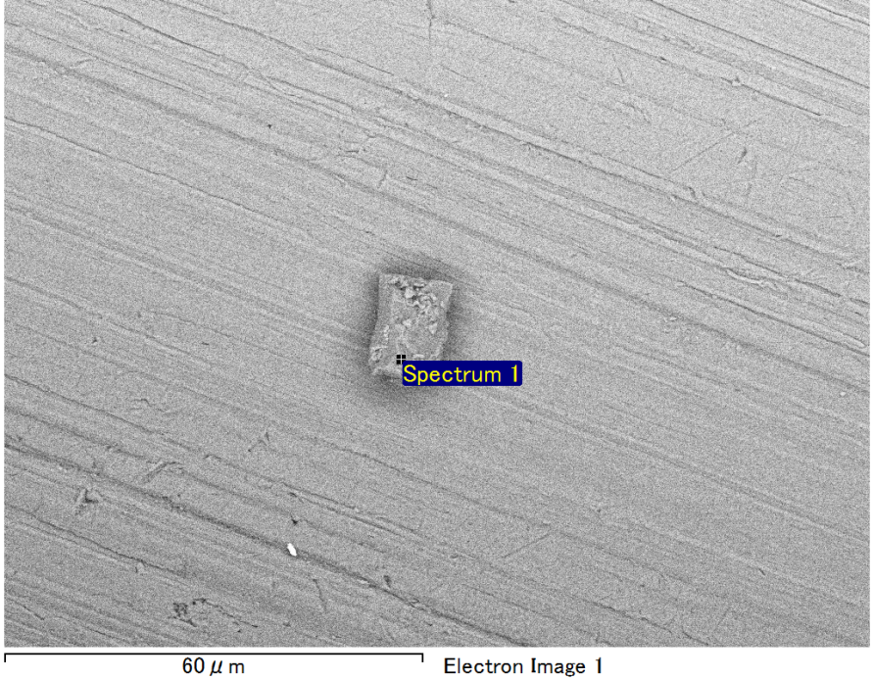

Spectrum Label: Spectrum 1

Livetime 90.0 s

Acquisition geometry ( degrees ):

Tilt = 0.0

Azimuth = 0.0

Elevation = 30.0

Accelerating voltage = 10.00 kV

Total spectrum counts = 67025

|  |  |  |  |
| --- | --- | --- | --- |
| Sample data : | Energy (eV) | Resn. (eV) | Area |
| Strobe : | 3.8 | 52.78 | 918208 |
|  |  |  |  |
| Optimization data : Manganese K series |  |  |  |
|  | Energy (eV) | Resn. (eV) | Area |
| Strobe : | .1 | 53.38 | 1150729 |
| Optimization element : | 5892.6 | 129.89 | 573533 |

Spectrum processing :

Peaks possibly omitted : 0.704, 6.400 keV

Processing option : Oxygen by stoichiometry (Normalised)

Number of iterations = 1

Standard :

Mg MgO 1-Jun-1999 12:00 AM

Al Al2O3 1-Jun-1999 12:00 AM

Si SiO2 1-Jun-1999 12:00 AM

|  |  |  |  |  |  |
| --- | --- | --- | --- | --- | --- |
| Element | Weight% | Atomic% | Compd% | Formula |  |
|  |  |  |  |  |  |
| Mg K | 4.90 | 4.09 | 8.12 | MgO |  |
| Al K | 43.29 | 32.62 | 81.79 | Al2O3 |  |
| Si K | 4.72 | 3.42 | 10.10 | SiO2 |  |
| O | 47.10 | 59.86 |  |  |  |
| Totals | 100.00 |  |  |  |  |

Project: Project 1

Owner: Operator

Site: Site of Interest 4

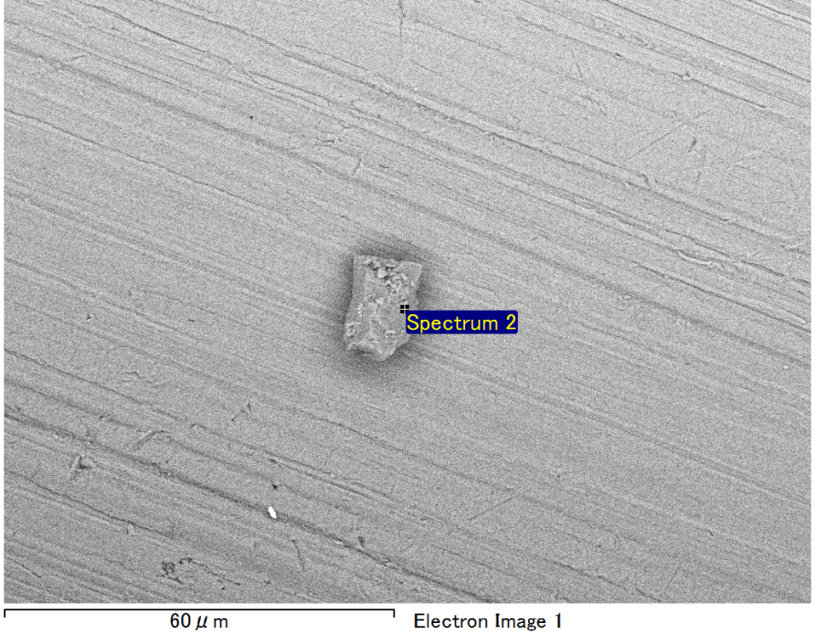

Spectrum Label: Spectrum 2

Livetime 90.0 s

Acquisition geometry ( degrees ):

Tilt = 0.0

Azimuth = 0.0

Elevation = 30.0

Accelerating voltage = 10.00 kV

Total spectrum counts = 66854

|  |  |  |  |
| --- | --- | --- | --- |
| Sample data : | Energy (eV) | Resn. (eV) | Area |
| Strobe : | 3.8 | 52.74 | 917154 |
|  |  |  |  |
| Optimization data : Manganese K series |  |  |  |
|  | Energy (eV) | Resn. (eV) | Area |
| Strobe : | .1 | 53.38 | 1150729 |
| Optimization element : | 5892.6 | 129.89 | 573533 |

Spectrum processing :

Peak possibly omitted : 0.710 keV

Processing option : Oxygen by stoichiometry (Normalised)

Number of iterations = 1

Standard :

Mg MgO 1-Jun-1999 12:00 AM

Al Al2O3 1-Jun-1999 12:00 AM

Si SiO2 1-Jun-1999 12:00 AM

|  |  |  |  |  |  |
| --- | --- | --- | --- | --- | --- |
| Element | Weight% | Atomic% | Compd% | Formula |  |
|  |  |  |  |  |  |
| Mg K | 3.86 | 3.23 | 6.41 | MgO |  |
| Al K | 45.24 | 34.12 | 85.48 | Al2O3 |  |
| Si K | 3.79 | 2.75 | 8.11 | SiO2 |  |
| O | 47.10 | 59.90 |  |  |  |
| Totals | 100.00 |  |  |  |  |

Project: Project 1

Owner: Operator

Site: Site of Interest 4

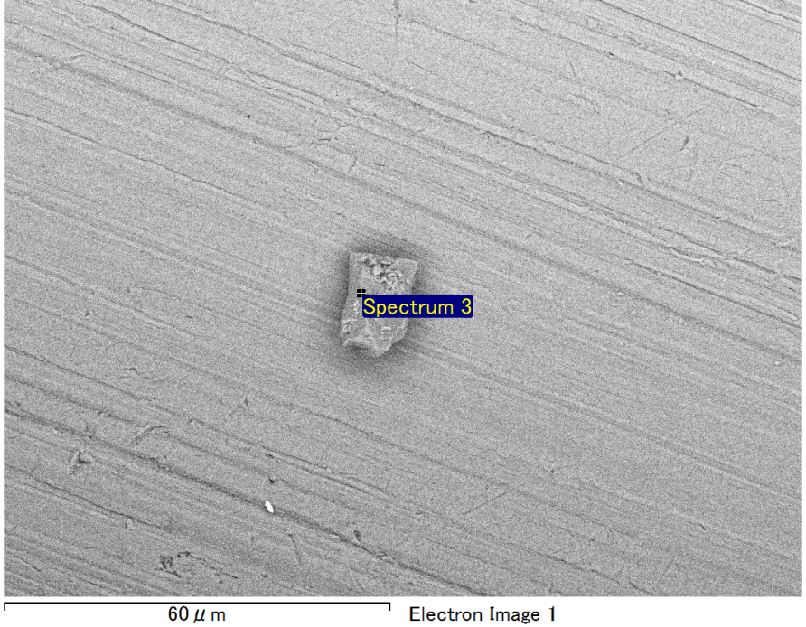

Spectrum Label: Spectrum 3

Livetime 90.0 s

Acquisition geometry ( degrees ):

Tilt = 0.0

Azimuth = 0.0

Elevation = 30.0

Accelerating voltage = 10.00 kV

Total spectrum counts = 68202

|  |  |  |  |
| --- | --- | --- | --- |
| Sample data : | Energy (eV) | Resn. (eV) | Area |
| Strobe : | 3.8 | 52.73 | 917906 |
|  |  |  |  |
| Optimization data : Manganese K series |  |  |  |
|  | Energy (eV) | Resn. (eV) | Area |
| Strobe : | .1 | 53.38 | 1150729 |
| Optimization element : | 5892.6 | 129.89 | 573533 |

Spectrum processing :

No peaks omitted

Processing option : Oxygen by stoichiometry (Normalised)

Number of iterations = 1

Standard :

Mg MgO 1-Jun-1999 12:00 AM

Al Al2O3 1-Jun-1999 12:00 AM

Si SiO2 1-Jun-1999 12:00 AM

Fe Fe 1-Jun-1999 12:00 AM

|  |  |  |  |  |  |
| --- | --- | --- | --- | --- | --- |
| Element | Weight% | Atomic% | Compd% | Formula |  |
|  |  |  |  |  |  |
| Mg K | 4.29 | 3.79 | 7.11 | MgO |  |
| Al K | 37.85 | 30.18 | 71.51 | Al2O3 |  |
| Si K | 4.08 | 3.12 | 8.72 | SiO2 |  |
| Fe L | 9.84 | 3.79 | 12.66 | FeO |  |
| O | 43.95 | 59.11 |  |  |  |
| Totals | 100.00 |  |  |  |  |

Project: Project 1

Owner: Operator

Site: Site of Interest 4

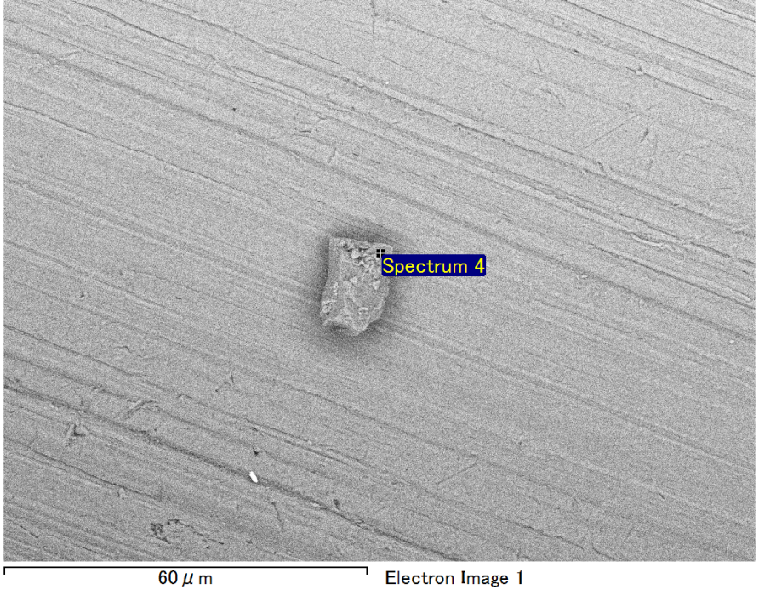

Spectrum Label: Spectrum 4

Livetime 90.0 s

Acquisition geometry ( degrees ):

Tilt = 0.0

Azimuth = 0.0

Elevation = 30.0

Accelerating voltage = 10.00 kV

Total spectrum counts = 67723

|  |  |  |  |
| --- | --- | --- | --- |
| Sample data : | Energy (eV) | Resn. (eV) | Area |
| Strobe : | 3.8 | 52.78 | 917428 |
|  |  |  |  |
| Optimization data : Manganese K series |  |  |  |
|  | Energy (eV) | Resn. (eV) | Area |
| Strobe : | .1 | 53.38 | 1150729 |
| Optimization element : | 5892.6 | 129.89 | 573533 |

Spectrum processing :

No peaks omitted

Processing option : Oxygen by stoichiometry (Normalised)

Number of iterations = 1

Standard :

Mg MgO 1-Jun-1999 12:00 AM

Al Al2O3 1-Jun-1999 12:00 AM

Si SiO2 1-Jun-1999 12:00 AM

Fe Fe 1-Jun-1999 12:00 AM

|  |  |  |  |  |  |
| --- | --- | --- | --- | --- | --- |
| Element | Weight% | Atomic% | Compd% | Formula |  |
|  |  |  |  |  |  |
| Mg K | 4.04 | 3.55 | 6.69 | MgO |  |
| Al K | 38.50 | 30.55 | 72.75 | Al2O3 |  |
| Si K | 4.22 | 3.22 | 9.03 | SiO2 |  |
| Fe L | 8.96 | 3.43 | 11.53 | FeO |  |
| O | 44.28 | 59.25 |  |  |  |
| Totals | 100.00 |  |  |  |  |

Project: Project 1

Owner: Operator

Site: Site of Interest 4