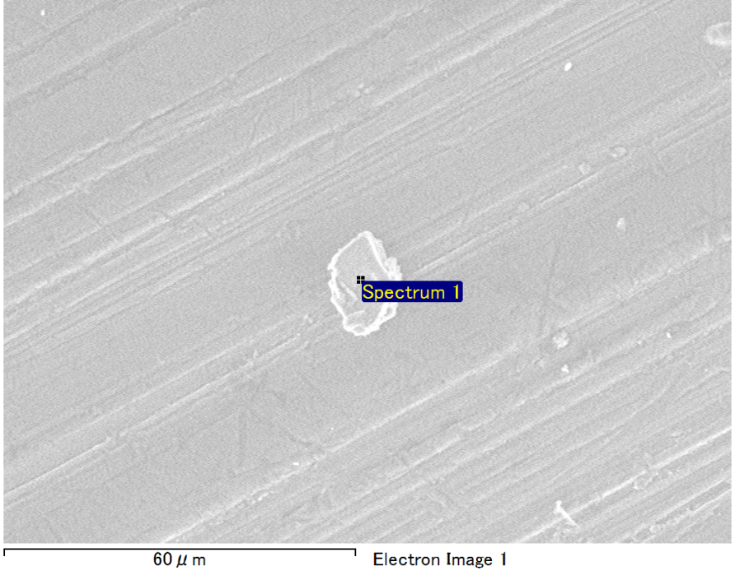

Spectrum Label: Spectrum 1

Livetime 90.0 s

Acquisition geometry ( degrees ):

Tilt = 0.0

Azimuth = 0.0

Elevation = 30.0

Accelerating voltage = 10.00 kV

Total spectrum counts = 57885

|  |  |  |  |
| --- | --- | --- | --- |
| Sample data : | Energy (eV) | Resn. (eV) | Area |
| Strobe : | 3.8 | 40.20 | 954140 |
|  |  |  |  |
| Optimization data : Cobalt K series |  |  |  |
|  | Energy (eV) | Resn. (eV) | Area |
| Strobe : | .1 | 41.16 | 1008028 |
| Optimization element : | 6916.2 | 136.04 | 88085 |

Spectrum processing :

No peaks omitted

Processing option : Oxygen by stoichiometry (Normalised)

Number of iterations = 1

Standard :

Na Albite 1-Jun-1999 12:00 AM

Al Al2O3 1-Jun-1999 12:00 AM

Si SiO2 1-Jun-1999 12:00 AM

|  |  |  |  |  |  |
| --- | --- | --- | --- | --- | --- |
| Element | Weight% | Atomic% | Compd% | Formula |  |
|  |  |  |  |  |  |
| Na K | 1.28 | 1.13 | 1.72 | Na2O |  |
| Al K | 42.13 | 31.74 | 79.60 | Al2O3 |  |
| Si K | 8.73 | 6.32 | 18.68 | SiO2 |  |
| O | 47.86 | 60.81 |  |  |  |
| Totals | 100.00 |  |  |  |  |

Project: Project 1

Owner: Operator

Site: Site of Interest 18