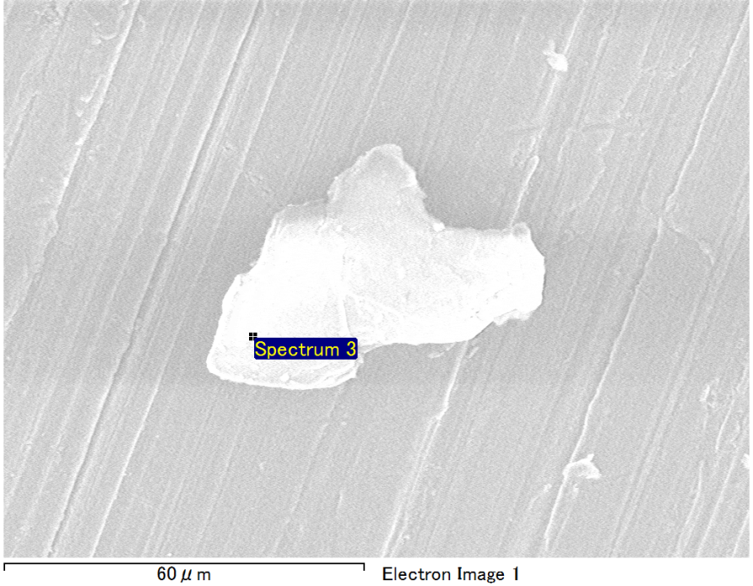

Spectrum Label: Spectrum 3

Livetime 90.0 s

Acquisition geometry ( degrees ):

Tilt = 0.0

Azimuth = 0.0

Elevation = 30.0

Accelerating voltage = 10.00 kV

Total spectrum counts = 62102

|  |  |  |  |
| --- | --- | --- | --- |
| Sample data : | Energy (eV) | Resn. (eV) | Area |
| Strobe : | 3.8 | 40.43 | 948827 |
|  |  |  |  |
| Optimization data : Cobalt K series |  |  |  |
|  | Energy (eV) | Resn. (eV) | Area |
| Strobe : | .1 | 41.16 | 1008028 |
| Optimization element : | 6916.2 | 136.04 | 88085 |

Spectrum processing :

No peaks omitted

Processing option : Oxygen by stoichiometry (Normalised)

Number of iterations = 1

Standard :

Mg MgO 1-Jun-1999 12:00 AM

Al Al2O3 1-Jun-1999 12:00 AM

Si SiO2 1-Jun-1999 12:00 AM

|  |  |  |  |  |  |
| --- | --- | --- | --- | --- | --- |
| Element | Weight% | Atomic% | Compd% | Formula |  |
|  |  |  |  |  |  |
| Mg K | 5.29 | 4.42 | 8.77 | MgO |  |
| Al K | 43.09 | 32.47 | 81.41 | Al2O3 |  |
| Si K | 4.59 | 3.32 | 9.82 | SiO2 |  |
| O | 47.03 | 59.78 |  |  |  |
| Totals | 100.00 |  |  |  |  |

Project: Project 1

Owner: Operator

Site: Site of Interest 38

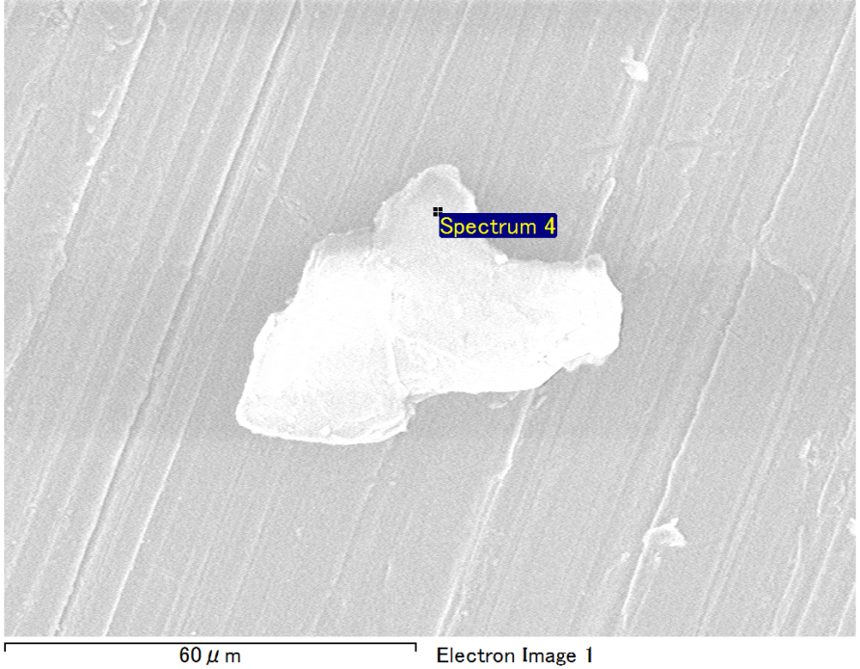

Spectrum Label: Spectrum 4

Livetime 90.0 s

Acquisition geometry ( degrees ):

Tilt = 0.0

Azimuth = 0.0

Elevation = 30.0

Accelerating voltage = 10.00 kV

Total spectrum counts = 62218

|  |  |  |  |
| --- | --- | --- | --- |
| Sample data : | Energy (eV) | Resn. (eV) | Area |
| Strobe : | 3.8 | 40.40 | 950848 |
|  |  |  |  |
| Optimization data : Cobalt K series |  |  |  |
|  | Energy (eV) | Resn. (eV) | Area |
| Strobe : | .1 | 41.16 | 1008028 |
| Optimization element : | 6916.2 | 136.04 | 88085 |

Spectrum processing :

No peaks omitted

Processing option : Oxygen by stoichiometry (Normalised)

Number of iterations = 1

Standard :

Mg MgO 1-Jun-1999 12:00 AM

Al Al2O3 1-Jun-1999 12:00 AM

Si SiO2 1-Jun-1999 12:00 AM

|  |  |  |  |  |  |
| --- | --- | --- | --- | --- | --- |
| Element | Weight% | Atomic% | Compd% | Formula |  |
|  |  |  |  |  |  |
| Mg K | 5.23 | 4.38 | 8.68 | MgO |  |
| Al K | 43.39 | 32.70 | 81.98 | Al2O3 |  |
| Si K | 4.37 | 3.16 | 9.35 | SiO2 |  |
| O | 47.01 | 59.76 |  |  |  |
| Totals | 100.00 |  |  |  |  |

Project: Project 1

Owner: Operator

Site: Site of Interest 38

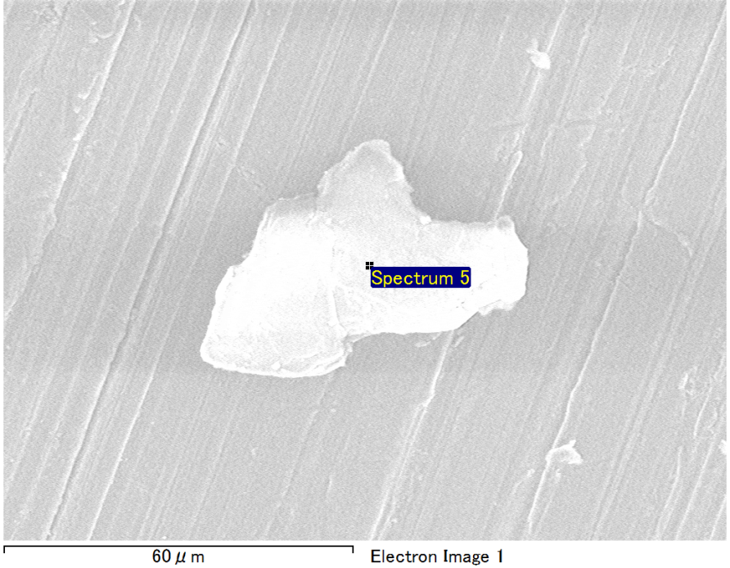

Spectrum Label: Spectrum 5

Livetime 90.0 s

Acquisition geometry ( degrees ):

Tilt = 0.0

Azimuth = 0.0

Elevation = 30.0

Accelerating voltage = 10.00 kV

Total spectrum counts = 61747

|  |  |  |  |
| --- | --- | --- | --- |
| Sample data : | Energy (eV) | Resn. (eV) | Area |
| Strobe : | 3.8 | 40.45 | 951772 |
|  |  |  |  |
| Optimization data : Cobalt K series |  |  |  |
|  | Energy (eV) | Resn. (eV) | Area |
| Strobe : | .1 | 41.16 | 1008028 |
| Optimization element : | 6916.2 | 136.04 | 88085 |

Spectrum processing :

No peaks omitted

Processing option : Oxygen by stoichiometry (Normalised)

Number of iterations = 1

Standard :

Mg MgO 1-Jun-1999 12:00 AM

Al Al2O3 1-Jun-1999 12:00 AM

Si SiO2 1-Jun-1999 12:00 AM

|  |  |  |  |  |  |
| --- | --- | --- | --- | --- | --- |
| Element | Weight% | Atomic% | Compd% | Formula |  |
|  |  |  |  |  |  |
| Mg K | 5.60 | 4.68 | 9.28 | MgO |  |
| Al K | 42.97 | 32.39 | 81.19 | Al2O3 |  |
| Si K | 4.45 | 3.22 | 9.53 | SiO2 |  |
| O | 46.98 | 59.71 |  |  |  |
| Totals | 100.00 |  |  |  |  |

Project: Project 1

Owner: Operator

Site: Site of Interest 38

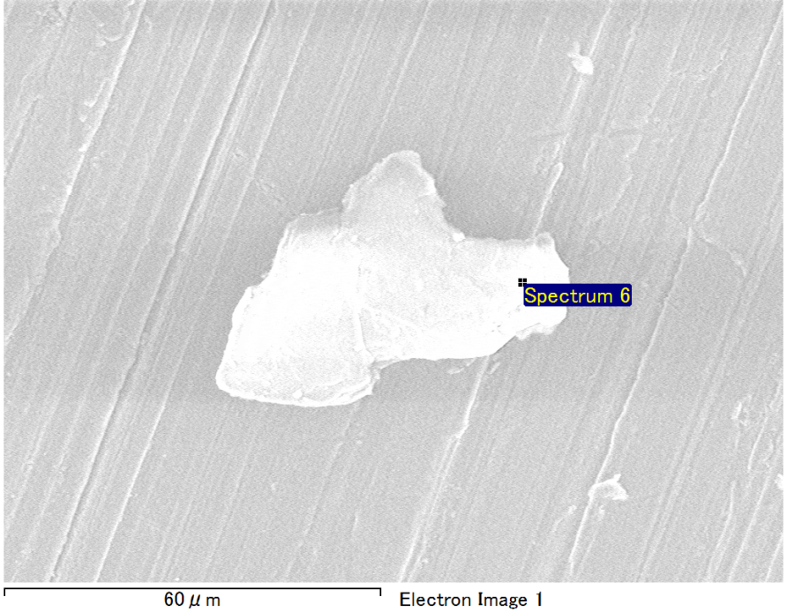

Spectrum Label: Spectrum 6

Livetime 90.0 s

Acquisition geometry ( degrees ):

Tilt = 0.0

Azimuth = 0.0

Elevation = 30.0

Accelerating voltage = 10.00 kV

Total spectrum counts = 61948

|  |  |  |  |
| --- | --- | --- | --- |
| Sample data : | Energy (eV) | Resn. (eV) | Area |
| Strobe : | 3.8 | 40.45 | 952472 |
|  |  |  |  |
| Optimization data : Cobalt K series |  |  |  |
|  | Energy (eV) | Resn. (eV) | Area |
| Strobe : | .1 | 41.16 | 1008028 |
| Optimization element : | 6916.2 | 136.04 | 88085 |

Spectrum processing :

No peaks omitted

Processing option : Oxygen by stoichiometry (Normalised)

Number of iterations = 1

Standard :

C CaCO3 1-Jun-1999 12:00 AM

Mg MgO 1-Jun-1999 12:00 AM

Al Al2O3 1-Jun-1999 12:00 AM

Si SiO2 1-Jun-1999 12:00 AM

|  |  |  |  |  |  |
| --- | --- | --- | --- | --- | --- |
| Element | Weight% | Atomic% | Compd% | Formula |  |
|  |  |  |  |  |  |
| C K | 3.87 | 6.22 | 14.20 | CO2 |  |
| Mg K | 4.21 | 3.34 | 6.98 | MgO |  |
| Al K | 37.77 | 26.99 | 71.35 | Al2O3 |  |
| Si K | 3.49 | 2.40 | 7.47 | SiO2 |  |
| O | 50.66 | 61.06 |  |  |  |
| Totals | 100.00 |  |  |  |  |

Project: Project 1

Owner: Operator

Site: Site of Interest 38

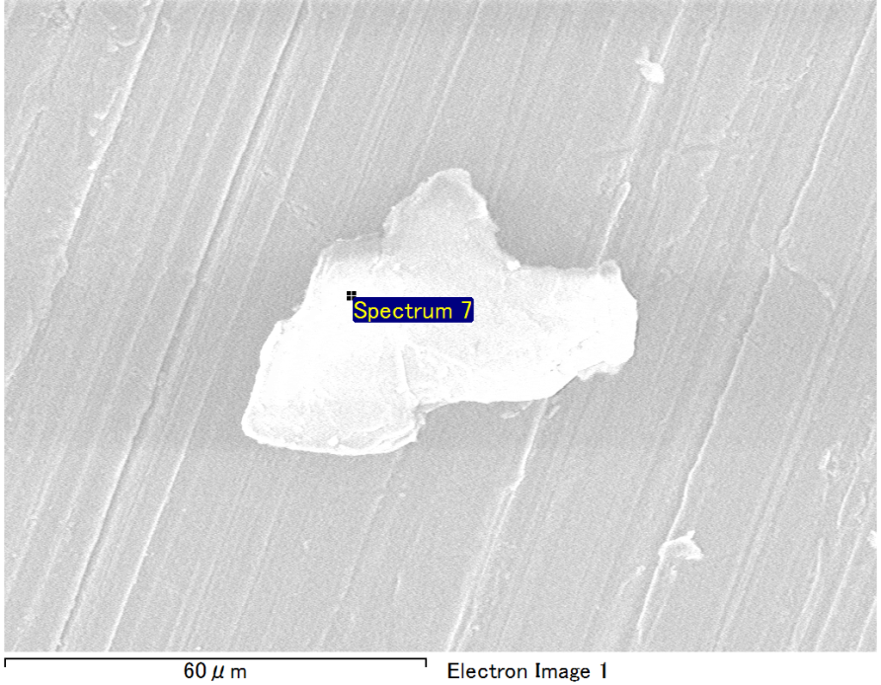

Spectrum Label: Spectrum 7

Livetime 90.0 s

Acquisition geometry ( degrees ):

Tilt = 0.0

Azimuth = 0.0

Elevation = 30.0

Accelerating voltage = 10.00 kV

Total spectrum counts = 61807

|  |  |  |  |
| --- | --- | --- | --- |
| Sample data : | Energy (eV) | Resn. (eV) | Area |
| Strobe : | 3.8 | 40.47 | 947706 |
|  |  |  |  |
| Optimization data : Cobalt K series |  |  |  |
|  | Energy (eV) | Resn. (eV) | Area |
| Strobe : | .1 | 41.16 | 1008028 |
| Optimization element : | 6916.2 | 136.04 | 88085 |

Spectrum processing :

No peaks omitted

Processing option : Oxygen by stoichiometry (Normalised)

Number of iterations = 1

Standard :

Mg MgO 1-Jun-1999 12:00 AM

Al Al2O3 1-Jun-1999 12:00 AM

Si SiO2 1-Jun-1999 12:00 AM

|  |  |  |  |  |  |
| --- | --- | --- | --- | --- | --- |
| Element | Weight% | Atomic% | Compd% | Formula |  |
|  |  |  |  |  |  |
| Mg K | 5.23 | 4.38 | 8.67 | MgO |  |
| Al K | 43.52 | 32.80 | 82.23 | Al2O3 |  |
| Si K | 4.25 | 3.08 | 9.10 | SiO2 |  |
| O | 47.00 | 59.74 |  |  |  |
| Totals | 100.00 |  |  |  |  |

Project: Project 1

Owner: Operator

Site: Site of Interest 38