ｽﾍﾟｸﾄﾙﾗﾍﾞﾙ: ｽﾍﾟｸﾄﾙ 1

ﾗｲﾌﾞﾀｲﾑ 120.0 s

収集ｼﾞｵﾒﾄﾘ[度] :

試料傾斜角 = 0.0

方位角 = 0.0

ｴﾚﾍﾞｰｼｮﾝ = 30.0

加速電圧 = 10.00 kV

ｽﾍﾟｸﾄﾙ全ｶｳﾝﾄ数 = 234402

|  |  |  |  |
| --- | --- | --- | --- |
| ｻﾝﾌﾟﾙﾃﾞｰﾀ : | ｴﾈﾙｷﾞｰ[eV] | 分解能[eV] | ｶｳﾝﾄ数 |
| ｽﾄﾛｰﾌﾞ : | 3.8 | 51.86 | 1194802 |
|  |  |  |  |

定量最適化がおこなわれていません

ｽﾍﾟｸﾄﾙ処理 :

省略されたﾋﾟｰｸはありません

処理ｵﾌﾟｼｮﾝ : 酸素 ｽﾄｲｷｵﾒﾄﾘ (ﾉｰﾏﾗｲｽﾞ)

繰り返し回数 = 2

ｽﾀﾝﾀﾞｰﾄﾞ :

Na Albite 1999/06/01

Mg MgO 1999/06/01

Al Al2O3 1999/06/01

Si SiO2 1999/06/01

P GaP 1999/06/01

S FeS2 1999/06/01

K MAD-10 Feldspar 1999/06/01

Ca Wollastonite 1999/06/01

Cr Cr 1999/06/01

Mn Mn 1999/06/01

Fe Fe 1999/06/01

Ni Ni 1999/06/01

|  |  |  |  |  |  |
| --- | --- | --- | --- | --- | --- |
| 元素 | 質量濃度 | 原子数 | 化合物 | 化学式 |  |
|  | [%] | 濃度[%] | 濃度[%] |  |  |
| Na K | -62.70 | -49.19 | -84.52 | Na2O |  |
| Mg K | 1.15 | 0.85 | 1.90 | MgO |  |
| Al K | -95.61 | -63.91 | -180.66 | Al2O3 |  |
| Si K | -262.97 | -168.86 | -562.56 | SiO2 |  |
| P K | 226.83 | 132.08 | 519.74 | P2O5 |  |
| S K | 175.39 | 98.65 | 437.94 | SO3 |  |
| K K | -10.64 | -4.91 | -12.82 | K2O |  |
| Ca K | -15.32 | -6.89 | -21.43 | CaO |  |
| Cr K | 14.07 | 4.88 | 20.56 | Cr2O3 |  |
| Mn K | -7.52 | -2.47 | -9.72 | MnO |  |
| Fe K | -19.14 | -6.18 | -24.63 | FeO |  |
| Ni K | 12.72 | 3.91 | 16.19 | NiO |  |
| O | 143.75 | 162.04 |  |  |  |
| ﾄｰﾀﾙ | 100.00 |  |  |  |  |

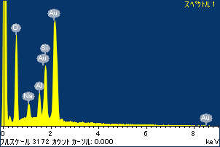

ﾌﾟﾛｼﾞｪｸﾄ : 20110613AU08

ｵｰﾅｰ : Administrator

領域 分析領域 1

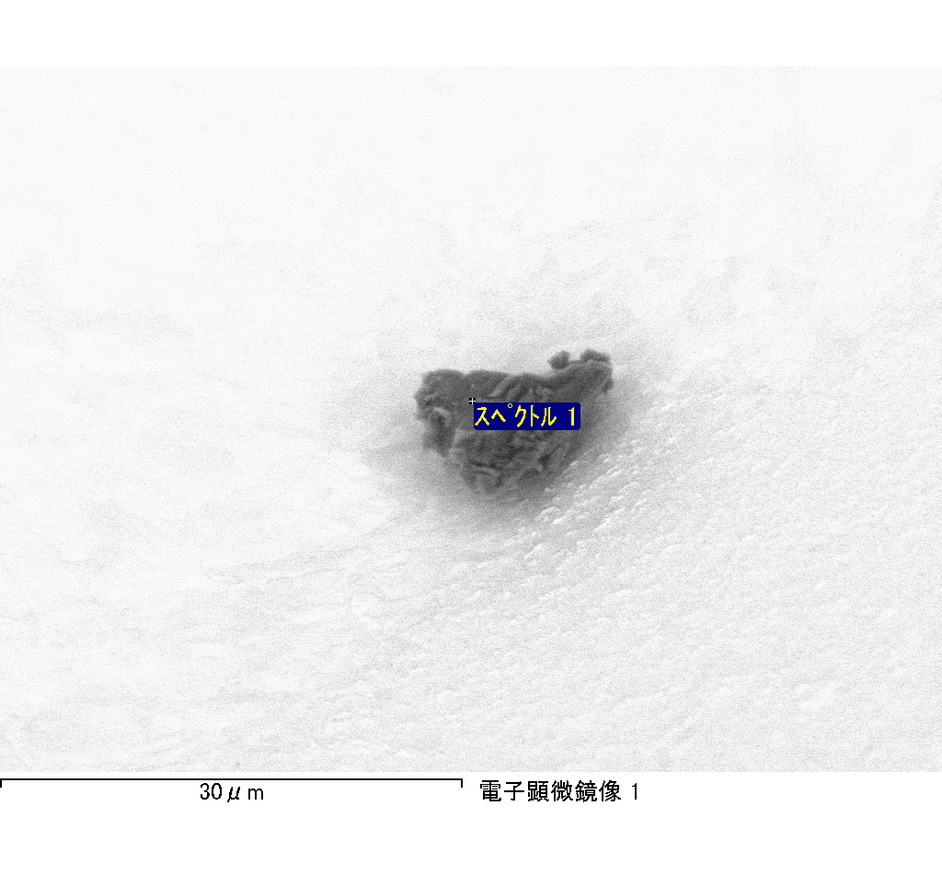

ｽﾍﾟｸﾄﾙ処理 :

省略されたﾋﾟｰｸはありません

処理ｵﾌﾟｼｮﾝ : 酸素 ｽﾄｲｷｵﾒﾄﾘ (ﾉｰﾏﾗｲｽﾞ)

繰り返し回数 = 2

ｽﾀﾝﾀﾞｰﾄﾞ :

Na Albite 1999/06/01

Mg MgO 1999/06/01

Al Al2O3 1999/06/01

Si SiO2 1999/06/01

P GaP 1999/06/01

S FeS2 1999/06/01

K MAD-10 Feldspar 1999/06/01

Ca Wollastonite 1999/06/01

Cr Cr 1999/06/01

Mn Mn 1999/06/01

Fe Fe 1999/06/01

Ni Ni 1999/06/01

|  |  |  |  |  |  |
| --- | --- | --- | --- | --- | --- |
| 元素 | 質量濃度 | 原子数 | 化合物 | 化学式 |  |
|  | [%] | 濃度[%] | 濃度[%] |  |  |
| Na K | 188.89 | 1691.87 | 254.61 | Na2O |  |
| Mg K | 0.77 | 6.51 | 1.27 | MgO |  |
| Al K | 256.76 | 1959.55 | 485.14 | Al2O3 |  |
| Si K | 747.87 | 5483.22 | 1599.91 | SiO2 |  |
| P K | -579.66 | -3853.67 | -1328.19 | P2O5 |  |
| S K | -451.37 | -2898.78 | -1127.03 | SO3 |  |
| K K | 14.98 | 78.91 | 18.05 | K2O |  |
| Ca K | 18.57 | 95.40 | 25.98 | CaO |  |
| Cr K | 14.61 | 57.86 | 21.35 | Cr2O3 |  |
| Mn K | 34.78 | 130.38 | 44.91 | MnO |  |
| Fe K | -15.03 | -55.41 | -19.33 | FeO |  |
| Ni K | 96.91 | 339.92 | 123.32 | NiO |  |
| O | -228.09 | -2935.76 |  |  |  |
| ﾄｰﾀﾙ | 100.00 |  |  |  |  |

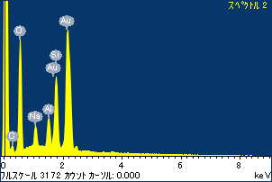

ﾌﾟﾛｼﾞｪｸﾄ : 20110613AU08

ｵｰﾅｰ : Administrator

領域 分析領域 1

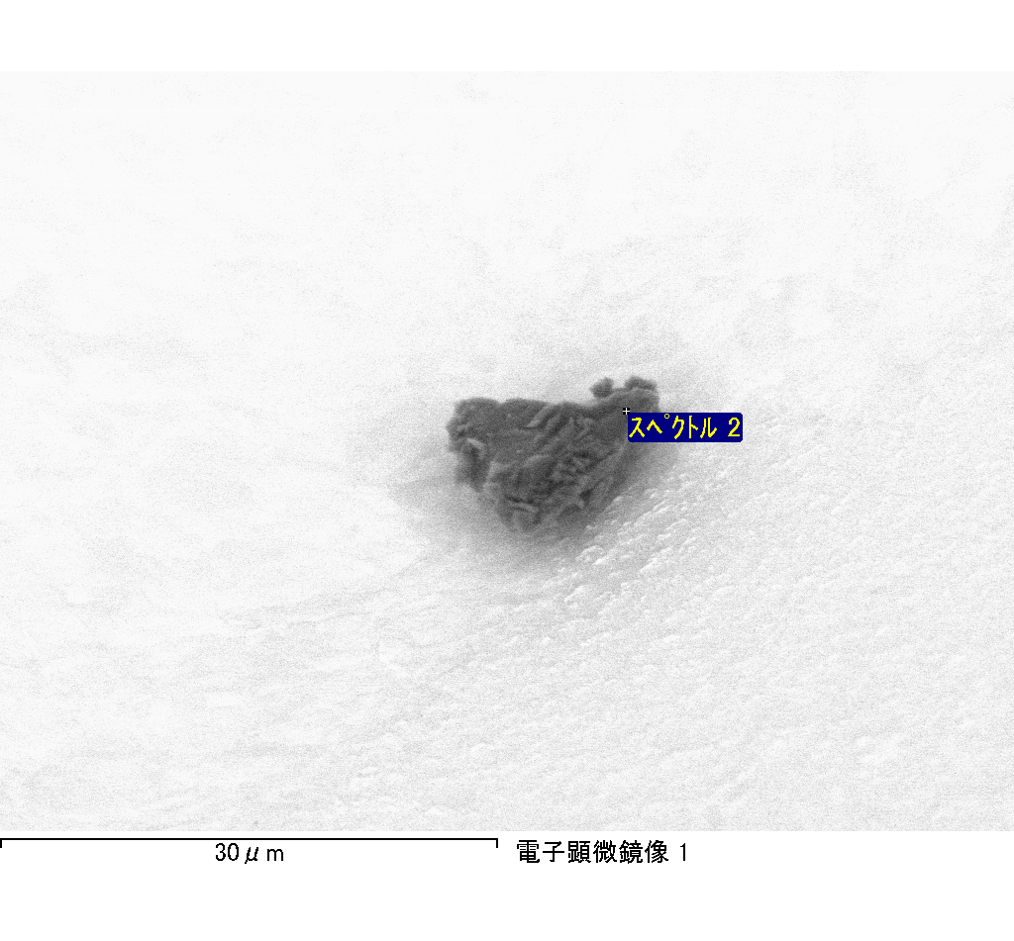

ｽﾍﾟｸﾄﾙﾗﾍﾞﾙ: ｽﾍﾟｸﾄﾙ 2

ﾗｲﾌﾞﾀｲﾑ 120.0 s

収集ｼﾞｵﾒﾄﾘ[度] :

試料傾斜角 = 0.0

方位角 = 0.0

ｴﾚﾍﾞｰｼｮﾝ = 30.0

加速電圧 = 10.00 kV

ｽﾍﾟｸﾄﾙ全ｶｳﾝﾄ数 = 230638

|  |  |  |  |
| --- | --- | --- | --- |
| ｻﾝﾌﾟﾙﾃﾞｰﾀ : | ｴﾈﾙｷﾞｰ[eV] | 分解能[eV] | ｶｳﾝﾄ数 |
| ｽﾄﾛｰﾌﾞ : | 3.8 | 51.84 | 1194073 |
|  |  |  |  |

定量最適化がおこなわれていません

ｽﾍﾟｸﾄﾙ処理 :

省略されたﾋﾟｰｸはありません

処理ｵﾌﾟｼｮﾝ : 酸素 ｽﾄｲｷｵﾒﾄﾘ (ﾉｰﾏﾗｲｽﾞ)

繰り返し回数 = 2

ｽﾀﾝﾀﾞｰﾄﾞ :

Na Albite 1999/06/01

Mg MgO 1999/06/01

Al Al2O3 1999/06/01

Si SiO2 1999/06/01

P GaP 1999/06/01

S FeS2 1999/06/01

K MAD-10 Feldspar 1999/06/01

Ca Wollastonite 1999/06/01

Cr Cr 1999/06/01

Mn Mn 1999/06/01

Fe Fe 1999/06/01

Ni Ni 1999/06/01

|  |  |  |  |  |  |
| --- | --- | --- | --- | --- | --- |
| 元素 | 質量濃度 | 原子数 | 化合物 | 化学式 |  |
|  | [%] | 濃度[%] | 濃度[%] |  |  |
| Na K | 394.66 | 2951.94 | 531.98 | Na2O |  |
| Mg K | 8.27 | 58.51 | 13.72 | MgO |  |
| Al K | 646.35 | 4119.24 | 1221.23 | Al2O3 |  |
| Si K | 1849.69 | 11324.88 | 3957.02 | SiO2 |  |
| P K | -1368.78 | -7599.07 | -3136.31 | P2O5 |  |
| S K | -1086.43 | -5826.50 | -2712.71 | SO3 |  |
| K K | 43.12 | 189.61 | 51.94 | K2O |  |
| Ca K | 87.88 | 377.04 | 122.96 | CaO |  |
| Cr K | -78.93 | -261.05 | -115.36 | Cr2O3 |  |
| Mn K | 62.50 | 195.63 | 80.70 | MnO |  |
| Fe K | 73.28 | 225.65 | 94.28 | FeO |  |
| Ni K | -7.41 | -21.70 | -9.43 | NiO |  |
| O | -524.20 | -5634.20 |  |  |  |
| ﾄｰﾀﾙ | 100.00 |  |  |  |  |

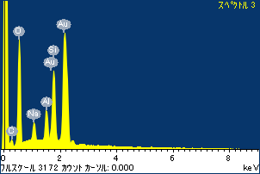

ﾌﾟﾛｼﾞｪｸﾄ : 20110613AU08

ｵｰﾅｰ : Administrator

領域 分析領域 1

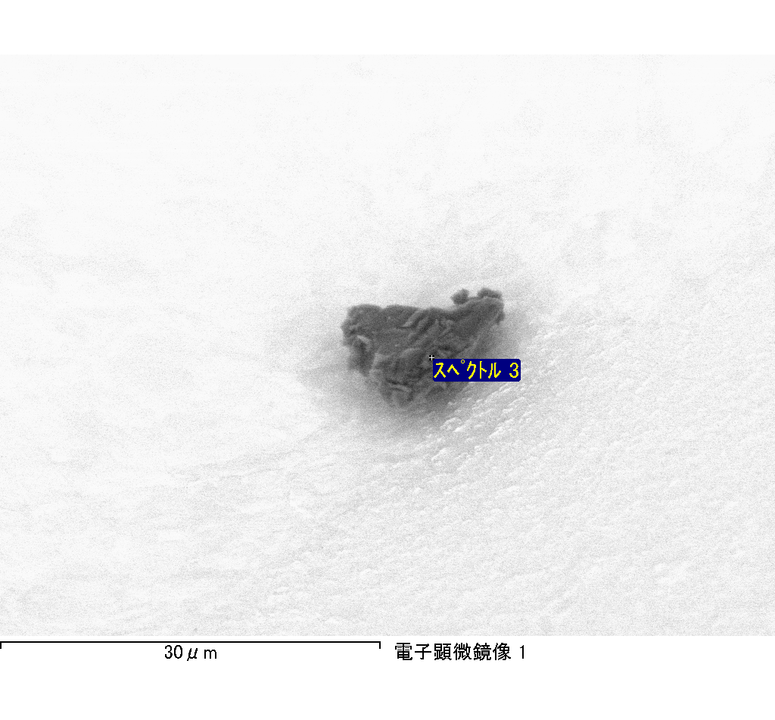

ｽﾍﾟｸﾄﾙﾗﾍﾞﾙ: ｽﾍﾟｸﾄﾙ 3

ﾗｲﾌﾞﾀｲﾑ 120.0 s

収集ｼﾞｵﾒﾄﾘ[度] :

試料傾斜角 = 0.0

方位角 = 0.0

ｴﾚﾍﾞｰｼｮﾝ = 30.0

加速電圧 = 10.00 kV

ｽﾍﾟｸﾄﾙ全ｶｳﾝﾄ数 = 228637

|  |  |  |  |
| --- | --- | --- | --- |
| ｻﾝﾌﾟﾙﾃﾞｰﾀ : | ｴﾈﾙｷﾞｰ[eV] | 分解能[eV] | ｶｳﾝﾄ数 |
| ｽﾄﾛｰﾌﾞ : | 3.8 | 51.81 | 1195167 |
|  |  |  |  |

定量最適化がおこなわれていません