ｽﾍﾟｸﾄﾙ処理 :

省略されたﾋﾟｰｸはありません

処理ｵﾌﾟｼｮﾝ : 酸素 ｽﾄｲｷｵﾒﾄﾘ (ﾉｰﾏﾗｲｽﾞ)

繰り返し回数 = 2

ｽﾀﾝﾀﾞｰﾄﾞ :

Na Albite 1999/06/01

Mg MgO 1999/06/01

Al Al2O3 1999/06/01

Si SiO2 1999/06/01

P GaP 1999/06/01

S FeS2 1999/06/01

K MAD-10 Feldspar 1999/06/01

Ca Wollastonite 1999/06/01

Cr Cr 1999/06/01

Mn Mn 1999/06/01

Fe Fe 1999/06/01

Ni Ni 1999/06/01

|  |  |  |  |  |  |
| --- | --- | --- | --- | --- | --- |
| 元素 | 質量濃度 | 原子数 | 化合物 | 化学式 |  |
|  | [%] | 濃度[%] | 濃度[%] |  |  |
| Na K | 29.33 | -17.20 | 39.53 | Na2O |  |
| Mg K | 499.81 | -277.21 | 828.73 | MgO |  |
| Al K | 87.61 | -43.78 | 165.53 | Al2O3 |  |
| Si K | 648.92 | -311.55 | 1388.23 | SiO2 |  |
| P K | -680.55 | 296.27 | -1559.37 | P2O5 |  |
| S K | -546.28 | 229.73 | -1364.01 | SO3 |  |
| K K | 11.63 | -4.01 | 14.00 | K2O |  |
| Ca K | 5.34 | -1.80 | 7.47 | CaO |  |
| Cr K | 32.35 | -8.39 | 47.28 | Cr2O3 |  |
| Mn K | 51.67 | -12.68 | 66.72 | MnO |  |
| Fe K | 401.33 | -96.90 | 516.31 | FeO |  |
| Ni K | -39.62 | 9.10 | -50.41 | NiO |  |
| O | -401.54 | 338.42 |  |  |  |
| ﾄｰﾀﾙ | 100.00 |  |  |  |  |

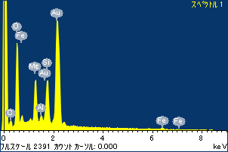

ﾌﾟﾛｼﾞｪｸﾄ : ﾌﾟﾛｼﾞｪｸﾄ 1

ｵｰﾅｰ : Administrator

領域 分析領域 4

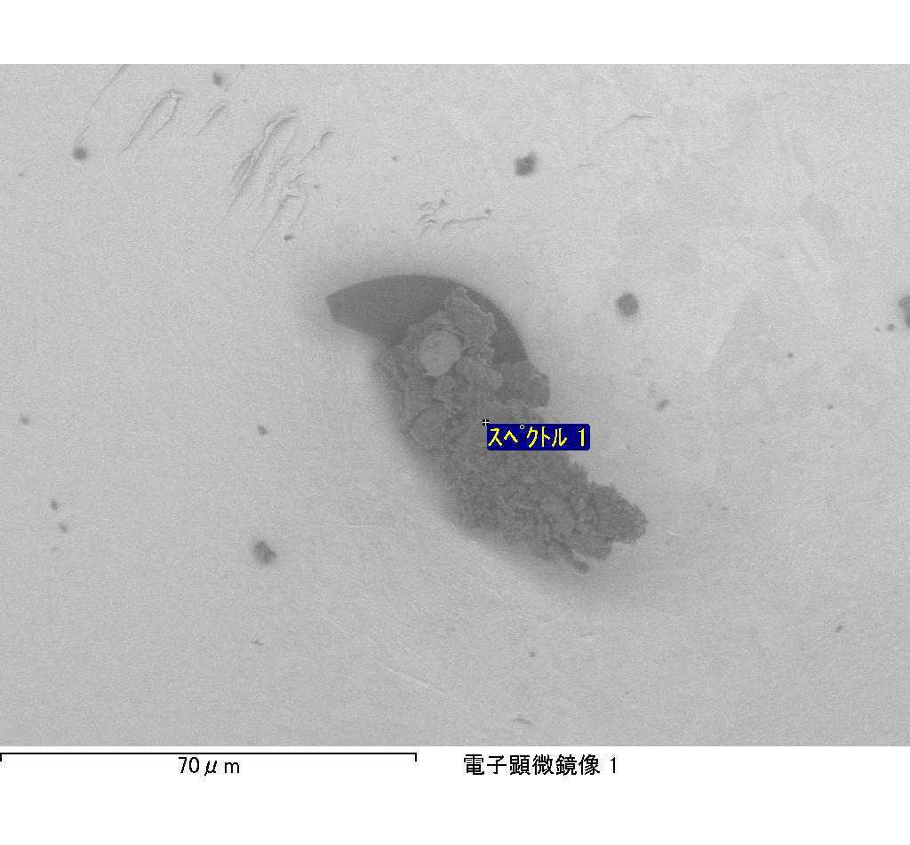

ｽﾍﾟｸﾄﾙﾗﾍﾞﾙ: ｽﾍﾟｸﾄﾙ 1

ﾗｲﾌﾞﾀｲﾑ 120.0 s

収集ｼﾞｵﾒﾄﾘ[度] :

試料傾斜角 = 0.0

方位角 = 0.0

ｴﾚﾍﾞｰｼｮﾝ = 30.0

加速電圧 = 10.00 kV

ｽﾍﾟｸﾄﾙ全ｶｳﾝﾄ数 = 197547

|  |  |  |  |
| --- | --- | --- | --- |
| ｻﾝﾌﾟﾙﾃﾞｰﾀ : | ｴﾈﾙｷﾞｰ[eV] | 分解能[eV] | ｶｳﾝﾄ数 |
| ｽﾄﾛｰﾌﾞ : | 3.8 | 51.83 | 1195258 |
|  |  |  |  |

定量最適化がおこなわれていません

ｽﾍﾟｸﾄﾙﾗﾍﾞﾙ: ｽﾍﾟｸﾄﾙ 2

ﾗｲﾌﾞﾀｲﾑ 120.0 s

収集ｼﾞｵﾒﾄﾘ[度] :

試料傾斜角 = 0.0

方位角 = 0.0

ｴﾚﾍﾞｰｼｮﾝ = 30.0

加速電圧 = 10.00 kV

ｽﾍﾟｸﾄﾙ全ｶｳﾝﾄ数 = 193473

|  |  |  |  |
| --- | --- | --- | --- |
| ｻﾝﾌﾟﾙﾃﾞｰﾀ : | ｴﾈﾙｷﾞｰ[eV] | 分解能[eV] | ｶｳﾝﾄ数 |
| ｽﾄﾛｰﾌﾞ : | 3.8 | 51.77 | 1195807 |
|  |  |  |  |

定量最適化がおこなわれていません

ｽﾍﾟｸﾄﾙ処理 :

省略されたﾋﾟｰｸはありません

処理ｵﾌﾟｼｮﾝ : 酸素 ｽﾄｲｷｵﾒﾄﾘ (ﾉｰﾏﾗｲｽﾞ)

繰り返し回数 = 2

ｽﾀﾝﾀﾞｰﾄﾞ :

Na Albite 1999/06/01

Mg MgO 1999/06/01

Al Al2O3 1999/06/01

Si SiO2 1999/06/01

P GaP 1999/06/01

S FeS2 1999/06/01

K MAD-10 Feldspar 1999/06/01

Ca Wollastonite 1999/06/01

Cr Cr 1999/06/01

Mn Mn 1999/06/01

Fe Fe 1999/06/01

Ni Ni 1999/06/01

|  |  |  |  |  |  |
| --- | --- | --- | --- | --- | --- |
| 元素 | 質量濃度 | 原子数 | 化合物 | 化学式 |  |
|  | [%] | 濃度[%] | 濃度[%] |  |  |
| Na K | 1.23 | 2.33 | 1.66 | Na2O |  |
| Mg K | 13.78 | 24.68 | 22.85 | MgO |  |
| Al K | 0.97 | 1.57 | 1.84 | Al2O3 |  |
| Si K | 11.84 | 18.35 | 25.32 | SiO2 |  |
| P K | -48.59 | -68.33 | -111.34 | P2O5 |  |
| S K | 13.08 | 17.76 | 32.66 | SO3 |  |
| K K | 0.66 | 0.74 | 0.80 | K2O |  |
| Ca K | 0.91 | 0.99 | 1.27 | CaO |  |
| Cr K | 4.53 | 3.79 | 6.62 | Cr2O3 |  |
| Mn K | -1.18 | -0.94 | -1.53 | MnO |  |
| Fe K | 96.95 | 75.61 | 124.73 | FeO |  |
| Ni K | -3.83 | -2.84 | -4.87 | NiO |  |
| O | 9.65 | 26.27 |  |  |  |
| ﾄｰﾀﾙ | 100.00 |  |  |  |  |

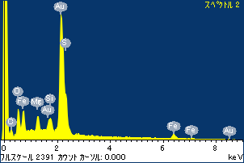

ﾌﾟﾛｼﾞｪｸﾄ : ﾌﾟﾛｼﾞｪｸﾄ 1

ｵｰﾅｰ : Administrator

領域 分析領域 4

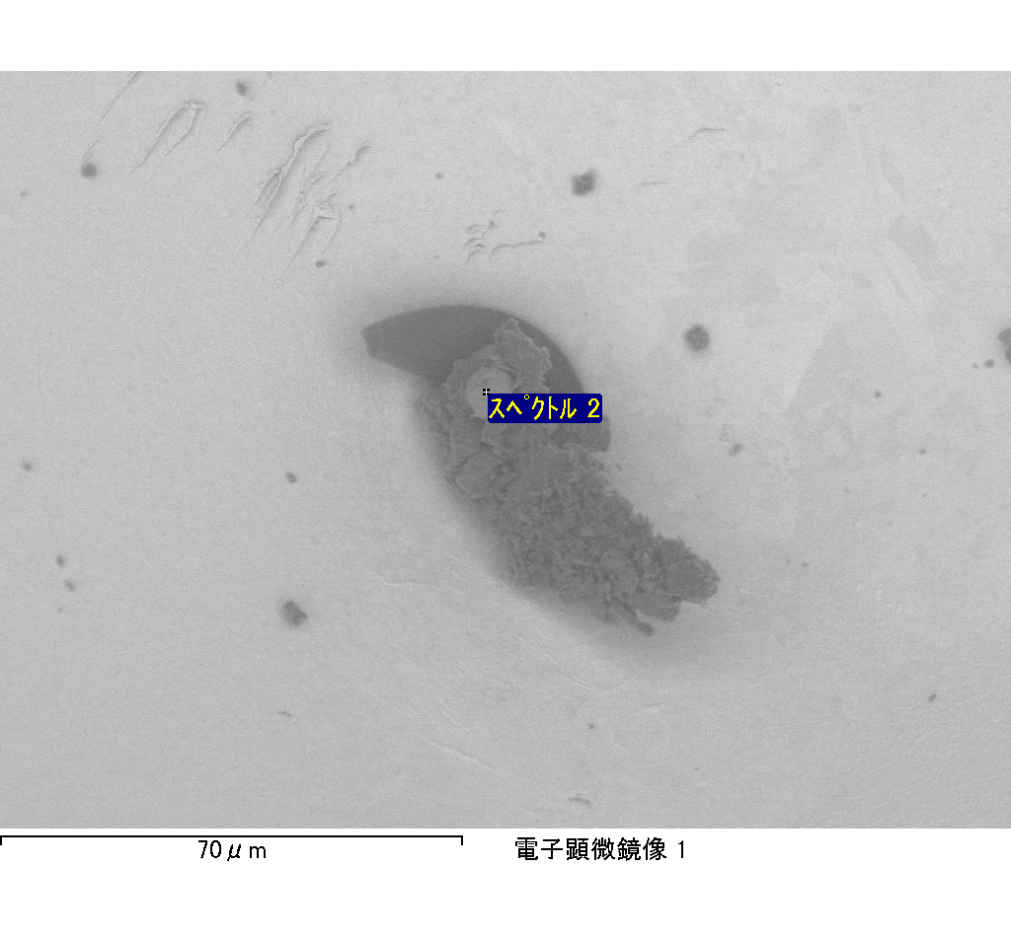

ｽﾍﾟｸﾄﾙﾗﾍﾞﾙ: ｽﾍﾟｸﾄﾙ 4

ﾗｲﾌﾞﾀｲﾑ 120.0 s

収集ｼﾞｵﾒﾄﾘ[度] :

試料傾斜角 = 0.0

方位角 = 0.0

ｴﾚﾍﾞｰｼｮﾝ = 30.0

加速電圧 = 10.00 kV

ｽﾍﾟｸﾄﾙ全ｶｳﾝﾄ数 = 192672

|  |  |  |  |
| --- | --- | --- | --- |
| ｻﾝﾌﾟﾙﾃﾞｰﾀ : | ｴﾈﾙｷﾞｰ[eV] | 分解能[eV] | ｶｳﾝﾄ数 |
| ｽﾄﾛｰﾌﾞ : | 3.8 | 51.81 | 1194351 |
|  |  |  |  |

定量最適化がおこなわれていません

ｽﾍﾟｸﾄﾙ処理 :

定量計算に使用されていないﾋﾟｰｸ : 2.799 keV

処理ｵﾌﾟｼｮﾝ : 酸素 ｽﾄｲｷｵﾒﾄﾘ (ﾉｰﾏﾗｲｽﾞ)

繰り返し回数 = 2

ｽﾀﾝﾀﾞｰﾄﾞ :

Na Albite 1999/06/01

Mg MgO 1999/06/01

Al Al2O3 1999/06/01

Si SiO2 1999/06/01

P GaP 1999/06/01

S FeS2 1999/06/01

K MAD-10 Feldspar 1999/06/01

Ca Wollastonite 1999/06/01

Cr Cr 1999/06/01

Mn Mn 1999/06/01

Fe Fe 1999/06/01

Ni Ni 1999/06/01

|  |  |  |  |  |  |
| --- | --- | --- | --- | --- | --- |
| 元素 | 質量濃度 | 原子数 | 化合物 | 化学式 |  |
|  | [%] | 濃度[%] | 濃度[%] |  |  |
| Na K | -0.48 | -0.32 | -0.65 | Na2O |  |
| Mg K | -11.14 | -7.12 | -18.47 | MgO |  |
| Al K | -1.09 | -0.63 | -2.06 | Al2O3 |  |
| Si K | -40.01 | -22.15 | -85.58 | SiO2 |  |
| P K | 64.34 | 32.30 | 147.42 | P2O5 |  |
| S K | 50.91 | 24.69 | 127.13 | SO3 |  |
| K K | -0.11 | -0.04 | -0.13 | K2O |  |
| Ca K | 0.12 | 0.05 | 0.16 | CaO |  |
| Cr K | 0.61 | 0.18 | 0.89 | Cr2O3 |  |
| Mn K | -8.41 | -2.38 | -10.86 | MnO |  |
| Fe K | -32.07 | -8.93 | -41.26 | FeO |  |
| Ni K | -13.03 | -3.45 | -16.58 | NiO |  |
| O | 90.36 | 87.82 |  |  |  |
| ﾄｰﾀﾙ | 100.00 |  |  |  |  |

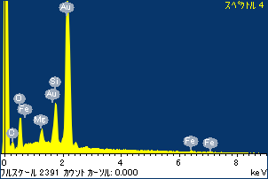

ﾌﾟﾛｼﾞｪｸﾄ : ﾌﾟﾛｼﾞｪｸﾄ 1

ｵｰﾅｰ : Administrator

領域 分析領域 4

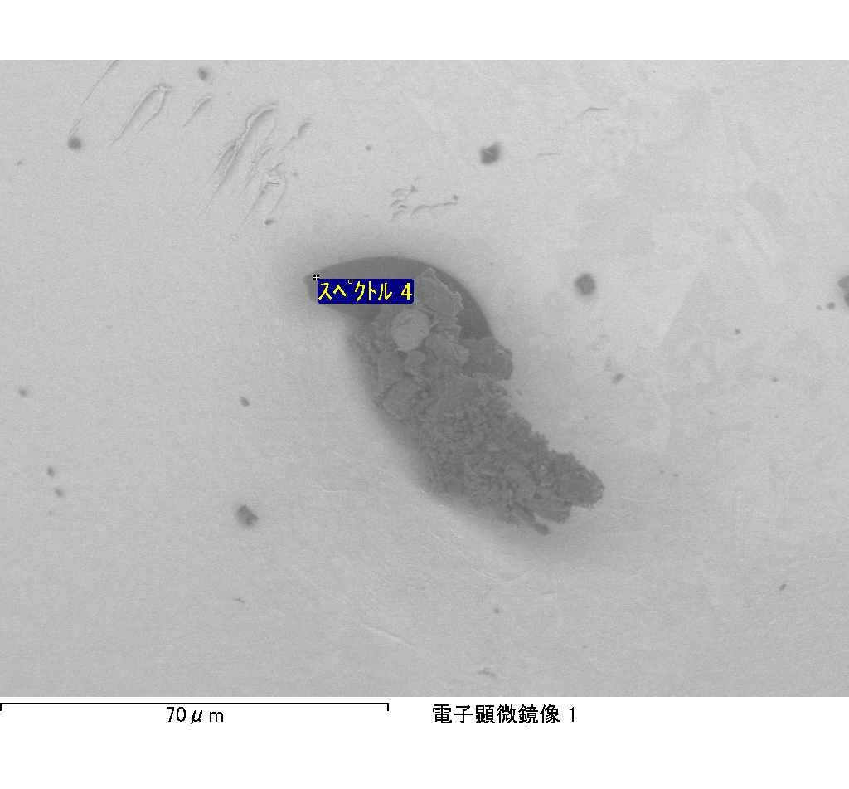

ｽﾍﾟｸﾄﾙﾗﾍﾞﾙ: ｽﾍﾟｸﾄﾙ 1

ﾗｲﾌﾞﾀｲﾑ 120.0 s

収集ｼﾞｵﾒﾄﾘ[度] :

試料傾斜角 = 0.0

方位角 = 0.0

ｴﾚﾍﾞｰｼｮﾝ = 30.0

加速電圧 = 10.00 kV

ｽﾍﾟｸﾄﾙ全ｶｳﾝﾄ数 = 181594

|  |  |  |  |
| --- | --- | --- | --- |
| ｻﾝﾌﾟﾙﾃﾞｰﾀ : | ｴﾈﾙｷﾞｰ[eV] | 分解能[eV] | ｶｳﾝﾄ数 |
| ｽﾄﾛｰﾌﾞ : | 3.8 | 51.84 | 1196257 |
|  |  |  |  |

定量最適化がおこなわれていません

ｽﾍﾟｸﾄﾙ処理 :

省略されたﾋﾟｰｸはありません

処理ｵﾌﾟｼｮﾝ : 酸素 ｽﾄｲｷｵﾒﾄﾘ (ﾉｰﾏﾗｲｽﾞ)

繰り返し回数 = 2

ｽﾀﾝﾀﾞｰﾄﾞ :

Na Albite 1999/06/01

Mg MgO 1999/06/01

Al Al2O3 1999/06/01

Si SiO2 1999/06/01

P GaP 1999/06/01

S FeS2 1999/06/01

K MAD-10 Feldspar 1999/06/01

Ca Wollastonite 1999/06/01

Cr Cr 1999/06/01

Mn Mn 1999/06/01

Fe Fe 1999/06/01

Ni Ni 1999/06/01

|  |  |  |  |  |  |
| --- | --- | --- | --- | --- | --- |
| 元素 | 質量濃度 | 原子数 | 化合物 | 化学式 |  |
|  | [%] | 濃度[%] | 濃度[%] |  |  |
| Na K | -2.90 | -1.56 | -3.91 | Na2O |  |
| Mg K | -58.65 | -29.75 | -97.25 | MgO |  |
| Al K | -4.31 | -1.97 | -8.15 | Al2O3 |  |
| Si K | -64.26 | -28.21 | -137.47 | SiO2 |  |
| P K | 114.93 | 45.76 | 263.35 | P2O5 |  |
| S K | 91.41 | 35.15 | 228.25 | SO3 |  |
| K K | -1.13 | -0.36 | -1.36 | K2O |  |
| Ca K | -2.53 | -0.78 | -3.53 | CaO |  |
| Cr K | 6.05 | 1.43 | 8.84 | Cr2O3 |  |
| Mn K | 1.68 | 0.38 | 2.17 | MnO |  |
| Fe K | -106.07 | -23.42 | -136.46 | FeO |  |
| Ni K | -11.37 | -2.39 | -14.47 | NiO |  |
| O | 137.15 | 105.71 |  |  |  |
| ﾄｰﾀﾙ | 100.00 |  |  |  |  |

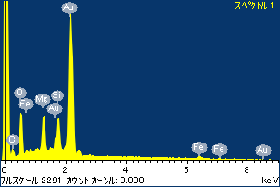

ﾌﾟﾛｼﾞｪｸﾄ : ﾌﾟﾛｼﾞｪｸﾄ 1

ｵｰﾅｰ : Administrator

領域 分析領域 5

