ｽﾍﾟｸﾄﾙﾗﾍﾞﾙ: ｽﾍﾟｸﾄﾙ 1

ﾗｲﾌﾞﾀｲﾑ 120.0 s

収集ｼﾞｵﾒﾄﾘ[度] :

試料傾斜角 = 0.0

方位角 = 0.0

ｴﾚﾍﾞｰｼｮﾝ = 30.0

加速電圧 = 10.00 kV

ｽﾍﾟｸﾄﾙ全ｶｳﾝﾄ数 = 205565

|  |  |  |  |
| --- | --- | --- | --- |
| ｻﾝﾌﾟﾙﾃﾞｰﾀ : | ｴﾈﾙｷﾞｰ[eV] | 分解能[eV] | ｶｳﾝﾄ数 |
| ｽﾄﾛｰﾌﾞ : | 3.8 | 51.80 | 1194423 |
|  |  |  |  |

定量最適化がおこなわれていません

ｽﾍﾟｸﾄﾙ処理 :

定量計算に使用されていないﾋﾟｰｸ : 2.775 keV

処理ｵﾌﾟｼｮﾝ : 酸素 ｽﾄｲｷｵﾒﾄﾘ (ﾉｰﾏﾗｲｽﾞ)

繰り返し回数 = 1

ｽﾀﾝﾀﾞｰﾄﾞ :

Na Albite 1999/06/01

Mg MgO 1999/06/01

Al Al2O3 1999/06/01

Si SiO2 1999/06/01

P GaP 1999/06/01

S FeS2 1999/06/01

K MAD-10 Feldspar 1999/06/01

Ca Wollastonite 1999/06/01

Cr Cr 1999/06/01

Mn Mn 1999/06/01

Fe Fe 1999/06/01

Ni Ni 1999/06/01

|  |  |  |  |  |  |
| --- | --- | --- | --- | --- | --- |
| 元素 | 質量濃度 | 原子数 | 化合物 | 化学式 |  |
|  | [%] | 濃度[%] | 濃度[%] |  |  |
| Na K | -0.18 | -0.17 | -0.24 | Na2O |  |
| Mg K | -0.12 | -0.10 | -0.19 | MgO |  |
| Al K | -0.25 | -0.20 | -0.48 | Al2O3 |  |
| Si K | -0.03 | -0.02 | -0.07 | SiO2 |  |
| P K | 20.11 | 13.82 | 46.08 | P2O5 |  |
| S K | 17.43 | 11.57 | 43.52 | SO3 |  |
| K K | 0.19 | 0.10 | 0.23 | K2O |  |
| Ca K | -0.60 | -0.32 | -0.84 | CaO |  |
| Cr K | -0.01 | 0.00 | -0.01 | Cr2O3 |  |
| Mn K | 0.12 | 0.04 | 0.15 | MnO |  |
| Fe K | 0.96 | 0.37 | 1.24 | FeO |  |
| Ni K | 8.34 | 3.02 | 10.61 | NiO |  |
| O | 54.04 | 71.89 |  |  |  |
| ﾄｰﾀﾙ | 100.00 |  |  |  |  |

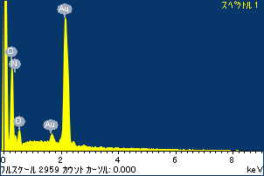

ﾌﾟﾛｼﾞｪｸﾄ : ﾌﾟﾛｼﾞｪｸﾄ 1

ｵｰﾅｰ : Administrator

領域 分析領域 2

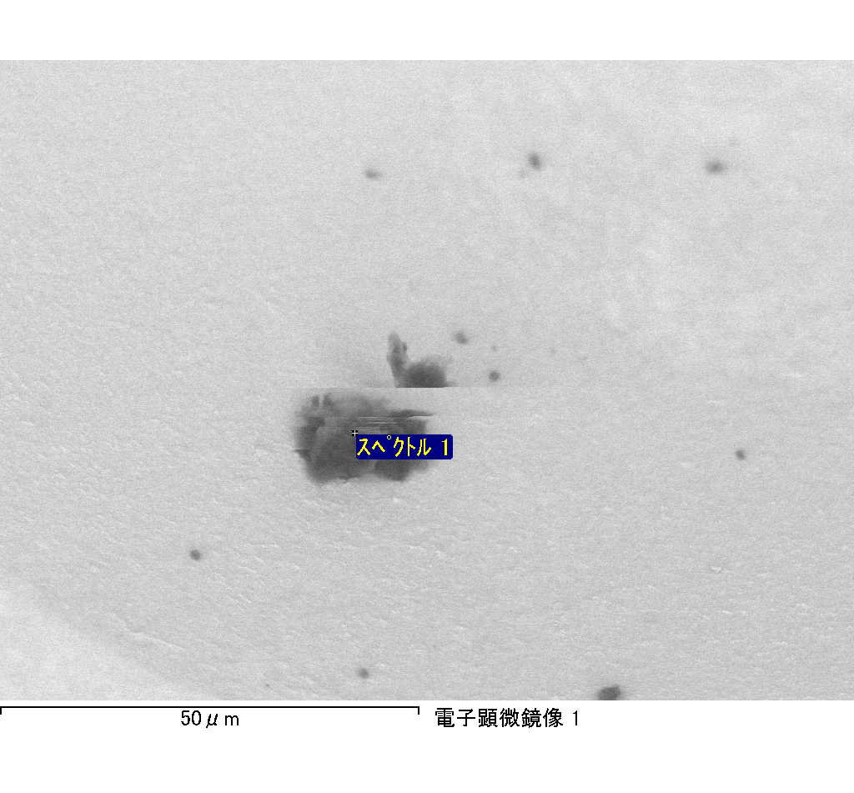

ｽﾍﾟｸﾄﾙﾗﾍﾞﾙ: ｽﾍﾟｸﾄﾙ 1

ﾗｲﾌﾞﾀｲﾑ 120.0 s

収集ｼﾞｵﾒﾄﾘ[度] :

試料傾斜角 = 0.0

方位角 = 0.0

ｴﾚﾍﾞｰｼｮﾝ = 30.0

加速電圧 = 10.00 kV

ｽﾍﾟｸﾄﾙ全ｶｳﾝﾄ数 = 180653

|  |  |  |  |
| --- | --- | --- | --- |
| ｻﾝﾌﾟﾙﾃﾞｰﾀ : | ｴﾈﾙｷﾞｰ[eV] | 分解能[eV] | ｶｳﾝﾄ数 |
| ｽﾄﾛｰﾌﾞ : | 3.8 | 51.80 | 1195317 |
|  |  |  |  |

定量最適化がおこなわれていません

ｽﾍﾟｸﾄﾙ処理 :

省略されたﾋﾟｰｸはありません

処理ｵﾌﾟｼｮﾝ : 酸素 ｽﾄｲｷｵﾒﾄﾘ (ﾉｰﾏﾗｲｽﾞ)

繰り返し回数 = 1

ｽﾀﾝﾀﾞｰﾄﾞ :

Na Albite 1999/06/01

Mg MgO 1999/06/01

Al Al2O3 1999/06/01

Si SiO2 1999/06/01

P GaP 1999/06/01

S FeS2 1999/06/01

K MAD-10 Feldspar 1999/06/01

Ca Wollastonite 1999/06/01

Cr Cr 1999/06/01

Mn Mn 1999/06/01

Fe Fe 1999/06/01

Ni Ni 1999/06/01

|  |  |  |  |  |  |
| --- | --- | --- | --- | --- | --- |
| 元素 | 質量濃度 | 原子数 | 化合物 | 化学式 |  |
|  | [%] | 濃度[%] | 濃度[%] |  |  |
| Na K | -0.31 | -0.28 | -0.42 | Na2O |  |
| Mg K | -0.07 | -0.06 | -0.11 | MgO |  |
| Al K | -0.59 | -0.44 | -1.12 | Al2O3 |  |
| Si K | -0.16 | -0.11 | -0.33 | SiO2 |  |
| P K | 22.98 | 15.00 | 52.67 | P2O5 |  |
| S K | 19.35 | 12.20 | 48.33 | SO3 |  |
| K K | -0.59 | -0.30 | -0.71 | K2O |  |
| Ca K | 0.62 | 0.31 | 0.87 | CaO |  |
| Cr K | 0.73 | 0.28 | 1.06 | Cr2O3 |  |
| Mn K | -1.49 | -0.55 | -1.93 | MnO |  |
| Fe K | -1.88 | -0.68 | -2.42 | FeO |  |
| Ni K | 3.23 | 1.11 | 4.11 | NiO |  |
| O | 58.17 | 73.50 |  |  |  |
| ﾄｰﾀﾙ | 100.00 |  |  |  |  |

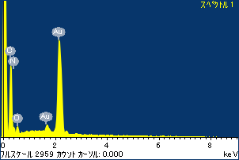

ﾌﾟﾛｼﾞｪｸﾄ : ﾌﾟﾛｼﾞｪｸﾄ 1

ｵｰﾅｰ : Administrator

領域 分析領域 3

