ｽﾍﾟｸﾄﾙﾗﾍﾞﾙ: ｽﾍﾟｸﾄﾙ 1

ﾗｲﾌﾞﾀｲﾑ 120.0 s

収集ｼﾞｵﾒﾄﾘ[度] :

試料傾斜角 = 0.0

方位角 = 0.0

ｴﾚﾍﾞｰｼｮﾝ = 30.0

加速電圧 = 10.00 kV

ｽﾍﾟｸﾄﾙ全ｶｳﾝﾄ数 = 205403

|  |  |  |  |
| --- | --- | --- | --- |
| ｻﾝﾌﾟﾙﾃﾞｰﾀ : | ｴﾈﾙｷﾞｰ[eV] | 分解能[eV] | ｶｳﾝﾄ数 |
| ｽﾄﾛｰﾌﾞ : | 3.8 | 51.81 | 1194921 |
|  |  |  |  |

定量最適化がおこなわれていません

ｽﾍﾟｸﾄﾙ処理 :

省略されたﾋﾟｰｸはありません

処理ｵﾌﾟｼｮﾝ : 酸素 ｽﾄｲｷｵﾒﾄﾘ (ﾉｰﾏﾗｲｽﾞ)

繰り返し回数 = 2

ｽﾀﾝﾀﾞｰﾄﾞ :

Na Albite 1999/06/01

Mg MgO 1999/06/01

Al Al2O3 1999/06/01

Si SiO2 1999/06/01

P GaP 1999/06/01

S FeS2 1999/06/01

K MAD-10 Feldspar 1999/06/01

Ca Wollastonite 1999/06/01

Cr Cr 1999/06/01

Mn Mn 1999/06/01

Fe Fe 1999/06/01

Ni Ni 1999/06/01

|  |  |  |  |  |  |
| --- | --- | --- | --- | --- | --- |
| 元素 | 質量濃度 | 原子数 | 化合物 | 化学式 |  |
|  | [%] | 濃度[%] | 濃度[%] |  |  |
| Na K | -1.06 | -1.89 | -1.43 | Na2O |  |
| Mg K | 74.01 | 124.53 | 122.72 | MgO |  |
| Al K | 2.38 | 3.61 | 4.50 | Al2O3 |  |
| Si K | 109.48 | 159.45 | 234.21 | SiO2 |  |
| P K | -91.06 | -120.26 | -208.65 | P2O5 |  |
| S K | -68.96 | -87.98 | -172.20 | SO3 |  |
| K K | -1.21 | -1.27 | -1.46 | K2O |  |
| Ca K | 3.69 | 3.76 | 5.16 | CaO |  |
| Cr K | 4.23 | 3.33 | 6.18 | Cr2O3 |  |
| Mn K | -0.22 | -0.16 | -0.29 | MnO |  |
| Fe K | 67.20 | 49.22 | 86.45 | FeO |  |
| Ni K | 19.48 | 13.57 | 24.79 | NiO |  |
| O | -17.96 | -45.92 |  |  |  |
| ﾄｰﾀﾙ | 100.00 |  |  |  |  |

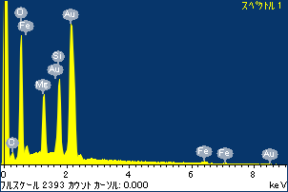

ﾌﾟﾛｼﾞｪｸﾄ : ﾌﾟﾛｼﾞｪｸﾄ 1

ｵｰﾅｰ : Administrator

領域 分析領域 1

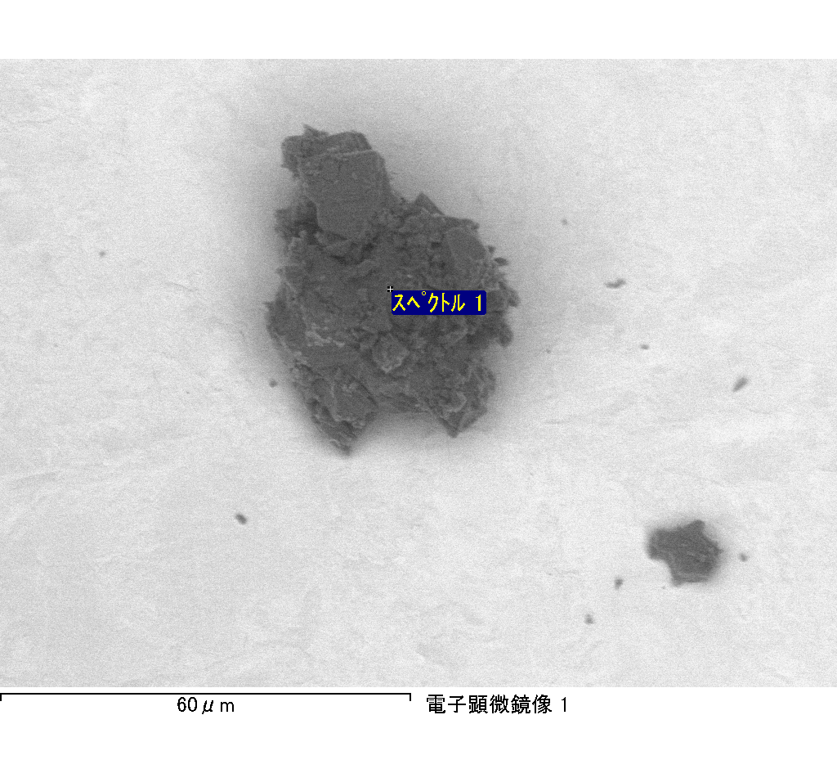

ｽﾍﾟｸﾄﾙﾗﾍﾞﾙ: ｽﾍﾟｸﾄﾙ 2

ﾗｲﾌﾞﾀｲﾑ 120.0 s

収集ｼﾞｵﾒﾄﾘ[度] :

試料傾斜角 = 0.0

方位角 = 0.0

ｴﾚﾍﾞｰｼｮﾝ = 30.0

加速電圧 = 10.00 kV

ｽﾍﾟｸﾄﾙ全ｶｳﾝﾄ数 = 195077

|  |  |  |  |
| --- | --- | --- | --- |
| ｻﾝﾌﾟﾙﾃﾞｰﾀ : | ｴﾈﾙｷﾞｰ[eV] | 分解能[eV] | ｶｳﾝﾄ数 |
| ｽﾄﾛｰﾌﾞ : | 3.8 | 51.80 | 1195733 |
|  |  |  |  |

定量最適化がおこなわれていません

ｽﾍﾟｸﾄﾙ処理 :

定量計算に使用されていないﾋﾟｰｸ : 2.775 keV

処理ｵﾌﾟｼｮﾝ : 酸素 ｽﾄｲｷｵﾒﾄﾘ (ﾉｰﾏﾗｲｽﾞ)

繰り返し回数 = 2

ｽﾀﾝﾀﾞｰﾄﾞ :

Na Albite 1999/06/01

Mg MgO 1999/06/01

Al Al2O3 1999/06/01

Si SiO2 1999/06/01

P GaP 1999/06/01

S FeS2 1999/06/01

K MAD-10 Feldspar 1999/06/01

Ca Wollastonite 1999/06/01

Cr Cr 1999/06/01

Mn Mn 1999/06/01

Fe Fe 1999/06/01

Ni Ni 1999/06/01

|  |  |  |  |  |  |
| --- | --- | --- | --- | --- | --- |
| 元素 | 質量濃度 | 原子数 | 化合物 | 化学式 |  |
|  | [%] | 濃度[%] | 濃度[%] |  |  |
| Na K | 0.43 | 0.33 | 0.58 | Na2O |  |
| Mg K | -57.75 | -41.70 | -95.76 | MgO |  |
| Al K | -0.94 | -0.61 | -1.78 | Al2O3 |  |
| Si K | -50.31 | -31.44 | -107.63 | SiO2 |  |
| P K | 79.52 | 45.06 | 182.21 | P2O5 |  |
| S K | 64.33 | 35.22 | 160.63 | SO3 |  |
| K K | 1.79 | 0.80 | 2.15 | K2O |  |
| Ca K | -0.79 | -0.35 | -1.10 | CaO |  |
| Cr K | -1.98 | -0.67 | -2.89 | Cr2O3 |  |
| Mn K | 4.15 | 1.33 | 5.36 | MnO |  |
| Fe K | -70.70 | -22.22 | -90.96 | FeO |  |
| Ni K | 38.65 | 11.56 | 49.19 | NiO |  |
| O | 93.60 | 102.69 |  |  |  |
| ﾄｰﾀﾙ | 100.00 |  |  |  |  |

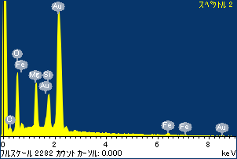

ﾌﾟﾛｼﾞｪｸﾄ : ﾌﾟﾛｼﾞｪｸﾄ 1

ｵｰﾅｰ : Administrator

領域 分析領域 1

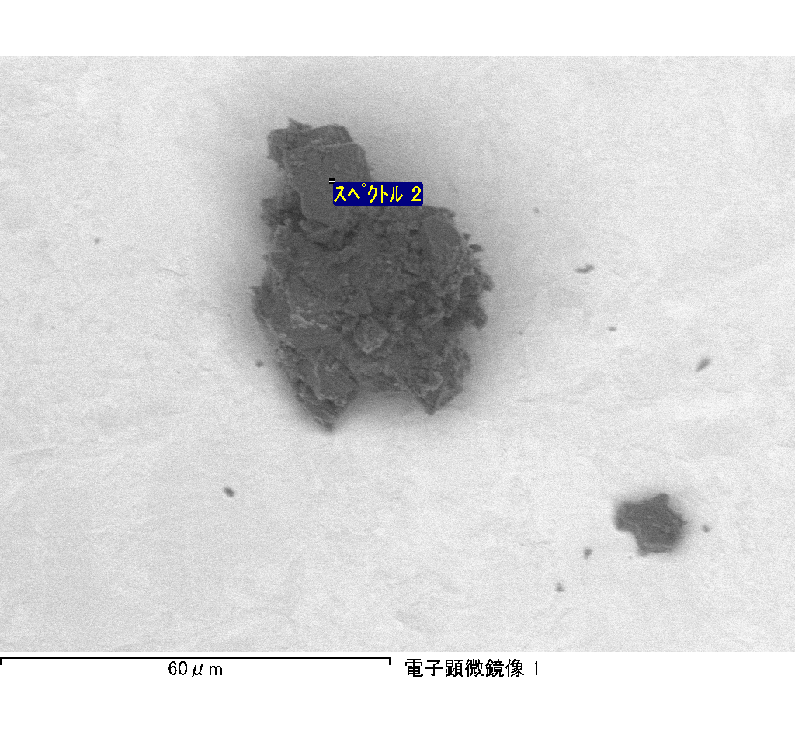

ｽﾍﾟｸﾄﾙ処理 :

定量計算に使用されていないﾋﾟｰｸ : 4.730 keV

処理ｵﾌﾟｼｮﾝ : 酸素 ｽﾄｲｷｵﾒﾄﾘ (ﾉｰﾏﾗｲｽﾞ)

繰り返し回数 = 2

ｽﾀﾝﾀﾞｰﾄﾞ :

Na Albite 1999/06/01

Mg MgO 1999/06/01

Al Al2O3 1999/06/01

Si SiO2 1999/06/01

P GaP 1999/06/01

S FeS2 1999/06/01

K MAD-10 Feldspar 1999/06/01

Ca Wollastonite 1999/06/01

Cr Cr 1999/06/01

Mn Mn 1999/06/01

Fe Fe 1999/06/01

Ni Ni 1999/06/01

|  |  |  |  |  |  |
| --- | --- | --- | --- | --- | --- |
| 元素 | 質量濃度 | 原子数 | 化合物 | 化学式 |  |
|  | [%] | 濃度[%] | 濃度[%] |  |  |
| Na K | -2.48 | -0.50 | -3.35 | Na2O |  |
| Mg K | -758.50 | -143.69 | -1257.64 | MgO |  |
| Al K | -8.30 | -1.42 | -15.69 | Al2O3 |  |
| Si K | -607.67 | -99.65 | -1299.97 | SiO2 |  |
| P K | 812.13 | 120.76 | 1860.84 | P2O5 |  |
| S K | 647.17 | 92.96 | 1615.92 | SO3 |  |
| K K | -18.09 | -2.13 | -21.79 | K2O |  |
| Ca K | -3.76 | -0.43 | -5.27 | CaO |  |
| Cr K | -26.85 | -2.38 | -39.24 | Cr2O3 |  |
| Mn K | -32.03 | -2.69 | -41.36 | MnO |  |
| Fe K | -494.35 | -40.77 | -635.97 | FeO |  |
| Ni K | -44.40 | -3.48 | -56.49 | NiO |  |
| O | 637.13 | 183.41 |  |  |  |
| ﾄｰﾀﾙ | 100.00 |  |  |  |  |

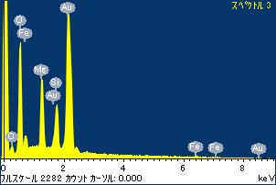

ﾌﾟﾛｼﾞｪｸﾄ : ﾌﾟﾛｼﾞｪｸﾄ 1

ｵｰﾅｰ : Administrator

領域 分析領域 1

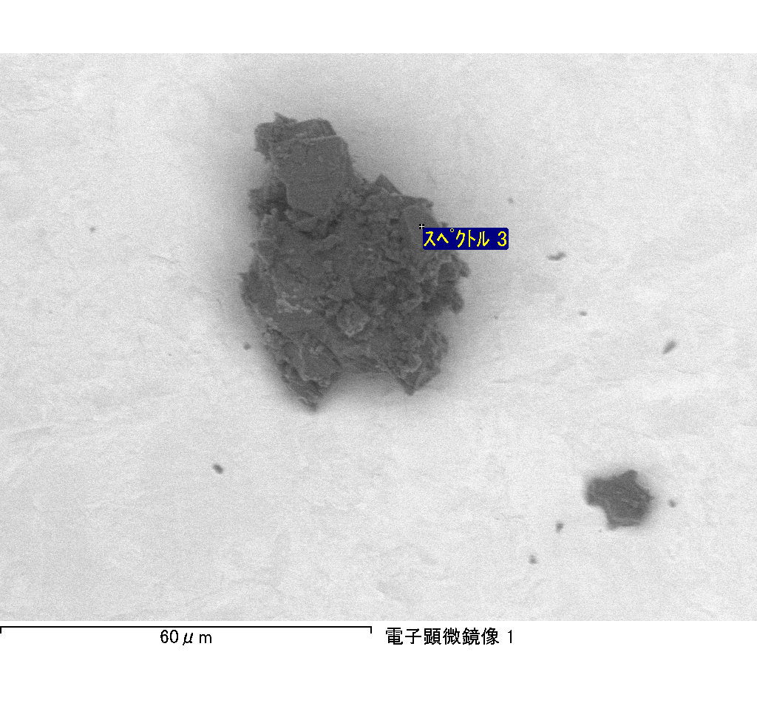

ｽﾍﾟｸﾄﾙﾗﾍﾞﾙ: ｽﾍﾟｸﾄﾙ 3

ﾗｲﾌﾞﾀｲﾑ 120.0 s

収集ｼﾞｵﾒﾄﾘ[度] :

試料傾斜角 = 0.0

方位角 = 0.0

ｴﾚﾍﾞｰｼｮﾝ = 30.0

加速電圧 = 10.00 kV

ｽﾍﾟｸﾄﾙ全ｶｳﾝﾄ数 = 204666

|  |  |  |  |
| --- | --- | --- | --- |
| ｻﾝﾌﾟﾙﾃﾞｰﾀ : | ｴﾈﾙｷﾞｰ[eV] | 分解能[eV] | ｶｳﾝﾄ数 |
| ｽﾄﾛｰﾌﾞ : | 3.8 | 51.76 | 1193833 |
|  |  |  |  |

定量最適化がおこなわれていません

ｽﾍﾟｸﾄﾙﾗﾍﾞﾙ: ｽﾍﾟｸﾄﾙ 5

ﾗｲﾌﾞﾀｲﾑ 120.0 s

収集ｼﾞｵﾒﾄﾘ[度] :

試料傾斜角 = 0.0

方位角 = 0.0

ｴﾚﾍﾞｰｼｮﾝ = 30.0

加速電圧 = 10.00 kV

ｽﾍﾟｸﾄﾙ全ｶｳﾝﾄ数 = 178661

|  |  |  |  |
| --- | --- | --- | --- |
| ｻﾝﾌﾟﾙﾃﾞｰﾀ : | ｴﾈﾙｷﾞｰ[eV] | 分解能[eV] | ｶｳﾝﾄ数 |
| ｽﾄﾛｰﾌﾞ : | 3.8 | 51.84 | 1196673 |
|  |  |  |  |

定量最適化がおこなわれていません

ｽﾍﾟｸﾄﾙ処理 :

定量計算に使用されていないﾋﾟｰｸ : 2.800 keV

処理ｵﾌﾟｼｮﾝ : 酸素 ｽﾄｲｷｵﾒﾄﾘ (ﾉｰﾏﾗｲｽﾞ)

繰り返し回数 = 2

ｽﾀﾝﾀﾞｰﾄﾞ :

Na Albite 1999/06/01

Mg MgO 1999/06/01

Al Al2O3 1999/06/01

Si SiO2 1999/06/01

P GaP 1999/06/01

S FeS2 1999/06/01

K MAD-10 Feldspar 1999/06/01

Ca Wollastonite 1999/06/01

Cr Cr 1999/06/01

Mn Mn 1999/06/01

Fe Fe 1999/06/01

Ni Ni 1999/06/01

|  |  |  |  |  |  |
| --- | --- | --- | --- | --- | --- |
| 元素 | 質量濃度 | 原子数 | 化合物 | 化学式 |  |
|  | [%] | 濃度[%] | 濃度[%] |  |  |
| Na K | -1.18 | -0.76 | -1.59 | Na2O |  |
| Mg K | -20.72 | -12.68 | -34.35 | MgO |  |
| Al K | -1.18 | -0.65 | -2.22 | Al2O3 |  |
| Si K | -44.47 | -23.56 | -95.14 | SiO2 |  |
| P K | 72.08 | 34.62 | 165.17 | P2O5 |  |
| S K | 60.11 | 27.89 | 150.09 | SO3 |  |
| K K | -0.13 | -0.05 | -0.15 | K2O |  |
| Ca K | -1.88 | -0.70 | -2.63 | CaO |  |
| Cr K | -1.74 | -0.50 | -2.54 | Cr2O3 |  |
| Mn K | -0.40 | -0.11 | -0.51 | MnO |  |
| Fe K | -34.16 | -9.10 | -43.94 | FeO |  |
| Ni K | -25.28 | -6.41 | -32.17 | NiO |  |
| O | 98.94 | 91.99 |  |  |  |
| ﾄｰﾀﾙ | 100.00 |  |  |  |  |

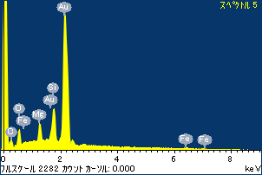

ﾌﾟﾛｼﾞｪｸﾄ : ﾌﾟﾛｼﾞｪｸﾄ 1

ｵｰﾅｰ : Administrator

領域 分析領域 1

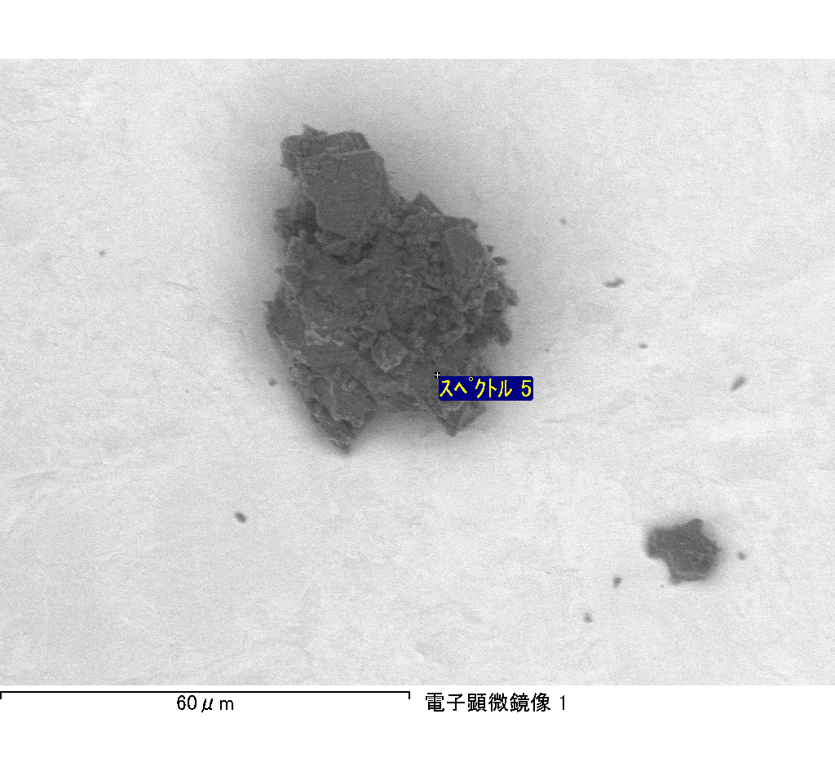

ｽﾍﾟｸﾄﾙﾗﾍﾞﾙ: ｽﾍﾟｸﾄﾙ 6

ﾗｲﾌﾞﾀｲﾑ 67.0 s

収集ｼﾞｵﾒﾄﾘ[度] :

試料傾斜角 = 0.0

方位角 = 0.0

ｴﾚﾍﾞｰｼｮﾝ = 30.0

加速電圧 = 10.00 kV

ｽﾍﾟｸﾄﾙ全ｶｳﾝﾄ数 = 106508

|  |  |  |  |
| --- | --- | --- | --- |
| ｻﾝﾌﾟﾙﾃﾞｰﾀ : | ｴﾈﾙｷﾞｰ[eV] | 分解能[eV] | ｶｳﾝﾄ数 |
| ｽﾄﾛｰﾌﾞ : | 3.8 | 51.80 | 667607 |
|  |  |  |  |

定量最適化がおこなわれていません

ｽﾍﾟｸﾄﾙ処理 :

省略されたﾋﾟｰｸはありません

処理ｵﾌﾟｼｮﾝ : 酸素 ｽﾄｲｷｵﾒﾄﾘ (ﾉｰﾏﾗｲｽﾞ)

繰り返し回数 = 2

ｽﾀﾝﾀﾞｰﾄﾞ :

Na Albite 1999/06/01

Mg MgO 1999/06/01

Al Al2O3 1999/06/01

Si SiO2 1999/06/01

P GaP 1999/06/01

S FeS2 1999/06/01

K MAD-10 Feldspar 1999/06/01

Ca Wollastonite 1999/06/01

Cr Cr 1999/06/01

Mn Mn 1999/06/01

Fe Fe 1999/06/01

Ni Ni 1999/06/01

|  |  |  |  |  |  |
| --- | --- | --- | --- | --- | --- |
| 元素 | 質量濃度 | 原子数 | 化合物 | 化学式 |  |
|  | [%] | 濃度[%] | 濃度[%] |  |  |
| Na K | -0.30 | -0.27 | -0.41 | Na2O |  |
| Mg K | -14.75 | -12.31 | -24.46 | MgO |  |
| Al K | -2.22 | -1.67 | -4.19 | Al2O3 |  |
| Si K | -29.60 | -21.39 | -63.32 | SiO2 |  |
| P K | 43.91 | 28.77 | 100.61 | P2O5 |  |
| S K | 36.60 | 23.17 | 91.39 | SO3 |  |
| K K | 0.07 | 0.04 | 0.09 | K2O |  |
| Ca K | -2.48 | -1.26 | -3.47 | CaO |  |
| Cr K | 5.92 | 2.31 | 8.65 | Cr2O3 |  |
| Mn K | -1.66 | -0.62 | -2.15 | MnO |  |
| Fe K | -21.86 | -7.95 | -28.13 | FeO |  |
| Ni K | 19.95 | 6.90 | 25.38 | NiO |  |
| O | 66.43 | 84.27 |  |  |  |
| ﾄｰﾀﾙ | 100.00 |  |  |  |  |

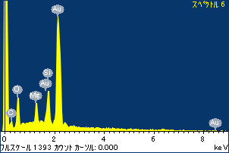

ﾌﾟﾛｼﾞｪｸﾄ : ﾌﾟﾛｼﾞｪｸﾄ 1

ｵｰﾅｰ : Administrator

領域 分析領域 1

