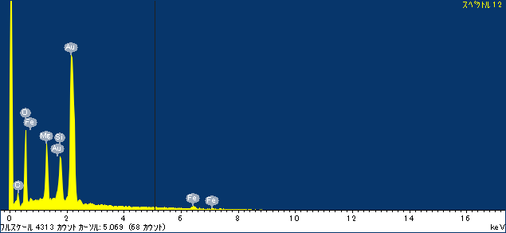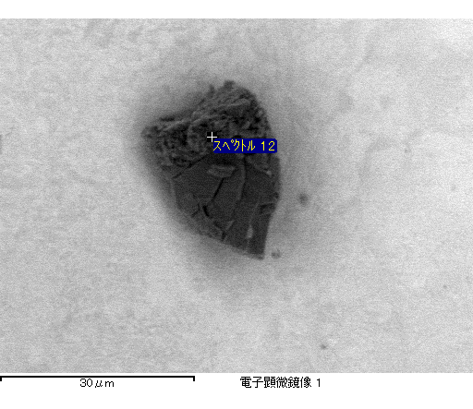

ｺﾒﾝﾄ :

2017/04/10 15:43:58

ﾌﾟﾛｼﾞｪｸﾄ 1

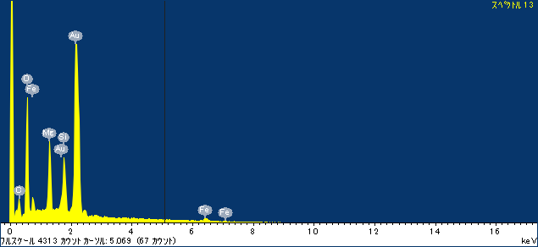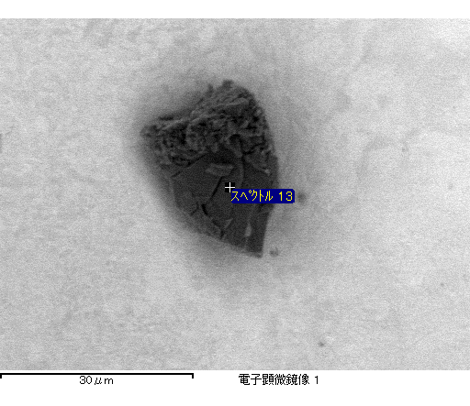

ｺﾒﾝﾄ :

2017/04/10 15:44:10

ﾌﾟﾛｼﾞｪｸﾄ 1

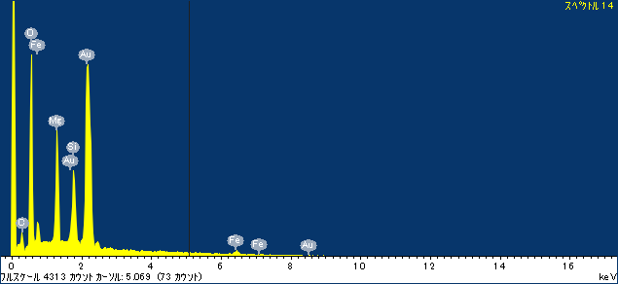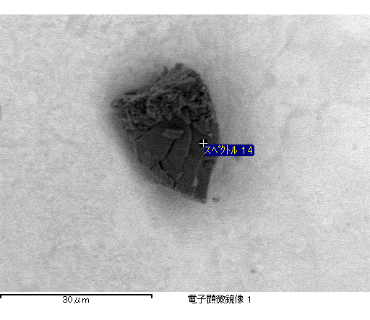

ｺﾒﾝﾄ :

2017/04/10 15:44:25

ﾌﾟﾛｼﾞｪｸﾄ 1

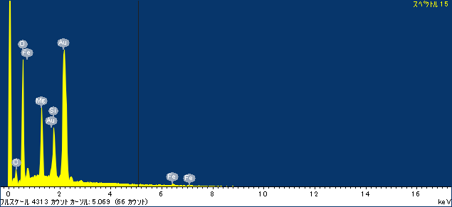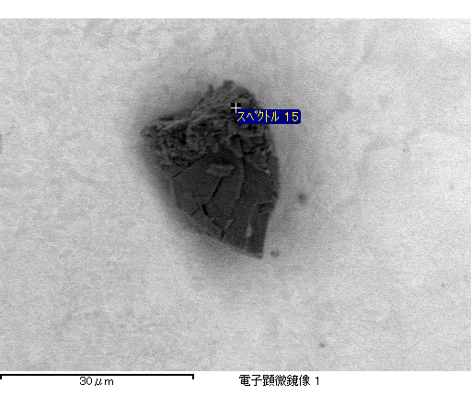

ｺﾒﾝﾄ :

2017/04/10 15:44:33

ﾌﾟﾛｼﾞｪｸﾄ 1

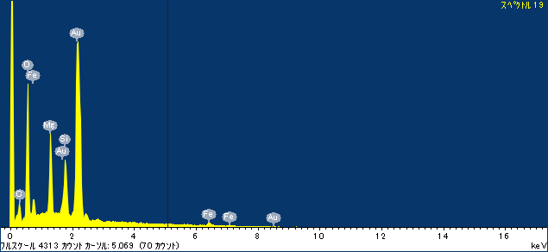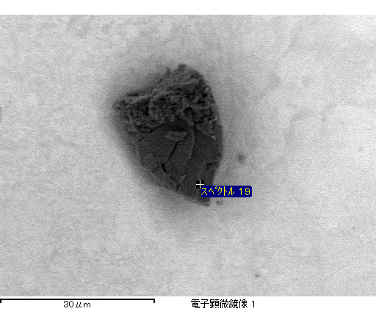

ｺﾒﾝﾄ :

2017/04/10 15:45:59

ﾌﾟﾛｼﾞｪｸﾄ 1