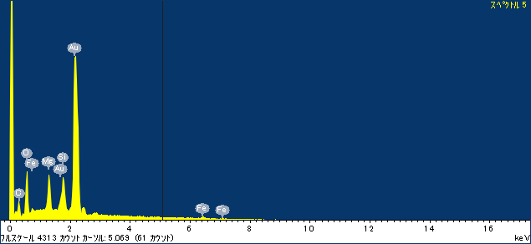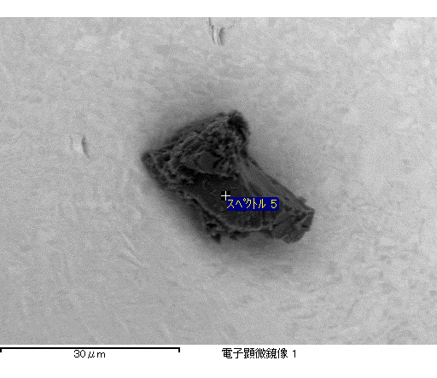

ｺﾒﾝﾄ :

2017/04/10 16:14:09

ﾌﾟﾛｼﾞｪｸﾄ 1

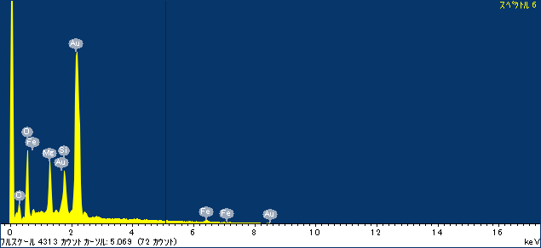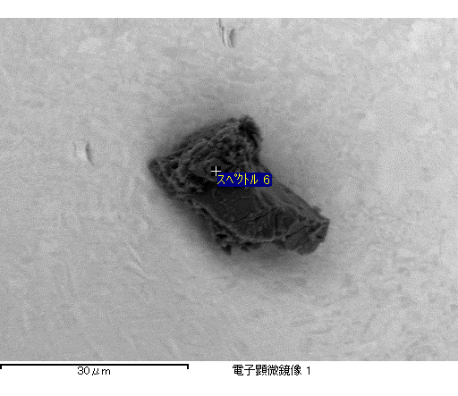

ｺﾒﾝﾄ :

2017/04/10 16:14:18

ﾌﾟﾛｼﾞｪｸﾄ 1

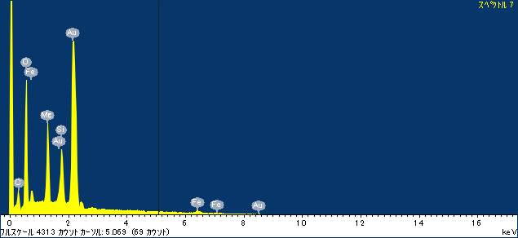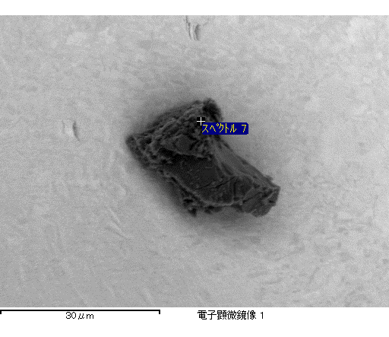

ｺﾒﾝﾄ :

2017/04/10 16:14:26

ﾌﾟﾛｼﾞｪｸﾄ 1

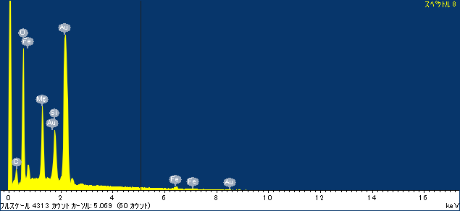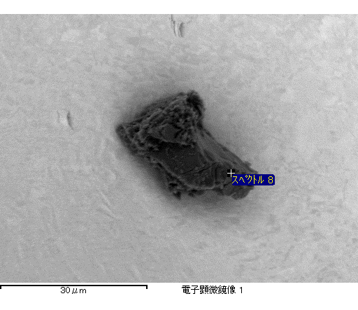

ｺﾒﾝﾄ :

2017/04/10 16:14:32

ﾌﾟﾛｼﾞｪｸﾄ 1

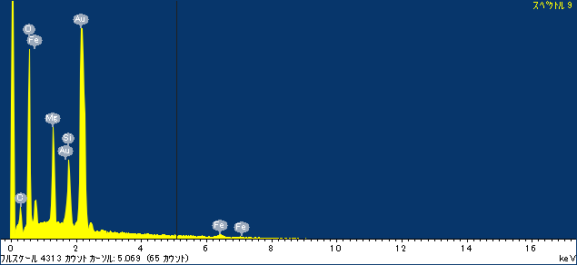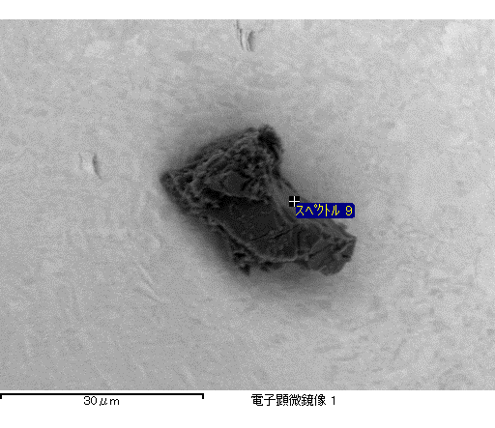

ｺﾒﾝﾄ :

2017/04/10 16:14:38

ﾌﾟﾛｼﾞｪｸﾄ 1