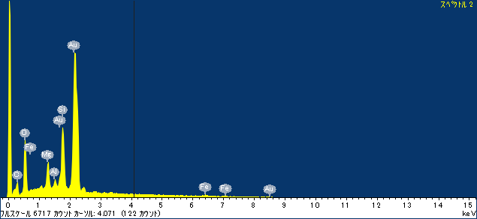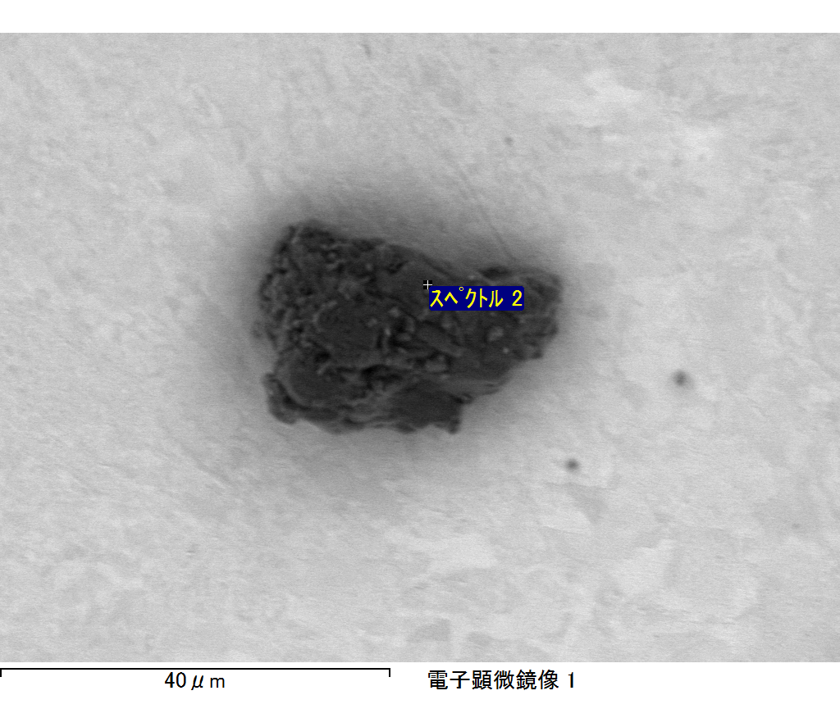

ｺﾒﾝﾄ :

2017/04/20 13:00:47

ﾌﾟﾛｼﾞｪｸﾄ 1

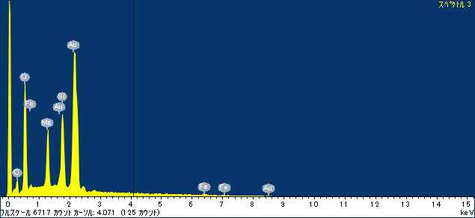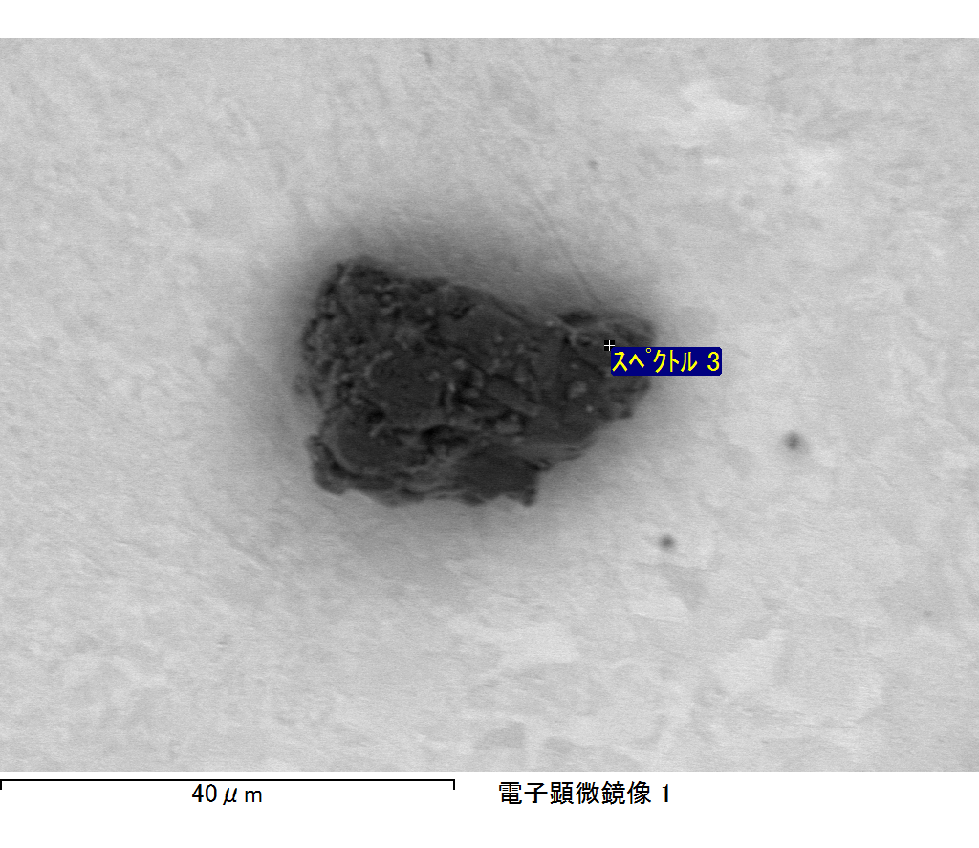

ｺﾒﾝﾄ :

2017/04/20 13:00:56

ﾌﾟﾛｼﾞｪｸﾄ 1

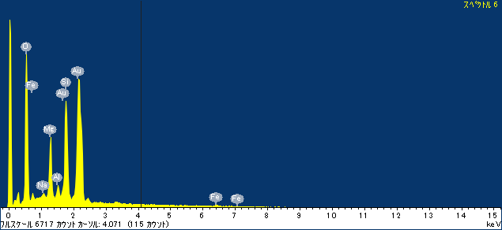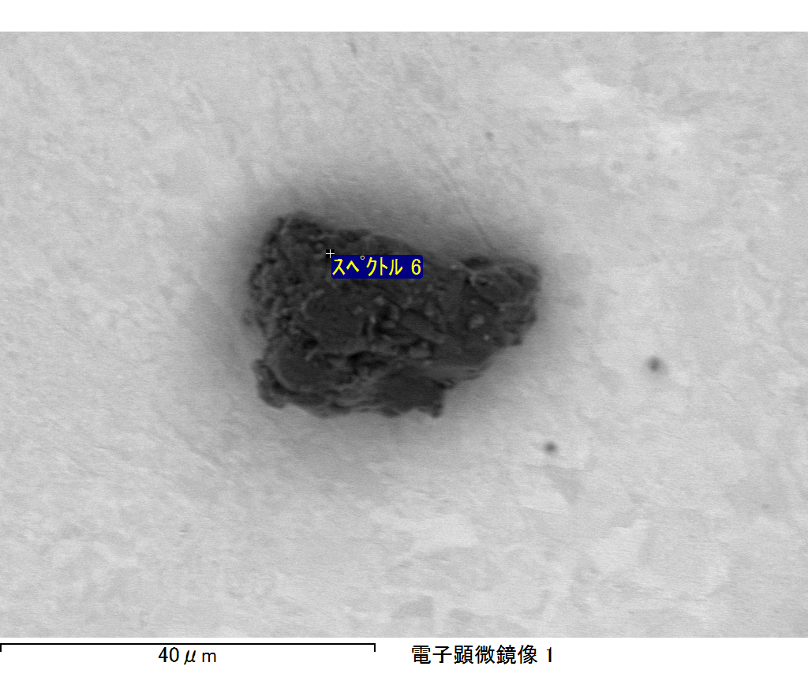

ｺﾒﾝﾄ :

2017/04/20 13:01:04

ﾌﾟﾛｼﾞｪｸﾄ 1

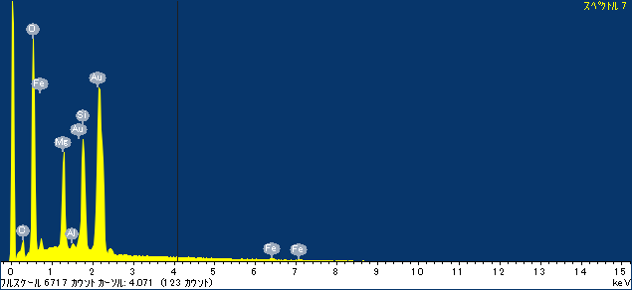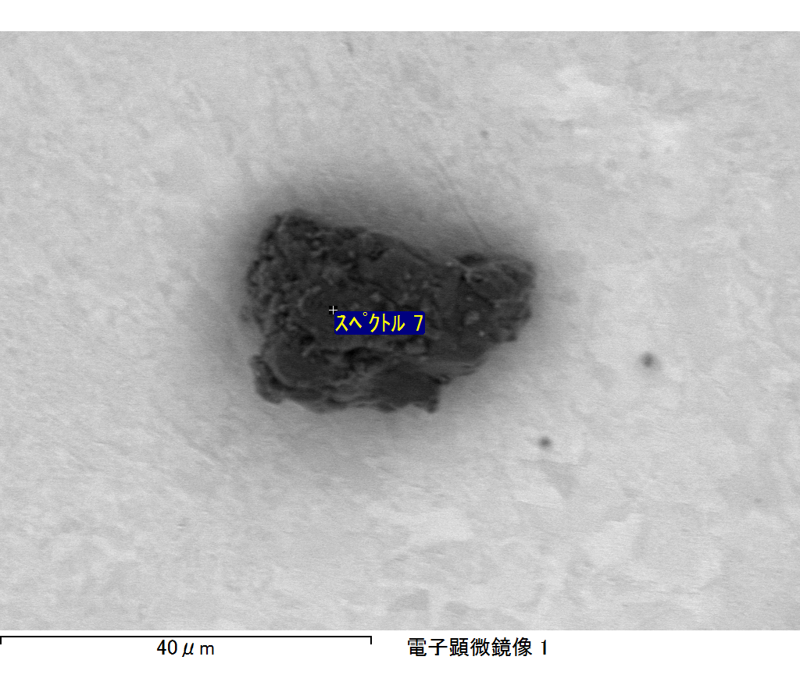

ｺﾒﾝﾄ :

2017/04/20 13:02:38

ﾌﾟﾛｼﾞｪｸﾄ 1

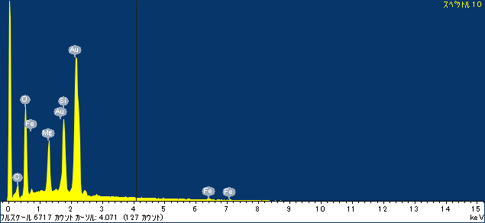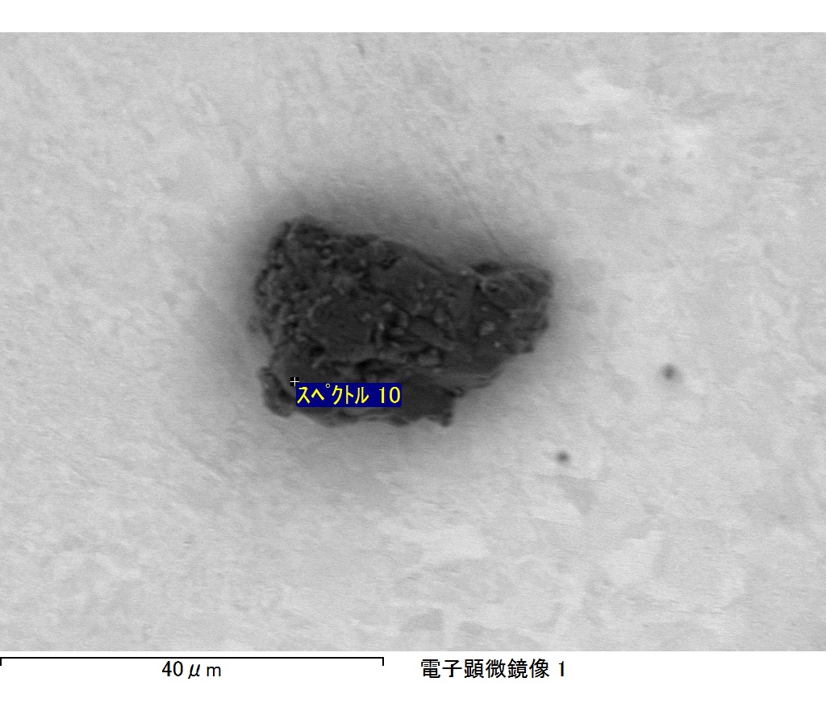

ｺﾒﾝﾄ :

2017/04/20 13:04:13

ﾌﾟﾛｼﾞｪｸﾄ 1