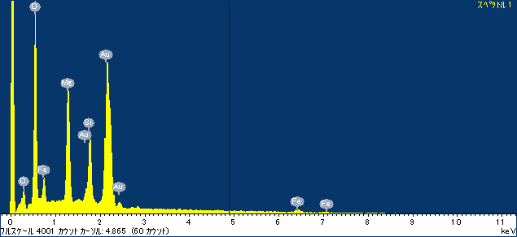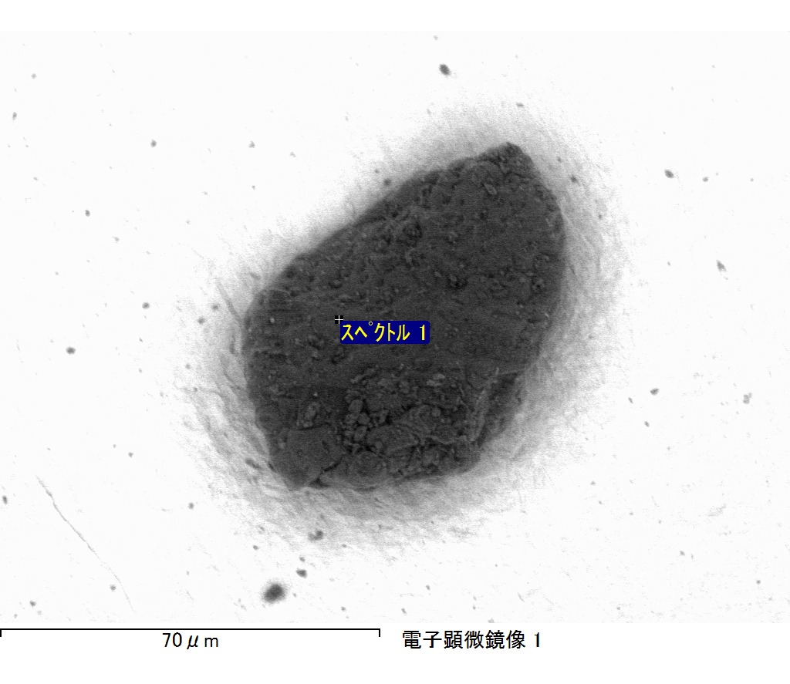

ｺﾒﾝﾄ :

2017/06/22 10:49:46

ﾌﾟﾛｼﾞｪｸﾄ 1

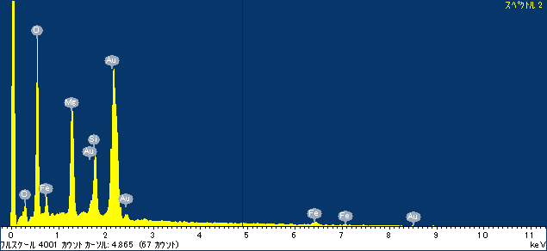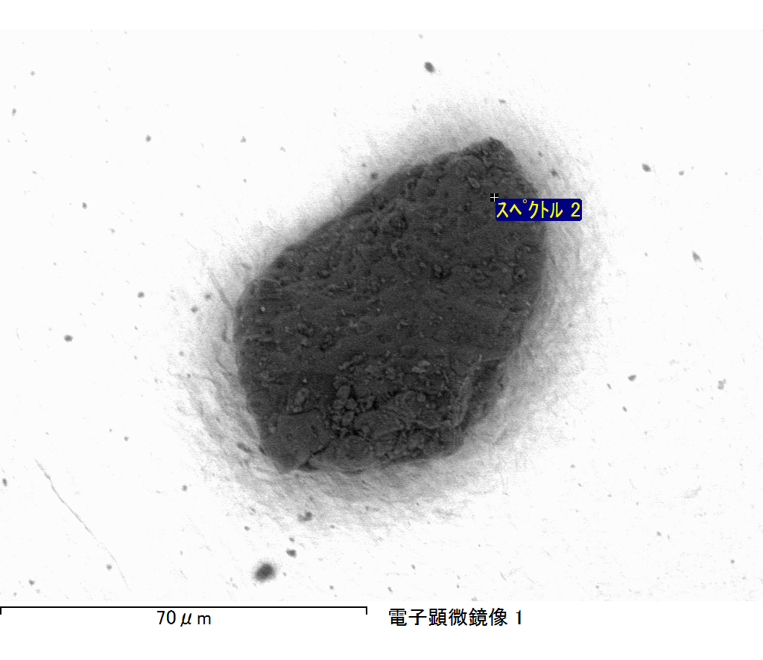

ｺﾒﾝﾄ :

2017/06/22 10:49:50

ﾌﾟﾛｼﾞｪｸﾄ 1

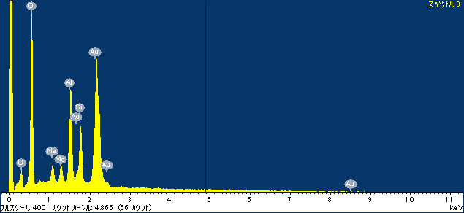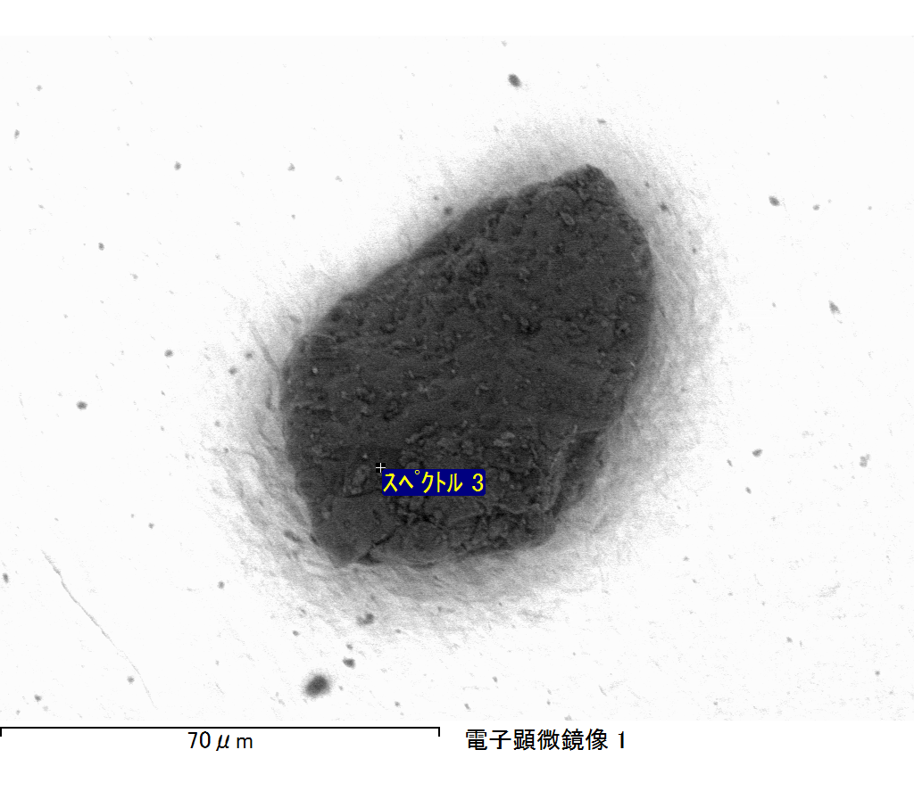

ｺﾒﾝﾄ :

2017/06/22 10:49:55

ﾌﾟﾛｼﾞｪｸﾄ 1

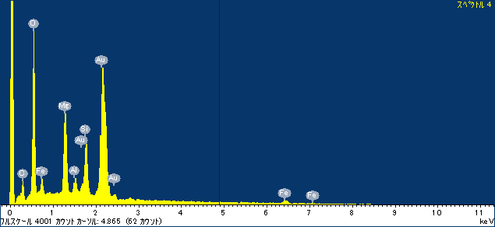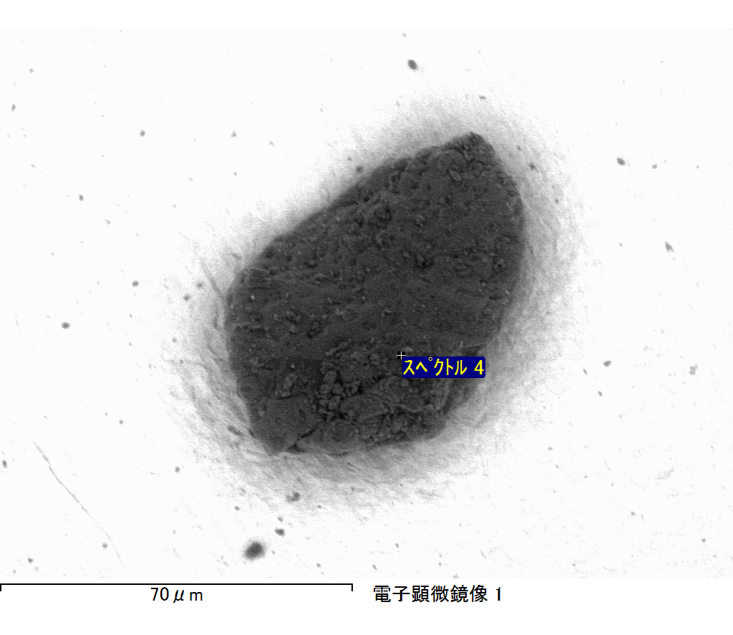

ｺﾒﾝﾄ :

2017/06/22 10:50:00

ﾌﾟﾛｼﾞｪｸﾄ 1

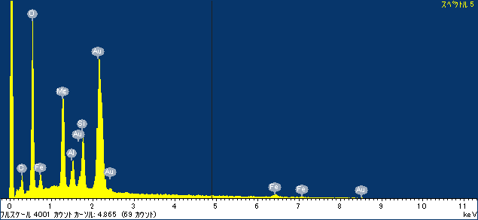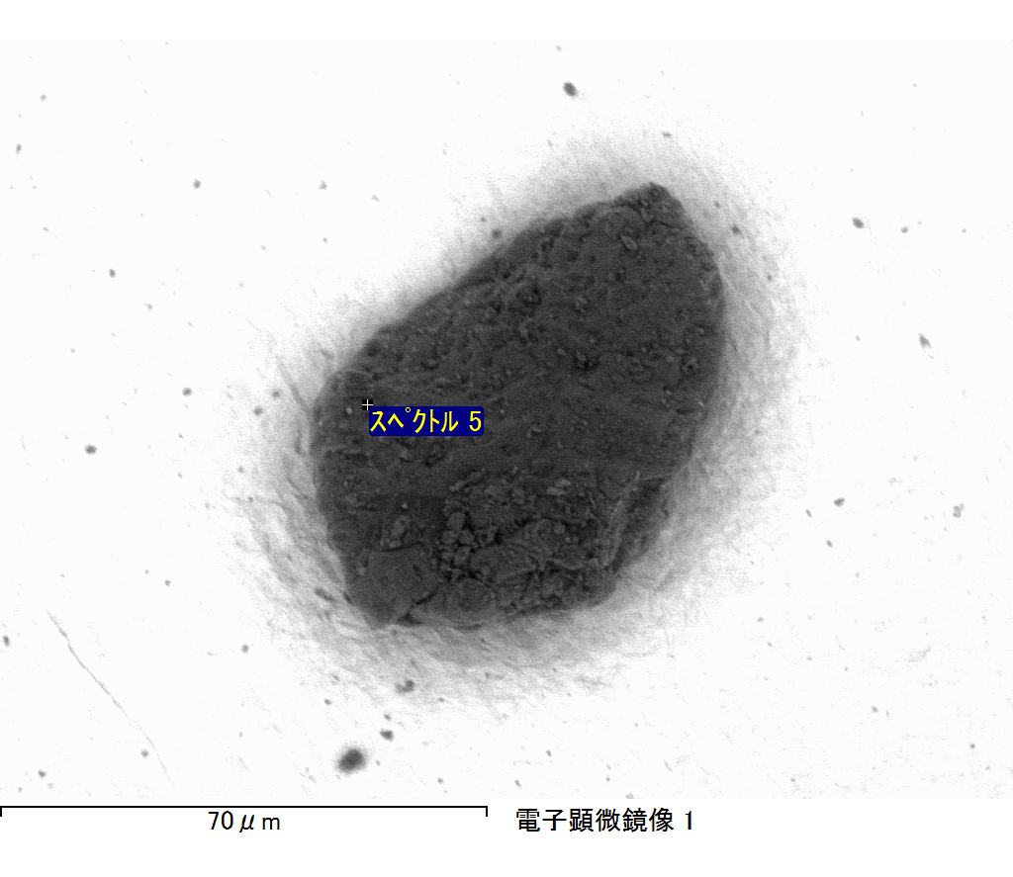

ｺﾒﾝﾄ :

2017/06/22 10:50:05

ﾌﾟﾛｼﾞｪｸﾄ 1

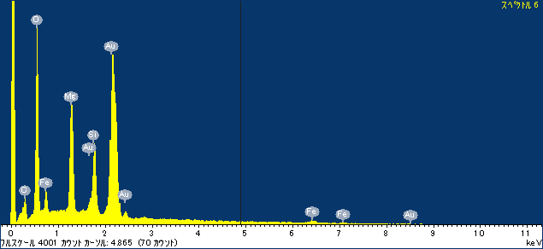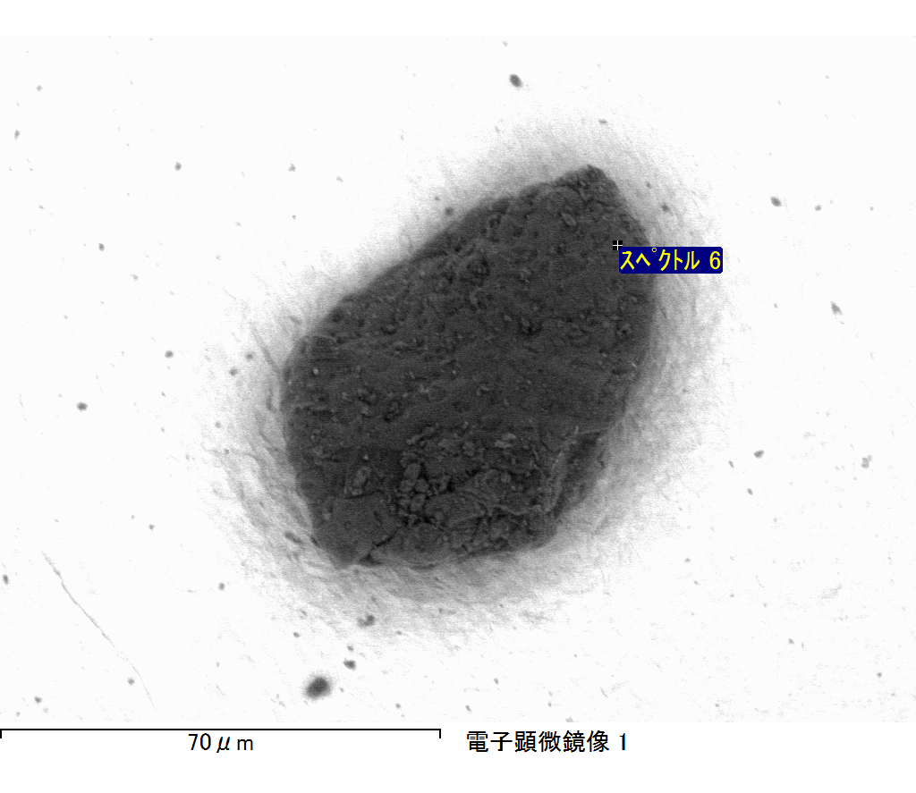

ｺﾒﾝﾄ :

2017/06/22 10:50:10

ﾌﾟﾛｼﾞｪｸﾄ 1