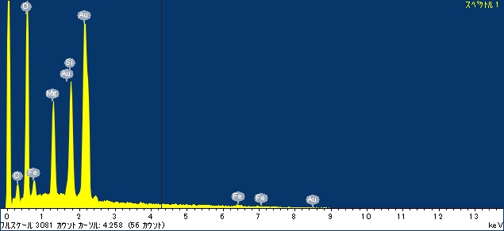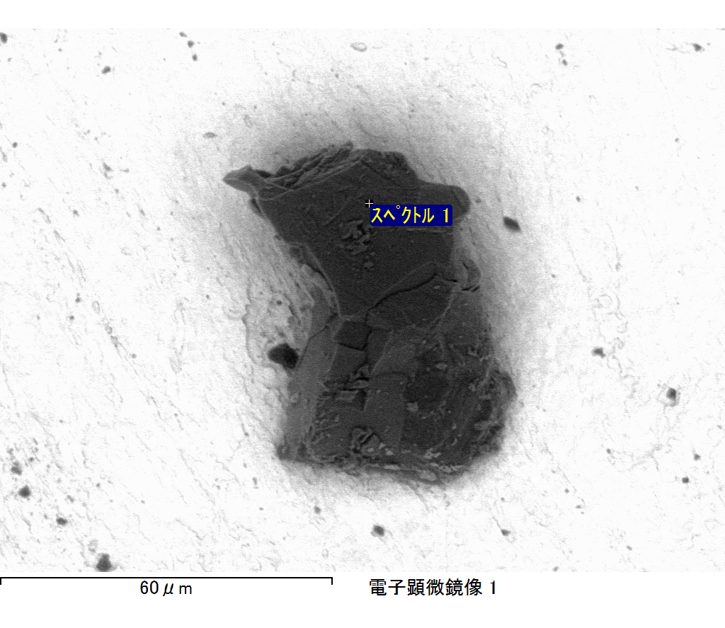

ｺﾒﾝﾄ :

2017/06/21 16:20:17

ﾌﾟﾛｼﾞｪｸﾄ 1

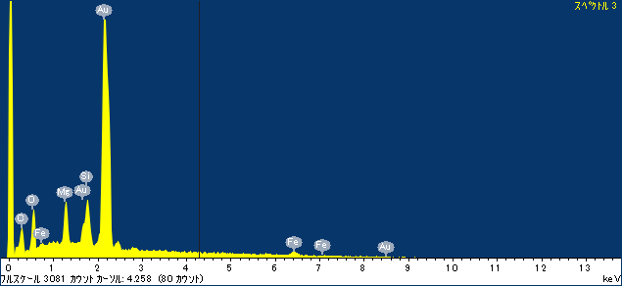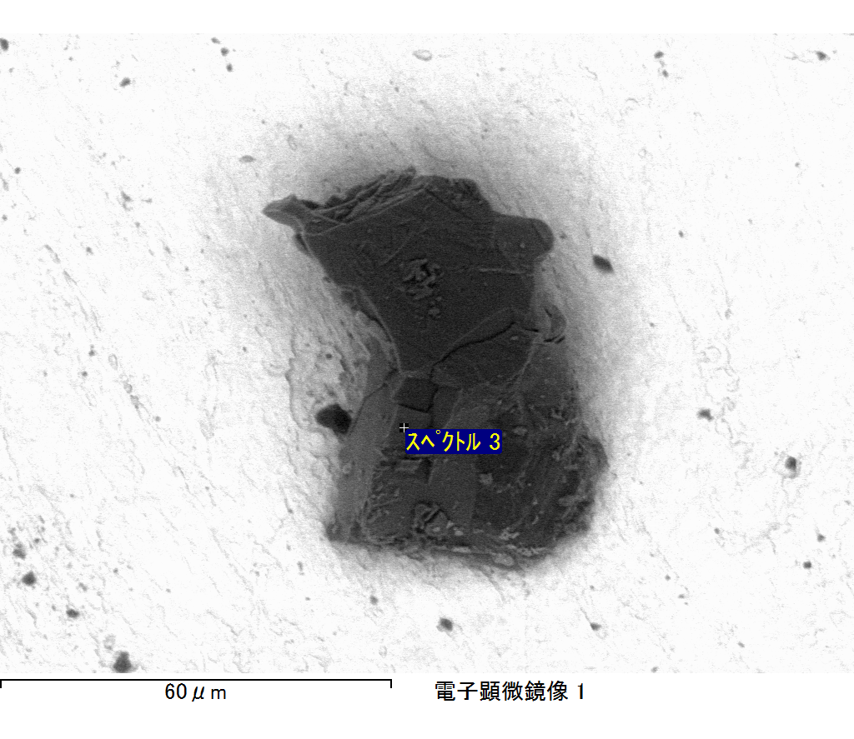

ｺﾒﾝﾄ :

2017/06/21 16:20:26

ﾌﾟﾛｼﾞｪｸﾄ 1

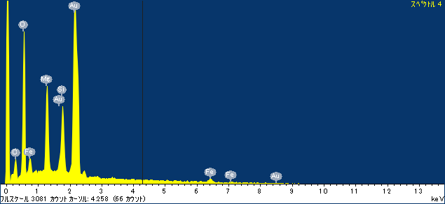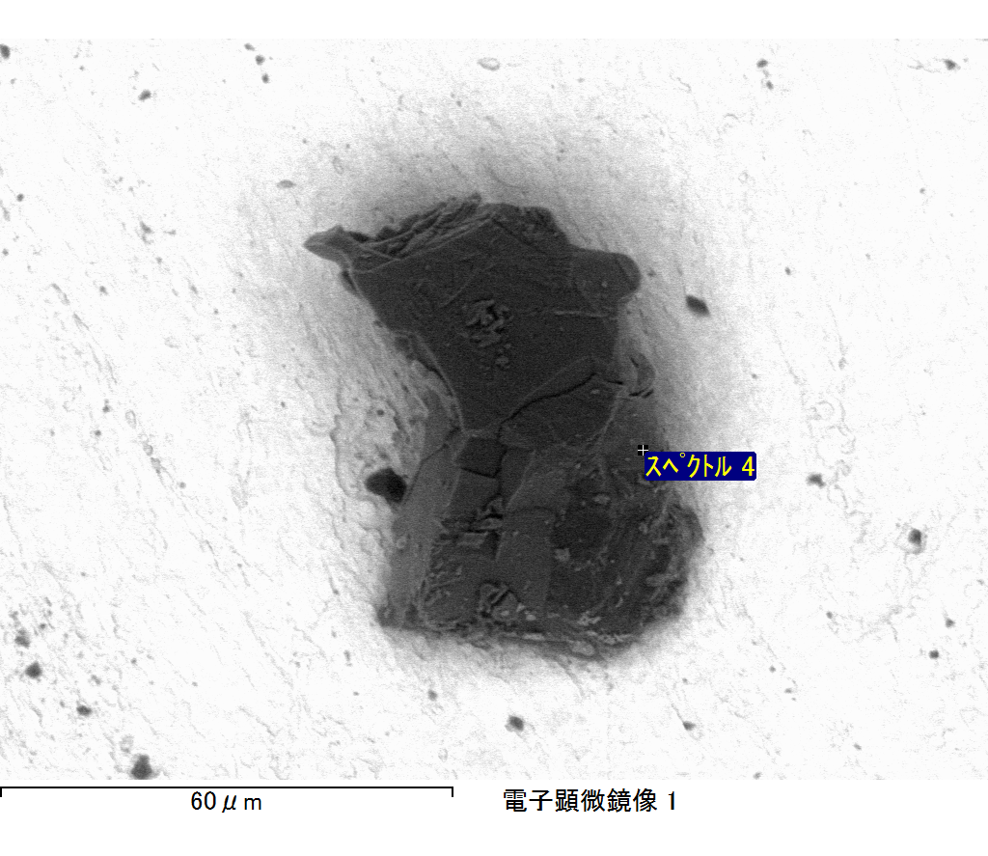

ｺﾒﾝﾄ :

2017/06/21 16:20:44

ﾌﾟﾛｼﾞｪｸﾄ 1

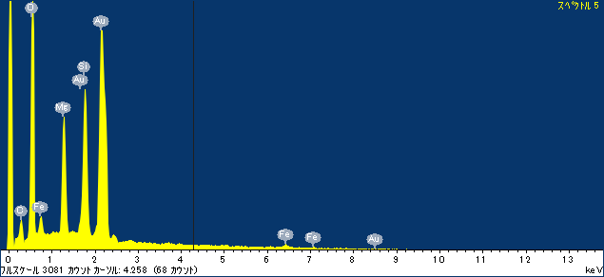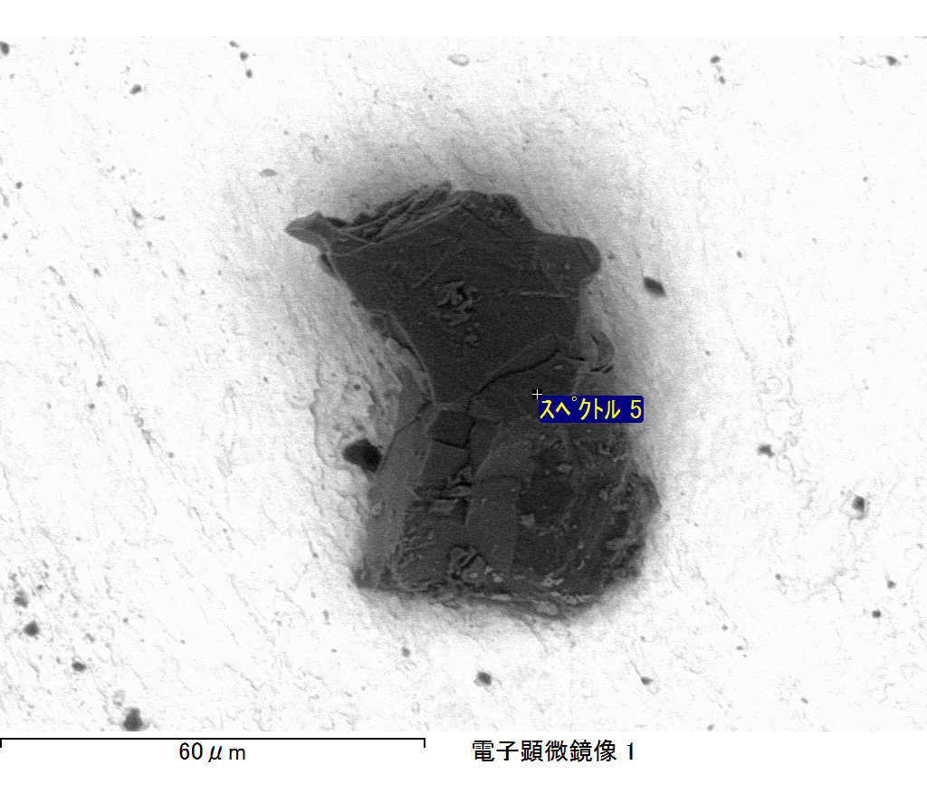

ｺﾒﾝﾄ :

2017/06/21 16:20:48

ﾌﾟﾛｼﾞｪｸﾄ 1

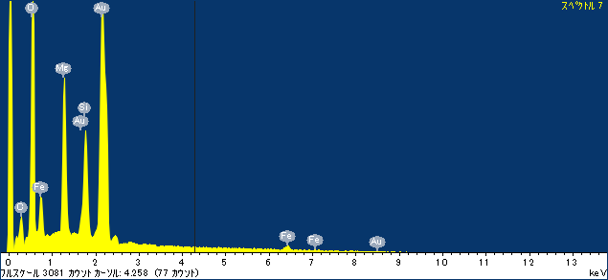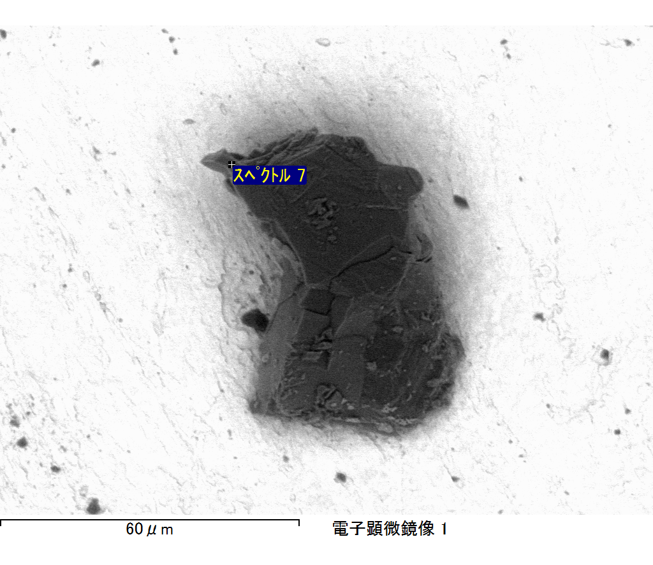

ｺﾒﾝﾄ :

2017/06/21 16:20:55

ﾌﾟﾛｼﾞｪｸﾄ 1