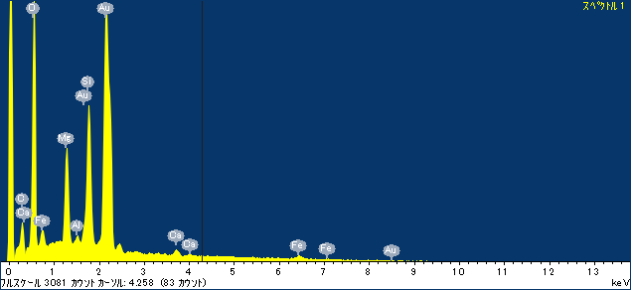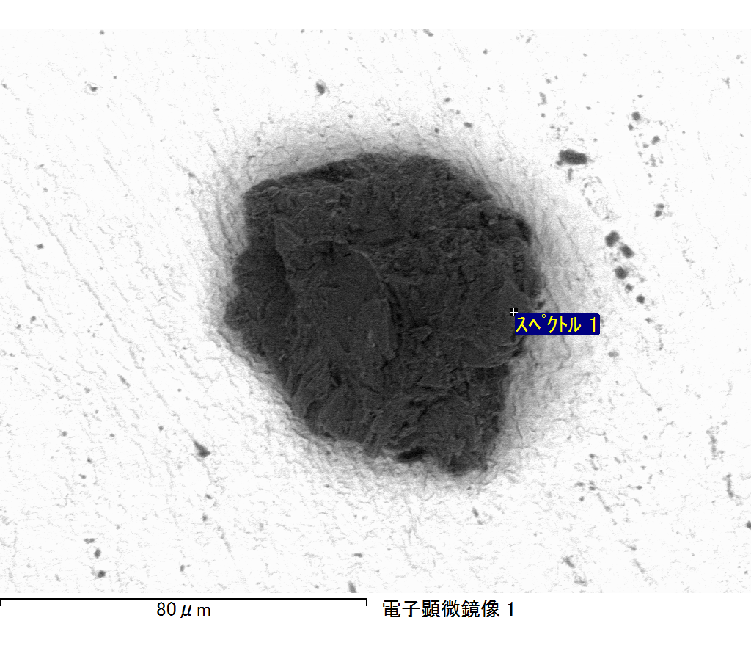

ｺﾒﾝﾄ :

2017/06/21 16:28:45

ﾌﾟﾛｼﾞｪｸﾄ 1

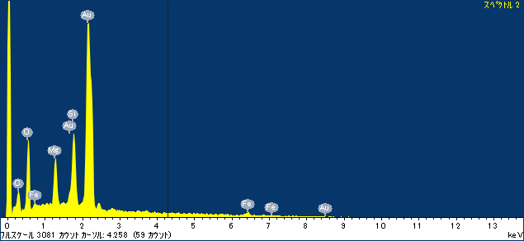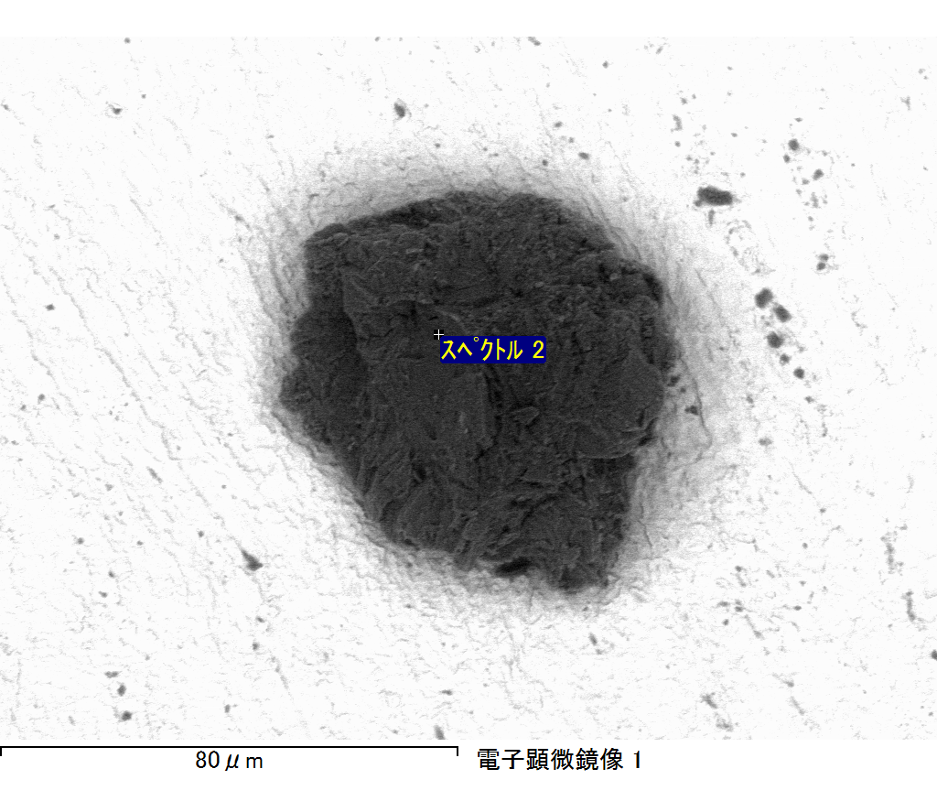

ｺﾒﾝﾄ :

2017/06/21 16:28:52

ﾌﾟﾛｼﾞｪｸﾄ 1

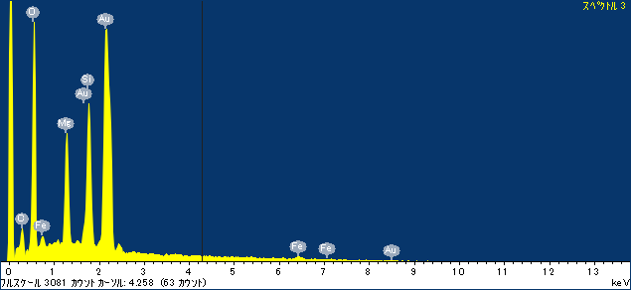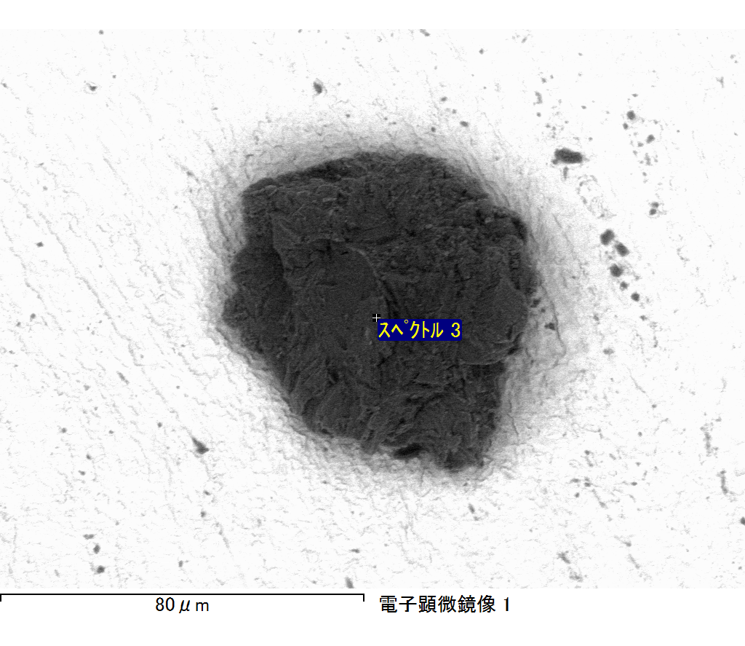

ｺﾒﾝﾄ :

2017/06/21 16:28:57

ﾌﾟﾛｼﾞｪｸﾄ 1

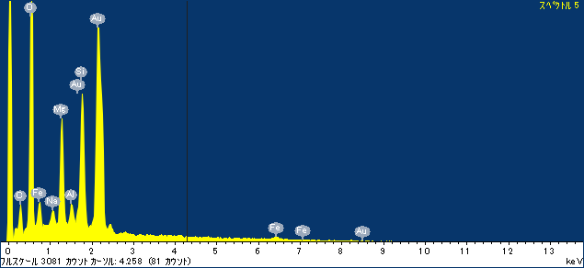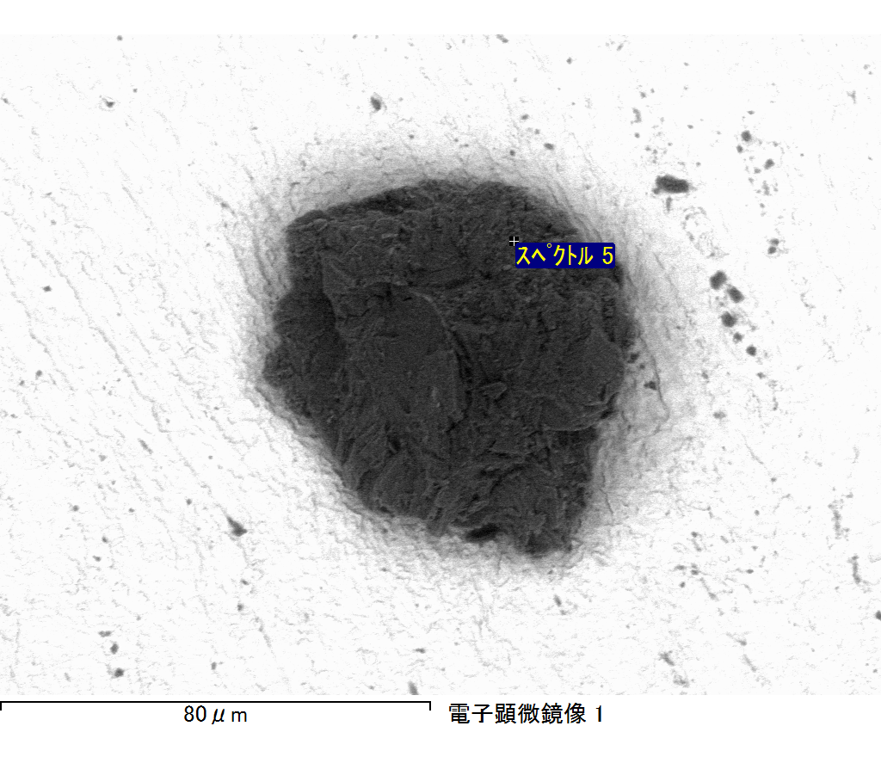

ｺﾒﾝﾄ :

2017/06/21 16:29:05

ﾌﾟﾛｼﾞｪｸﾄ 1

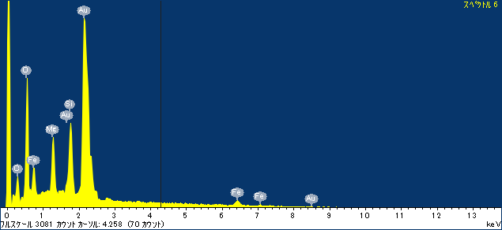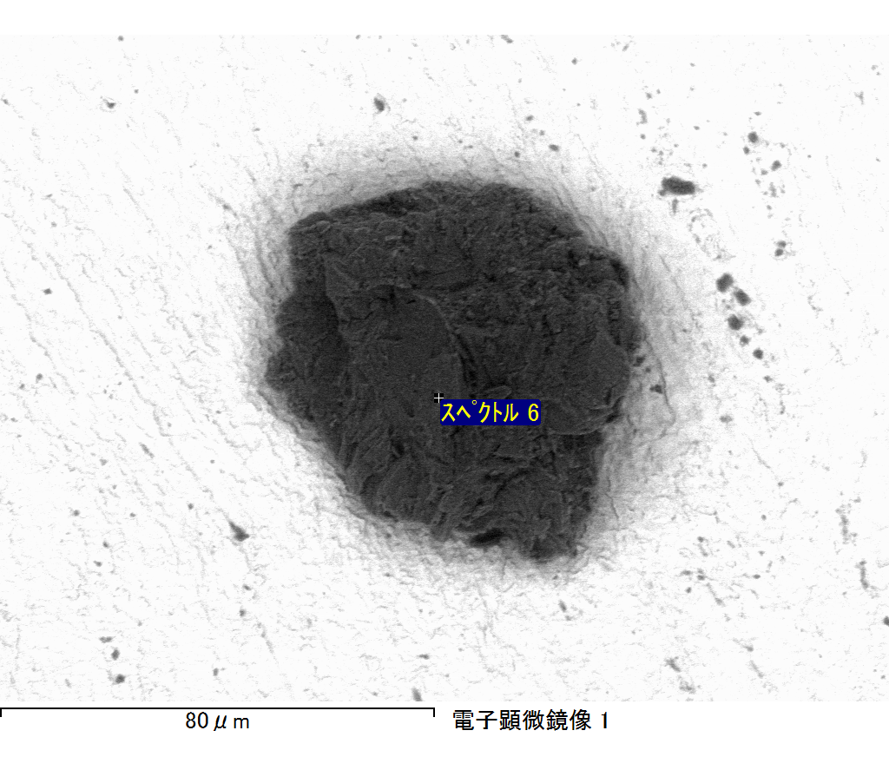

ｺﾒﾝﾄ :

2017/06/21 16:29:14

ﾌﾟﾛｼﾞｪｸﾄ 1

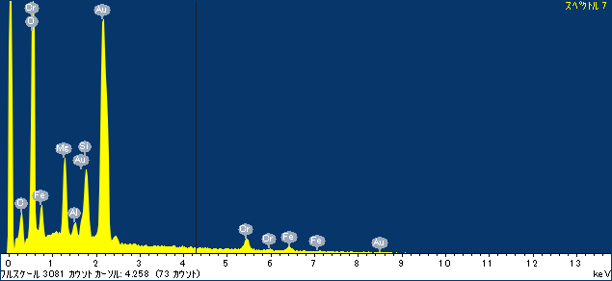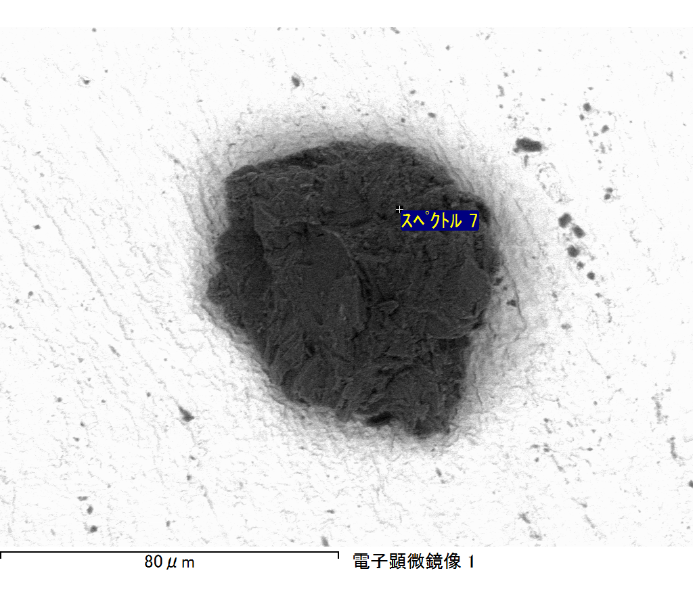

ｺﾒﾝﾄ :

2017/06/21 16:29:18

ﾌﾟﾛｼﾞｪｸﾄ 1