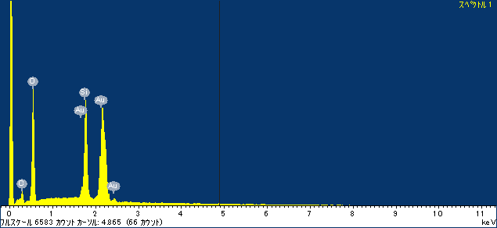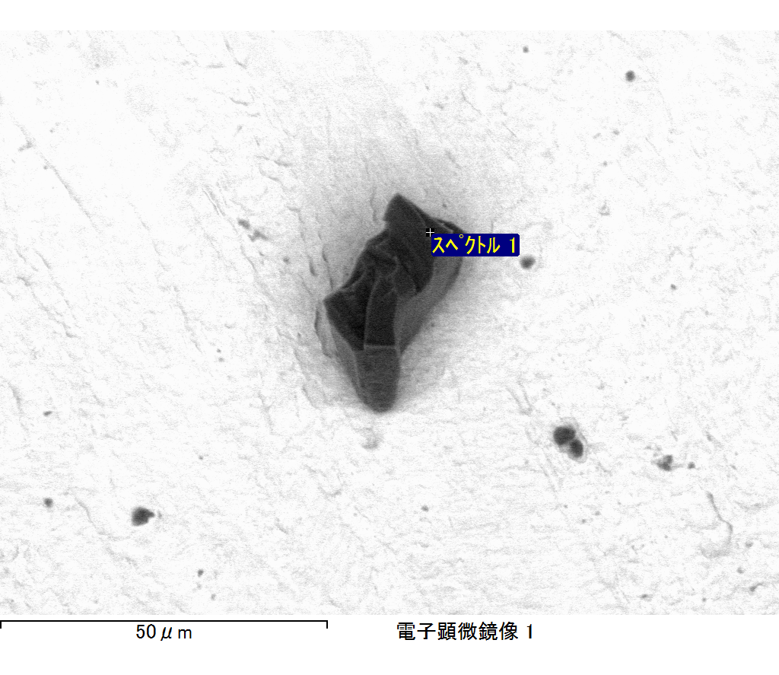

ｺﾒﾝﾄ :

2017/06/22 10:31:28

ﾌﾟﾛｼﾞｪｸﾄ 1

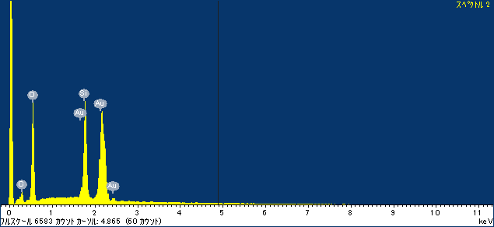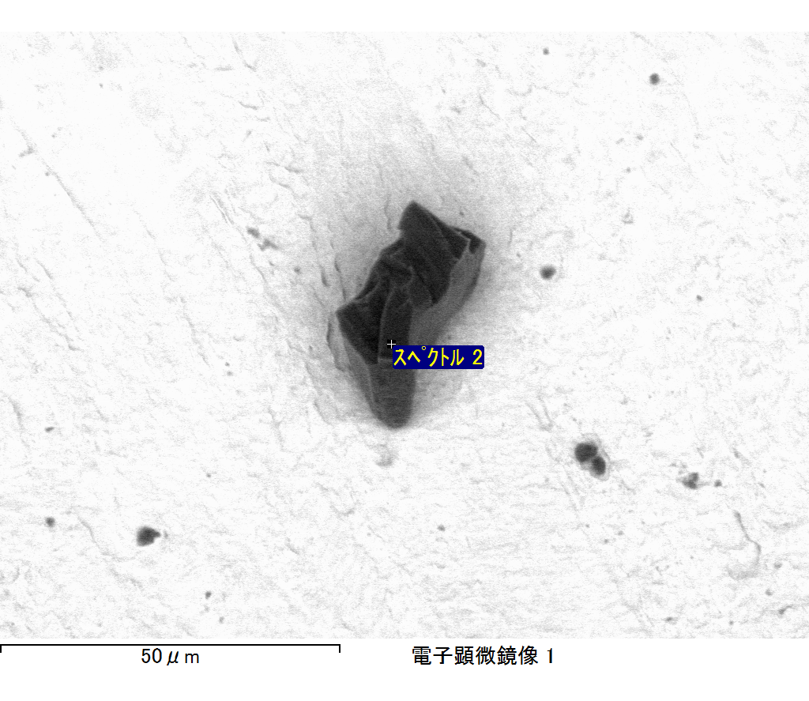

ｺﾒﾝﾄ :

2017/06/22 10:31:32

ﾌﾟﾛｼﾞｪｸﾄ 1

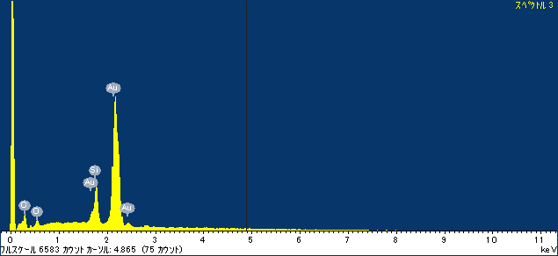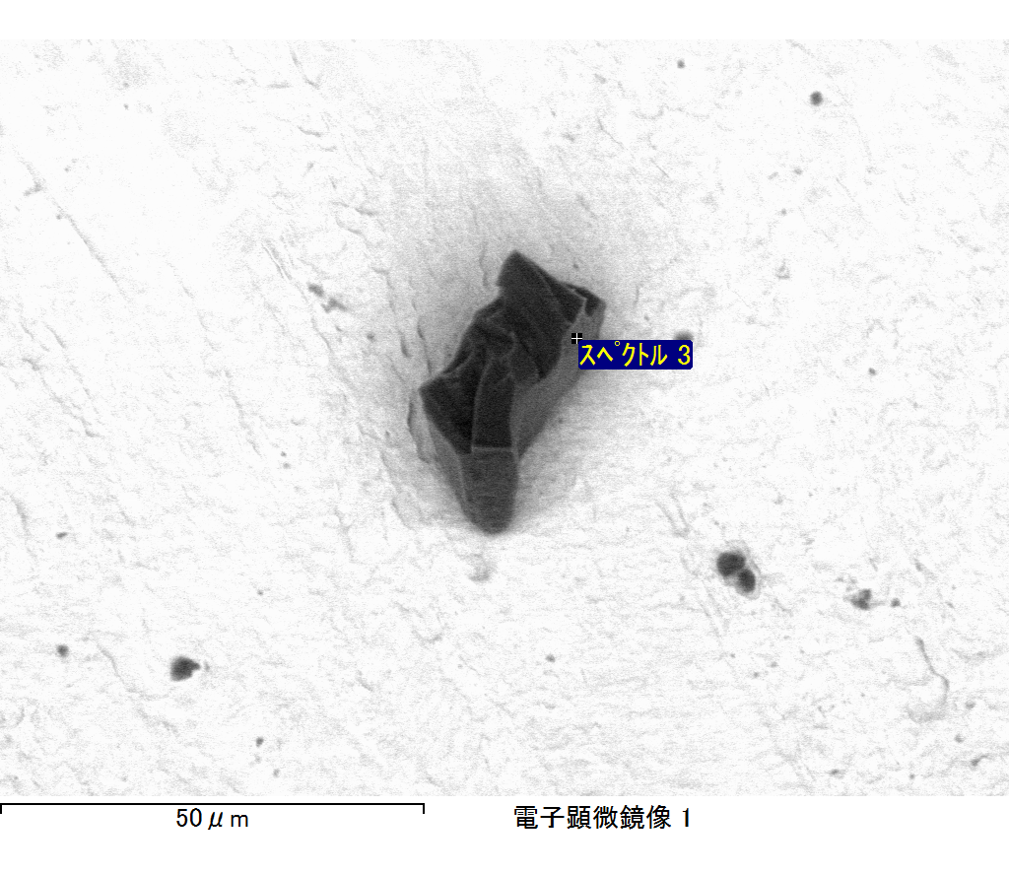

ｺﾒﾝﾄ :

2017/06/22 10:31:35

ﾌﾟﾛｼﾞｪｸﾄ 1