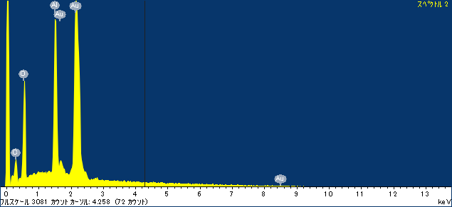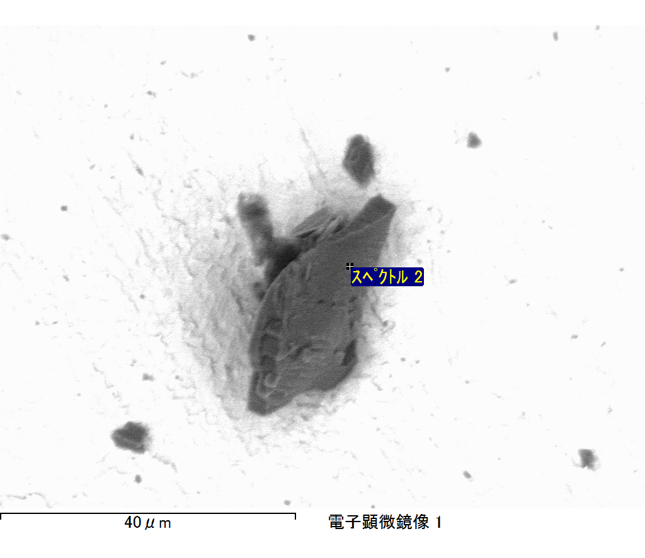

ｺﾒﾝﾄ :

2017/06/21 16:34:25

ﾌﾟﾛｼﾞｪｸﾄ 1

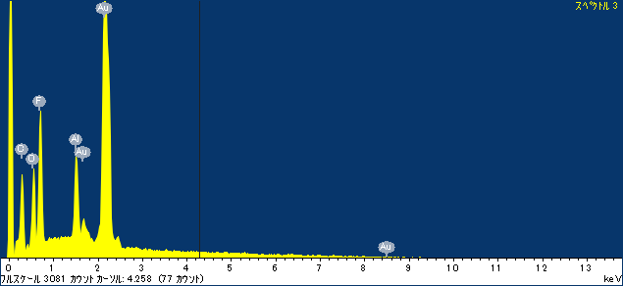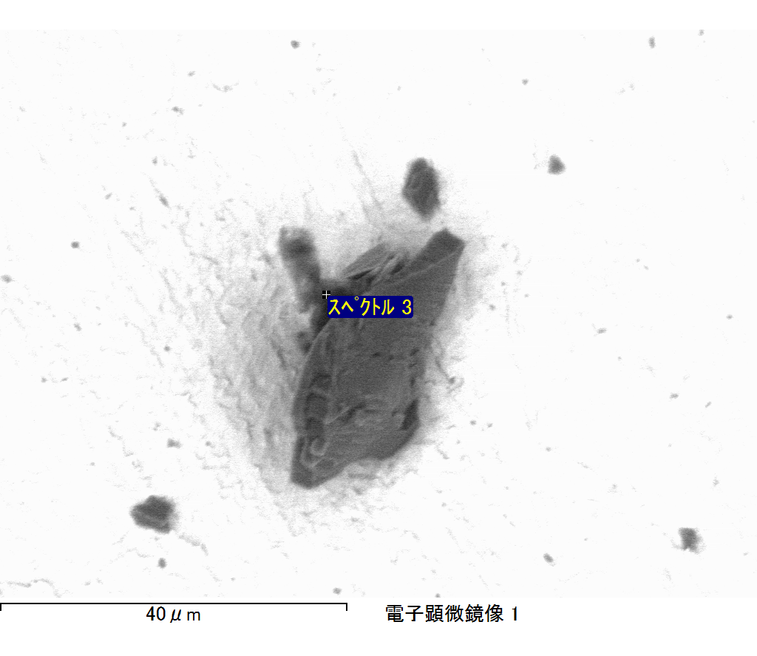

ｺﾒﾝﾄ :

2017/06/21 16:34:30

ﾌﾟﾛｼﾞｪｸﾄ 1

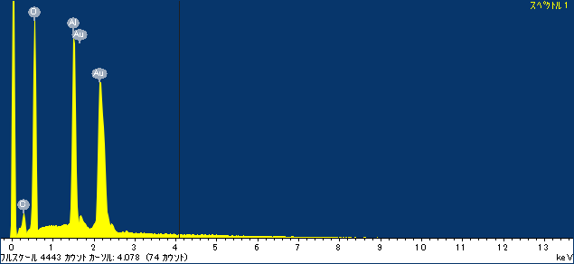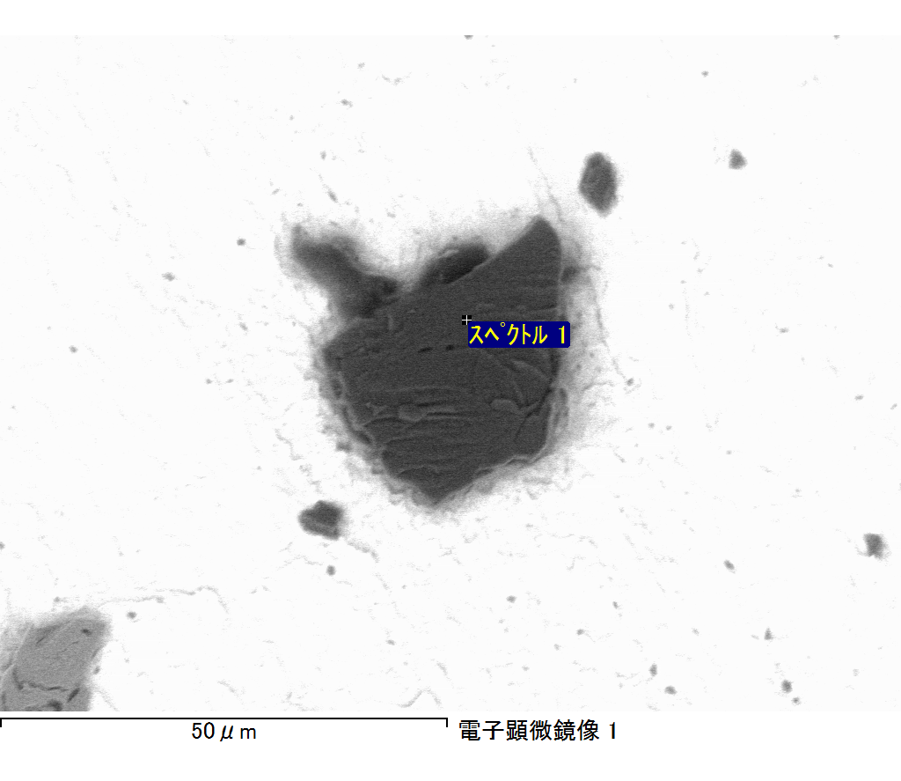

ｺﾒﾝﾄ :

2017/06/21 16:38:23

ﾌﾟﾛｼﾞｪｸﾄ 1

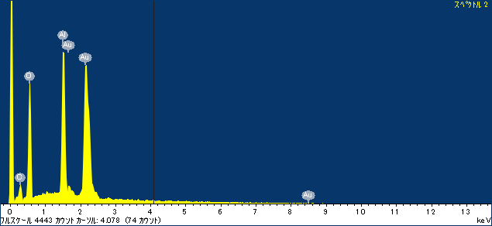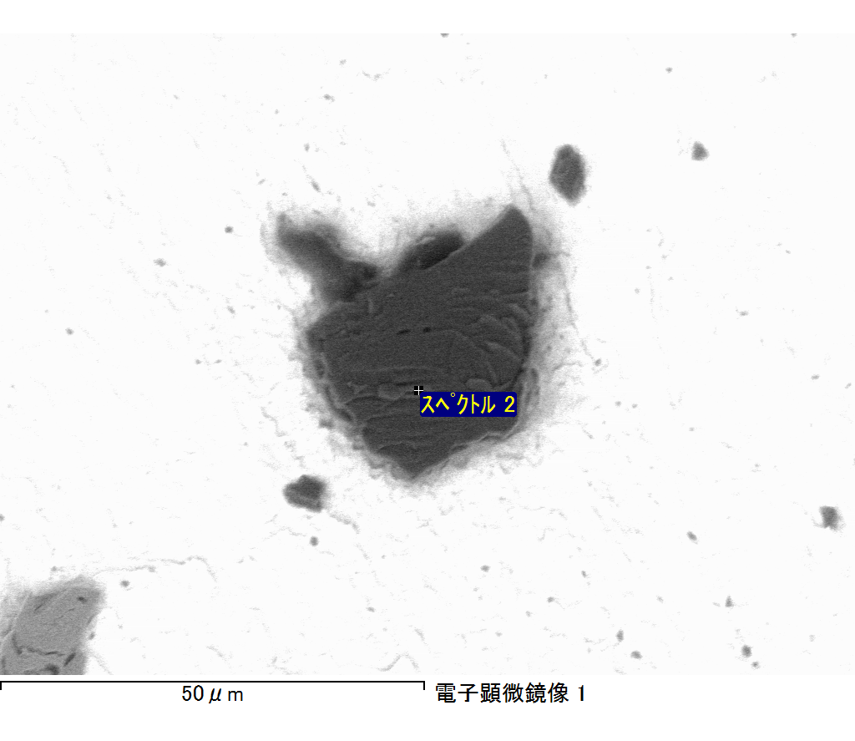

ｺﾒﾝﾄ :

2017/06/21 16:38:28

ﾌﾟﾛｼﾞｪｸﾄ 1

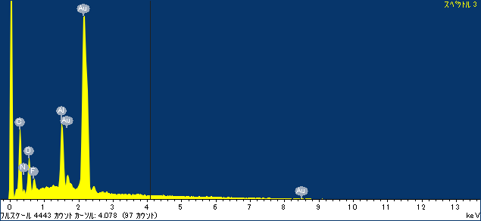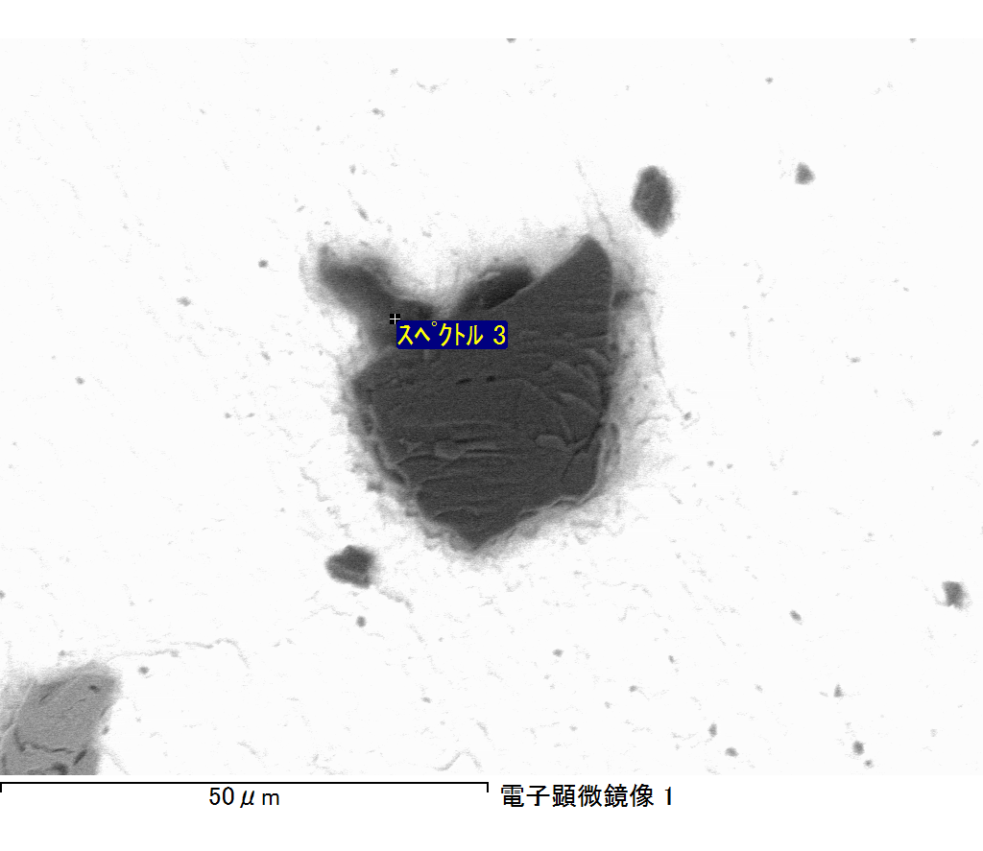

ｺﾒﾝﾄ :

2017/06/21 16:38:33

ﾌﾟﾛｼﾞｪｸﾄ 1