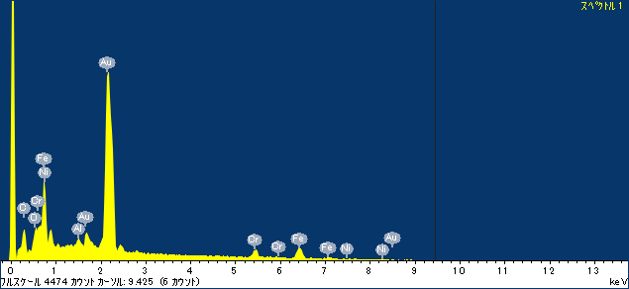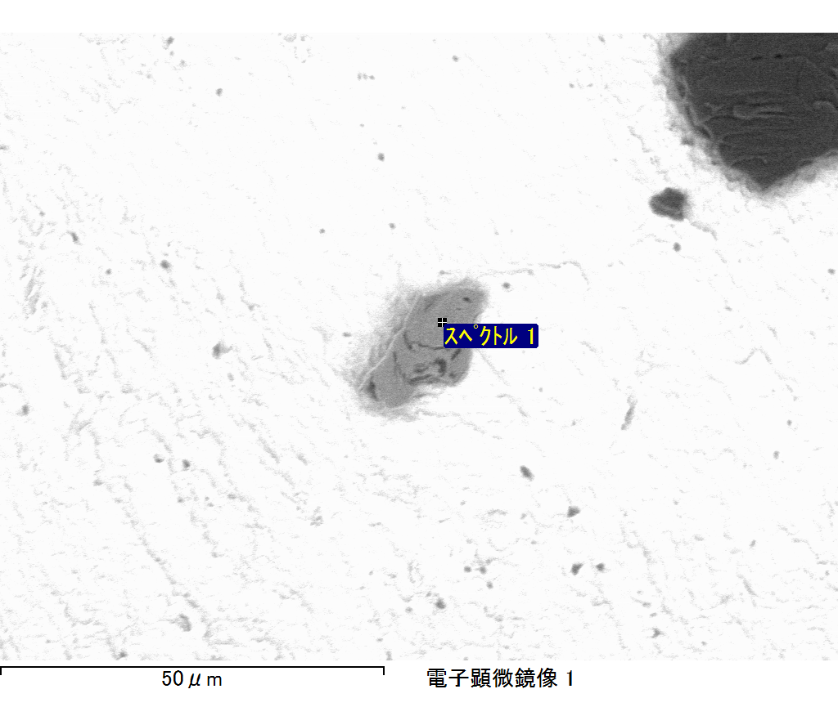

ｺﾒﾝﾄ :

2017/06/21 16:44:35

ﾌﾟﾛｼﾞｪｸﾄ 1

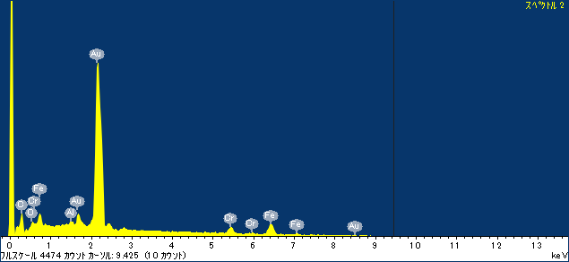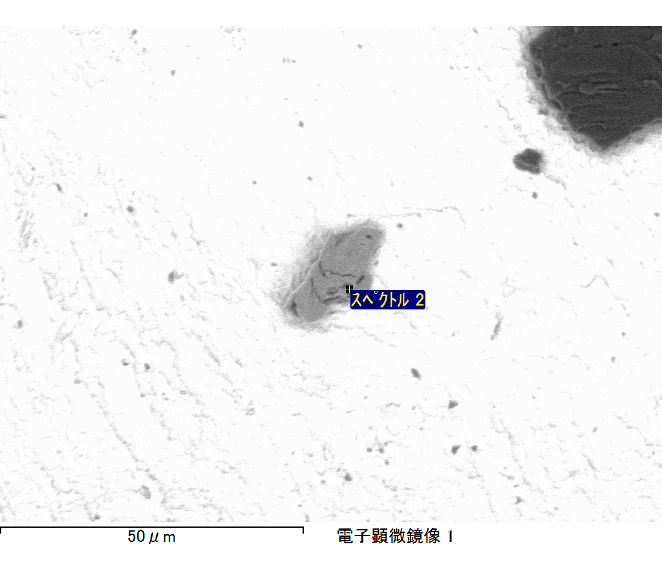

ｺﾒﾝﾄ :

2017/06/21 16:44:38

ﾌﾟﾛｼﾞｪｸﾄ 1

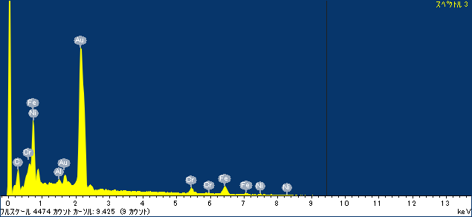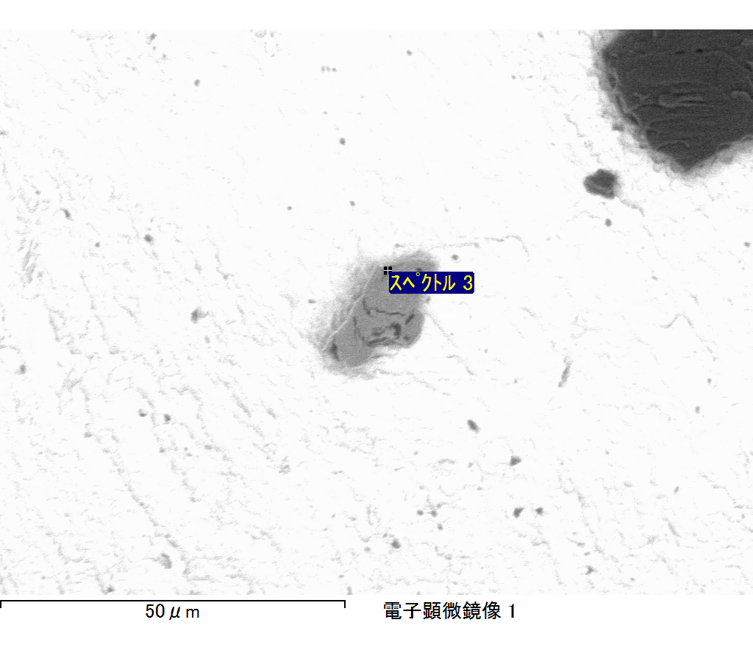

ｺﾒﾝﾄ :

2017/06/21 16:44:42

ﾌﾟﾛｼﾞｪｸﾄ 1

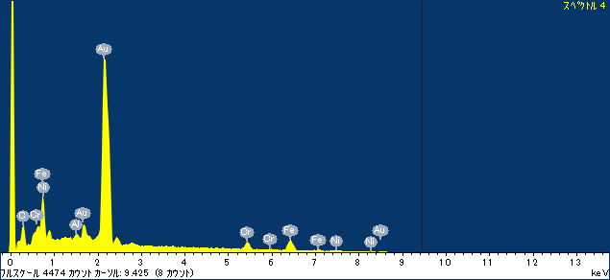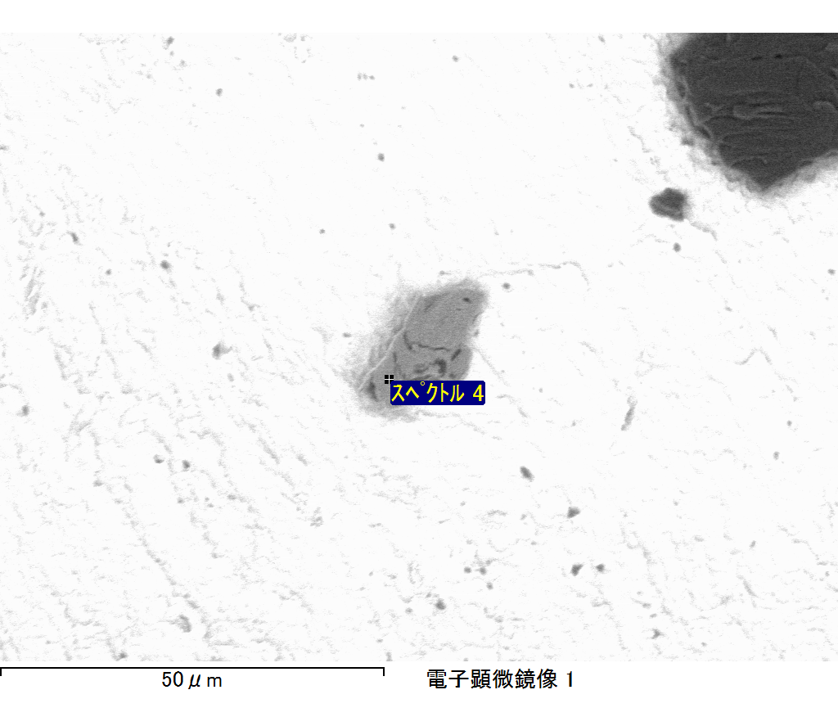

ｺﾒﾝﾄ :

2017/06/21 16:44:45

ﾌﾟﾛｼﾞｪｸﾄ 1

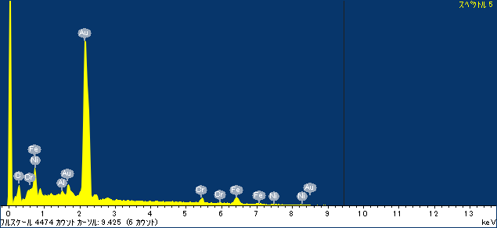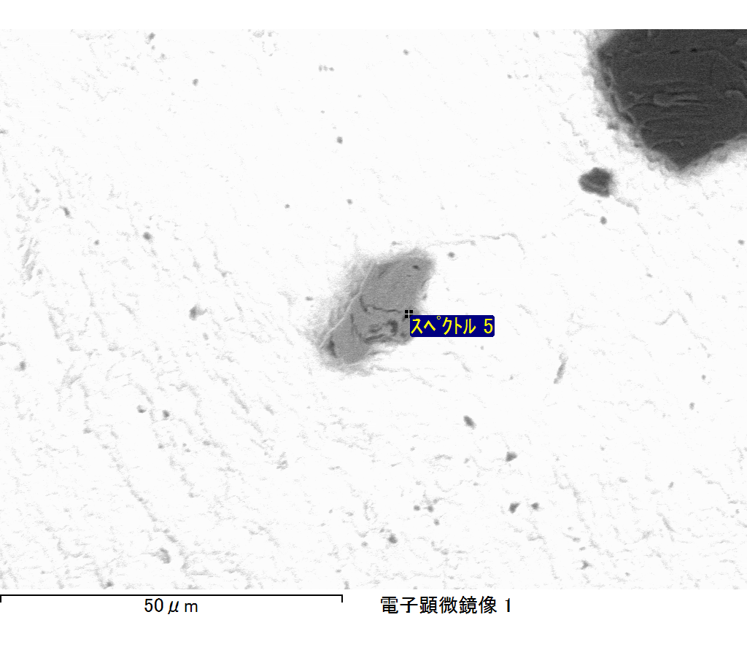

ｺﾒﾝﾄ :

2017/06/21 16:44:49

ﾌﾟﾛｼﾞｪｸﾄ 1