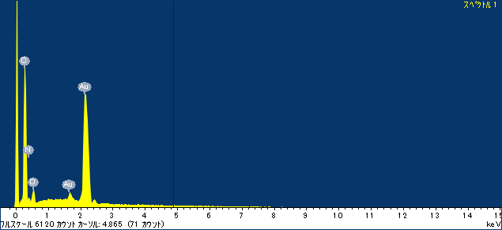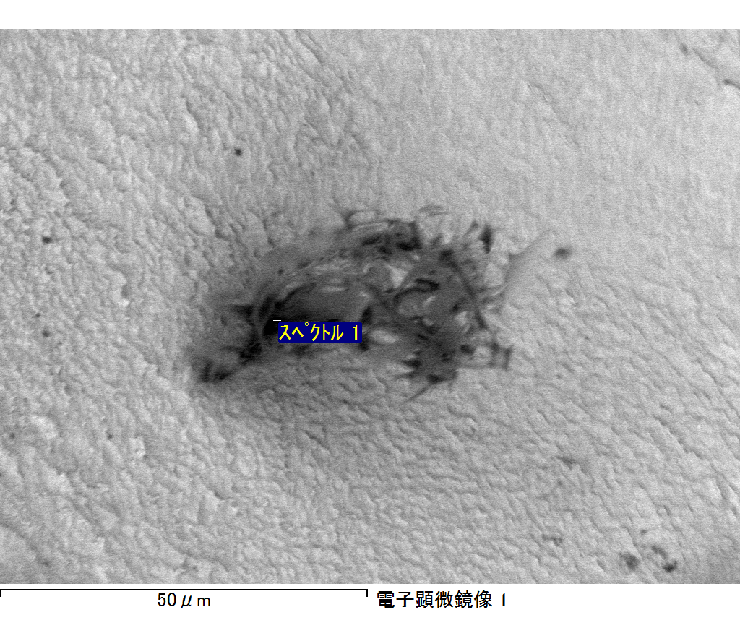

ｺﾒﾝﾄ :

2017/06/22 10:24:36

ﾌﾟﾛｼﾞｪｸﾄ 1

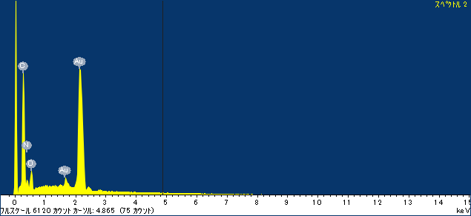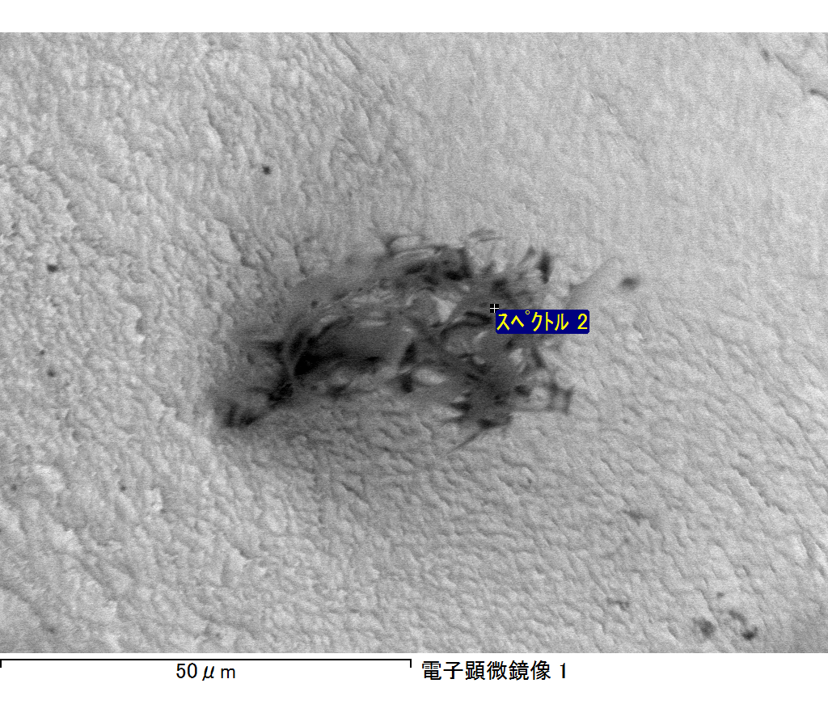

ｺﾒﾝﾄ :

2017/06/22 10:24:42

ﾌﾟﾛｼﾞｪｸﾄ 1

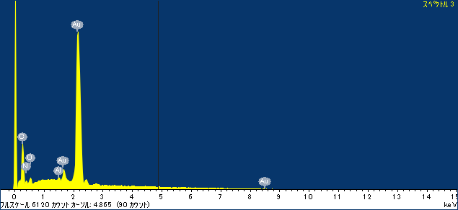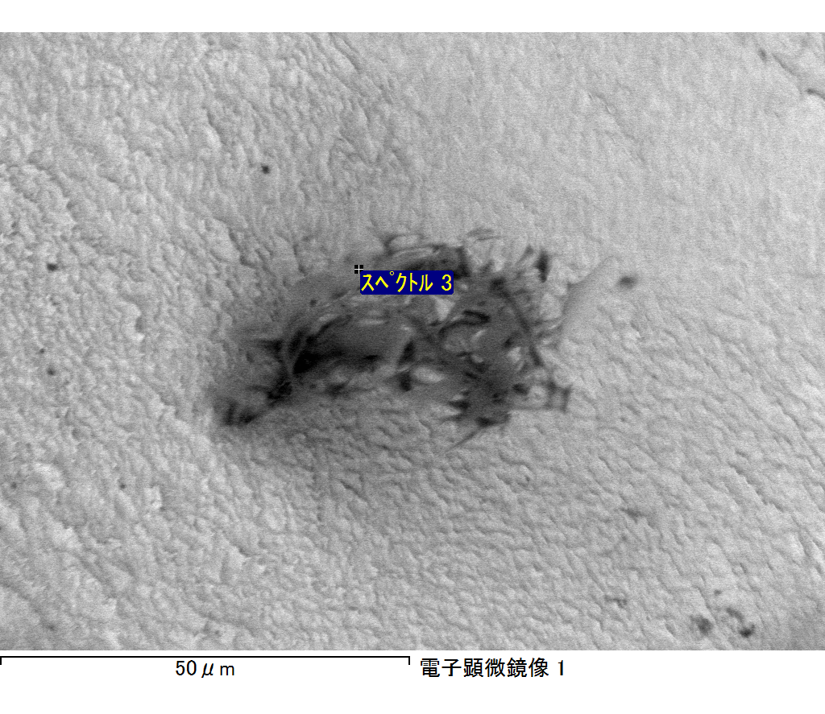

ｺﾒﾝﾄ :

2017/06/22 10:24:48

ﾌﾟﾛｼﾞｪｸﾄ 1

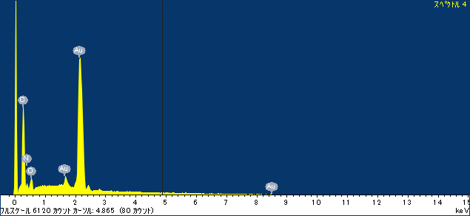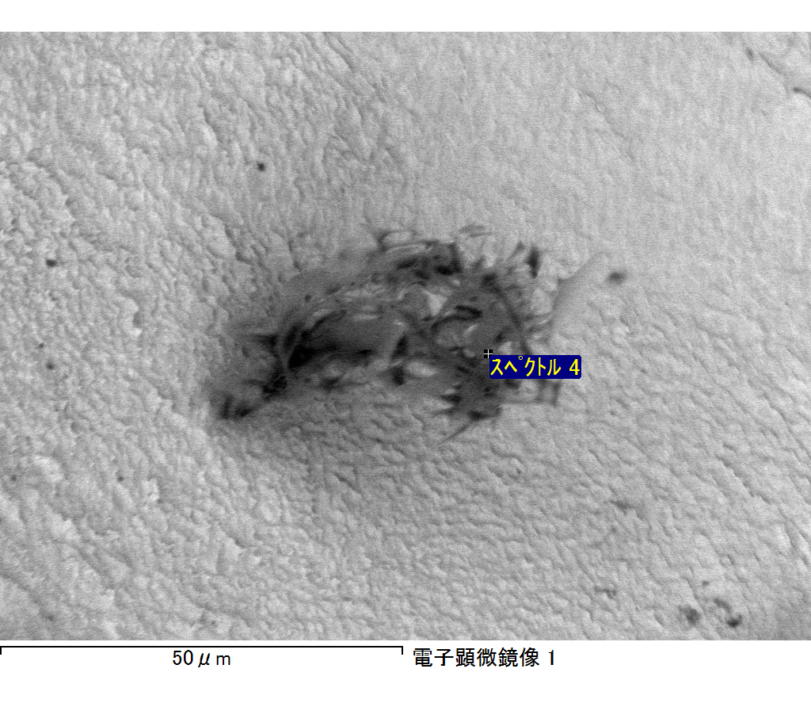

ｺﾒﾝﾄ :

2017/06/22 10:24:54

ﾌﾟﾛｼﾞｪｸﾄ 1

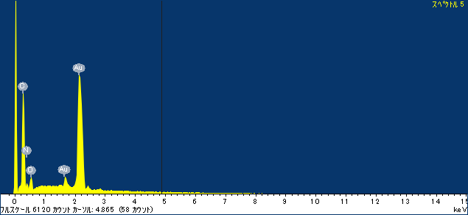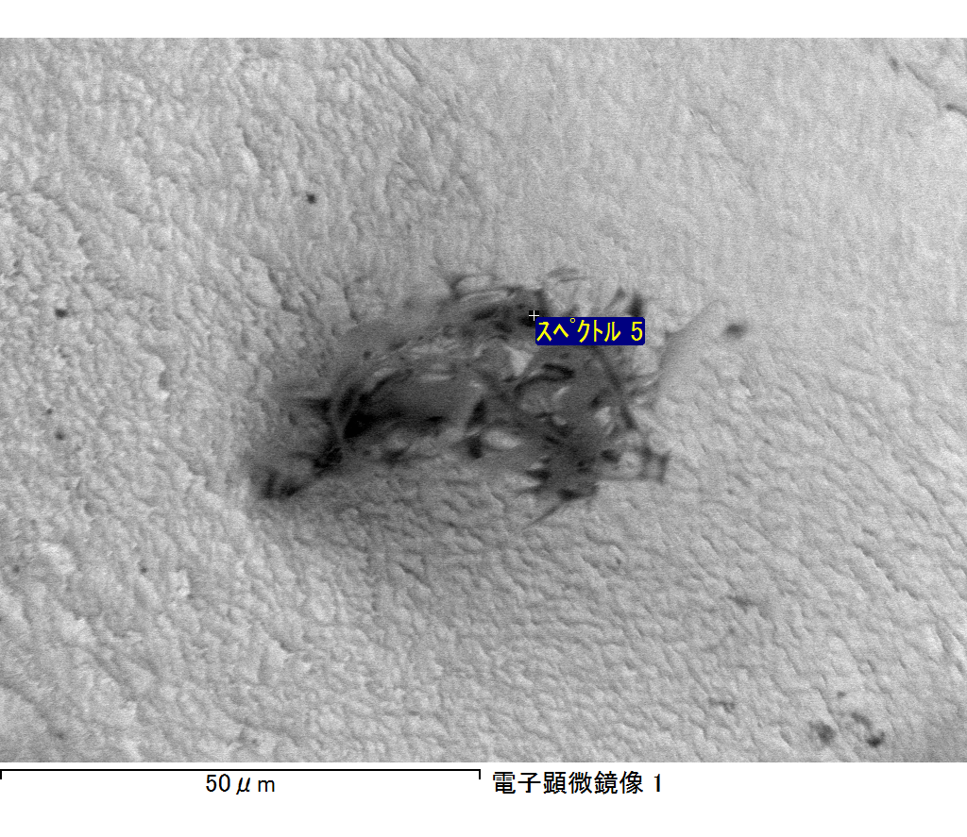

ｺﾒﾝﾄ :

2017/06/22 10:24:58

ﾌﾟﾛｼﾞｪｸﾄ 1