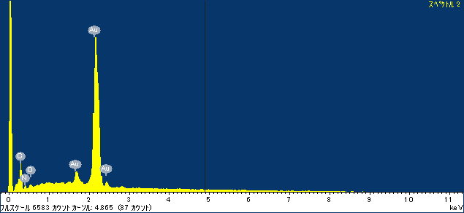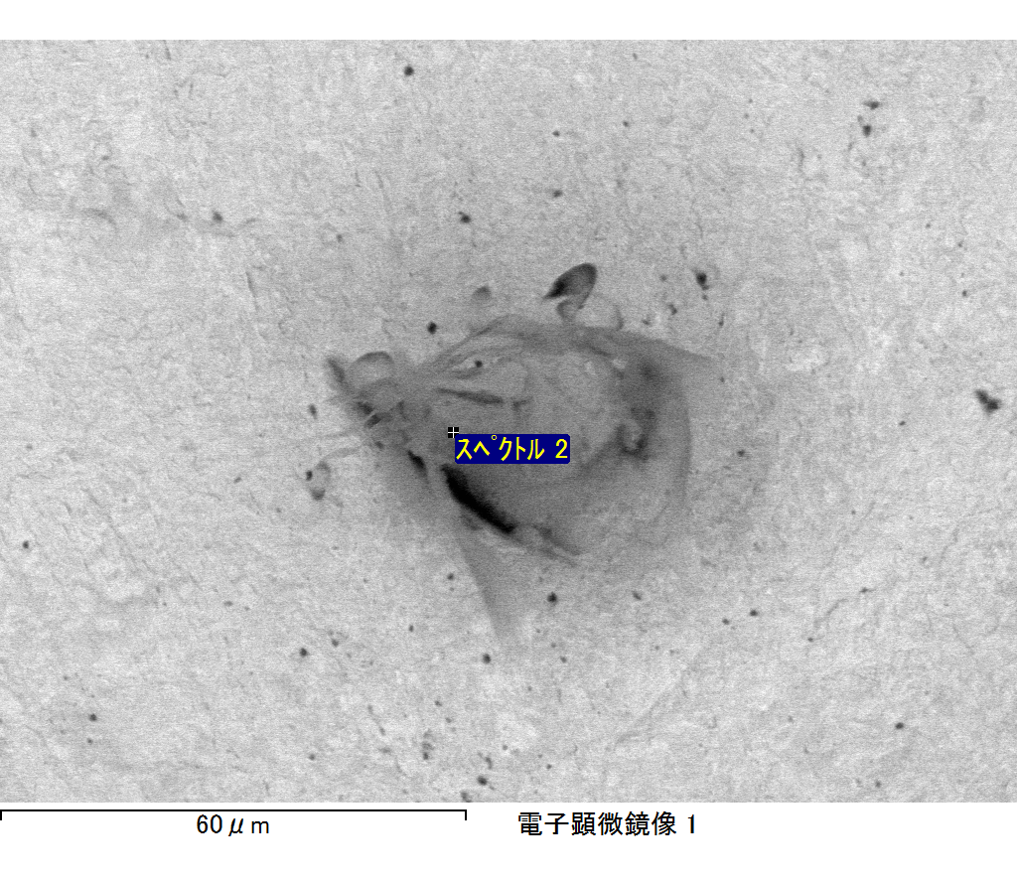

ｺﾒﾝﾄ :

2017/06/22 10:35:40

ﾌﾟﾛｼﾞｪｸﾄ 1

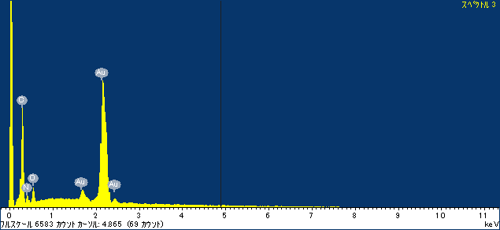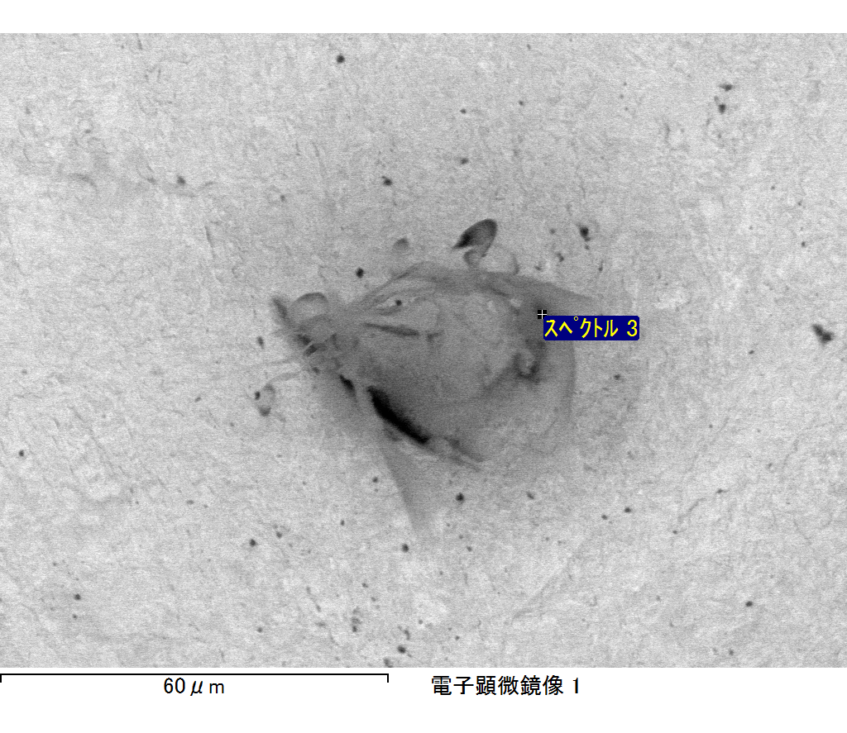

ｺﾒﾝﾄ :

2017/06/22 10:35:44

ﾌﾟﾛｼﾞｪｸﾄ 1