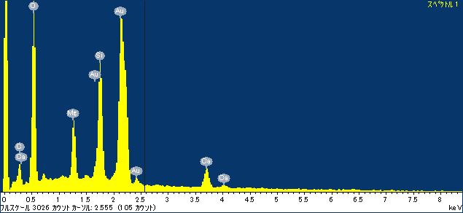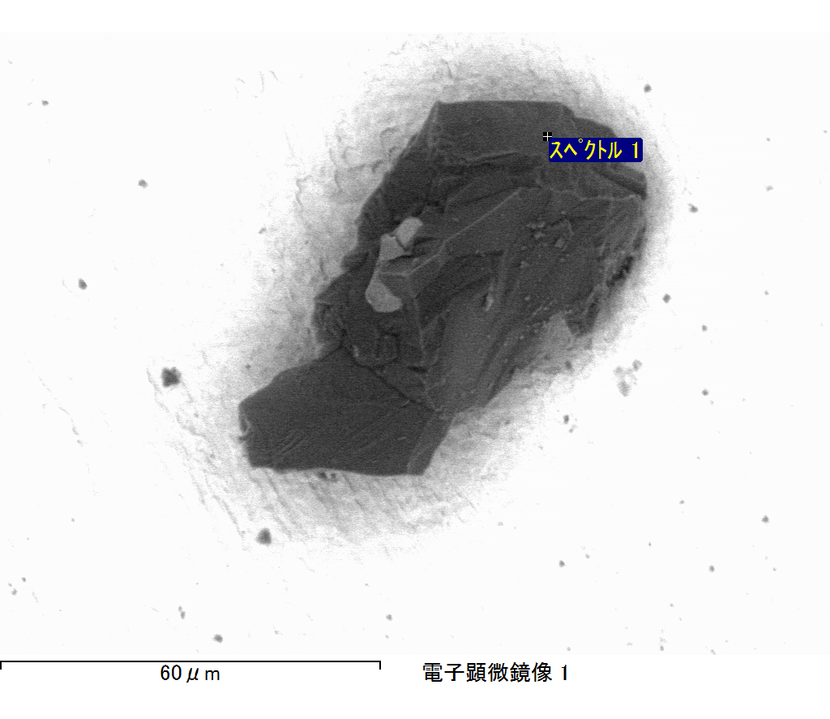

ｺﾒﾝﾄ :

2017/07/12 14:39:09

ﾌﾟﾛｼﾞｪｸﾄ 1

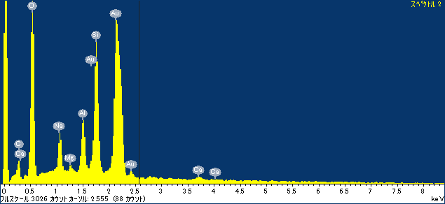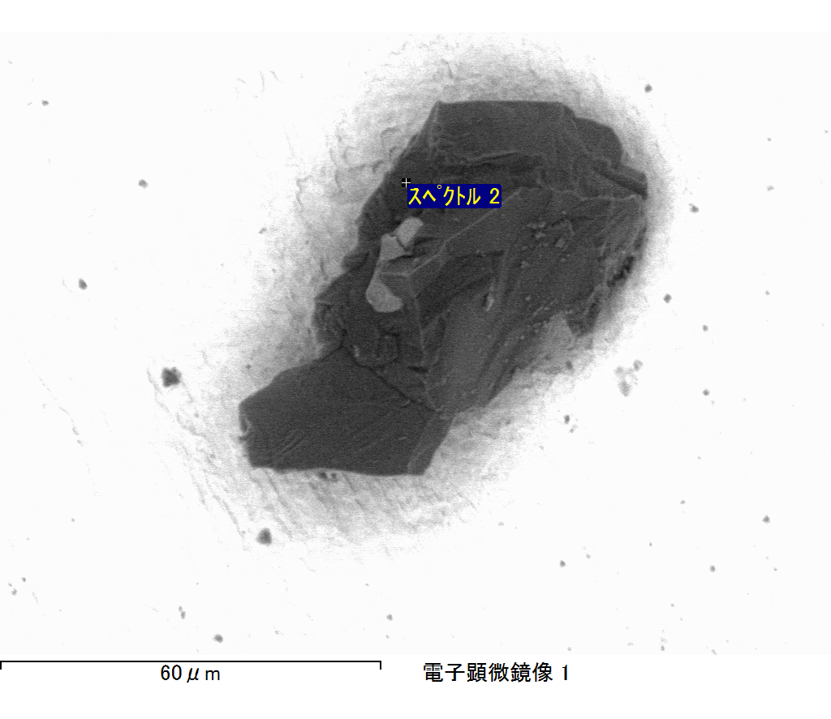

ｺﾒﾝﾄ :

2017/07/12 14:39:14

ﾌﾟﾛｼﾞｪｸﾄ 1

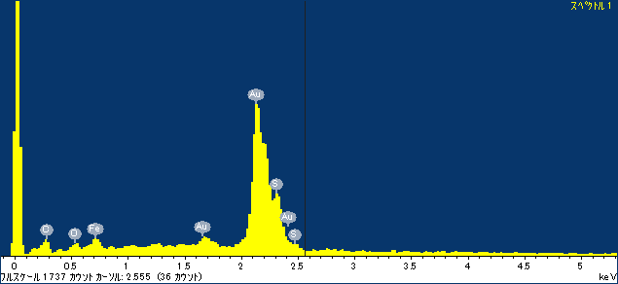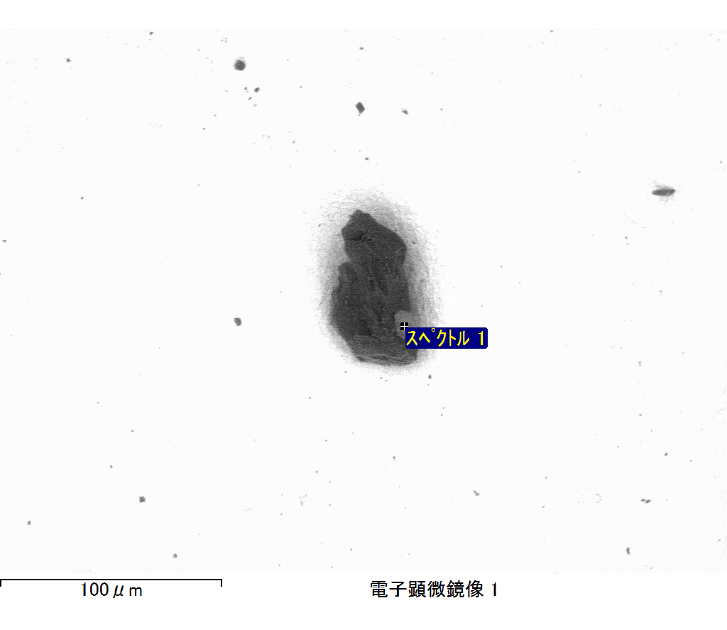

ｺﾒﾝﾄ :

2017/07/12 14:58:28

ﾌﾟﾛｼﾞｪｸﾄ 1

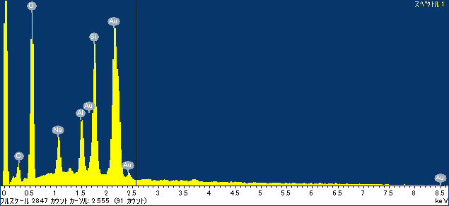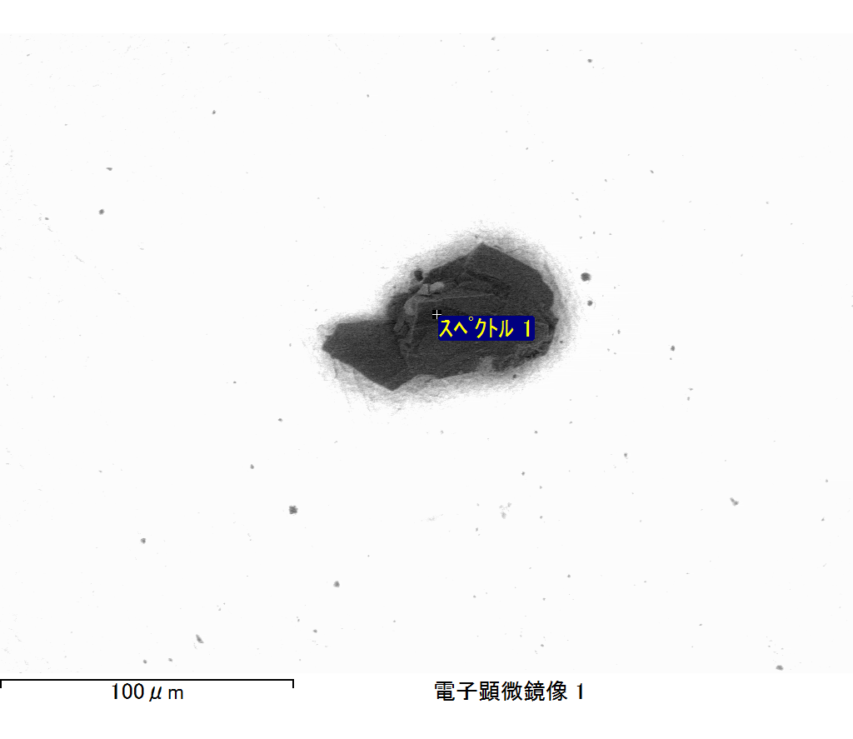

ｺﾒﾝﾄ :

2017/07/12 15:02:52

ﾌﾟﾛｼﾞｪｸﾄ 1

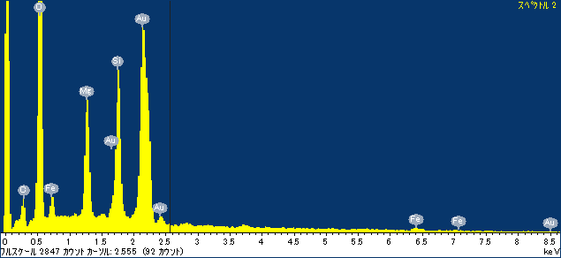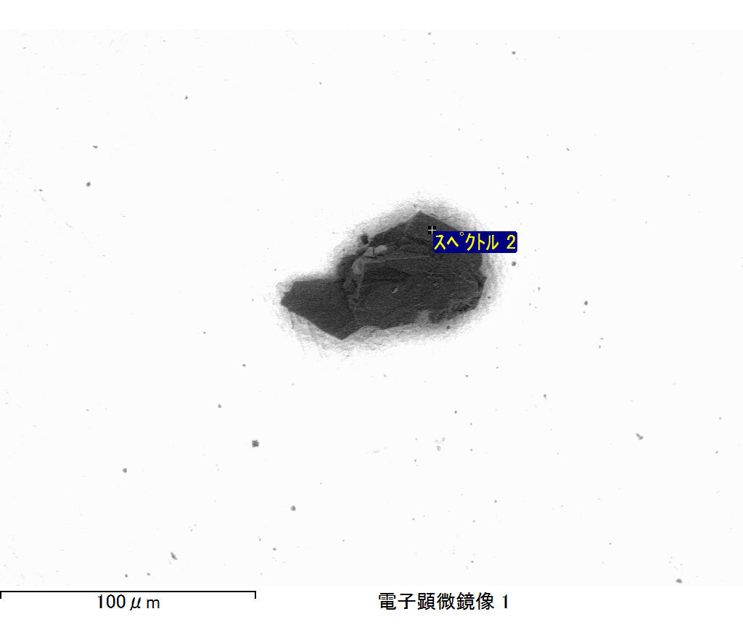

ｺﾒﾝﾄ :

2017/07/12 15:02:57

ﾌﾟﾛｼﾞｪｸﾄ 1

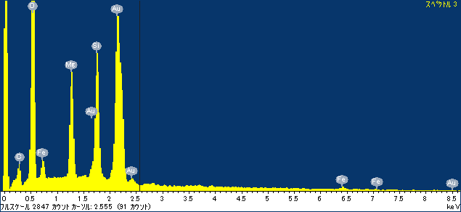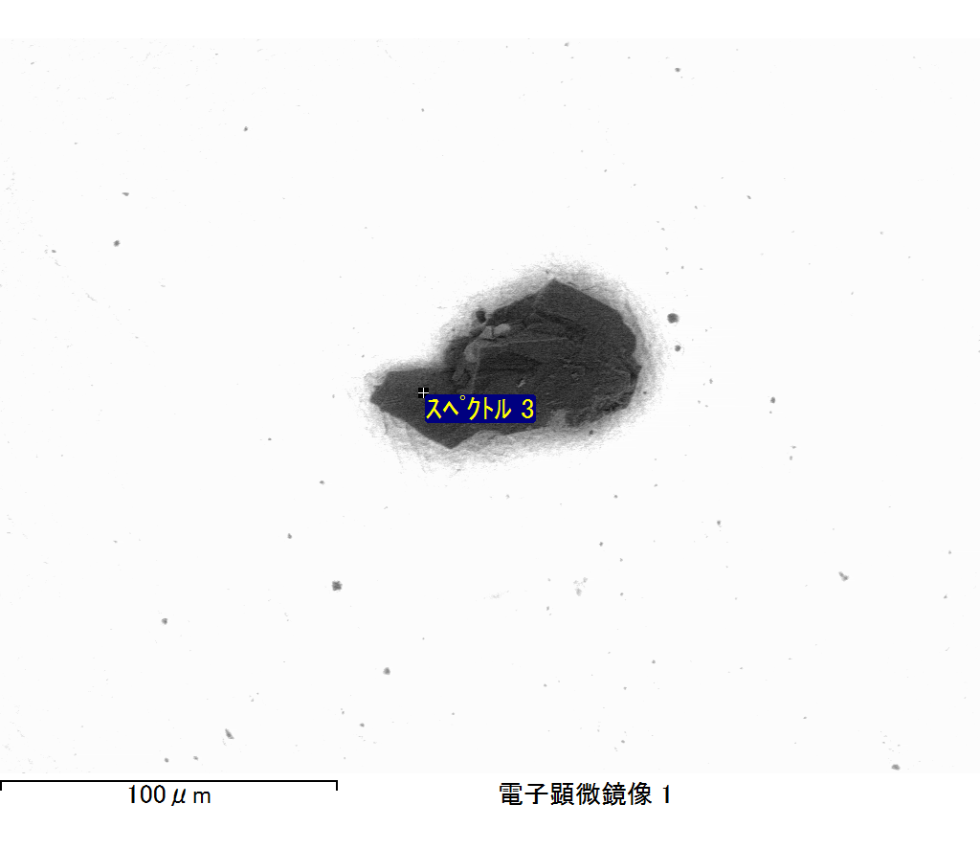

ｺﾒﾝﾄ :

2017/07/12 15:03:01

ﾌﾟﾛｼﾞｪｸﾄ 1