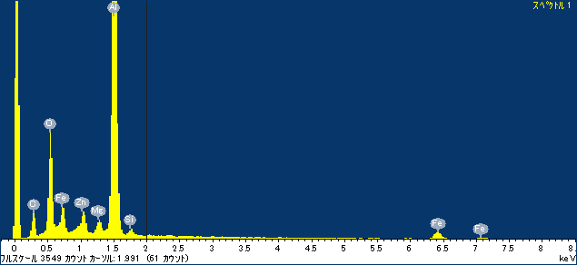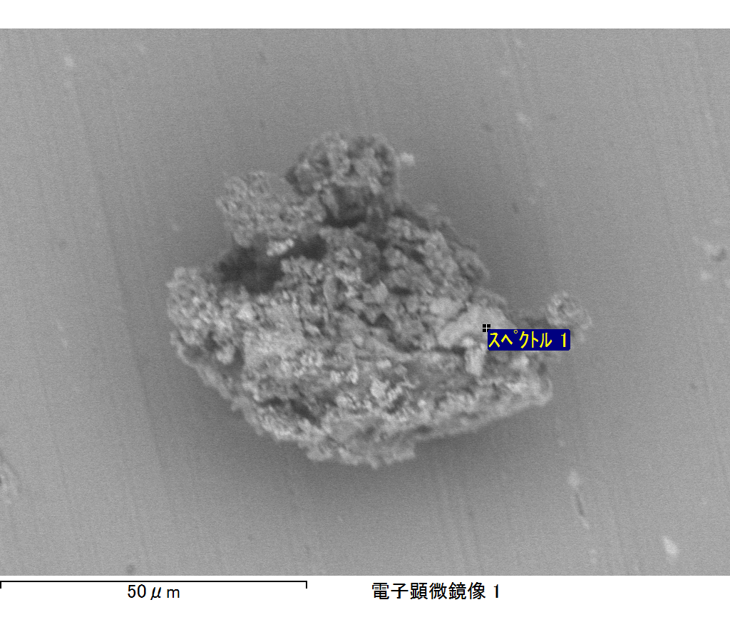

ｺﾒﾝﾄ :

2017/08/09 14:52:29

ﾌﾟﾛｼﾞｪｸﾄ 1

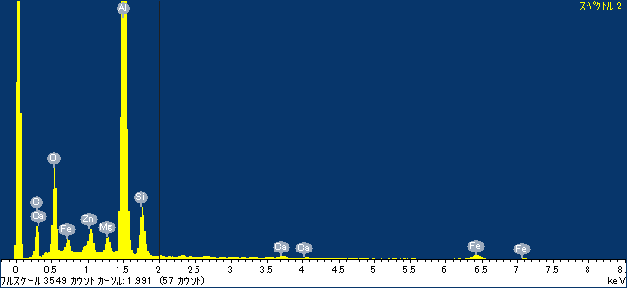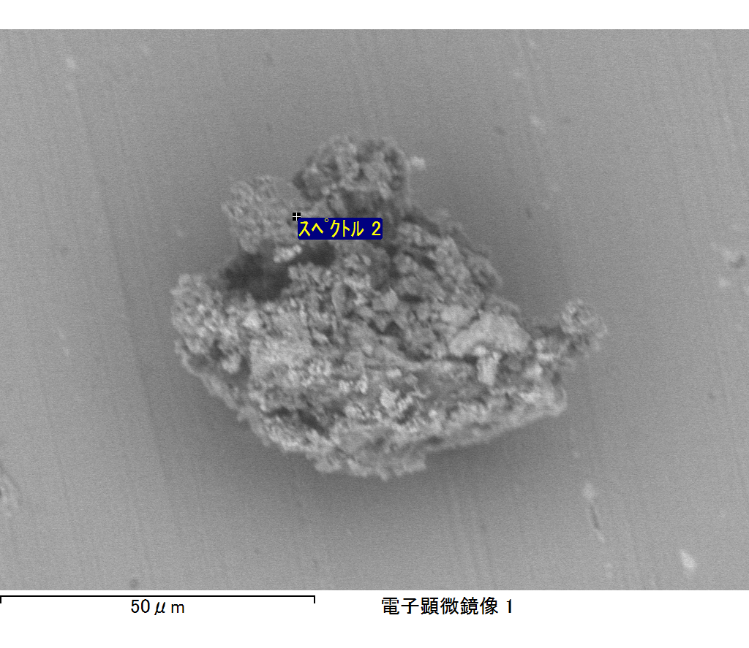

ｺﾒﾝﾄ :

2017/08/09 14:52:34

ﾌﾟﾛｼﾞｪｸﾄ 1

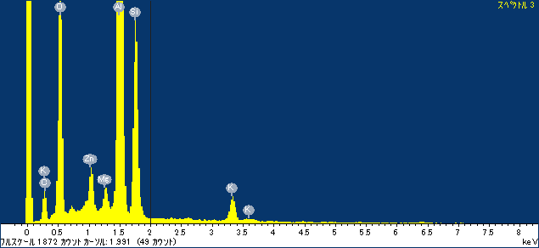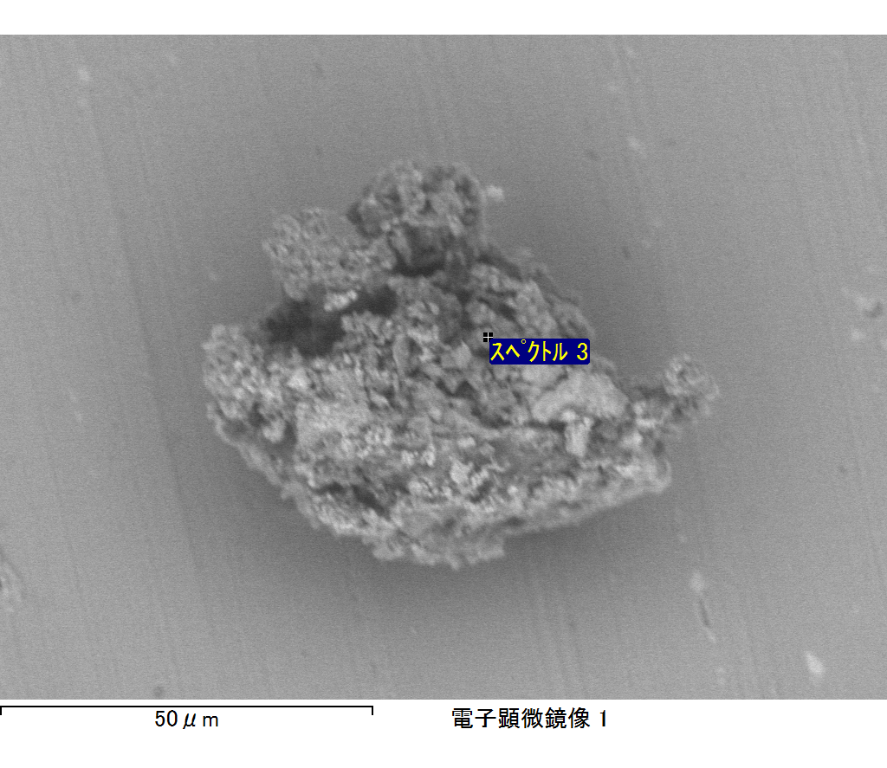

ｺﾒﾝﾄ :

2017/08/09 14:57:05

ﾌﾟﾛｼﾞｪｸﾄ 1

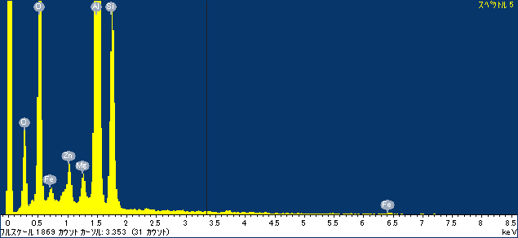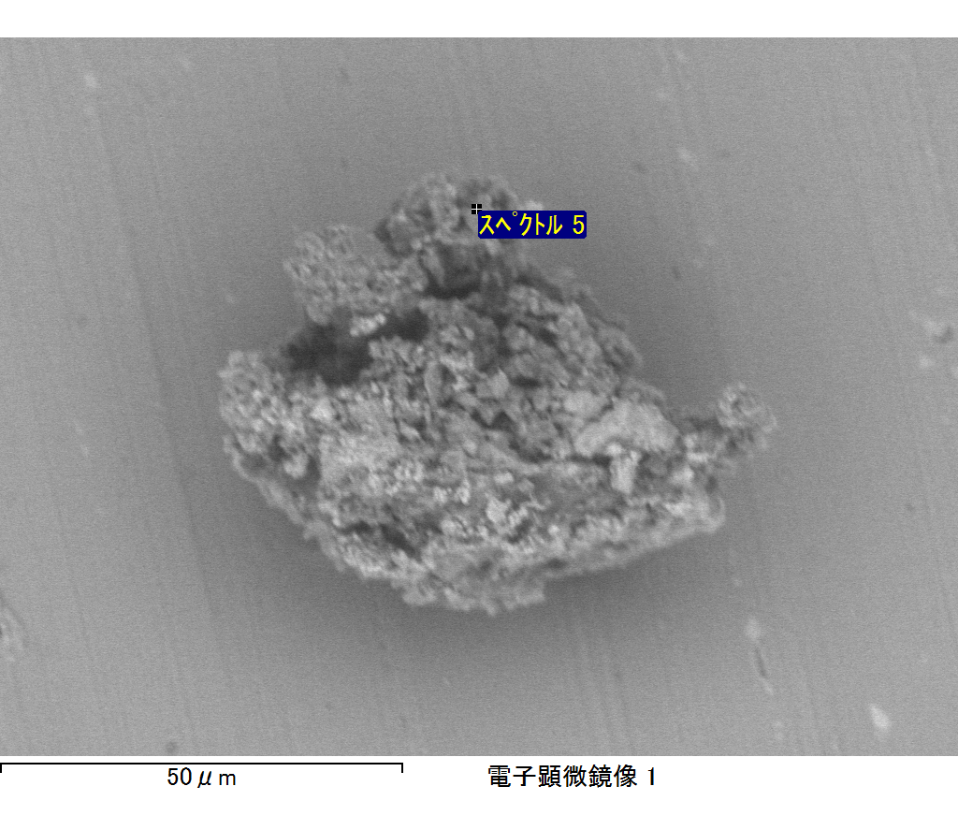

ｺﾒﾝﾄ :

2017/08/09 14:57:20

ﾌﾟﾛｼﾞｪｸﾄ 1

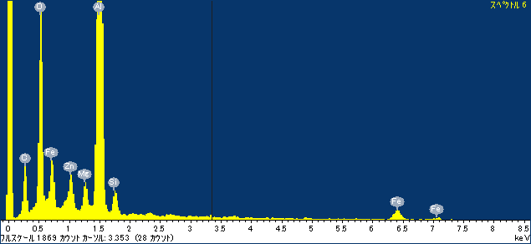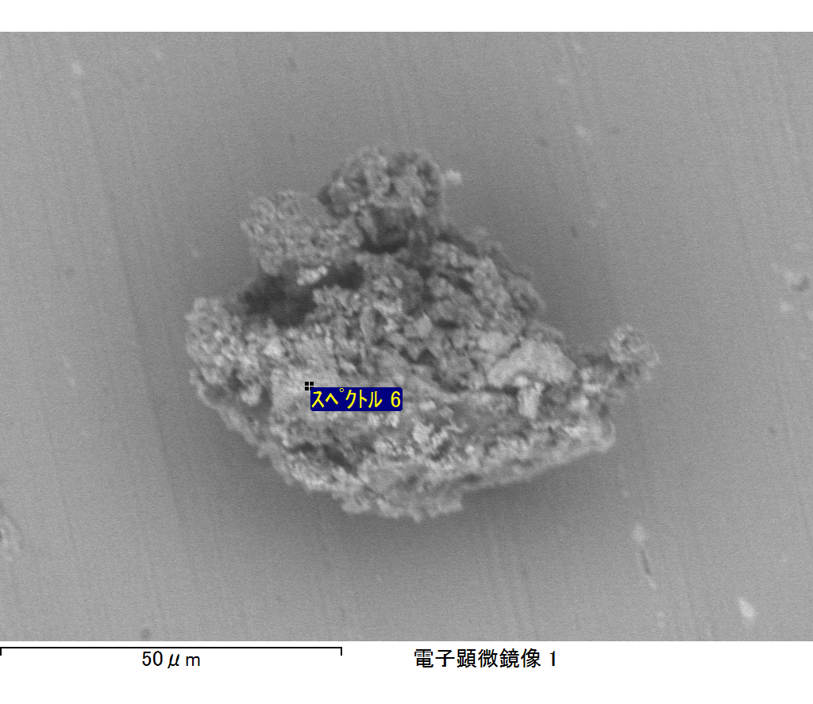

ｺﾒﾝﾄ :

2017/08/09 14:57:25

ﾌﾟﾛｼﾞｪｸﾄ 1