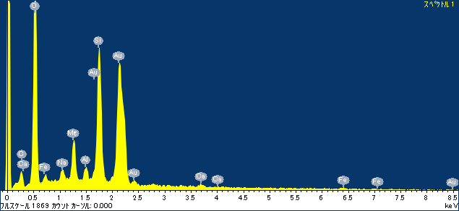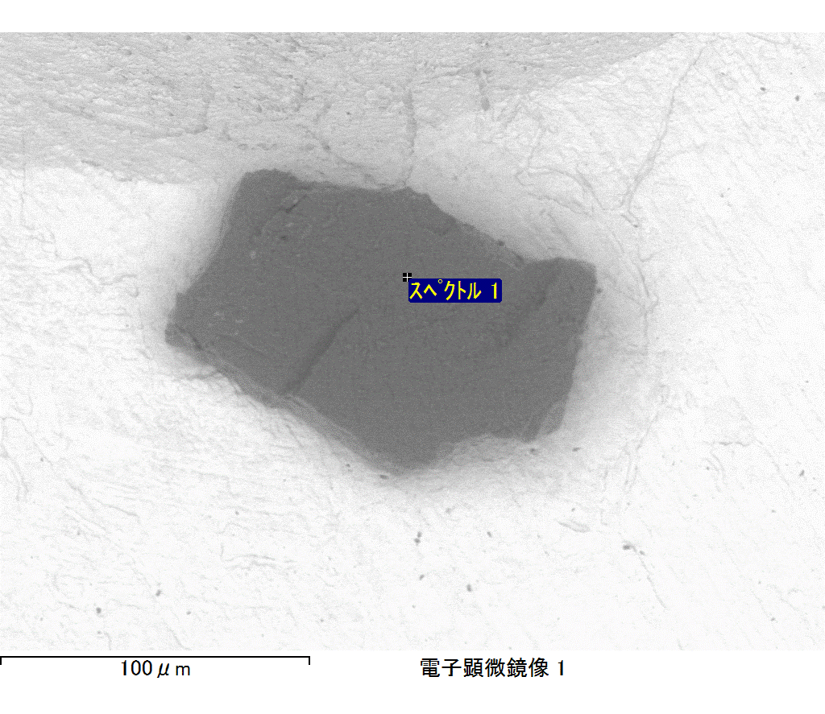

ｺﾒﾝﾄ :

2017/09/08 11:06:45

ﾌﾟﾛｼﾞｪｸﾄ 1

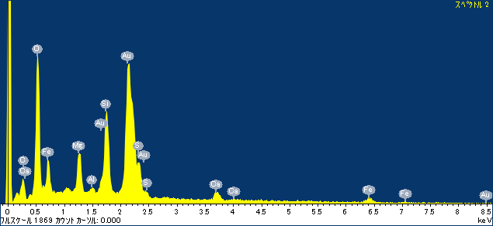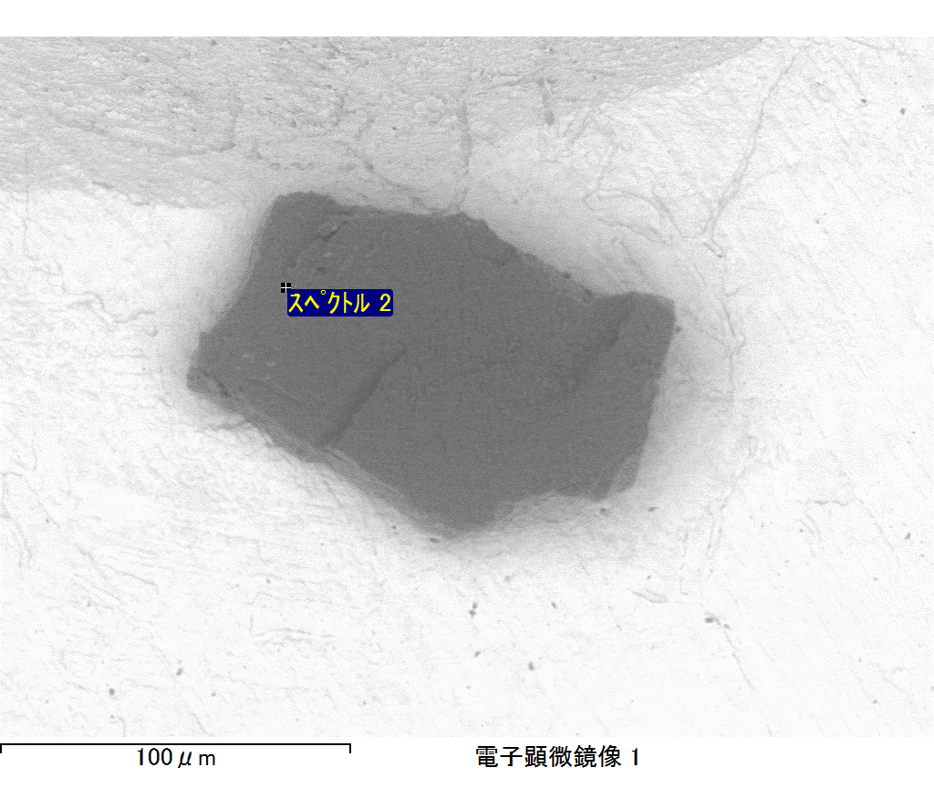

ｺﾒﾝﾄ :

2017/09/08 11:06:48

ﾌﾟﾛｼﾞｪｸﾄ 1

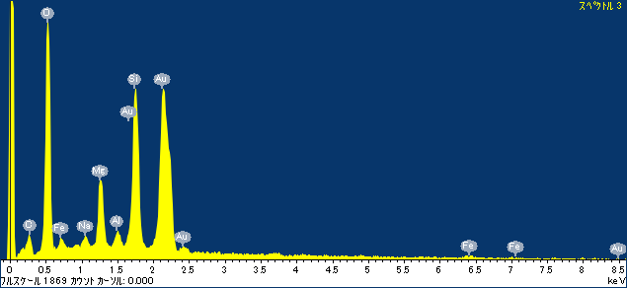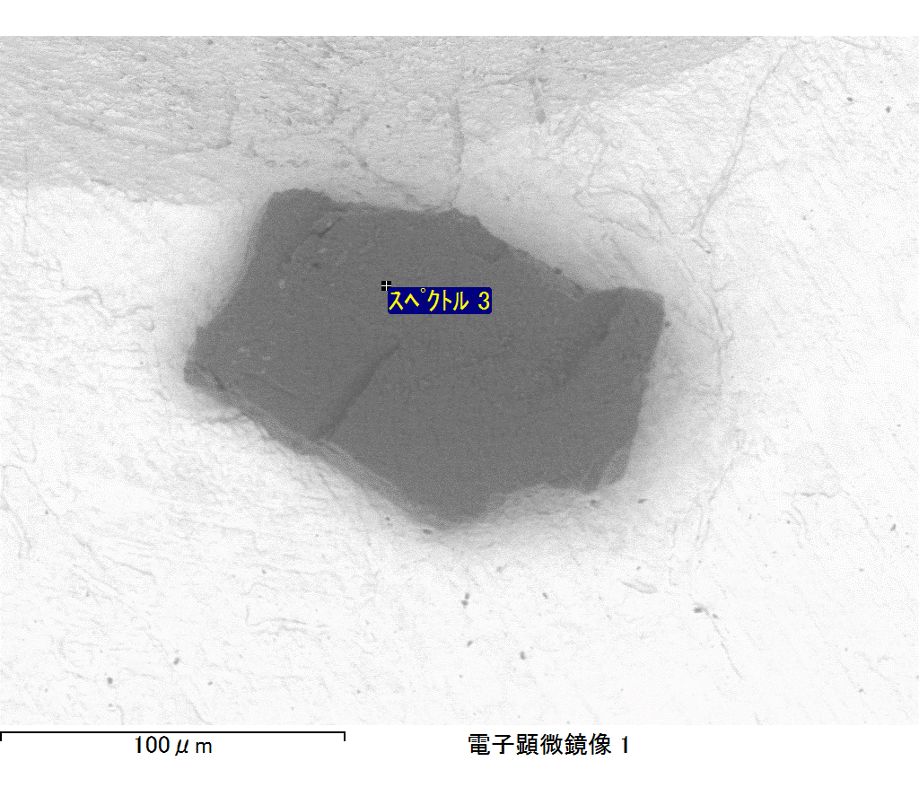

ｺﾒﾝﾄ :

2017/09/08 11:06:52

ﾌﾟﾛｼﾞｪｸﾄ 1

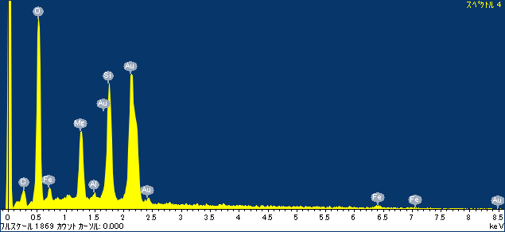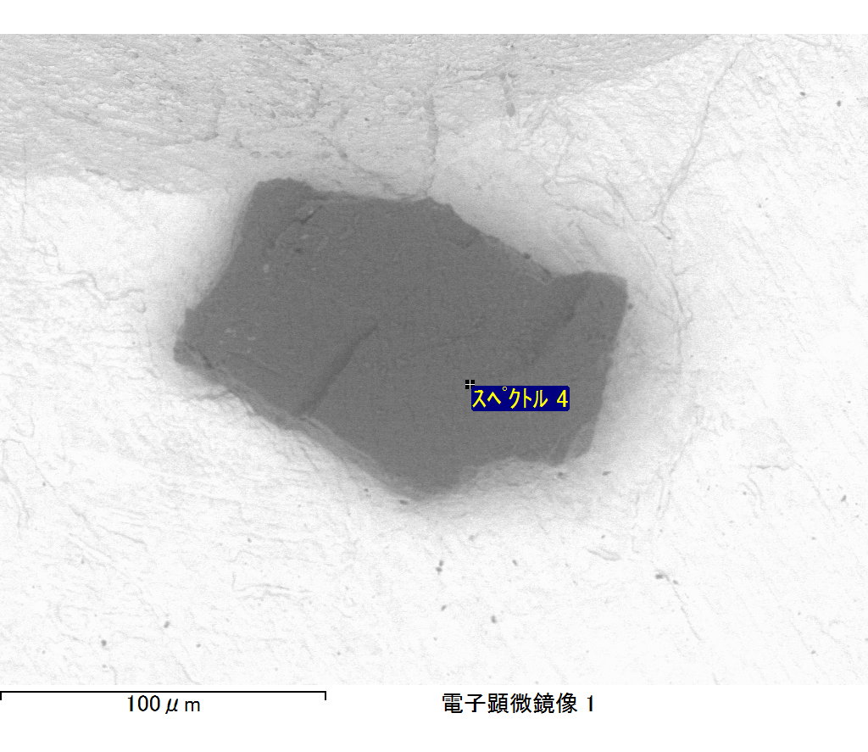

ｺﾒﾝﾄ :

2017/09/08 11:06:56

ﾌﾟﾛｼﾞｪｸﾄ 1

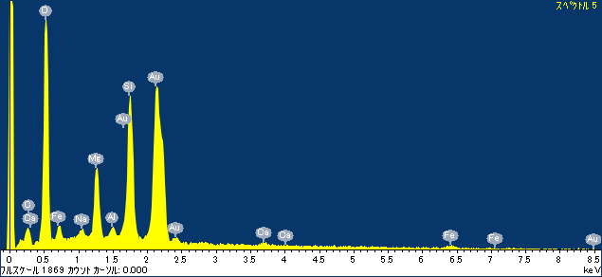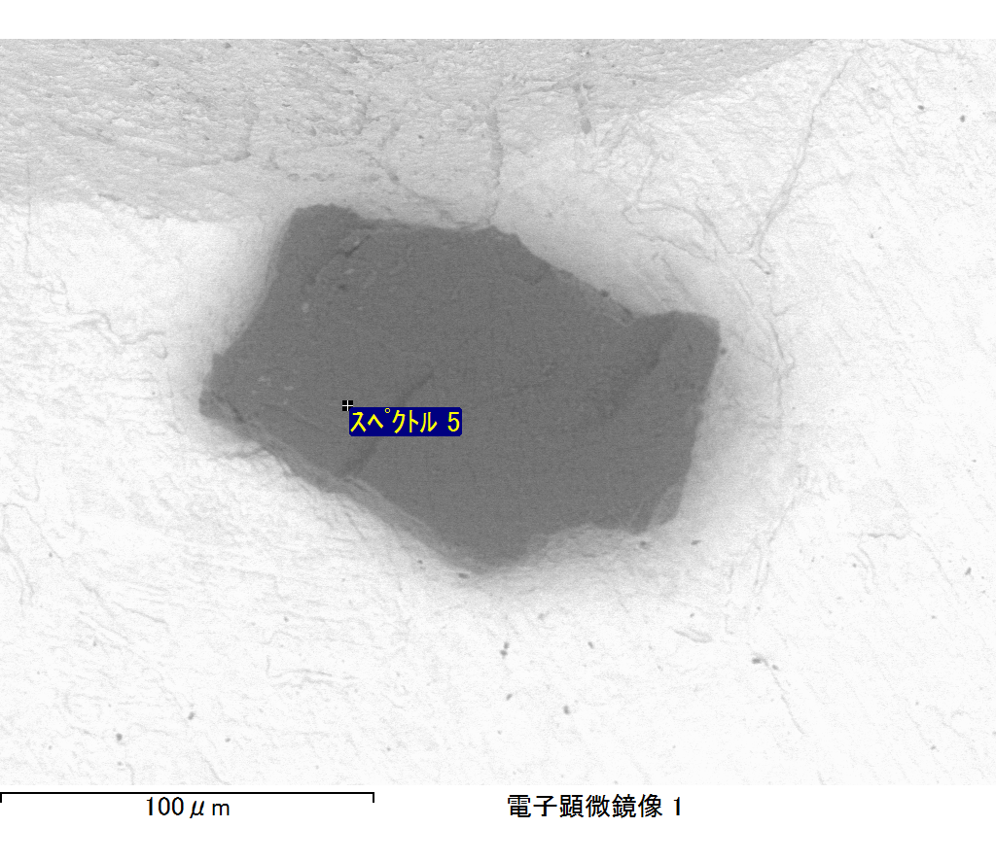

ｺﾒﾝﾄ :

2017/09/08 11:06:59

ﾌﾟﾛｼﾞｪｸﾄ 1