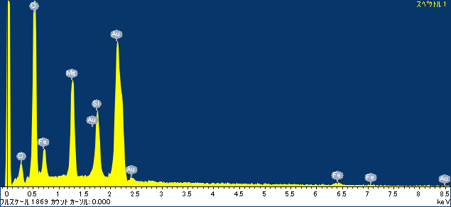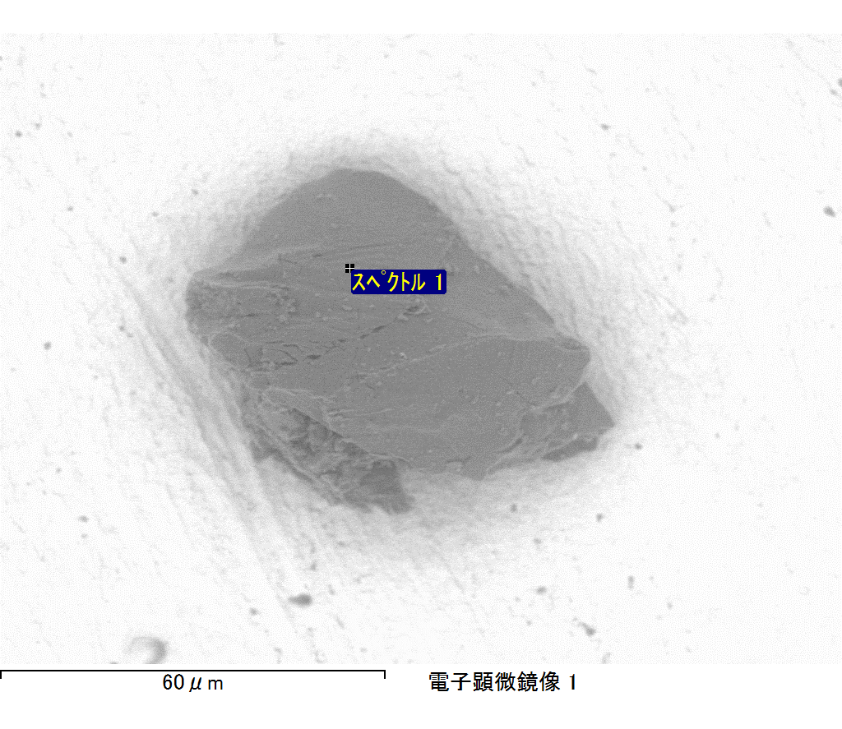

ｺﾒﾝﾄ :

2017/09/08 11:52:52

ﾌﾟﾛｼﾞｪｸﾄ 1

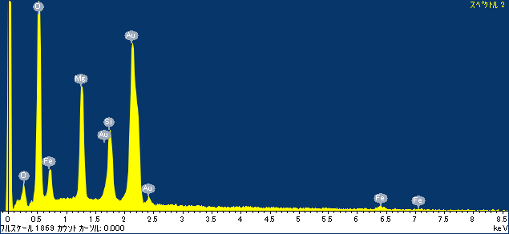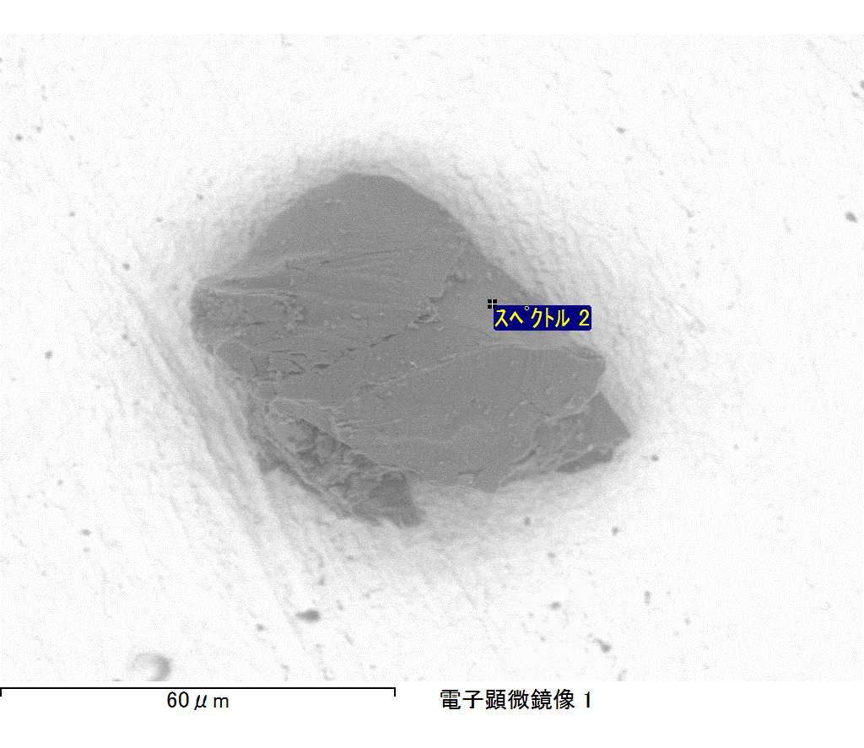

ｺﾒﾝﾄ :

2017/09/08 11:52:55

ﾌﾟﾛｼﾞｪｸﾄ 1

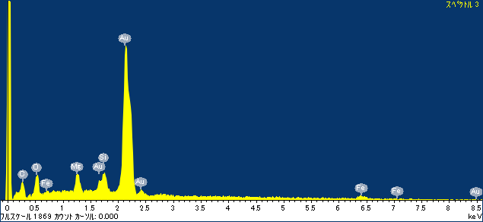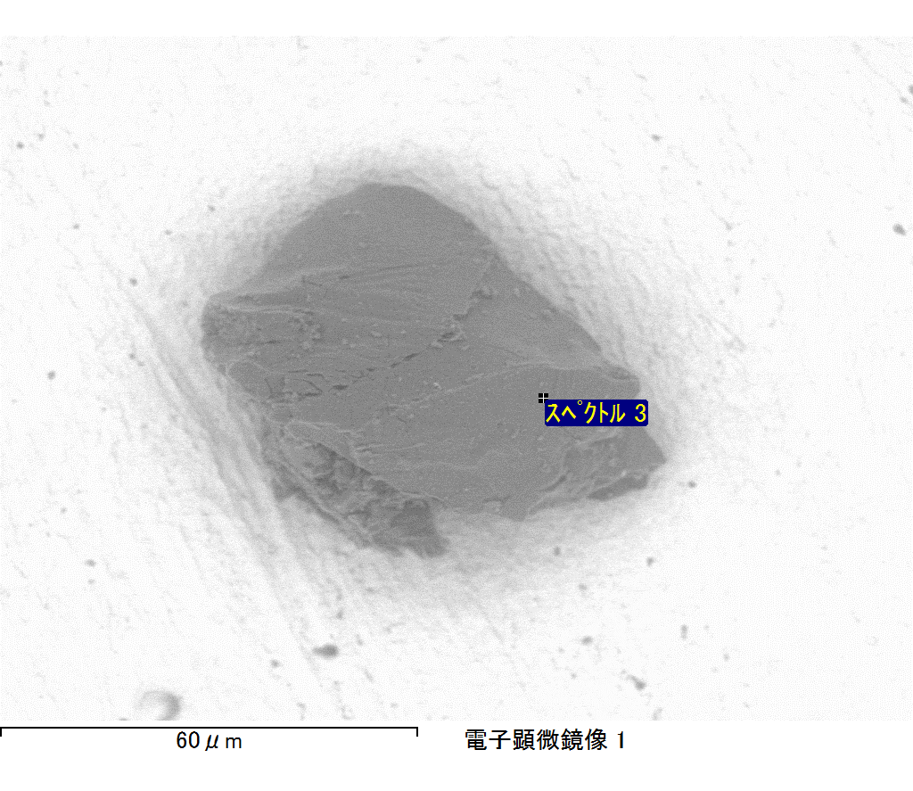

ｺﾒﾝﾄ :

2017/09/08 11:52:58

ﾌﾟﾛｼﾞｪｸﾄ 1

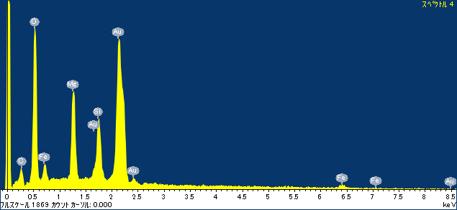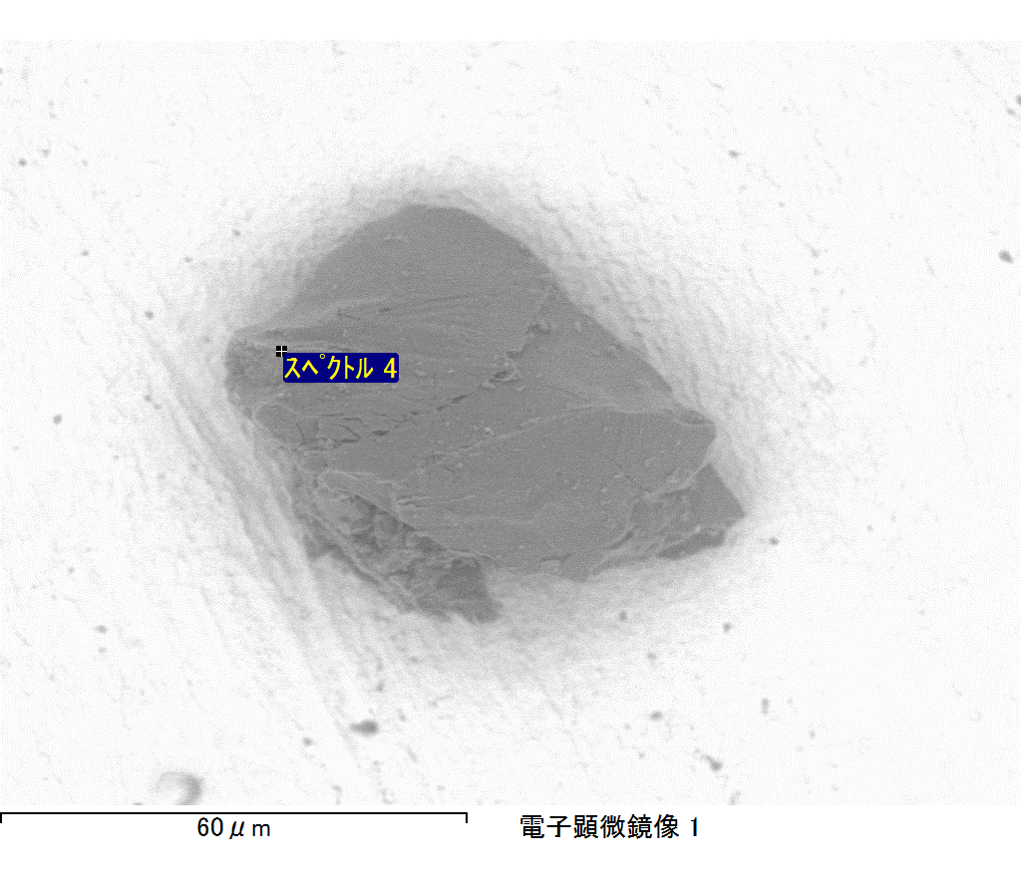

ｺﾒﾝﾄ :

2017/09/08 11:53:01

ﾌﾟﾛｼﾞｪｸﾄ 1

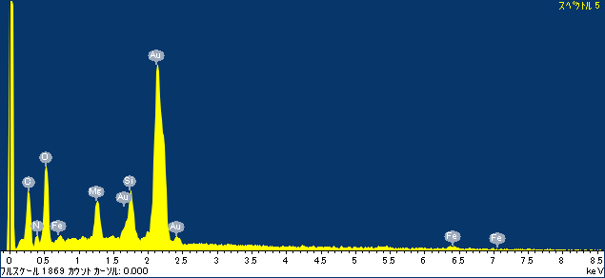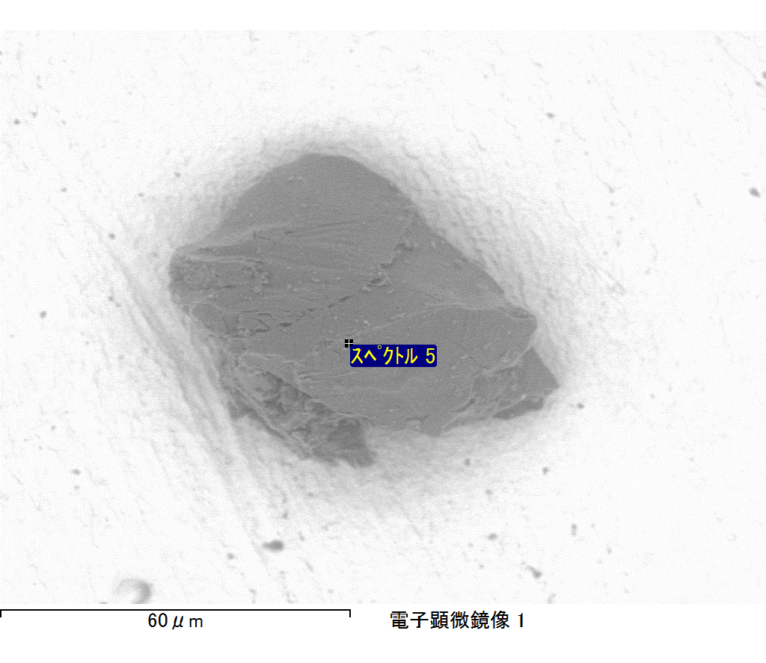

ｺﾒﾝﾄ :

2017/09/08 11:53:05

ﾌﾟﾛｼﾞｪｸﾄ 1