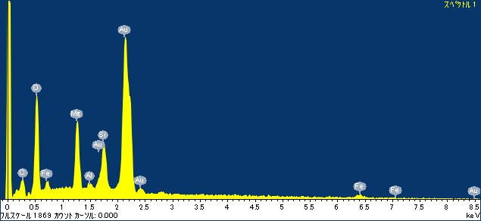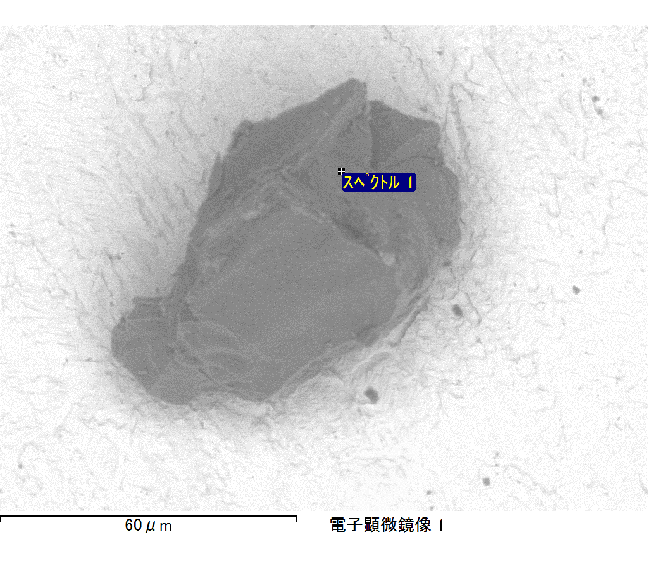

ｺﾒﾝﾄ :

2017/09/08 11:20:23

ﾌﾟﾛｼﾞｪｸﾄ 1

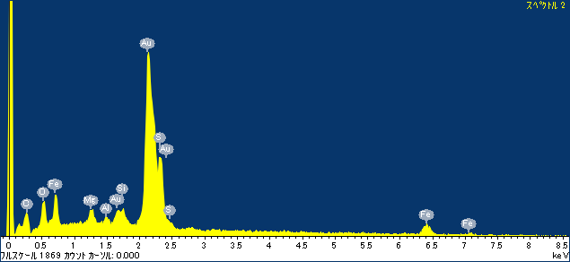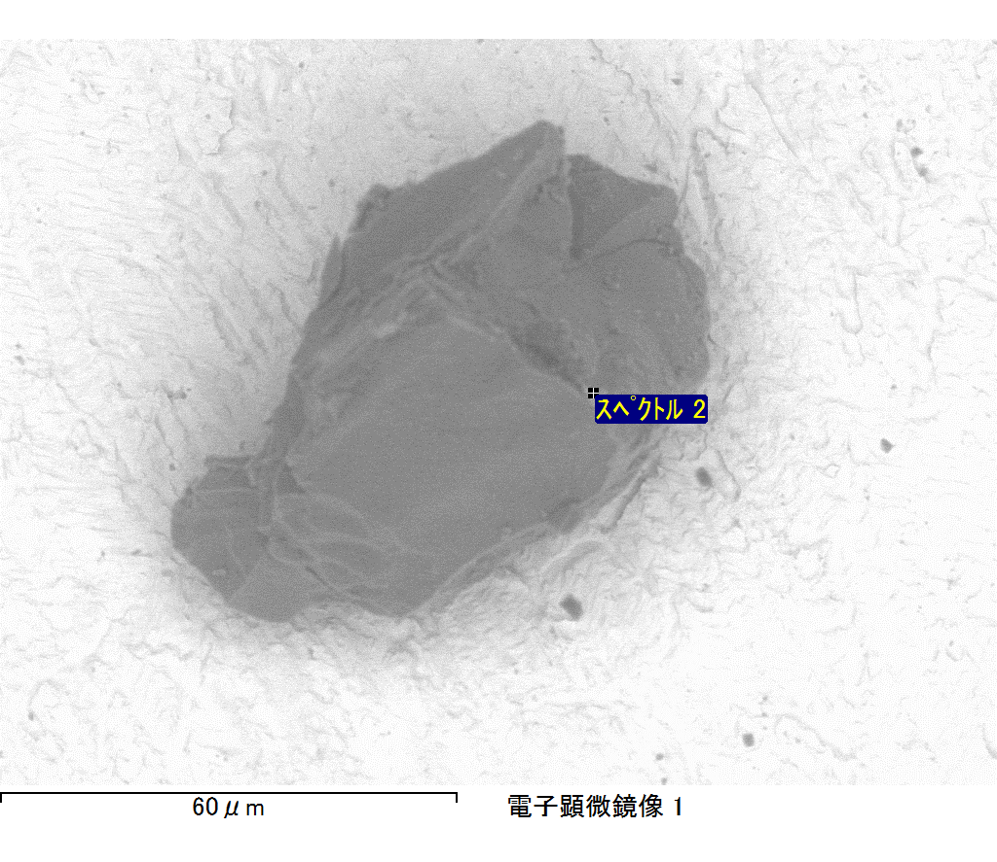

ｺﾒﾝﾄ :

2017/09/08 11:20:27

ﾌﾟﾛｼﾞｪｸﾄ 1

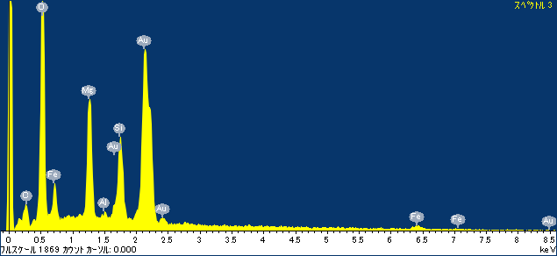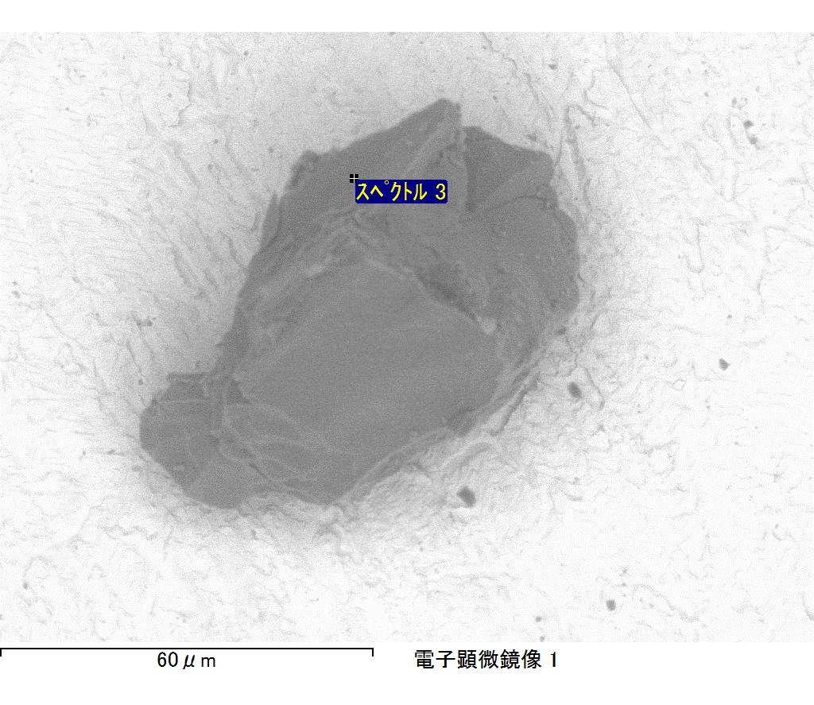

ｺﾒﾝﾄ :

2017/09/08 11:20:31

ﾌﾟﾛｼﾞｪｸﾄ 1

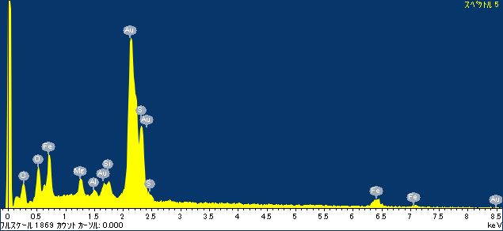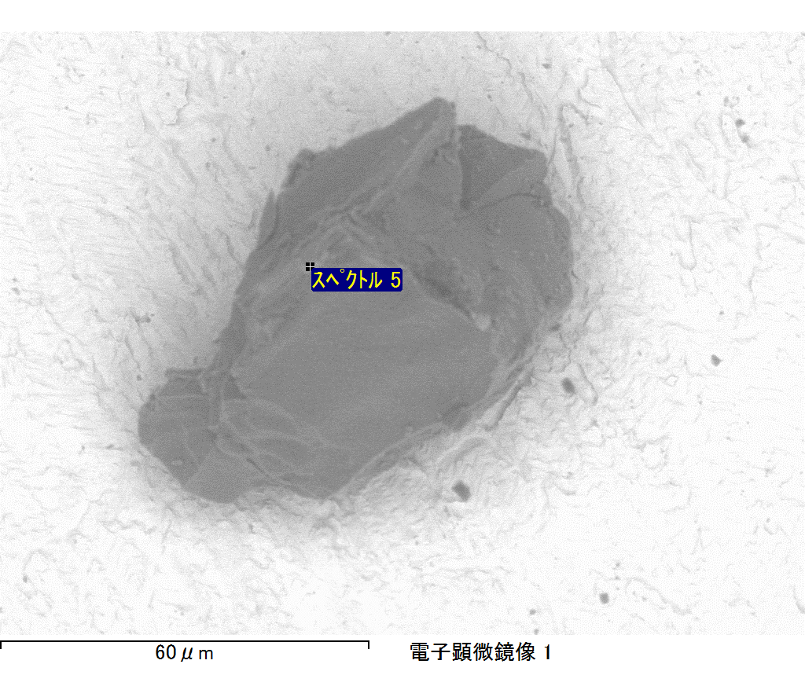

ｺﾒﾝﾄ :

2017/09/08 11:20:37

ﾌﾟﾛｼﾞｪｸﾄ 1

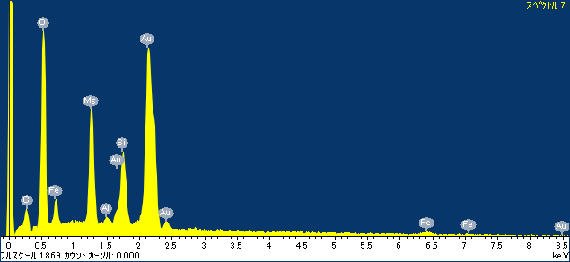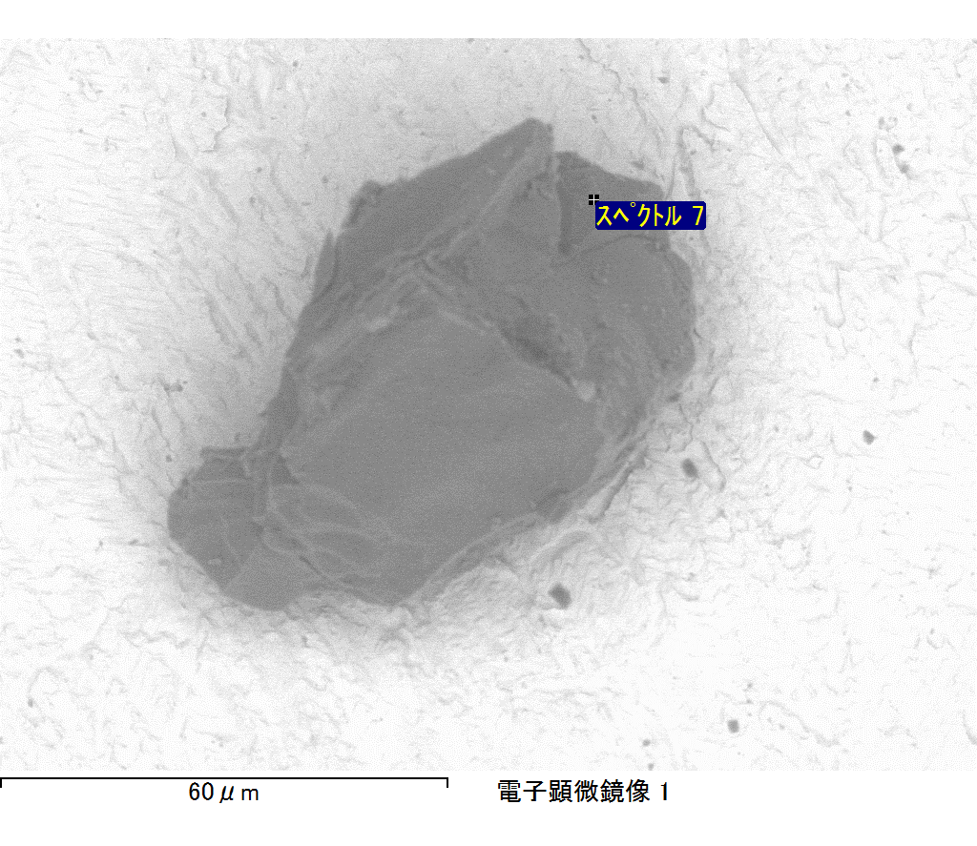

ｺﾒﾝﾄ :

2017/09/08 11:20:41

ﾌﾟﾛｼﾞｪｸﾄ 1