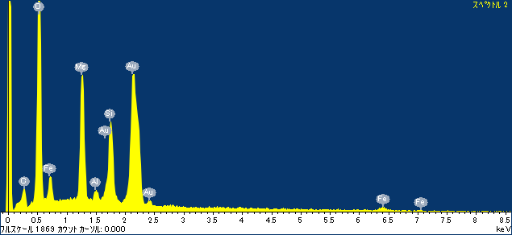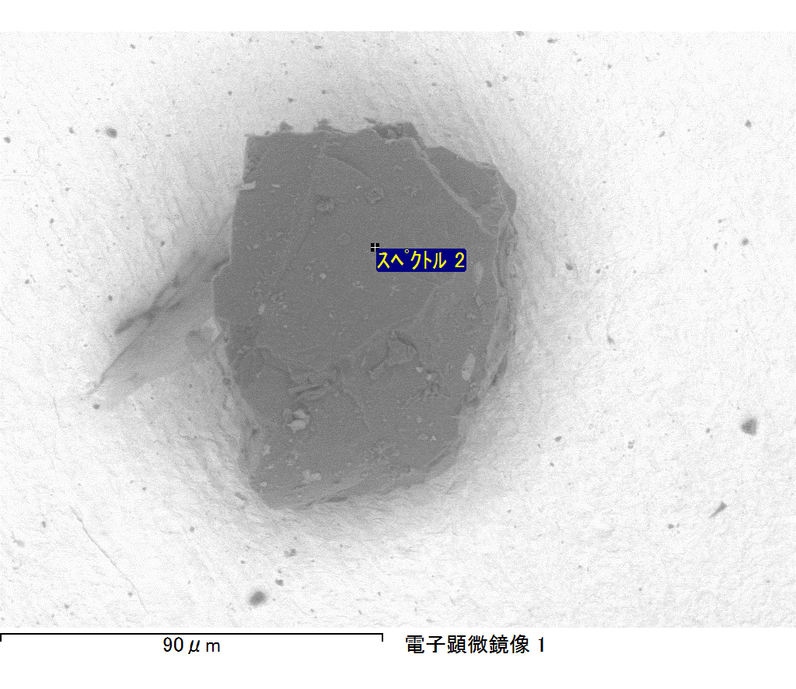

ｺﾒﾝﾄ :

2017/09/08 10:52:57

ﾌﾟﾛｼﾞｪｸﾄ 1

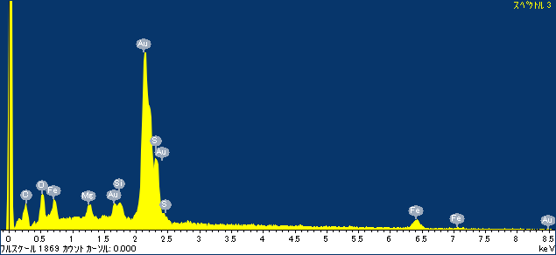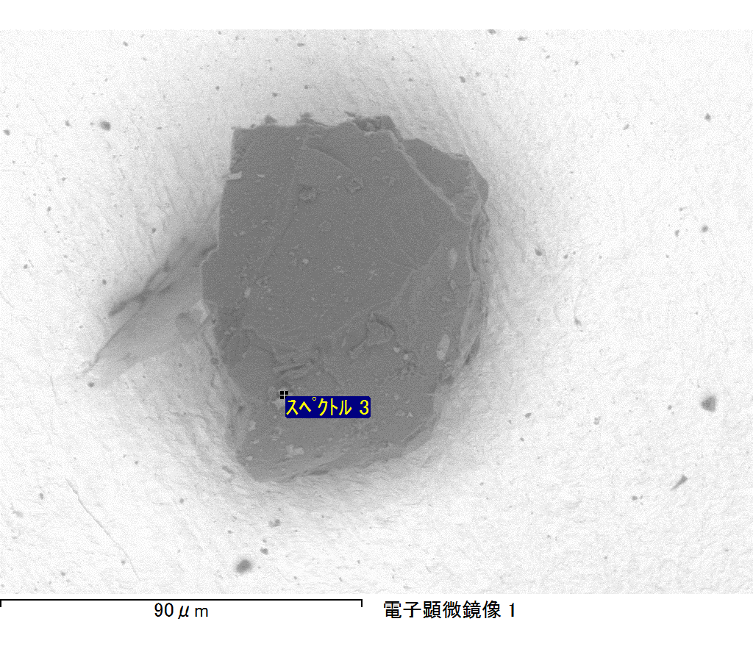

ｺﾒﾝﾄ :

2017/09/08 10:53:02

ﾌﾟﾛｼﾞｪｸﾄ 1

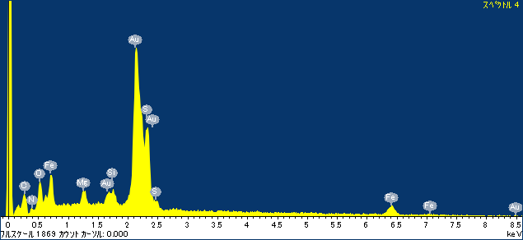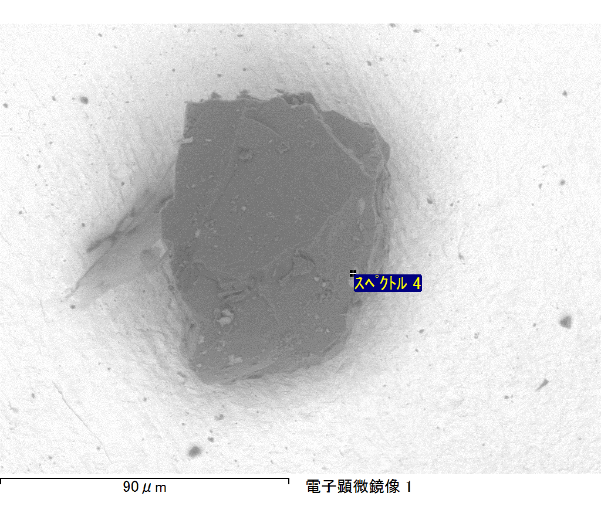

ｺﾒﾝﾄ :

2017/09/08 10:53:07

ﾌﾟﾛｼﾞｪｸﾄ 1

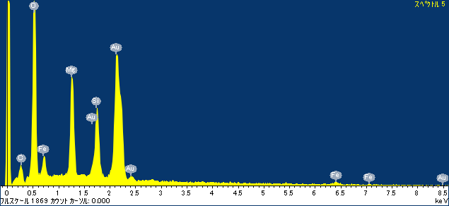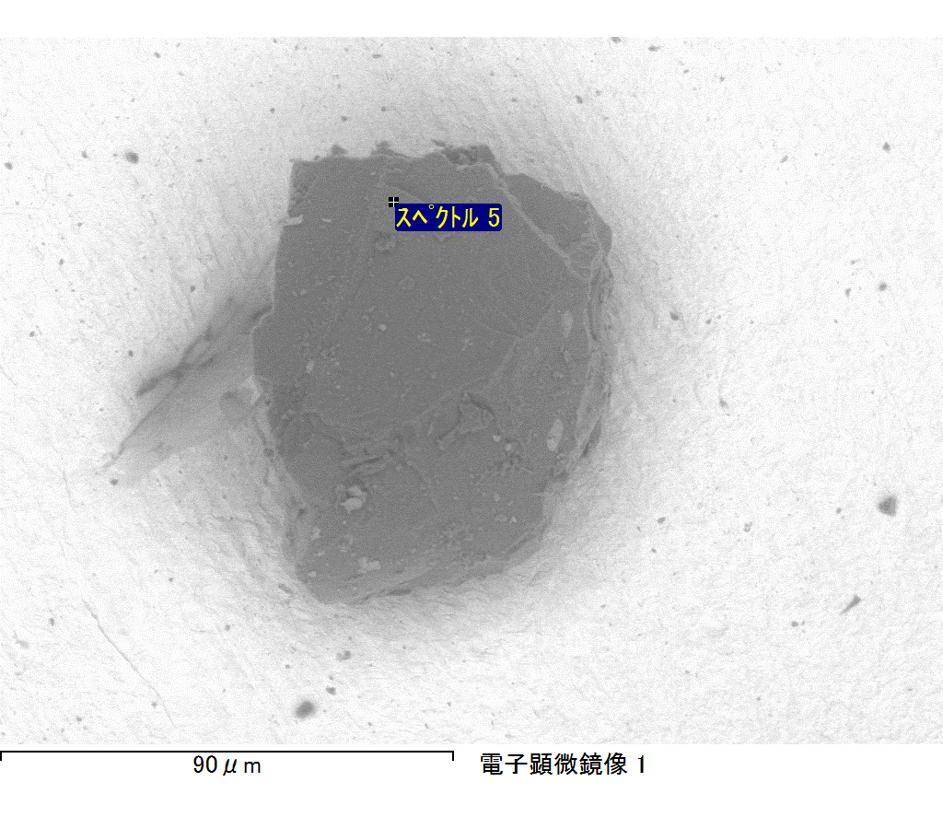

ｺﾒﾝﾄ :

2017/09/08 10:53:10

ﾌﾟﾛｼﾞｪｸﾄ 1

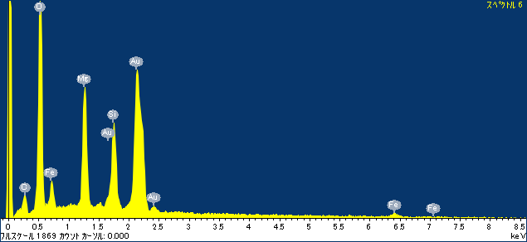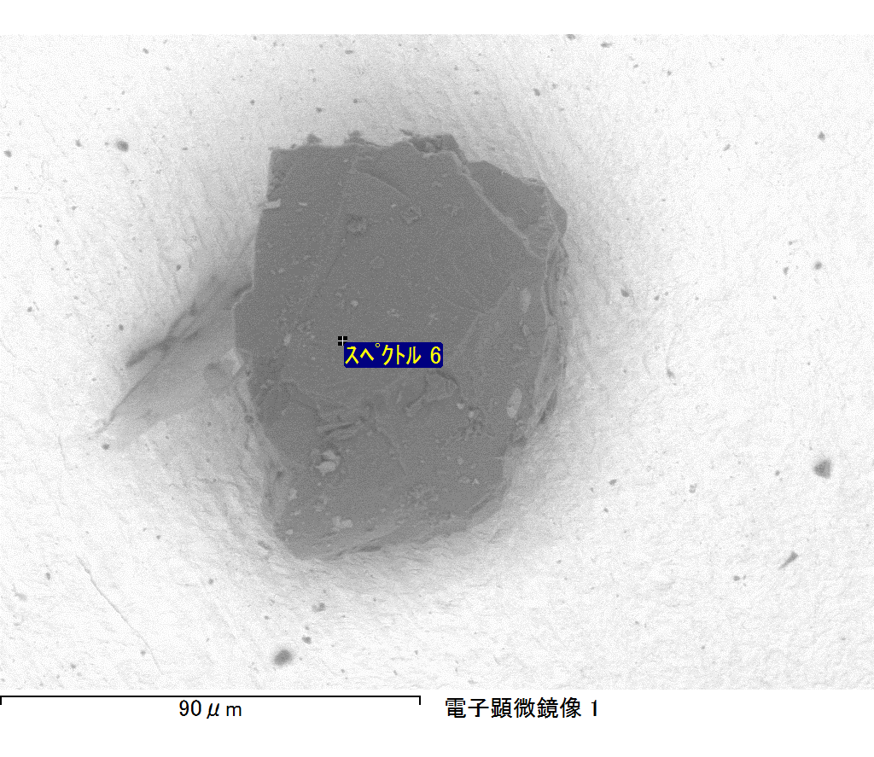

ｺﾒﾝﾄ :

2017/09/08 10:53:14

ﾌﾟﾛｼﾞｪｸﾄ 1