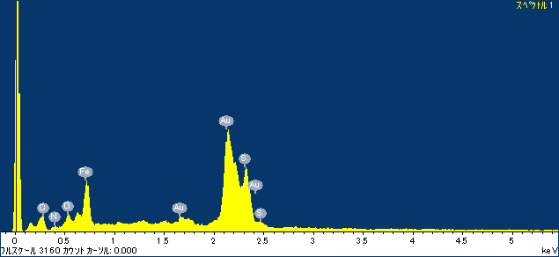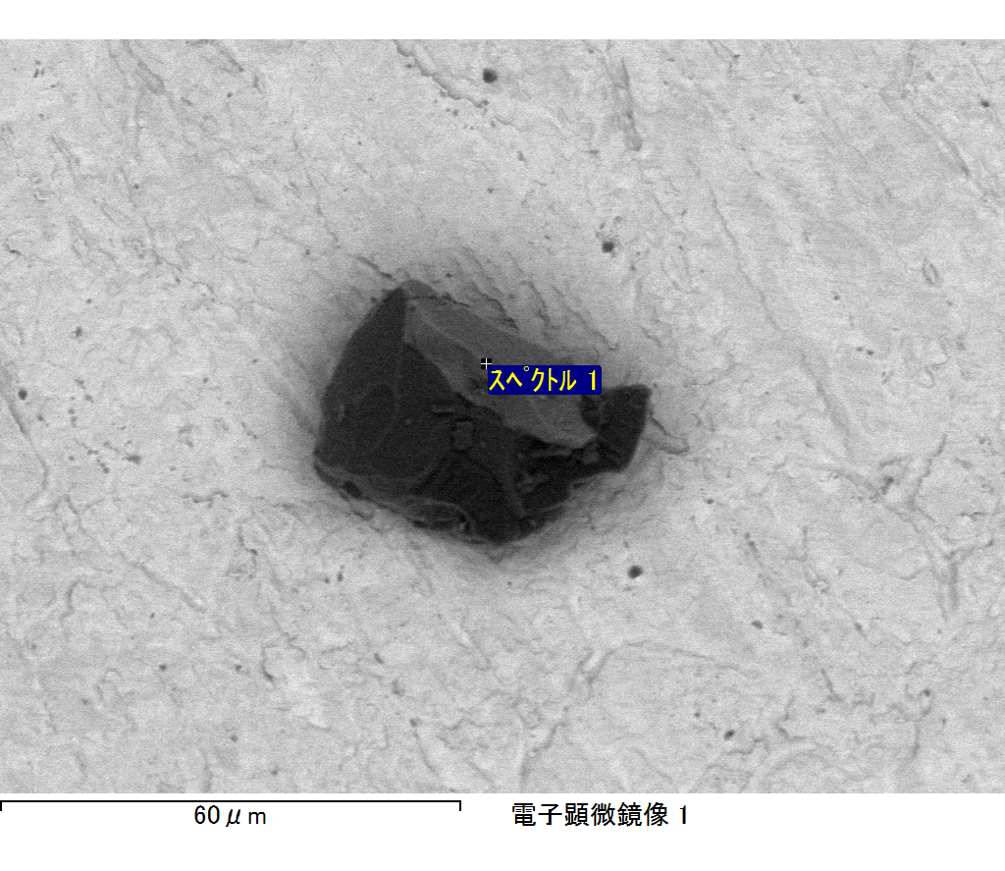

ｺﾒﾝﾄ :

2017/10/06 11:13:10

ﾌﾟﾛｼﾞｪｸﾄ 1

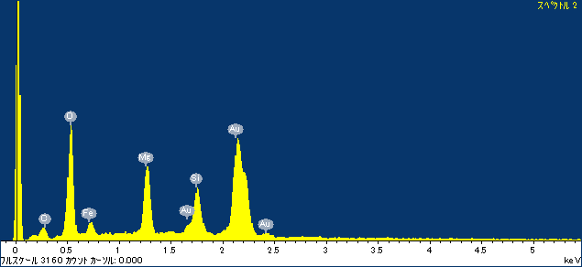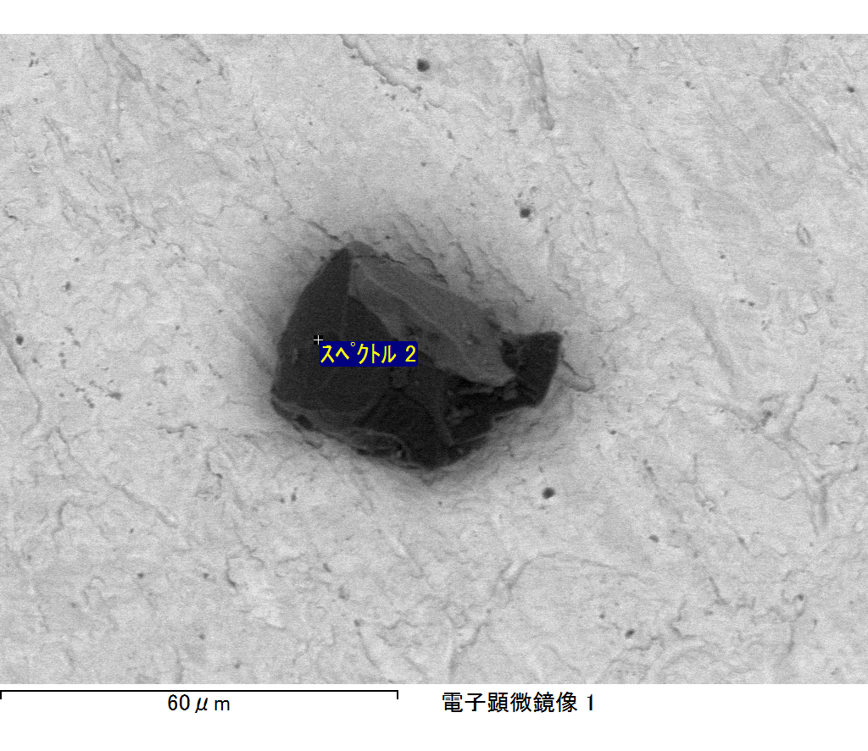

ｺﾒﾝﾄ :

2017/10/06 11:13:14

ﾌﾟﾛｼﾞｪｸﾄ 1

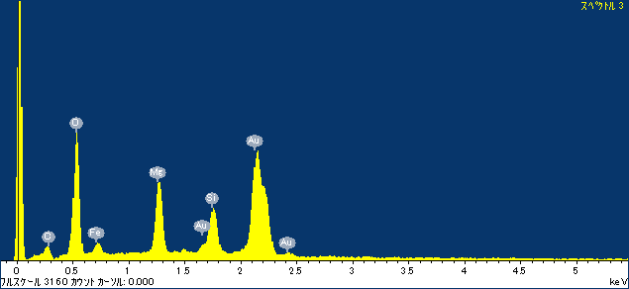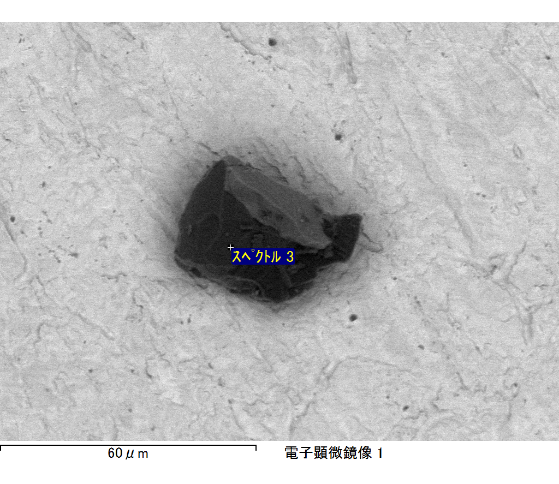

ｺﾒﾝﾄ :

2017/10/06 11:13:18

ﾌﾟﾛｼﾞｪｸﾄ 1

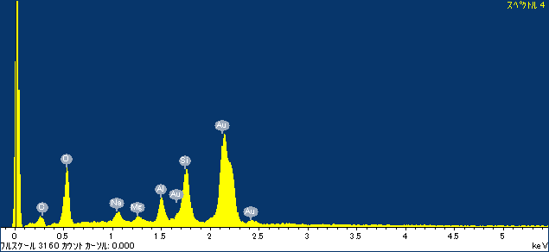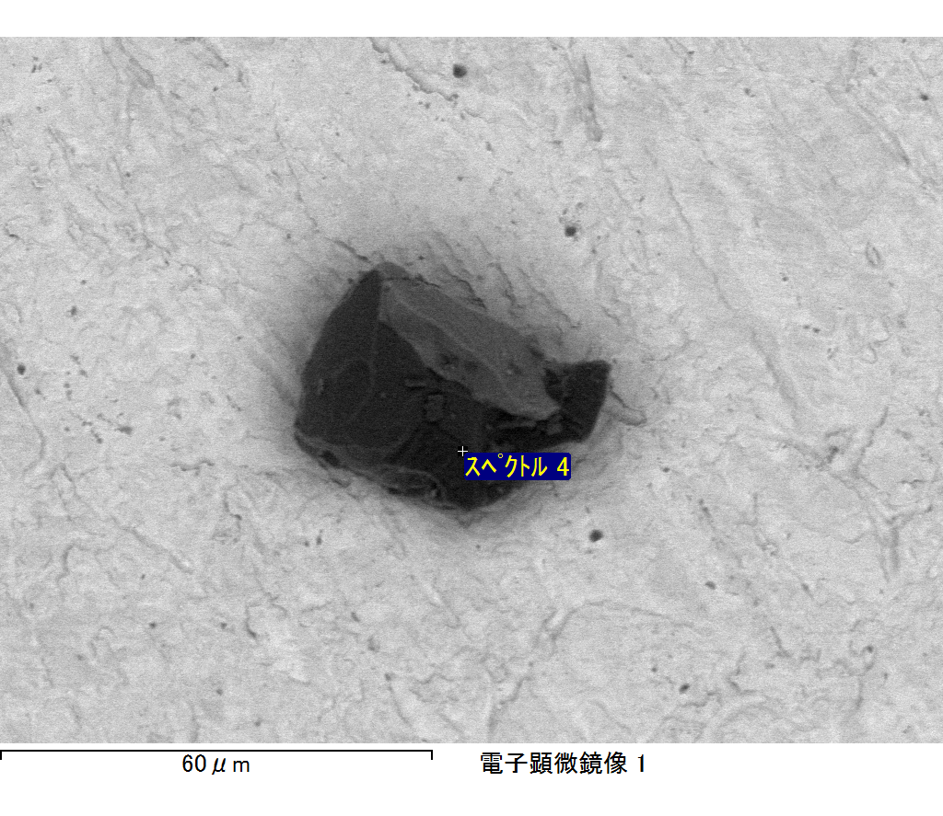

ｺﾒﾝﾄ :

2017/10/06 11:13:21

ﾌﾟﾛｼﾞｪｸﾄ 1

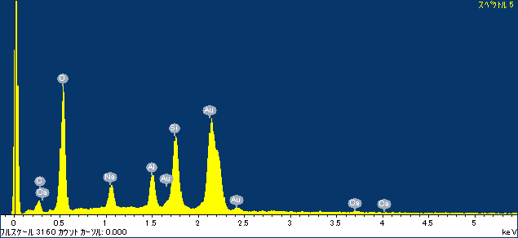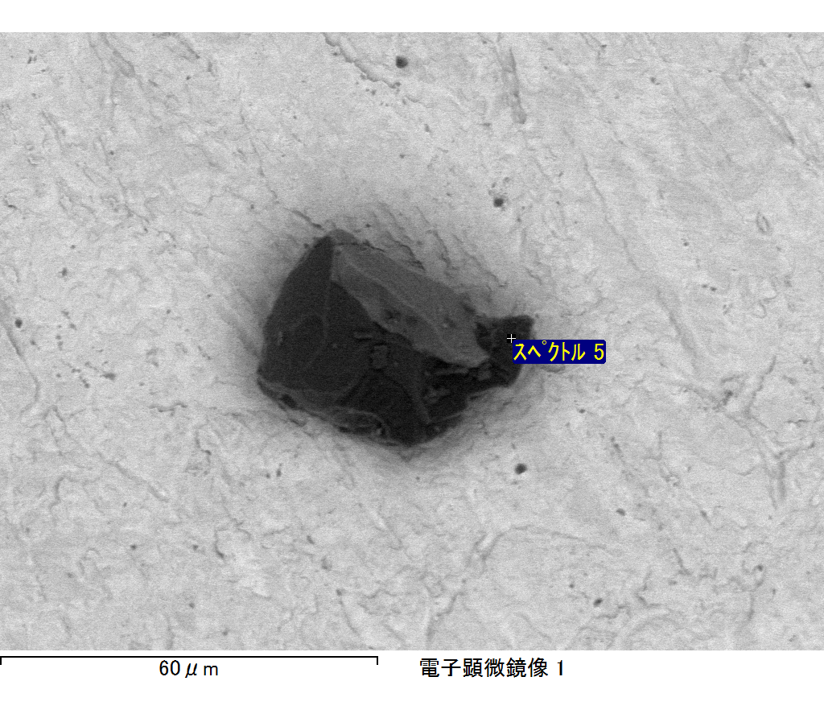

ｺﾒﾝﾄ :

2017/10/06 11:13:25

ﾌﾟﾛｼﾞｪｸﾄ 1