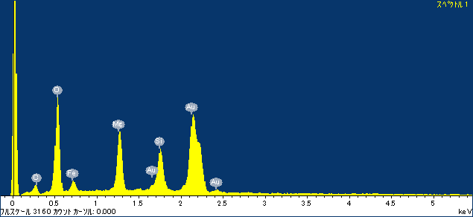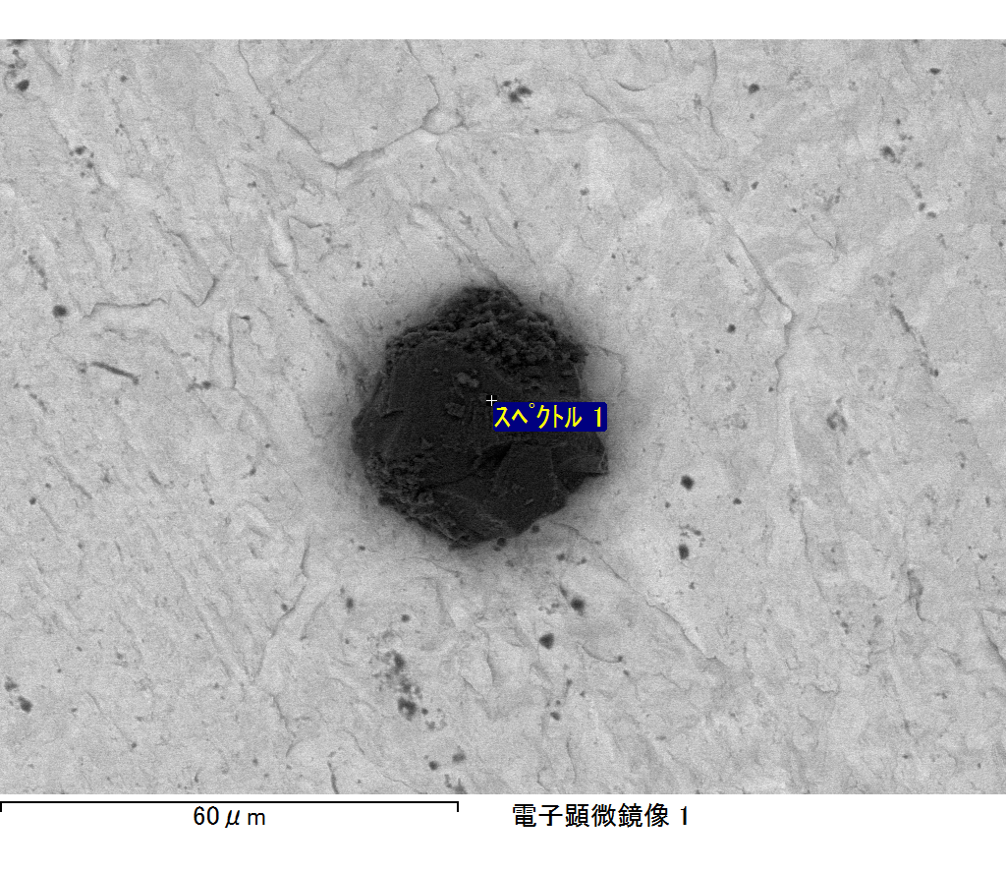

ｺﾒﾝﾄ :

2017/10/06 10:32:31

ﾌﾟﾛｼﾞｪｸﾄ 1

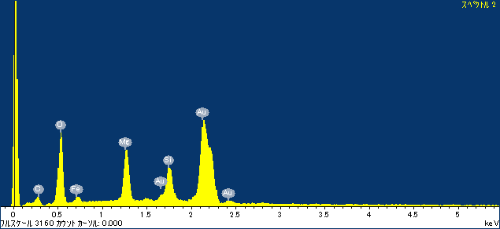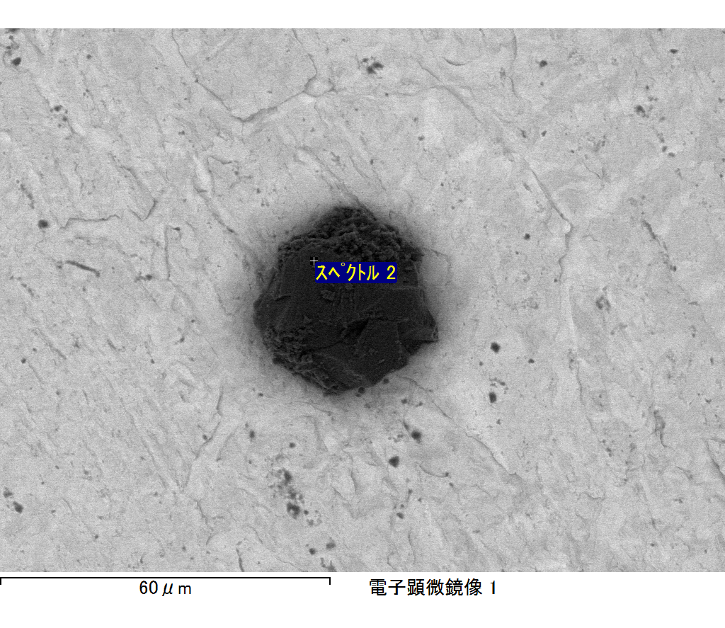

ｺﾒﾝﾄ :

2017/10/06 10:32:36

ﾌﾟﾛｼﾞｪｸﾄ 1

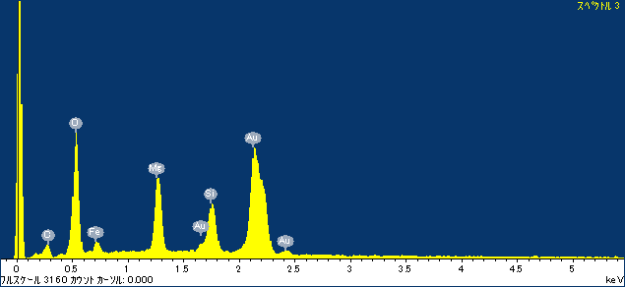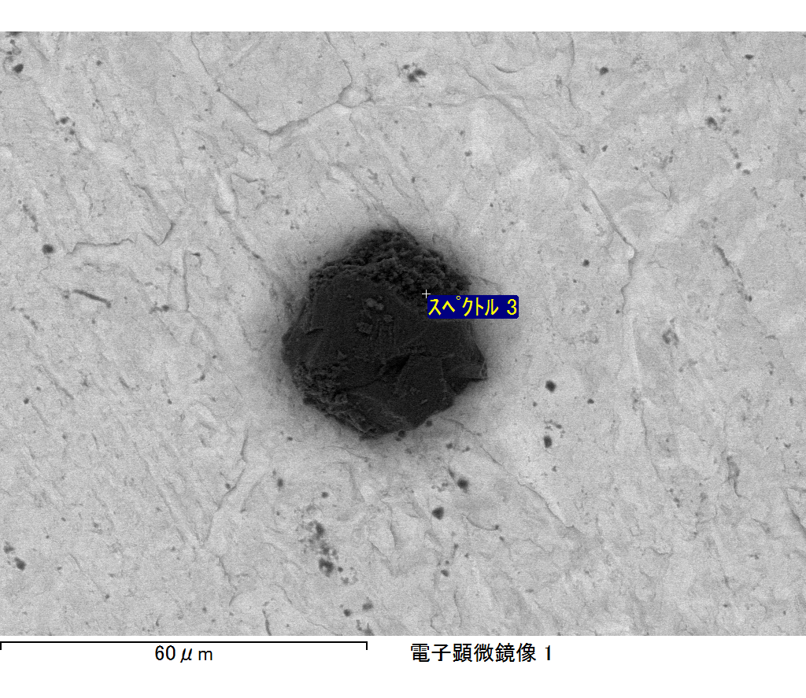

ｺﾒﾝﾄ :

2017/10/06 10:32:42

ﾌﾟﾛｼﾞｪｸﾄ 1

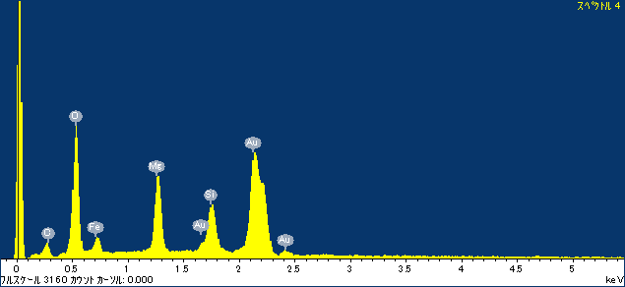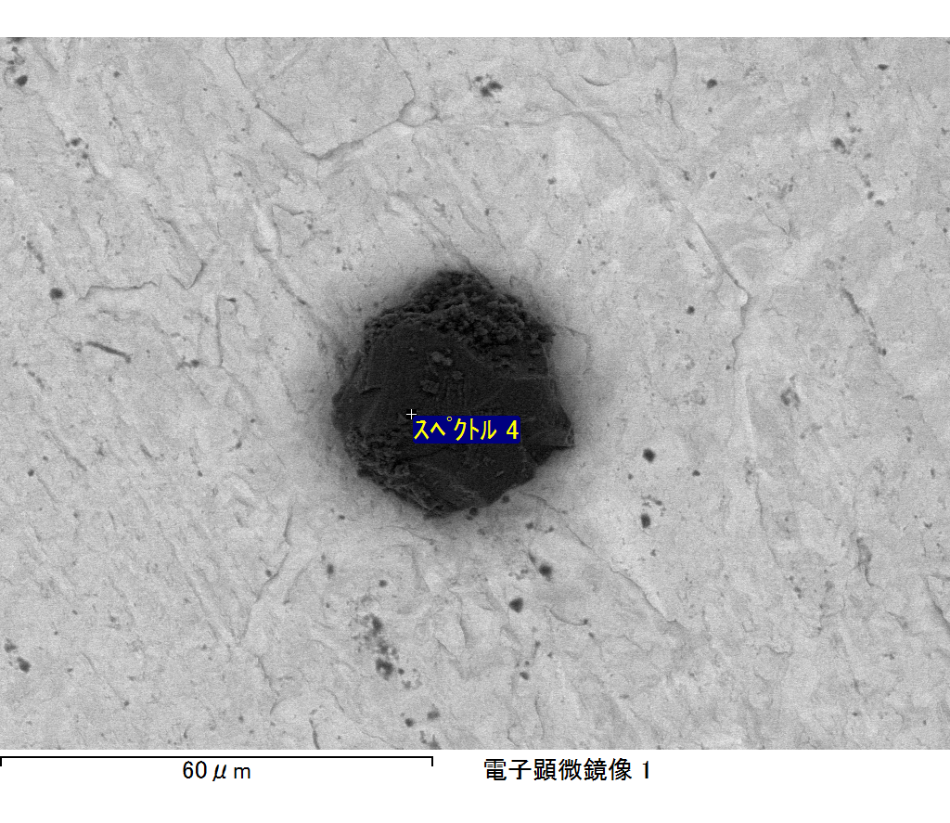

ｺﾒﾝﾄ :

2017/10/06 10:32:45

ﾌﾟﾛｼﾞｪｸﾄ 1

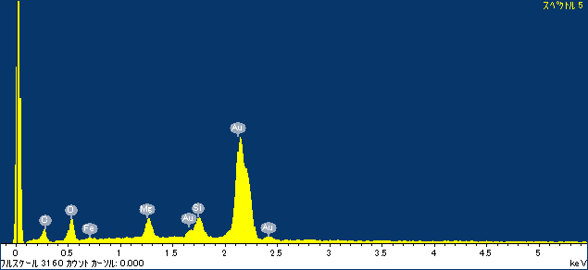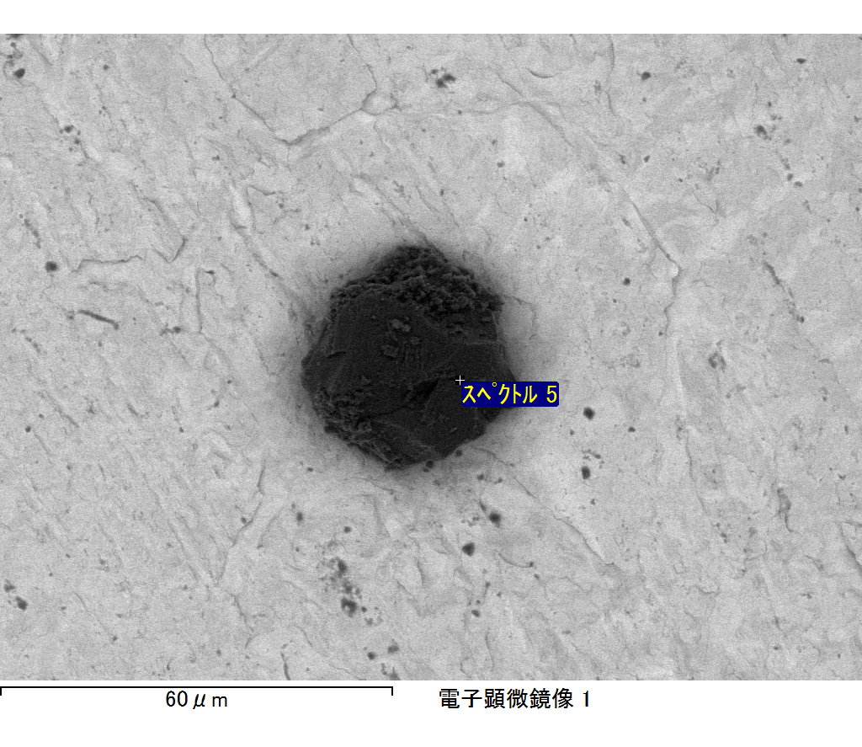

ｺﾒﾝﾄ :

2017/10/06 10:32:56

ﾌﾟﾛｼﾞｪｸﾄ 1