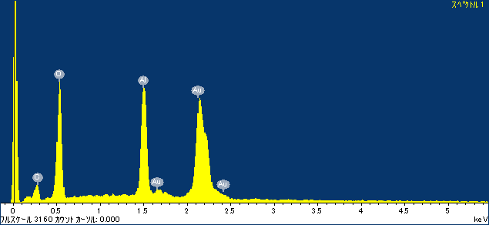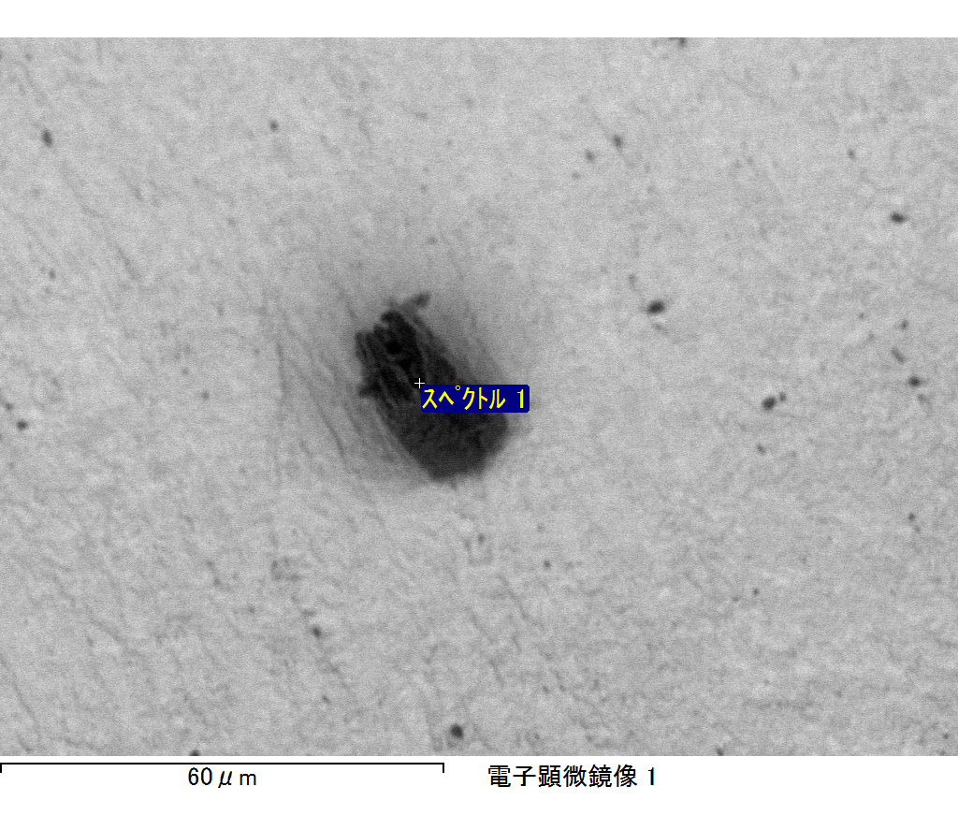

ｺﾒﾝﾄ :

2017/10/06 10:21:16

ﾌﾟﾛｼﾞｪｸﾄ 1