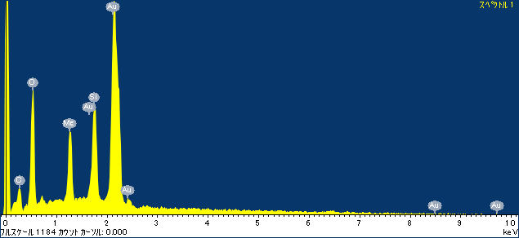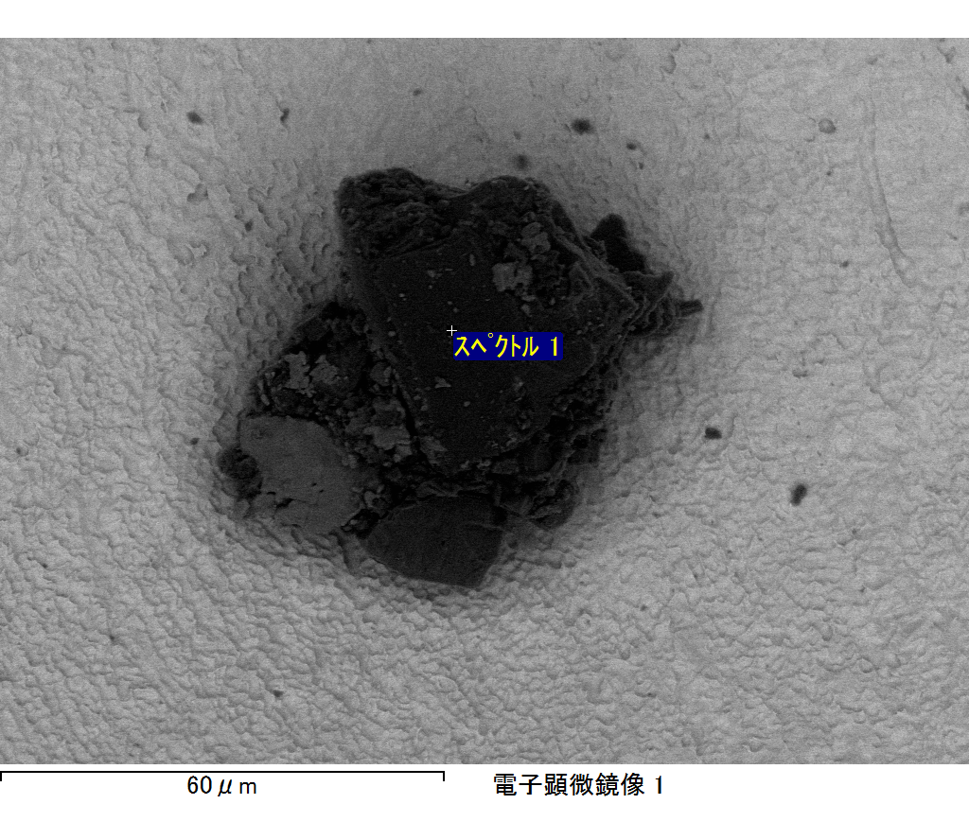

ｺﾒﾝﾄ :

2017/10/17 11:05:01

ﾌﾟﾛｼﾞｪｸﾄ 1

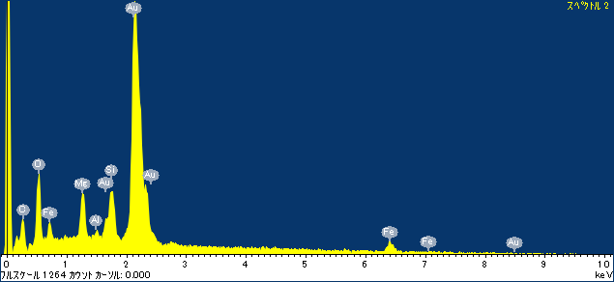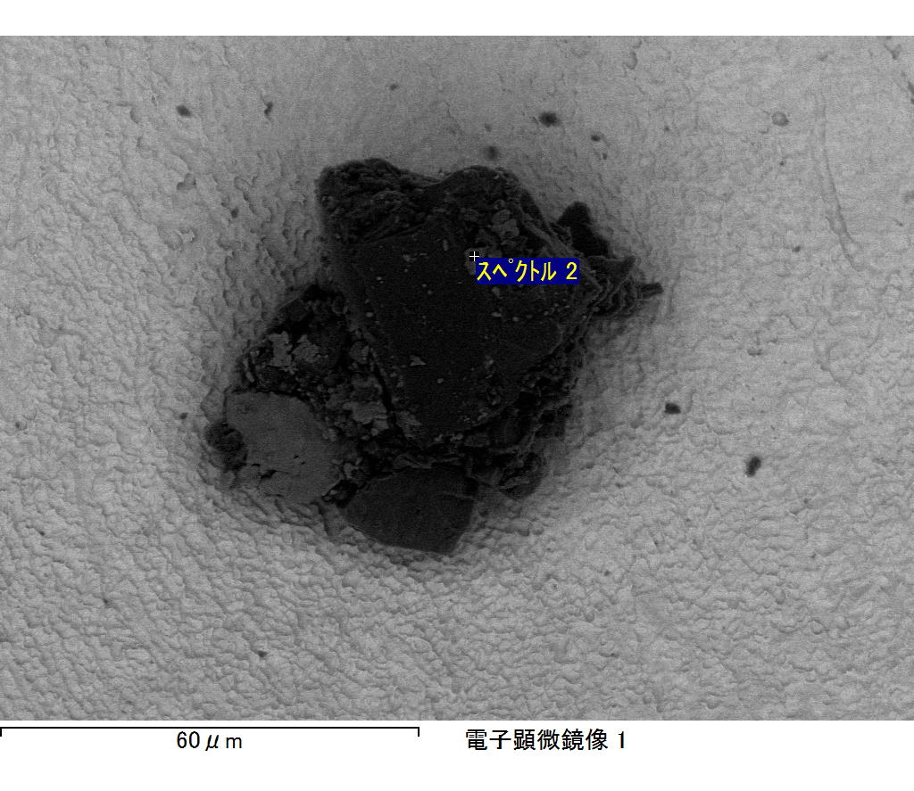

ｺﾒﾝﾄ :

2017/10/17 11:05:06

ﾌﾟﾛｼﾞｪｸﾄ 1

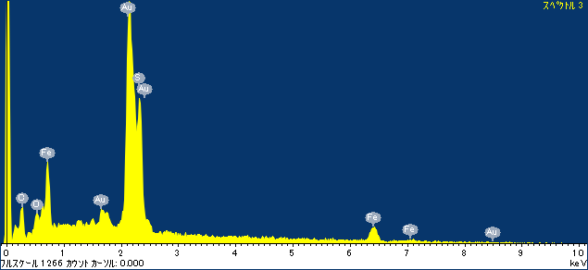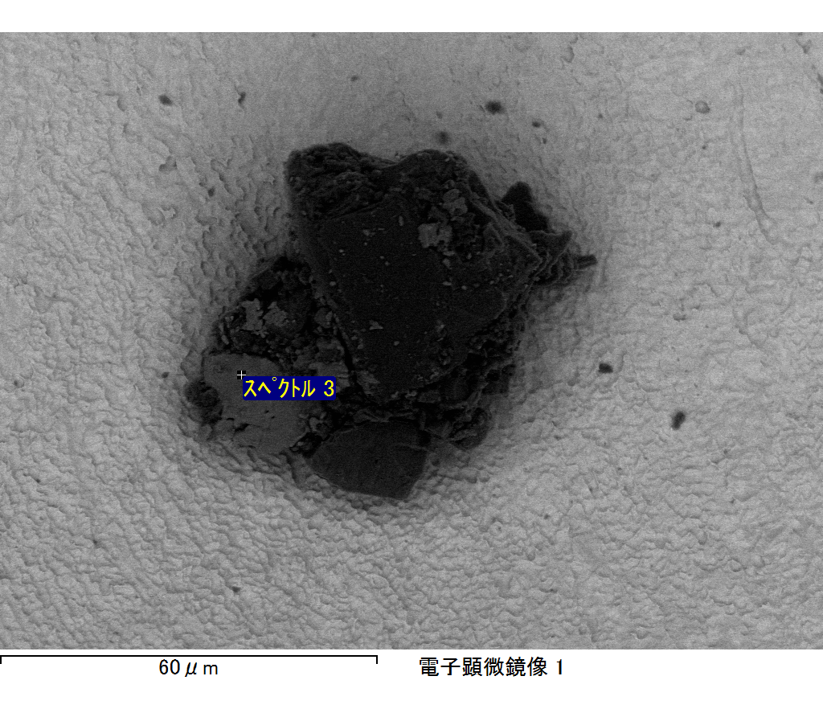

ｺﾒﾝﾄ :

2017/10/17 11:05:11

ﾌﾟﾛｼﾞｪｸﾄ 1

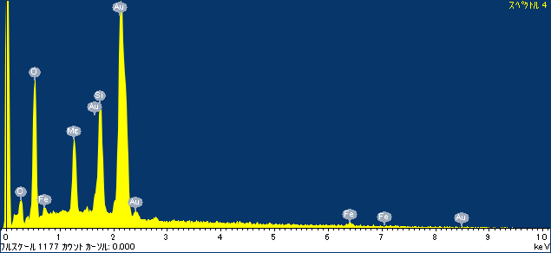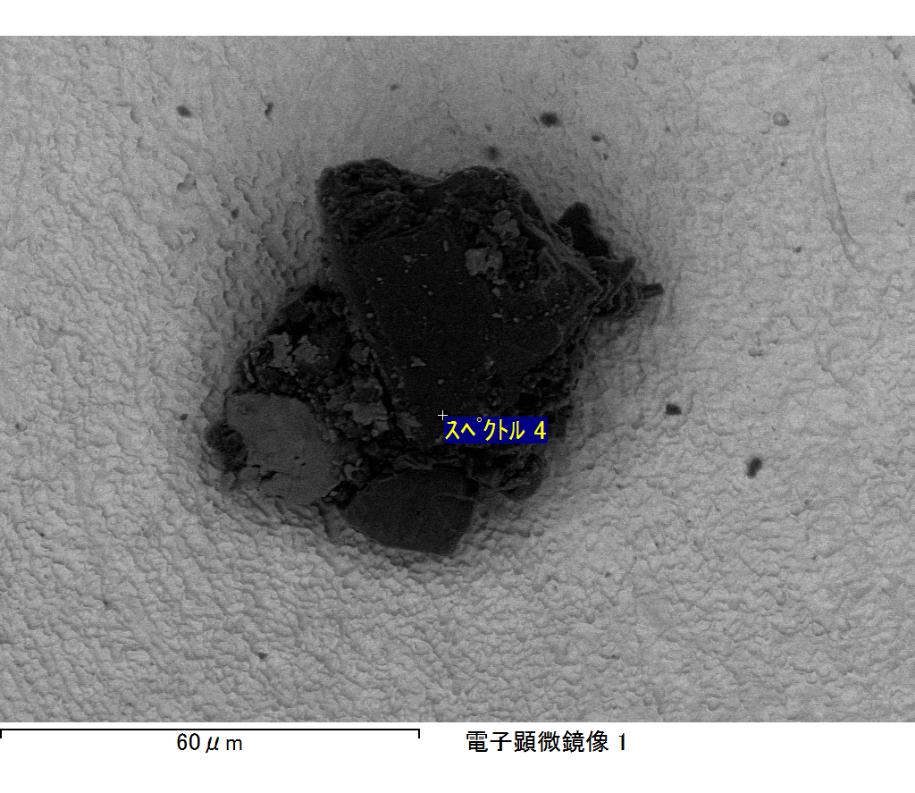

ｺﾒﾝﾄ :

2017/10/17 11:05:14

ﾌﾟﾛｼﾞｪｸﾄ 1

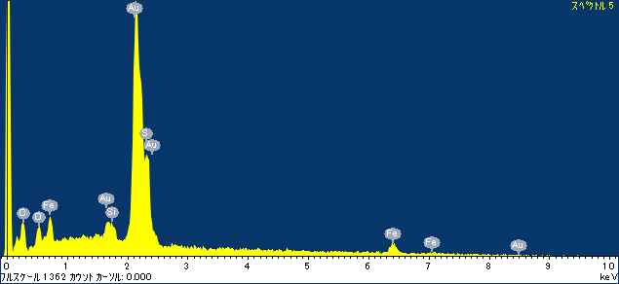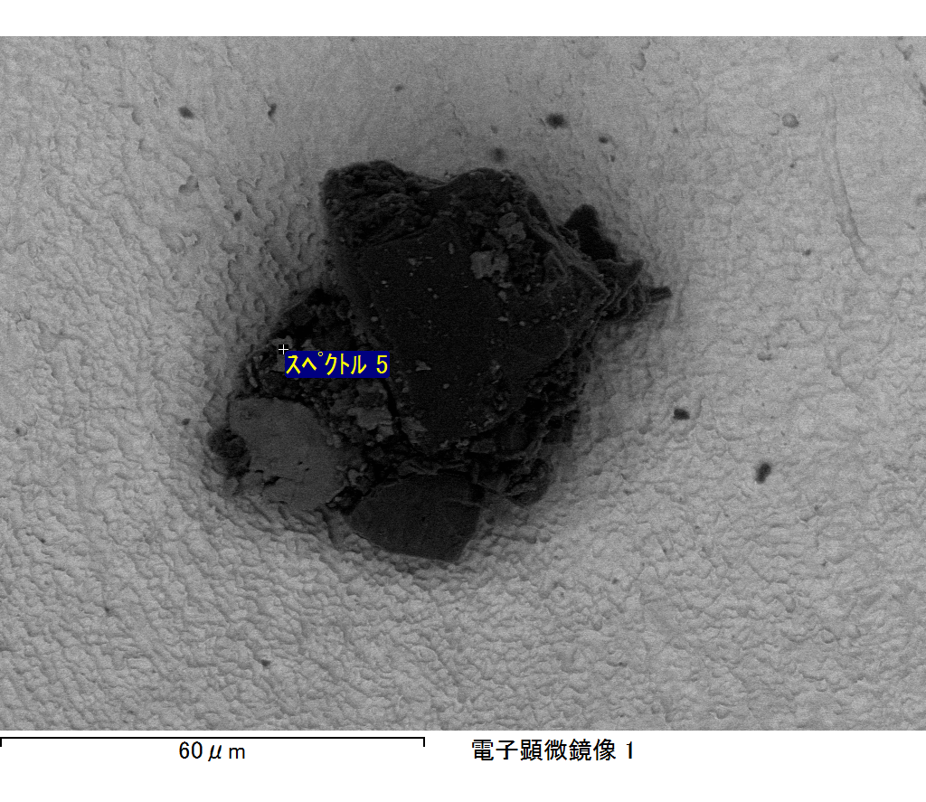

ｺﾒﾝﾄ :

2017/10/17 11:05:19

ﾌﾟﾛｼﾞｪｸﾄ 1

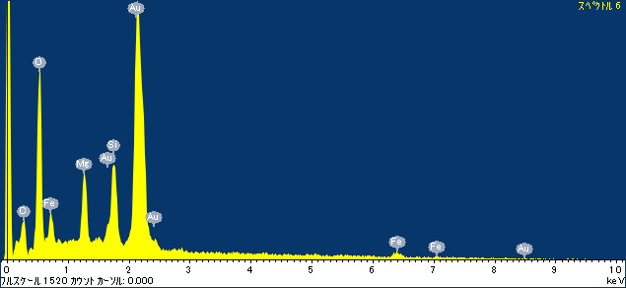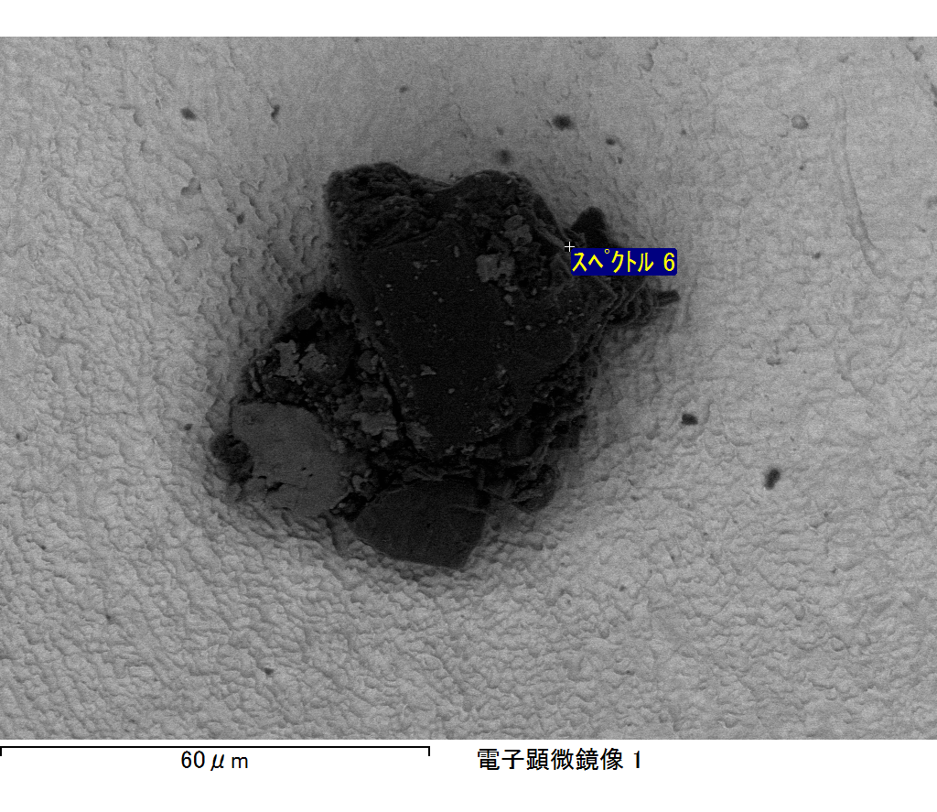

ｺﾒﾝﾄ :

2017/10/17 11:05:23

ﾌﾟﾛｼﾞｪｸﾄ 1

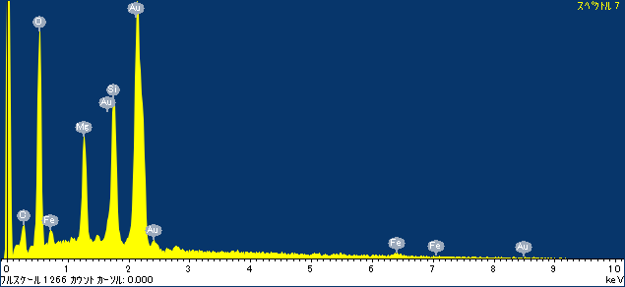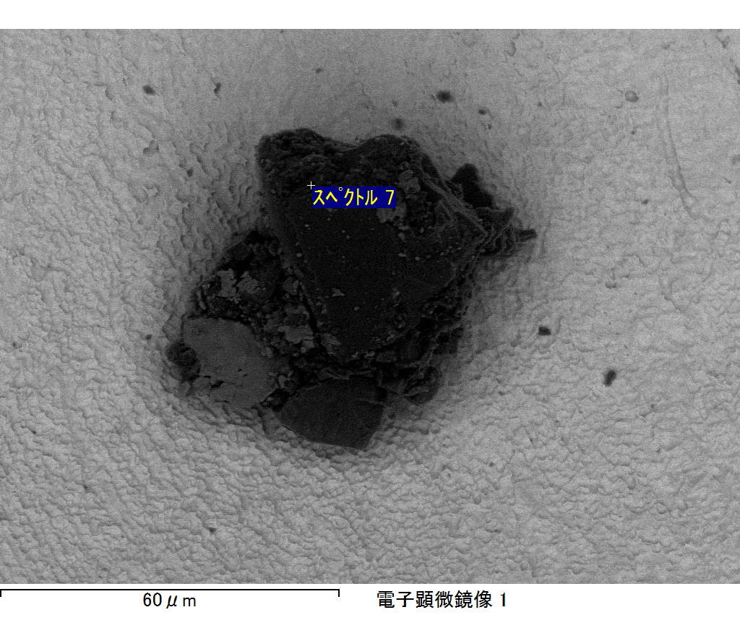

ｺﾒﾝﾄ :

2017/10/17 11:05:27

ﾌﾟﾛｼﾞｪｸﾄ 1