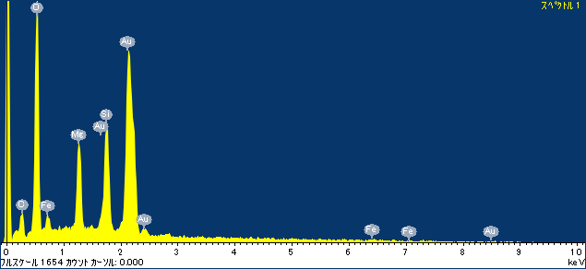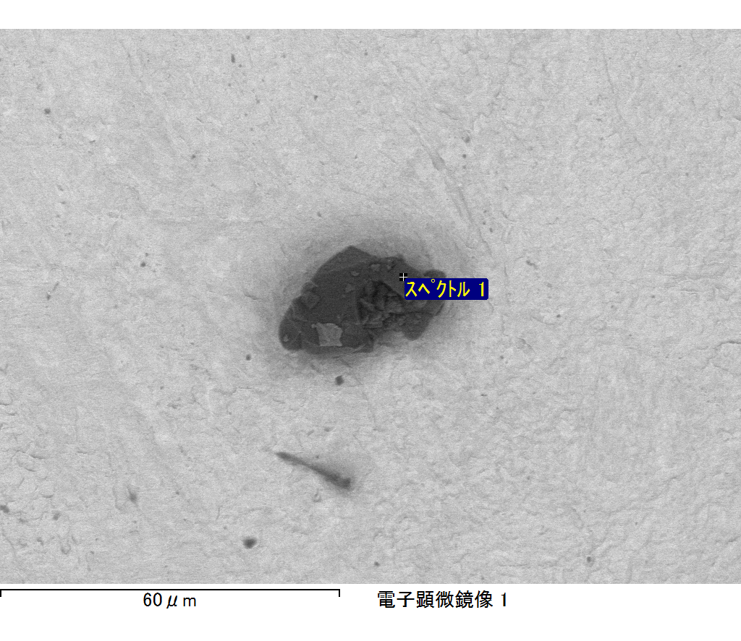

ｺﾒﾝﾄ :

2017/10/17 11:29:53

ﾌﾟﾛｼﾞｪｸﾄ 1

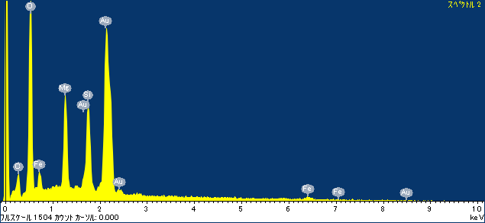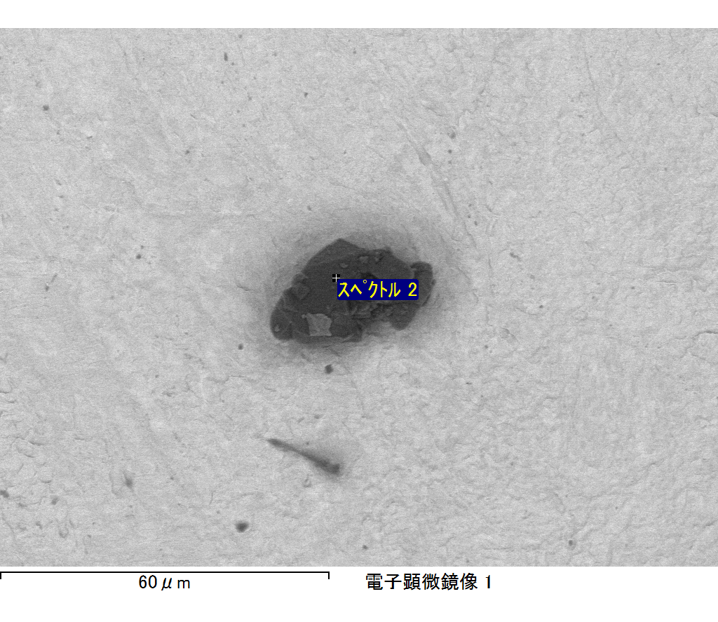

ｺﾒﾝﾄ :

2017/10/17 11:29:56

ﾌﾟﾛｼﾞｪｸﾄ 1

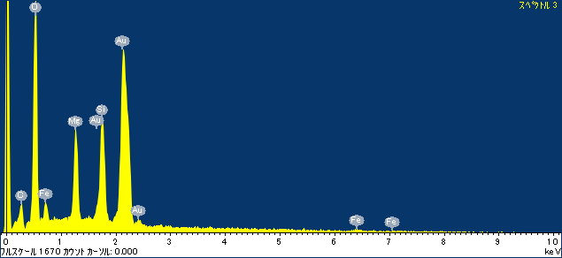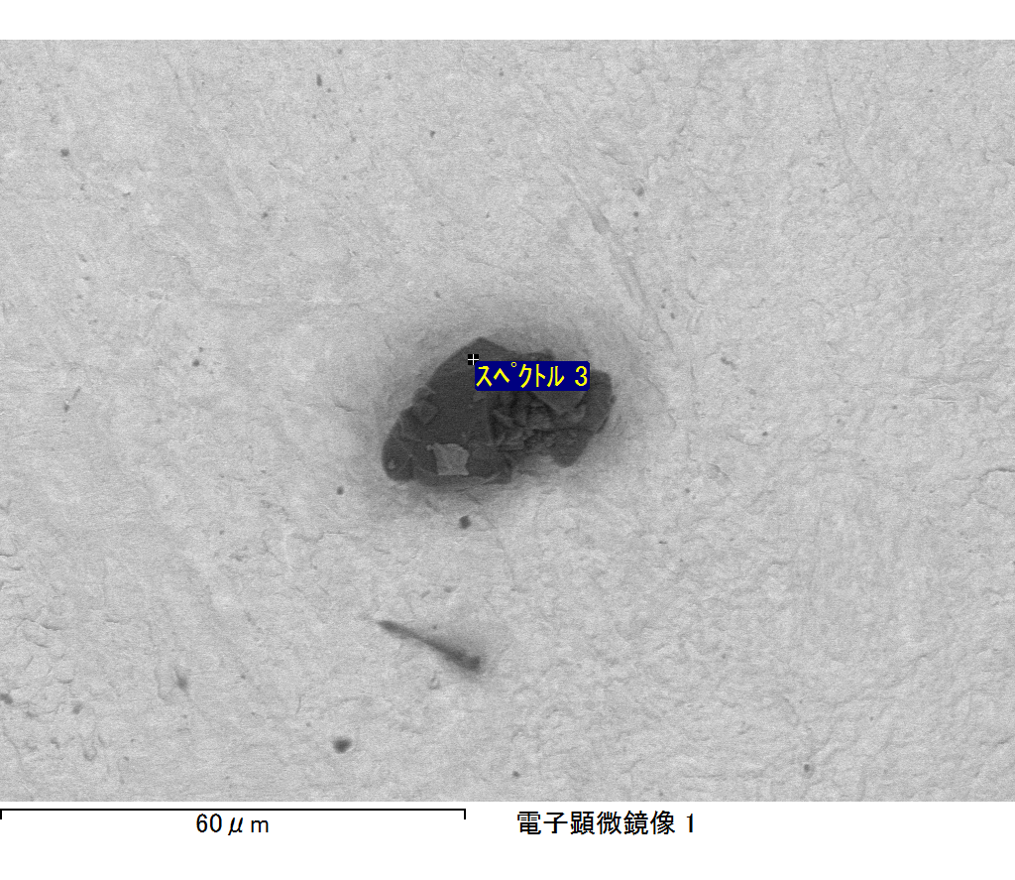

ｺﾒﾝﾄ :

2017/10/17 11:30:06

ﾌﾟﾛｼﾞｪｸﾄ 1

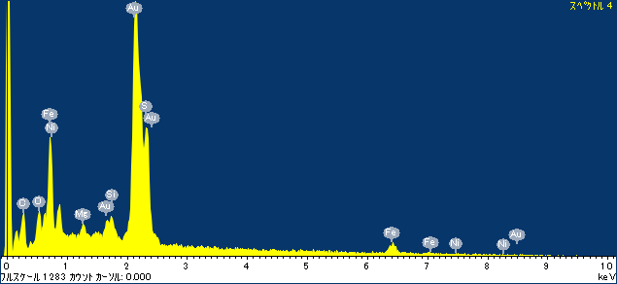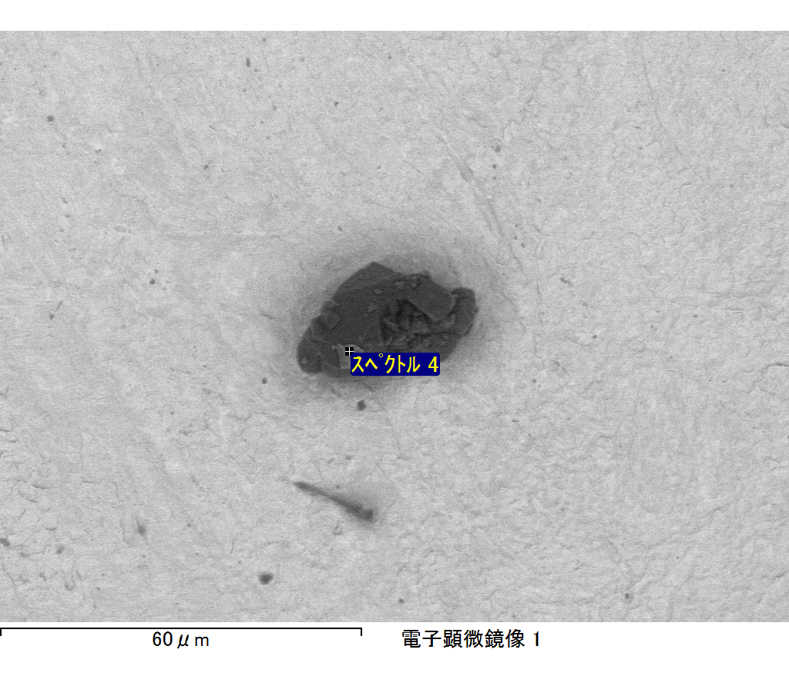

ｺﾒﾝﾄ :

2017/10/17 11:30:09

ﾌﾟﾛｼﾞｪｸﾄ 1

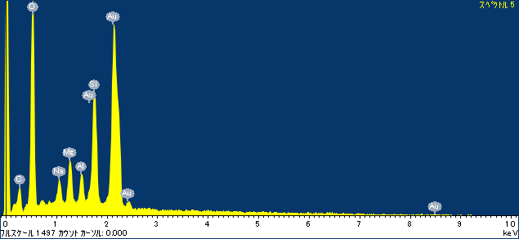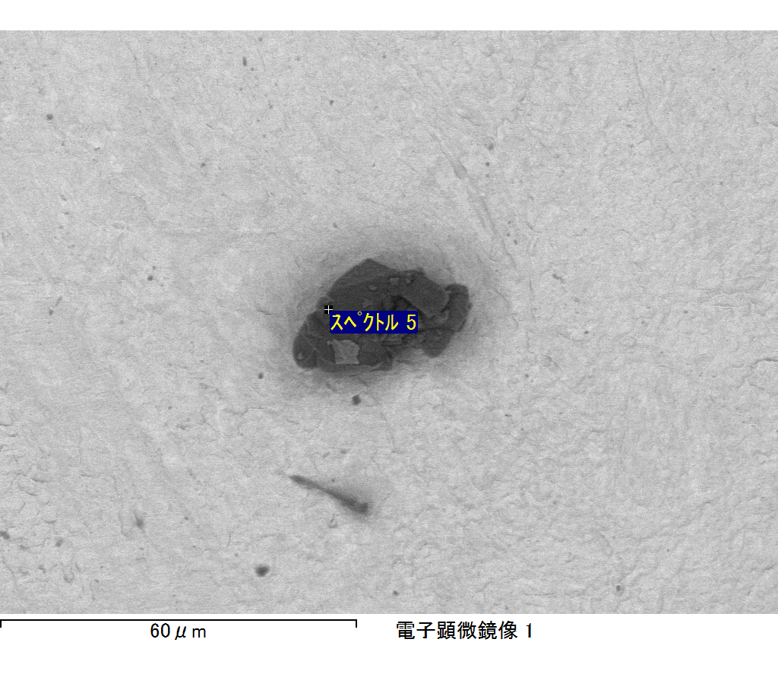

ｺﾒﾝﾄ :

2017/10/17 11:30:13

ﾌﾟﾛｼﾞｪｸﾄ 1