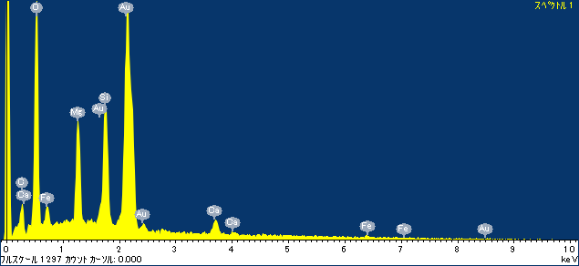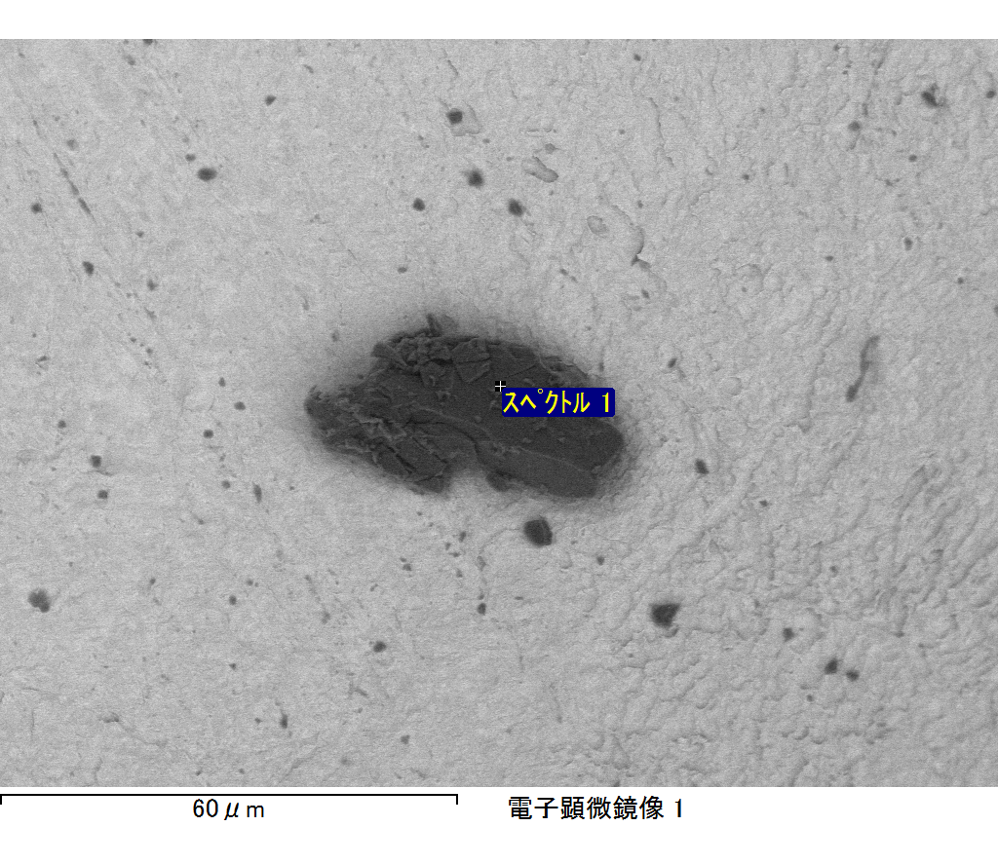

ｺﾒﾝﾄ :

2017/10/17 11:43:17

ﾌﾟﾛｼﾞｪｸﾄ 1

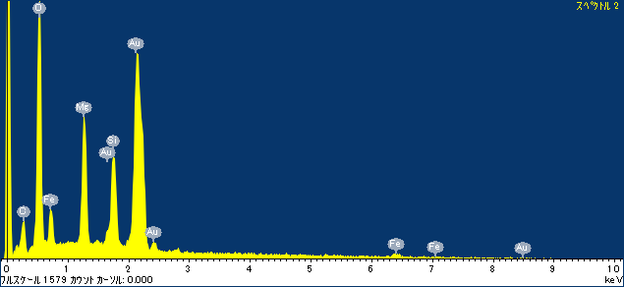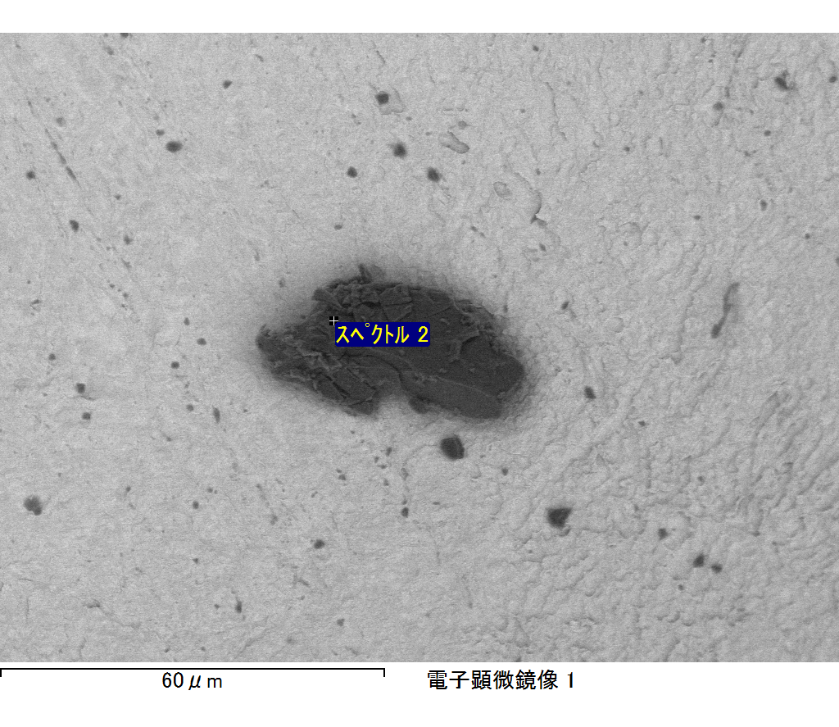

ｺﾒﾝﾄ :

2017/10/17 11:43:21

ﾌﾟﾛｼﾞｪｸﾄ 1

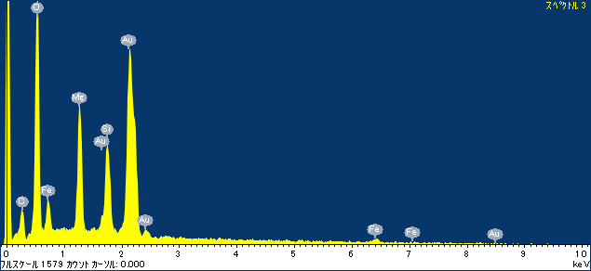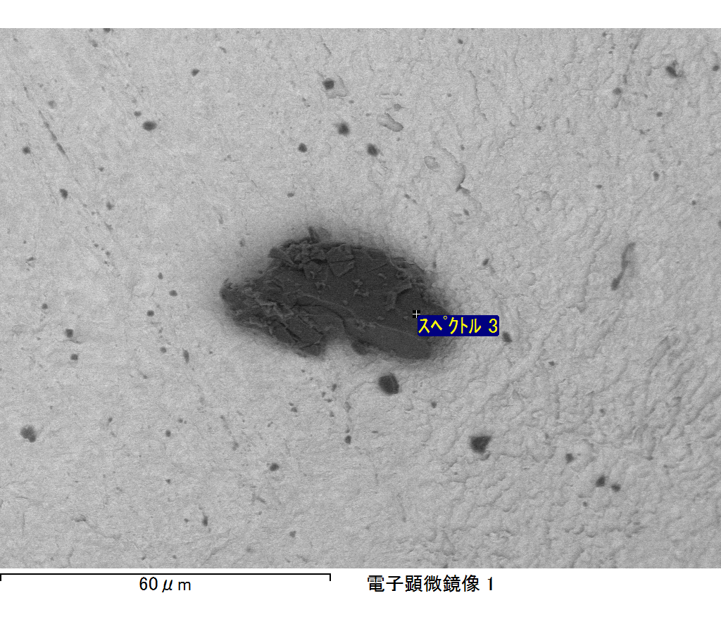

ｺﾒﾝﾄ :

2017/10/17 11:43:24

ﾌﾟﾛｼﾞｪｸﾄ 1

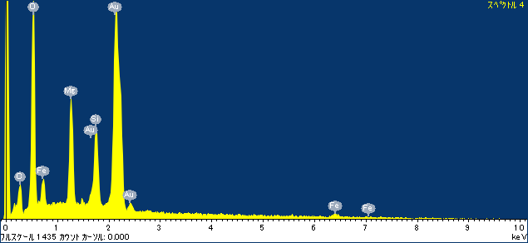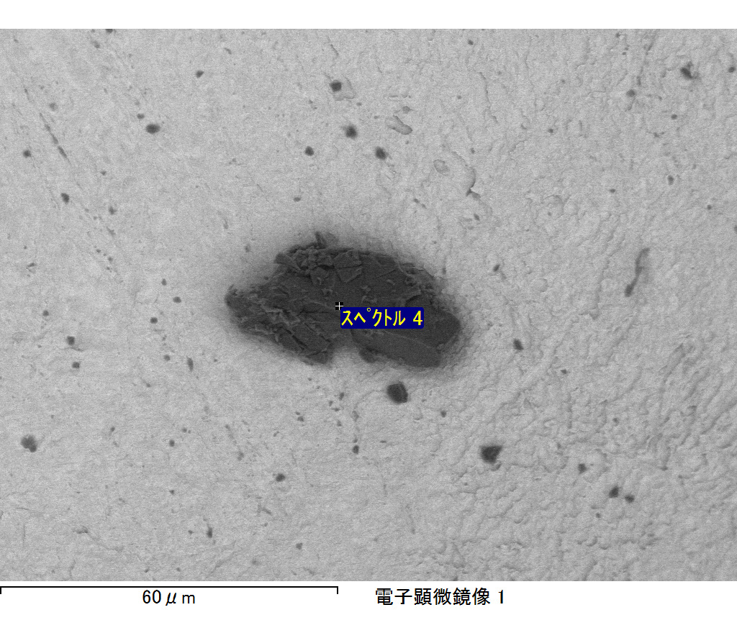

ｺﾒﾝﾄ :

2017/10/17 11:43:29

ﾌﾟﾛｼﾞｪｸﾄ 1

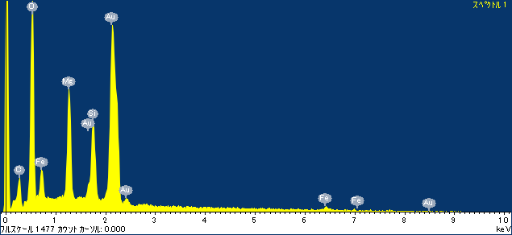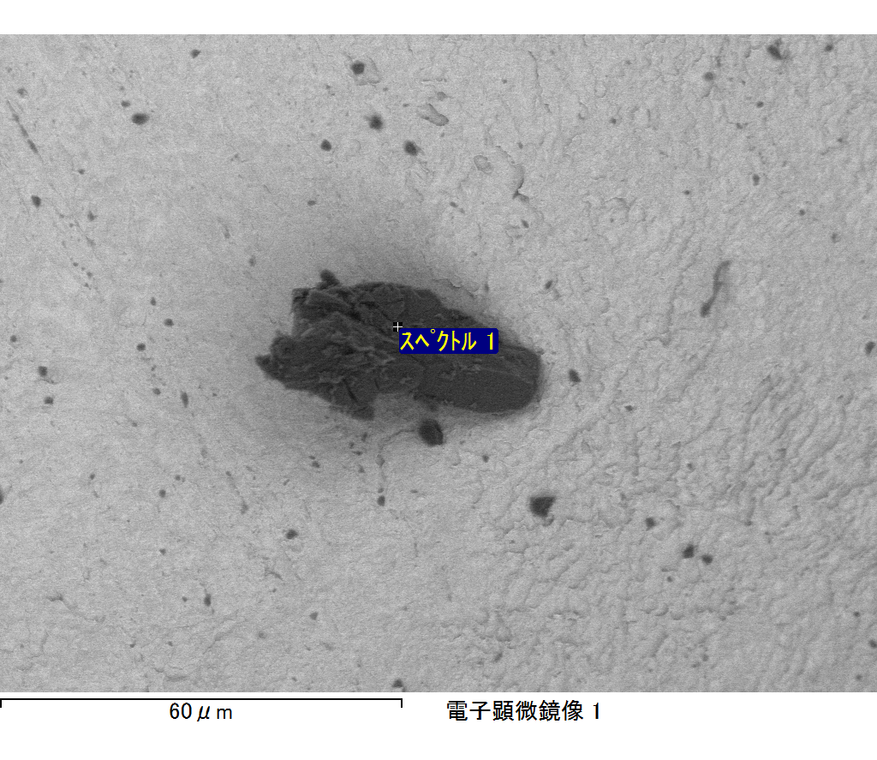

ｺﾒﾝﾄ :

2017/10/17 11:43:45

ﾌﾟﾛｼﾞｪｸﾄ 1