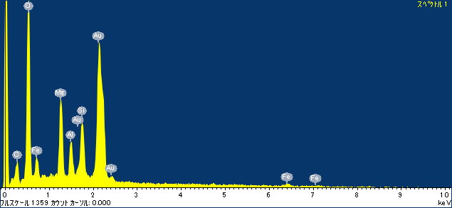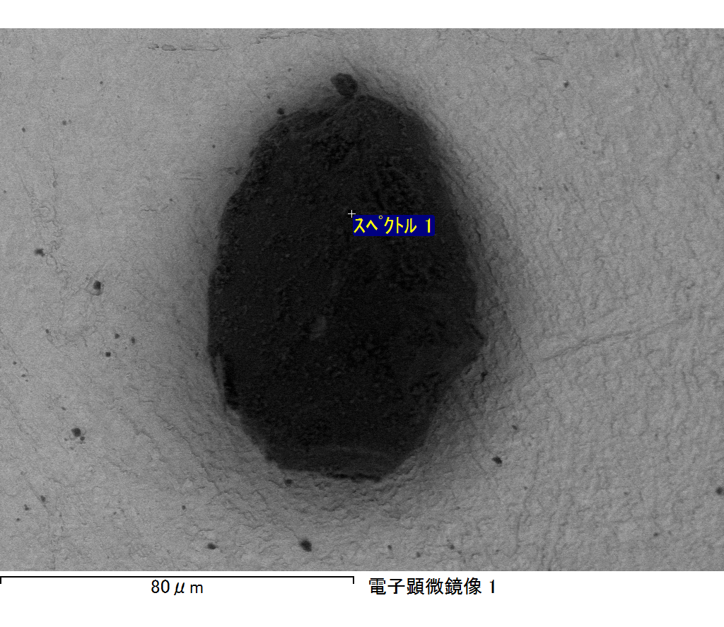

ｺﾒﾝﾄ :

2017/10/17 13:17:06

ﾌﾟﾛｼﾞｪｸﾄ 1

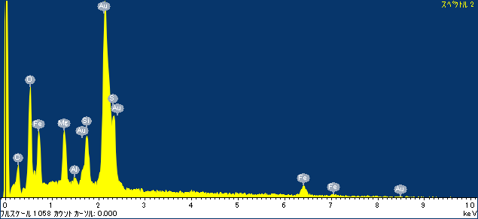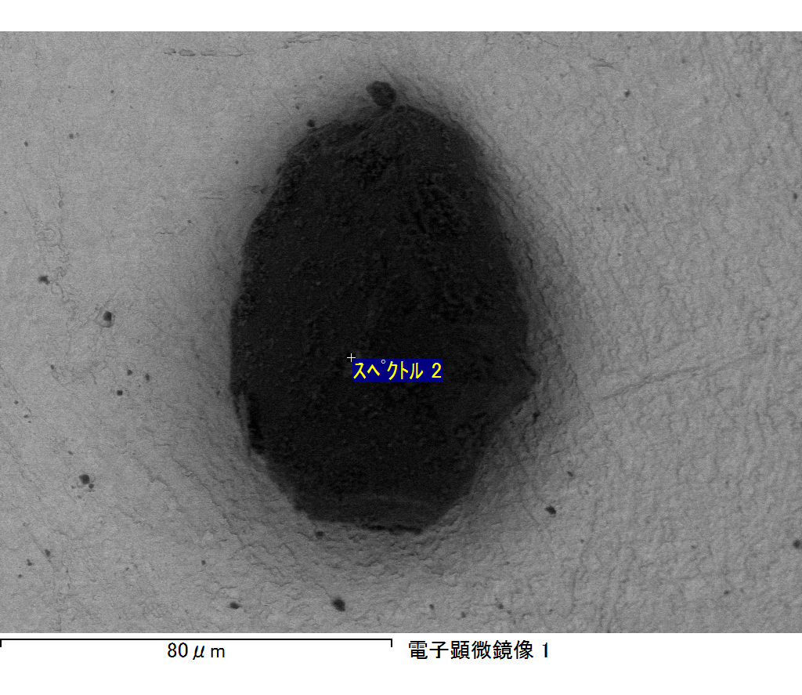

ｺﾒﾝﾄ :

2017/10/17 13:17:13

ﾌﾟﾛｼﾞｪｸﾄ 1

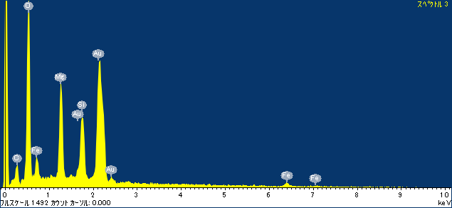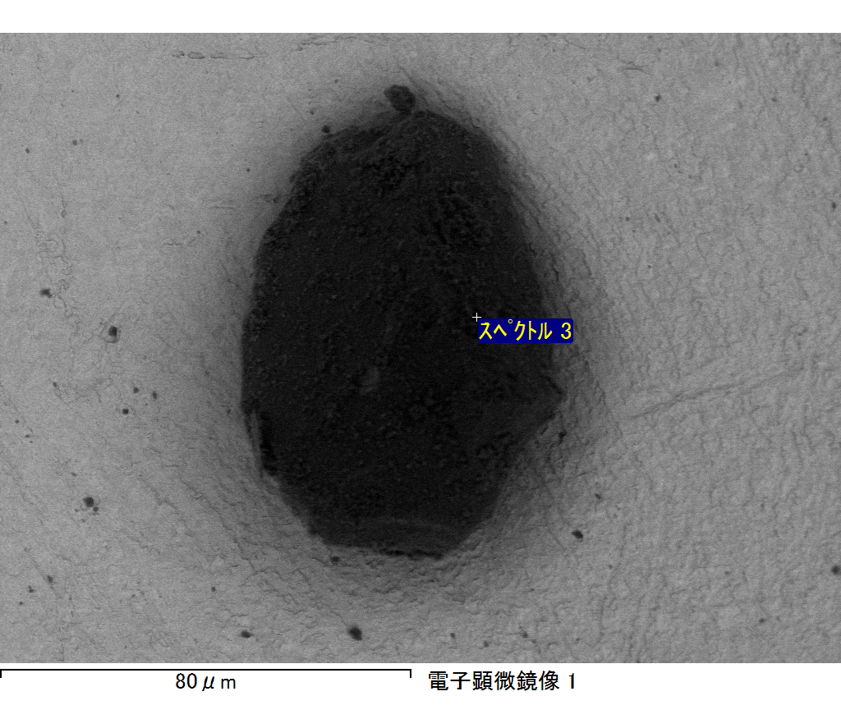

ｺﾒﾝﾄ :

2017/10/17 13:17:17

ﾌﾟﾛｼﾞｪｸﾄ 1

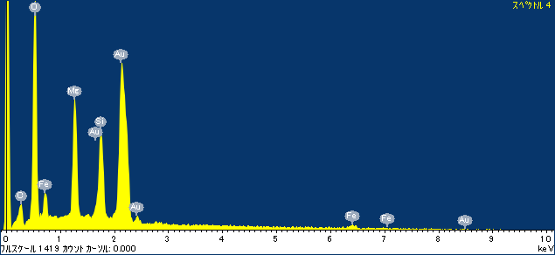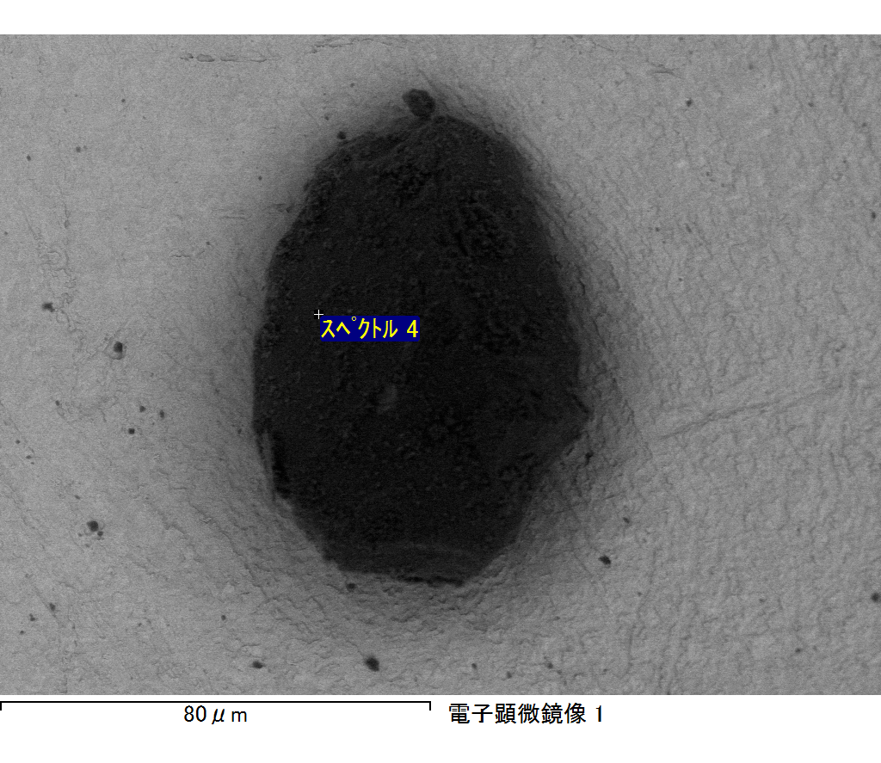

ｺﾒﾝﾄ :

2017/10/17 13:17:21

ﾌﾟﾛｼﾞｪｸﾄ 1

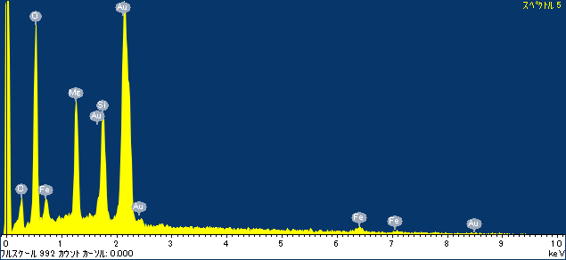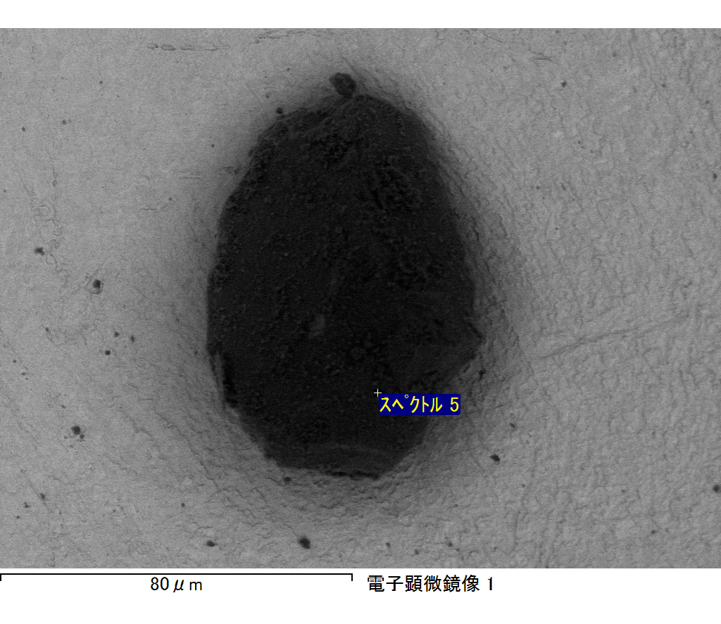

ｺﾒﾝﾄ :

2017/10/17 13:17:26

ﾌﾟﾛｼﾞｪｸﾄ 1